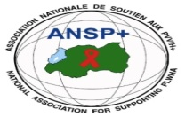  [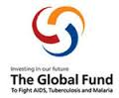](http://scottfiller.info/)

**PROJECT NAME: ANSP+/RBC/SPIU**

**NAME OF ORGANIZATION: NATIONAL ASSOCIATION FOR SUPPORTING PEOPLELIVING WITH HIV/AIDS (ANSP+)**

**NAME OF ORGANIZATION: NATIONAL ASSOCIATION FOR SUPPORTING PEOPLELIVING WITH HIV/AIDS (ANSP+)**

**NSP PROGRAM: COVID-19 IMPACT MITIGATION**

**ACTIVITY: FOUR-DAY TRAINING FOR CAPACITY BUILDING OF ANSP+ CONSTITUENCIES (MEMBERS) TO INCREASE THEIR ENGAGEMENT IN COMMUNITY MOBILIZATION AND ADVOCACY DURING COVID-19**

**TARGET GROUP: KEY POPULATIONS**

**AREA OF INTERVENTION: RUBAVU DISTRICT**

**MISSION REPORT**

**I.INTRODUCTION**

ANSP+ stands as a National Association for supporting People living with HIV/AIDS. It is a Rwandan local Non-Governmental Organization created in September 2000 by People Living with HIV themselves, with the leading mission of striving for the quality of life of HIV infected /affected people in Rwanda and fighting against the spread of HIV/AIDS and other epidemics. Towards this mission, our potential beneficiaries include Key Populations which runs a high risk of getting HIV.

The concern of ANSP+ is not only to fight against the spread of HIV among key populations but also other epidemics like covid 19, TB, malaria are concerned. Within this perspective, the National Association for Supporting people living with HIV in partnership with the Global Fund through the Rwanda Biomedical Center (RBC) has carried out a four day training to key populations in Rubavu district with the aim of increasing their engagement in community mobilization to fight against the spread of the disease.

**II.TRAINING OBJECTIVE**

As highlighted in the introduction above, the objective of this activity is to increase the engagement of ANSP+ constituencies in community mobilization as a contribution in the battle of fighting against Covid-19,HIV and other pandemics such Hepatitis, TB and malaria.

**III. HOW THE ACTIVITIES WERE CONDUCTED**

The field work in Rubavu District was for four days starting from the 12 up to 15th September 2023. As it was planned, the first day of activities was reserved for the departure of ANSP+ team from the office in Kigali to Rubavu. The same day, the team would meet with the head of Gisenyi health facility to discuss about the activities and then preparing for the training sessions.

The following day of activities targeted the heads of departments at Gisenyi health center to discuss how health centers are engaging KPs in Covid-19 prevention and take actions. At this health facility, the team of ANSP+ discussed with the heads of departments about how they serve key populations and how they put emphasis on the continuity of preventing against the spread of covid 19. The heads of Gisenyi health facility said that the pandemic of covid-19 is still there and that the health facility has not stopped prevention activities against Covid 19, the head of Gisenyi health facility request ANSP+ to train health providers and Key population in friendly service delivery at the health center so that this will help in reducing auto stigma and stigma faced by MSM at the health facility. As they said, the activities are not only oriented to key populations but to the whole population in general. The team of ANSP+ encouraged healthcare providers at Gisenyi health facility to continue working with key populations in preventing different diseases such as malaria, TB, HIV and also continue helping them preventing against Covid 19.

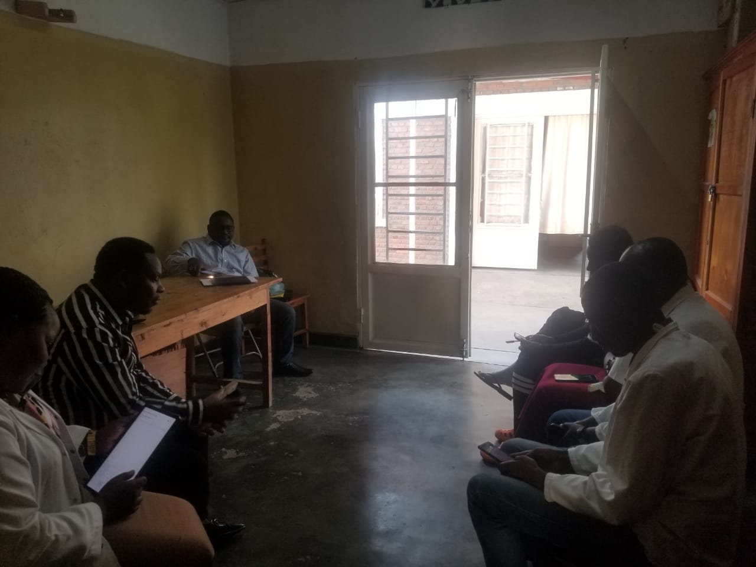

**Photo of ANSP+team in a meeting with Healthcare providers at Gisenyi health facility**

The first day of the training, the trainer started by giving question to Key population by explaining Key populations what is covid-19 it Effects to our country :

1.What is Covid 19?

2.What are the symptoms of covid 19?

3.What are the most people likely to be affected by covid 19?

4. How can I protect myself and protect others against covid 19?

5.What is HIV?

6.What is TB?

Participants of the training were divided into two groups and worked on the questions and each group had five minutes to present the findings.

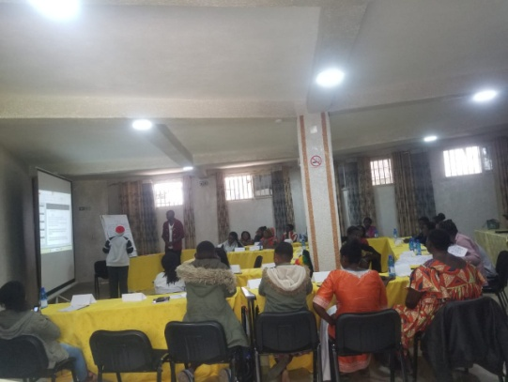 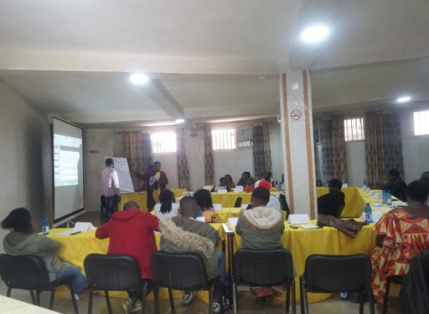

**Photo of the groups presenting the results of the work**

After presentations by key populations, the trainer explained deeply about covid 19,HIV ,TB, Malaria and Ebola where it came from, its symptoms and ways to prevent against it , the symptoms of COVID-19 which are flu – fever and a dry cough [(the two most common symptoms)](https://www.cdc.gov/coronavirus/2019-ncov/about/share-facts.html), fatigue, aches and pains, and nasal congestion. As the pandemic spread around the world, other symptoms such as a loss of sense of smell or taste have emerged. She continue saying that the mode of covid-19 virus transmission is spread from person to person through small respiratory droplets. When a person coughs or sneezes, these droplets can also land on nearby surfaces. There is also evidence that the COVID-19 virus can [last on surfaces](https://www.gavi.org/vaccineswork/what-not-touch-how-avoid-contact-new-coronavirus) – especially plastic or metal. The preventing method are: Wear masks,

Social distance, Hand washing using soap or sanitizer, Vaccination

After training about covid-19 she continue training about HIV and TB

What is HIV?

**HIV**: human immunodeficiency virus)

**AIDS:** acquired immunodeficiency syndrome

* HIV is a virus that attacks the body’s immune system. If HIV is not treated, it can lead to [AIDS](https://www.cdc.gov/hiv/basics/livingwithhiv/opportunisticinfections.html)
* There is currently no effective cure. Once people get HIV, they have it for life.
* But with proper medical care, HIV can be controlled. People with HIV who get [effective HIV treatment](https://www.cdc.gov/hiv/basics/livingwithhiv/treatment.html) can live long, healthy lives and protect their partners.

**HIV TRANSMISSION**

Most people who get HIV get it through anal or vaginal sex, or sharing needles, syringes, or other drug injection equipment (for example, cookers). But there are powerful tools that can help [prevent HIV](https://www.cdc.gov/hiv/basics/prevention.html) transmission.

This section answers some of the most common questions about the risk of HIV transmission for different types of sex, injection drug use, and other activities.

**HIV PREVENTION**

Today, more tools than ever are available to prevent HIV. You can use strategies such as abstinence (not having sex), never sharing needles, and using condoms the right way every time you have sex. You may also be able to take advantage of HIV prevention medicines such as [pre-exposure prophylaxis](https://www.cdc.gov/hiv/basics/prep.html) (PrEP) and [post-exposure prophylaxis](https://www.cdc.gov/hiv/basics/pep.html) (PEP). If you have HIV, there are many actions you can take to prevent transmitting HIV to others.

**Whats is TB?**

Tuberculosis (TB) is **a potentially serious infectious disease that mainly affects the lungs** but can also affect other parts of the body. The bacteria that cause tuberculosis (**Mycobacterium tuberculosis)** are spread from person to person through tiny droplets released into the air via coughs and sneezes.

**Symptoms**

* a persistent cough, lasting at least 3 weeks,hemoptysis
* a loss of appetite and weight,a general feeling of [fatigue](https://www.medicalnewstoday.com/articles/248002.php) and being unwell
* swelling in the neck, a [fever](https://www.medicalnewstoday.com/articles/168266.php)
* night sweats, chest pain

Prevention

* getting a diagnosis and treatment early
* staying away from other people until there is no longer a risk of infection
* wearing a mask, covering the mouth, and ventilating rooms
* vaccination (BCG)

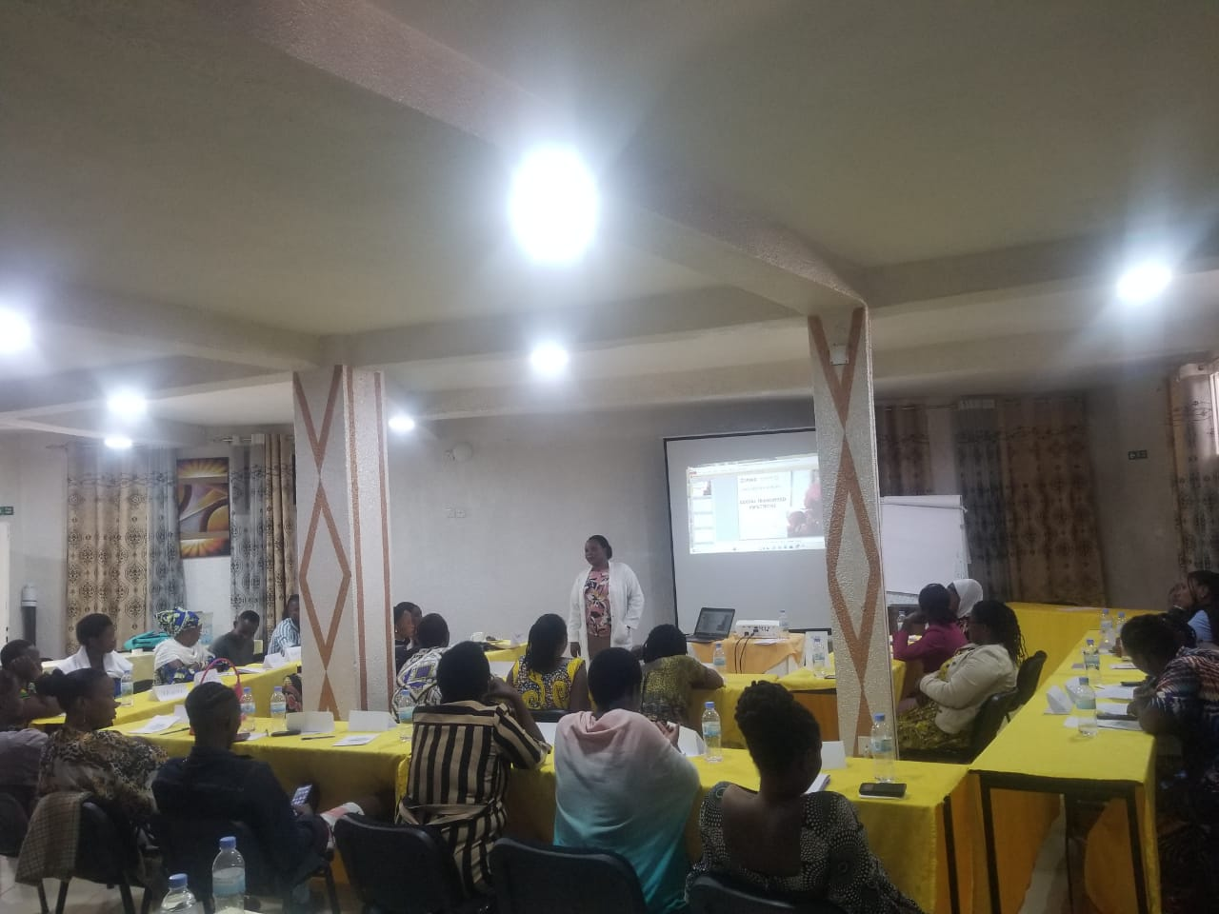

**Picture of the trainer training Key Population at Kivu peace view Hotel at Rubavu District**

After the presentation by the trainer, participants were given time to ask questions. The questions asked include ones of the real source/cause of covid 19 and its relations to other pandemics. To these questions, the trainer said that covid 19 is a virus that originated from China in the city of Huan. The only difference between Covid 19 and HIV is that covid 19 is treated and cured while HIV is not cured.HIV has no vaccine while covid 19 is vaccinated.

The fourth and the last day of the training was about HIV and Ebola. Like the previous day, the trainer gave questions about HIV and Ebola to be worked in groups. The work from different groups showed the causes of those two diseases, their symptoms, ways to prevent them and treatment.It was after presentations of the groups that the trainer gave full explanations of the two diseases; theirs causes, symptoms, prevention and treatment. Questions for fully understanding were asked and answers provided by the trainer. The trainer show Key Population how to wash their hands to prevent Covid-19 and other sickness which is be infected through hands

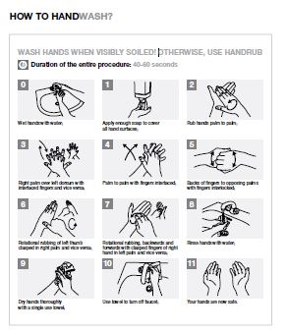

**IV. EXPECTED OUTCOMES OF THE FIELD WORK**

After the four days of the work, participants had full understanding of covid 19, HIV and Ebola, how they are transmitted, ways to prevent them and their treatment. Participants were also aware of the similarities and differences between those diseases. On the side of the health care providers, they were also aware that the pandemic of covid 19 has not ended and that they have to continue fighting it in the community in general and among key populations in particular and the trainer ask Key Population to share what they learned to their friends and cooperatives members and to mobilize other Key Population to come at the health facility for HIV testing and to prevent their life.

**V. CONCLUSIONS AND RECCOMENDATIONS**

By the end of the training, the director of administration and finance within ANSP+ Mr NIZEYIMANA Jean Marie Vianney thanked all the participants for the contribution they have carried out during the training. He said that people need to work together in the fight against the spread of covid 19.’’ Even if the pandemic has decreased, it has not ended’’ he added. The Director of Administration and Finance therefore called the participants to actively work together and fight all kind of diseases. He continuous by asking Key population to work together in Associations /Cooperatives for fighting poverty and improving their lifestyle.

After the word by DAF, all the participants took a photo.

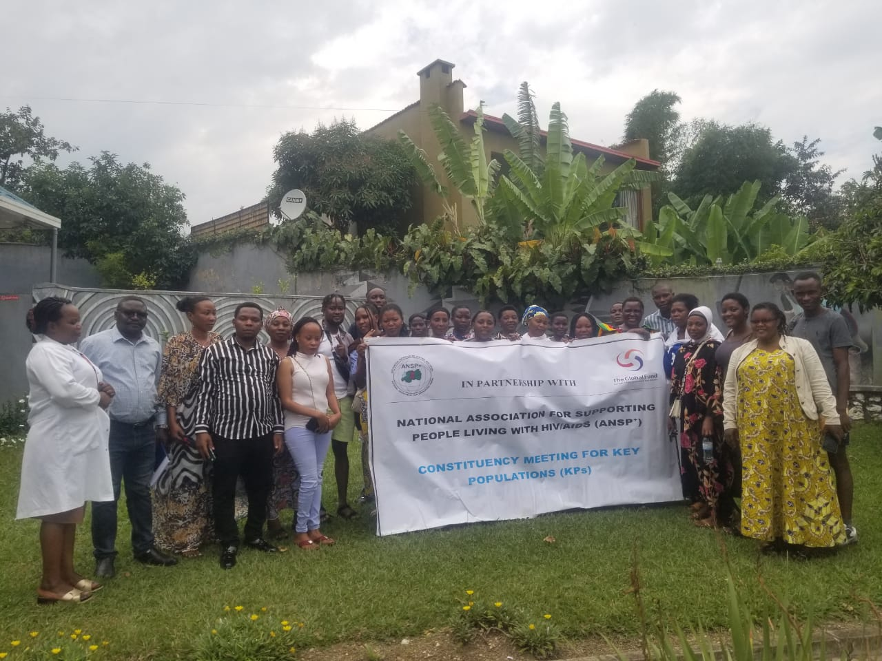

**Memorial Photo of the participants in Rubavu District**

Done at Kigali on the 18th September 2023

**ANSP+ TEAM MEMBERS IN MISSION**

Aimable BUCYANAYANDI

MUKAYIRANGA Marceline

NZIRINGIRIMANA Joseph

UMUTONI WA MANA Laurence

NIZEYIMANA Jean Marie Vianney

MUKASEKURU Deborah