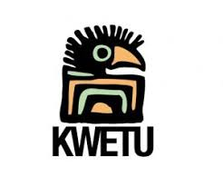
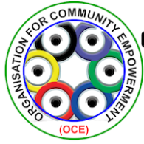
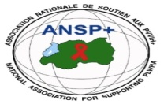
______________________________________________________________________________

PROJECT NAME: ANSP+/KC/FuG

REPORT ON THE TWO DAYS TRAINING WORKSHOP OF KEY POPULATIONS, COMMUNITY HEALTH WORKERS AND MEDIA PROFESSIONALS ON HIV PREVENTION, SAFE SEX, USE OF CONDOM, SEXUAL ORIENTATION AND HUMAN RIGHTS AND FACILITATING RADIO TALKS.
I. Introduction
ANSP+ stands for the National Association for Supporting People living with HIV (ANSP+). It is a Rwandan Civil Society Organization created in September 2000 with the main purpose of improving the quality of life of its beneficiaries. ANSP+ strives for quality of life of those infected and directly affected by HIV and fights against the spread of HIV.

Under the sponsorship of Forum Syd via Pharmacist without borders (FuG) Sweden and Kwetu connectors; from 2000 up to now, the National Association Supporting People living with HIV(ANSP+) through the program goal of “Free from HIV,zero discrimination of Key populations and Healthy and including society in six borders districts of Uganda&Rwanda” has been implementing the project activities in the city of Kigali(Gasabo,Kicukiro and Nyarugenge districts), Musanze district of the northern province and Nyagatare district in the Eastern province.

From 29-30 December 2021, a two day training for KPs, community health workers and media professionals was organized in Nyagatare district at Moons Charity Hotel .The focus of the training was on HIV prevention, safe sex, use of condom, sexual orientation and human rights and facilitating radio talks.

The objectives of the training were set as follows:

1. To train KPs, community health workers and media professionals on HIV prevention, safe sex, use of condom, Sexual orientation and human rights

2. To enhance the knowledge and skills of participants of the meeting on the above mentioned subjects;

3. Sensitize journalists to help the community by public awareness on the above subjects through their radios talks, articles published and postures on different media channels.

The training gathered together 27 participants including 6 personnel from ANSP+ that would be supervising the training activities,8 media professionals,5 health services providers and 5 representatives of KPs and 1 training facilitator.

It was expected that by the end of the training, participants would get enough knowledge on the issue around the SRHR, human rights, positive living with HIV and safe sex.

II. RESULTS OF THE TRAINING

The results of the training were very fruitful as it was planned. On the first day of the training at Moons Charity Hotel, after the welcome speech and opening remarks by the representative of local government, the project Manager of ANSP+/KC/FuG Mr. NIZEYIMANA Jean Marie Vianney introduced the project to the participants, its essence and its objectives. The project manager told the participants that HIV has been a danger to the populations of many nations around the world during the years about 2000. It was within this year that ANSP+ was created by people living with HIV with the main purpose of striving for the quality of life of those infected and directly affected by HIV and fighting against the spread of HIV.

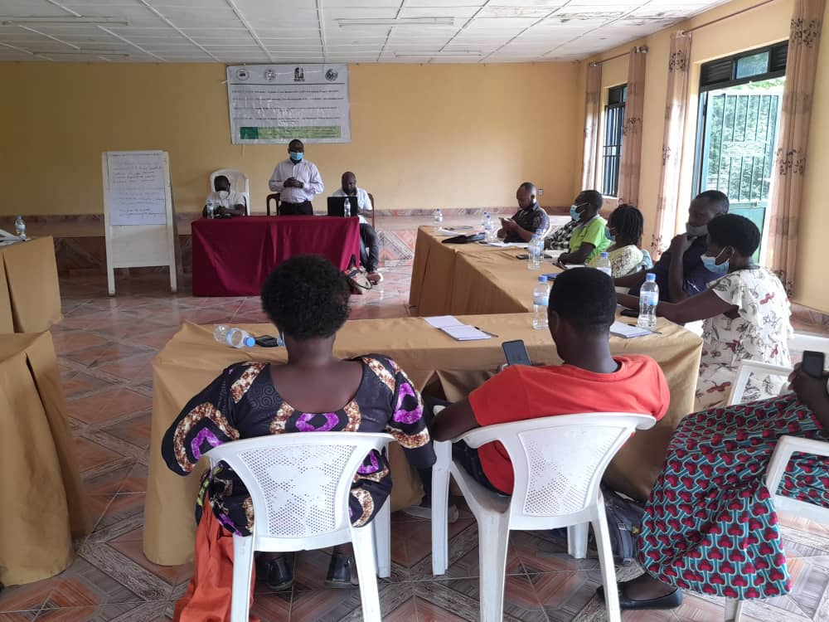

The Project Manager of ANSP+/KC /Fu G addressing participants at Nyagatare on 29/12/2021

The speech by the project Manager of the project was followed by the training facilitator who explained to the participants what HIV is, how it is infected and ways to prevent it. The trainer deeply explained HIV by illustrating what each letter stands for and its meaning.as follows:

H: Human

I: Immuno deficiency

V: Virus

The training facilitator further explained that HIV is spread mostly through unprotected sex and that people likely to spread it include Key populations including sex workers, LGBTs and drug users. Some of the methods of preventing against HIV mentioned include the proper use of condoms, self-testing kits and PrEp .

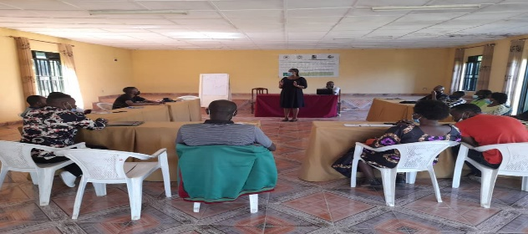

The training facilitator talking to the participants at Moons Charity Hotel Nyagatare on 29 Dec 2021

For the abbreviation of LGBTS, the facilitator of the training explained to participants what each letter stands for as follows:

L =Lesbians

G=Gay

B=Bisexual

T=Transgender

The facilitator of the training further explained who these people are and how they differ from one another as far as sex is concerned. Participants of the training gave different views on the explanations of the abbreviation given by the facilitator of the training. Mr NZIRINGIRIMANA Joseph, a volunteer of ANSP+/KC/FuG project who was there in the training helped participants to understand more.

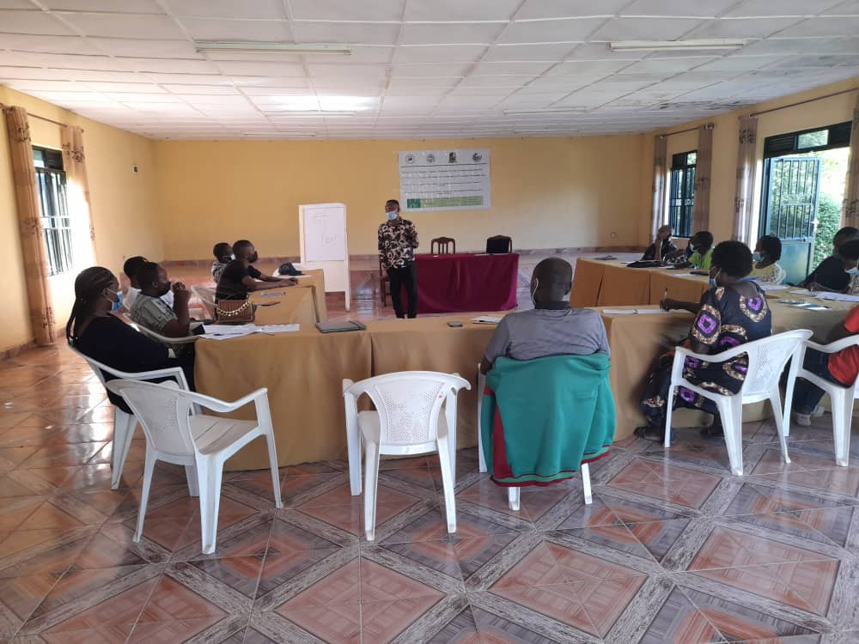

The volunteer of ANSP+/KC/FuG Mr NZIRINGIRIMANA Joseph addressing the participants of the training

During the afternoon of the first day, the training facilitator went on exchanging with participants about different ways to prevent against new infection of H IV. Participants listed different methods of prevention including the proper use of condoms, self-testing kits, use of prophylaxis (Pre and post prophylaxis), how to stay on treatment and positively live with HIV. After discussions, it has been agreed that testing for HIV, accepting and adhering to treatment, staying on treatment is a key to living positively with HIV. Key populations were encouraged to be the role model of preaching to their peers into the community particularly how to live positively with HIV and generally to the whole population into villages so as to facilitate the UN AIDS goals to eliminate the spread of HIV within 2030.

The second day of the training was opened by recapitulating the presentations of day one. The training facilitator asked small questions about what was covered during the first day of the training. The participants answered to the questions by showing enthusiasms to know more.

The first session of the second day was about sexual orientations and human rights. On this point, key populations raised the challenges that they face in the community where they live. Some of the problems they raised include the violence to them which is often done by local authorities and security officers at village level. As they said, most KP are violated without reasons. By exchanging ideas on this point, participants (mostly journalists) said that most of KPS are among people that are said to bring insecurity and disharmony in the community and when they are punished like other people, they say that their rights have been violated. The issue of discipline to KPs was very talked and it was concluded that all people are equal and therefore should follow the government policies and be treated equally. Journalists should advocate for Kps in case there is violation of their rights.

The next session of the second day was about the friendly service delivery to key populations, roles and responsibilities of media professionals in community mobilization. Discussions on this point were opened to every one present in the training. Health care providers there present said that key populations are well served at health facilities. “Problems of stigma and discriminations are no longer there. Those are the problems of the past,” a nurse said. She added that coming for HIV services at health facilities should not be a problem to KPS and that different people including professionals of media should advocate for the rights of KPs. Journalists were asked to reinforce advocacy to key populations and promote their rights into the community. The district official who was invited to attend this training said, on behalf of the district authorities that no one is bound the country rules and policies and that it is the responsibility of the government to protect its people. Key populations are populations like others and should be also protected like others. However, he added that it is also their responsibility to obey to the rules of the country in general and particularly the community where they live. They would therefore live in harmony with other people. The district official concluded his speech by thanking the ANSP+/KC/FuG for having organized this training for it will help in the implementations and achievements of the districts performance contracts in a way or another.

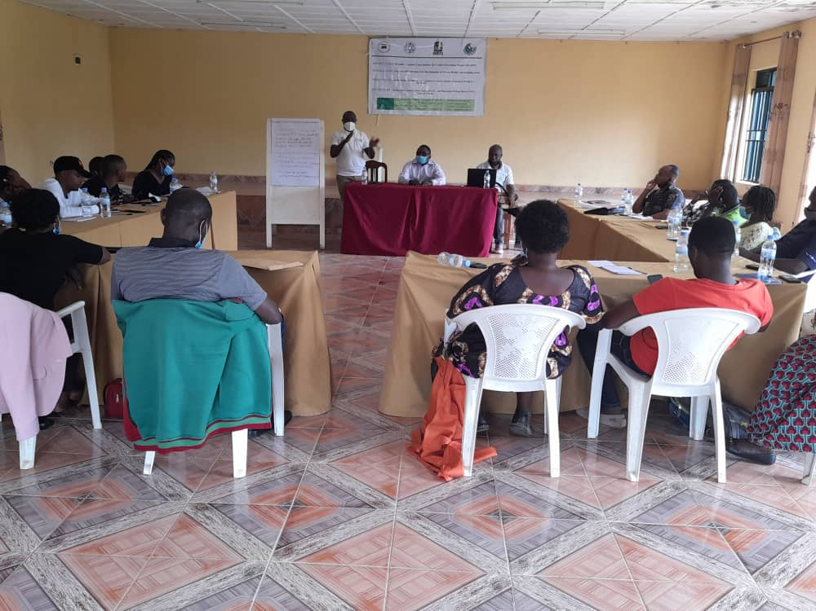

The district official (DJAF) talking to the participants of the training

After the speech by the district official, the next step was about what should be done by each group of people there present to promote the rights of Key populations. Different questions were given to participants and they gave their recommendations as follow:

QUESTIONS TO PARTICIPANTS OF THE TRAINING

1. As journalists, what is our contribution to stop the spread of HIV?

The journalists gave different points of view
- Mobilization teaching through plays, games, etc

Advocacy

Journalists should have the spirit to work professionally.

2. As community influencers, how do you think K P are treated in the community?

a. They are treated like non valuable people

b. They are violated in different ways

c. They are said to be irresponsible

d. They are said to be source of disharmony

e. They use drugs

3. What should KPs request from the Rwandan community?

a. Human rights

b. Eliminate discrimination and violences against them

c. Advocacy for them.

d. Inclusion in the society.

4. As healthcare providers, what is our contributions to give good services to KP?

a. Care to them

b. Treat them equally like other people

c. Advocating for them into the community

5. As people who participated in this training (KPs, media, Healthcare providers) what should we do to reduce and eliminate discrimination in our society?

a. Fight for the human rights

b. Work professionally promoting the human rights (Journalists)

c. Be ethical and work professionally) Healthcare providers)

The training agenda was closed by the project manager of ANSP+/KC/FuG project who thanked the local authorities in Nyagatare district for the endless collaboration in the project activities. He also thanked all the participants of the training and wished that all that was talked should not be left out and that they would contribute to the promotion of the KPs rights into their respective place of works.

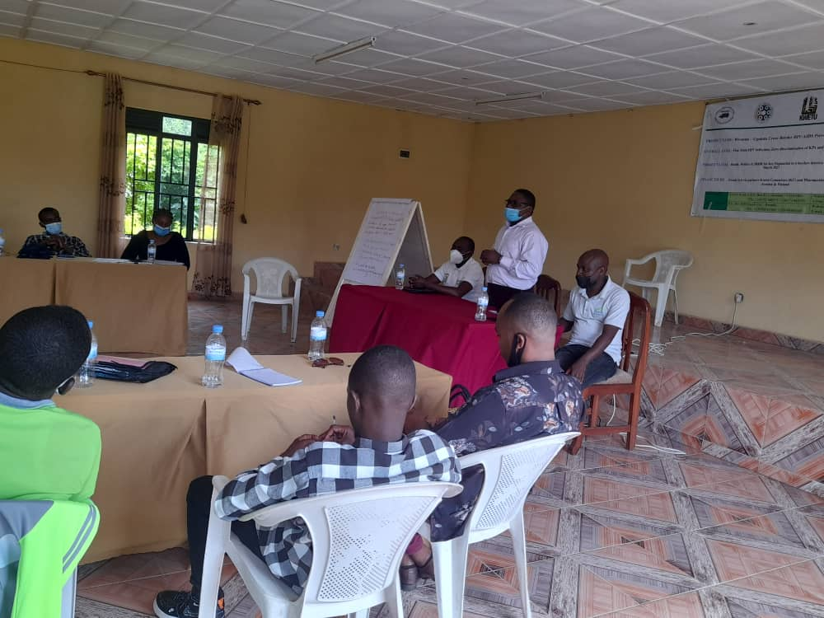

The project Manager of ANSP+/KC/FuG project during his closing remarks

Done at Kigali on the 4th January 2022.

ANSP+ STAFF MEMBERS IN MISSION
- Aimable BUCYANAYANDI
- MUKAYIRANGA Marceline
- NZIRINGIRIMANA Joseph
- NIZEYIMANA Jean Marie Vianney
- MUKASEKURU Deborah
- UMUTONI WA MANA Laurence

