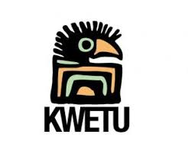
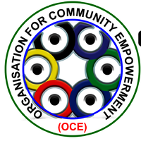
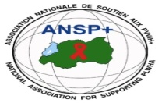

ANSP⁺/KC/FuG Project

OVERALL GOAL: Free from HIV infection, zero discrimination of KPs and healthy and including society.
PROJECT GOAL: Health, welfare & SRHR for key population in 6 border districts of Uganda & Rwanda by 1st March 2023
Subgoal2: Effective healthcare services (Testing, treatment, compliance, TB, hepatitis)

MISSION REPORT ON CONDUCTING A ONE DAY SENSITIZATION MEETINGS FOR BAR/LODGE MANAGERS ON HIV PREVENTION, USE OF CONDOMS AND INSTALLATION OF CONDOMS DISPENSING BOXES AT MUSANZE

I.BACKGROUND

ANSP⁺ in partnership with KWETU Connector ,Pharmacists without Borders and Organization for Community Empowerment collaboration with its key partners like KWETU Connectors, Pharmacists without Borders and Organization for Community Empowerment(OCE) have implemented activity A.2.5 Conducting a one day sensitization meetings for bar/lodge managers on HIV prevention ,use of condoms and installation of condoms and installation of condoms dispensing boxes at Musanze from 11to 12/05/2023 under the sponsorship of Forum Syd.

II. OBJECTIVES OF THE ACTIVITY

The activity was implemented in framework of meeting different local authorities and the health center provider of Musanze District discuss about the project activities.
the key activity considering the designed project implementation work plan. Therefore, the specific objectives of this activity are set as follows:
- To increases awareness of key populations ,healthcare providers and community health workers about HIV prevention ,side effects, family planning ,human rights ,sexual reproductive health ,male circumcision and consistent use of condom ,TB, hepatitis and malaria
- To Strengthen the knowledge of the participants about HIV and other diseases above mentioned and ways to prevent them
- To set strategies for community mobilization to fight against HIV and other diseases in the community by peer educators.
- To distribute kits/IEC materials to be used during mobilization in the community by peer educators.

III.TARGETED GROUPS OF PARTICIPANTS
The participants of the training are 27 bar/lodge Managers ,The health center provider and 5 staffs of ANSP+
IV.DATE AND VENUES
This one day sensitization meetings for bar/lodge managers on HIV prevention ,use of condoms and installation of condoms dispensing boxes at Musanze ,the mission activities were planned in two consecutive days from 11 to 12 /05/2023 days. The meeting was held in Muhabura Hotel at Musanze District.

V.EXPECTED OUTPUTS

- Project activities related information is shared among the project stakeholders(local authorities, beneficiaries and ANSP⁺) through the meeting;
- The Bar /Lodge Managers will have sufficient knowledge about HIV Prevention ,Family planning, human right, sexual reproductive health ,male circumcision ,and consistent use of condom, TB ,hepatitis and malaria ;
- The Bar/Lodge Managers will share the knowledge with their customers and neighbors

VI. MISSION ACHIEVEMENTS

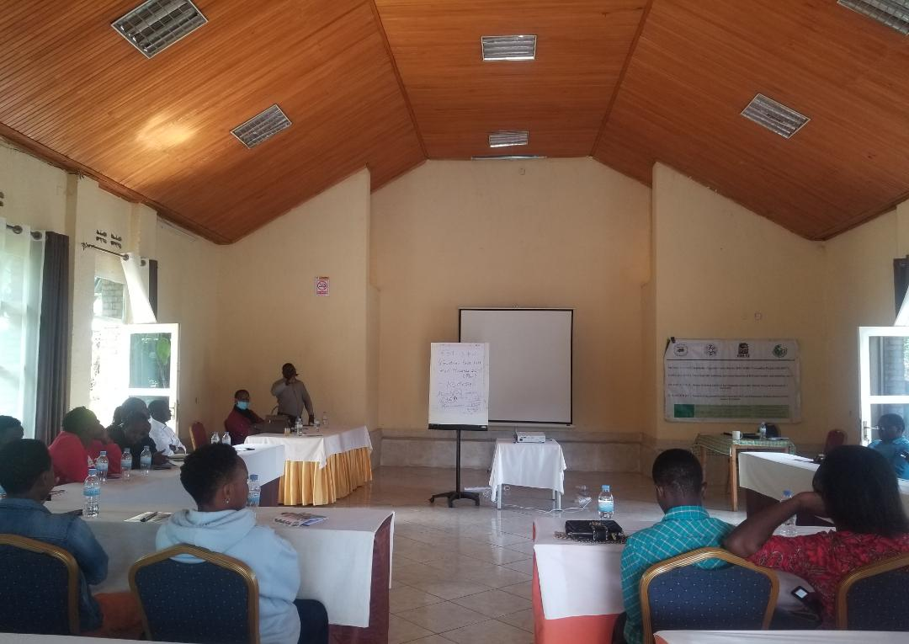

The Picture of the DAF of ANSP+: NIZEYIMANA JEAN MARIE VIANNEY welcoming the participants at Musanze District .

The meeting started by introduction the DAF OF ANSP+ Nizeyimana Jean Marie Vianney welcomed all participants and did introduction of ANSP+ to the bar/lodge Managers ,he said that ANSP+ started on 2000 by the people living with HIV , where HIV people was discriminated and stigmatize in community but with the advocacy of ANSP+ ,different partners and government support the stigma and discrimination faced by people living with HIV was reduced . He continue explaining that ANSP+ are working in three areas of intervention: Human Right, HIV Prevention and Poverty Reduction.
The health center provider started by asking bar lodge managers why are them invited to the training ,it is because they are the one who receive many customers at their daily work ,Many of the customers after taking beers ,they pay also for room where they go to the room with girls for doing sex . she continue asking the bar lodge Manager to protect customers by putting condom at the room and sensitize them to come to take condom for free at the health sector for HIV Prevention .she sensitized the bar Managers to mobilize customers for HIV Testing at the health facility and motivate them for circumcision for those men who never did it .she said that condom use it not only for HIV prevention but it is also use before sex for prevention of hepatitis ,cervical cancer and some people are using it for family planning.
She explained also about the Target of Government 95%, 95%, and 95%
The first 95% is 95 % person who know there status
The second 95% is 95% of the person who know that they are HIV positive and their taking drugs
The last 95% is 95% of the person who know their status who are taking HIV drugs their viral road suppressed
She said so many women are contracting the cervical cancer because they did sex with Men who never did a circumcision that being circumcised is necessary because it prevent HIV at 40%.
In Musanze District 6368 people are HIV Positive,72 are refusing to take HIV Drugs.26,1%Female Sex Workers are HIV Positive,5,4% Men doing Sex with Men have HIV.
For HIV prevalence in Musanze, Men 4174 are HIV Positive ,Women 2122 are HIV Positive
The health center provider continues explaining the sign of TB and said that so many time when a person have TB have also HIV.The sign of TB are: weakness, having a fever ,lost weight .

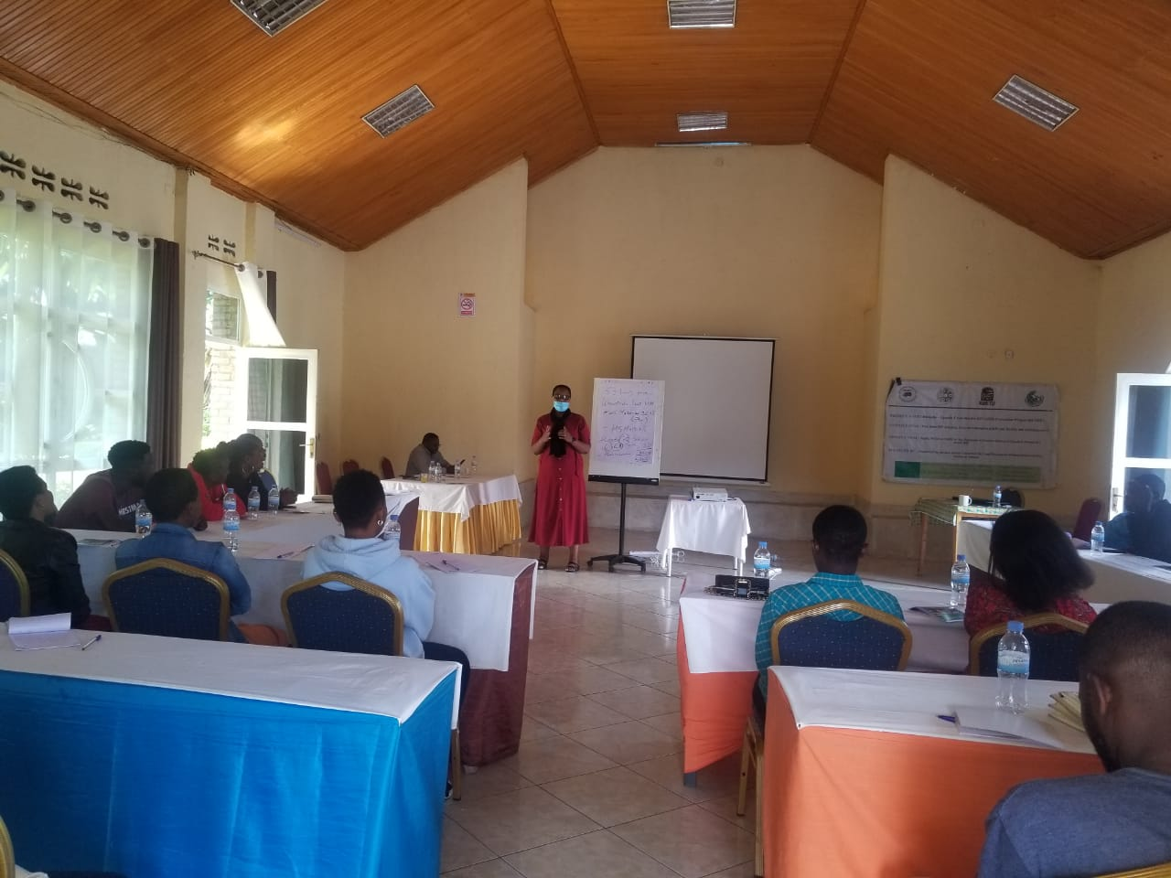
Picture of the Health center Provider at Musanze District : Solange Yampiriye explaining the participants .
She finished by thanking ANSP+ ,Kwetu connector and FUG for their support on organizing this training workshop remaining the Bar/lodge Managers that she is waiting their contribution on HIV prevention by convincing their customers to come at the health center for HIV Testing and for circumcision of Men who never did it.
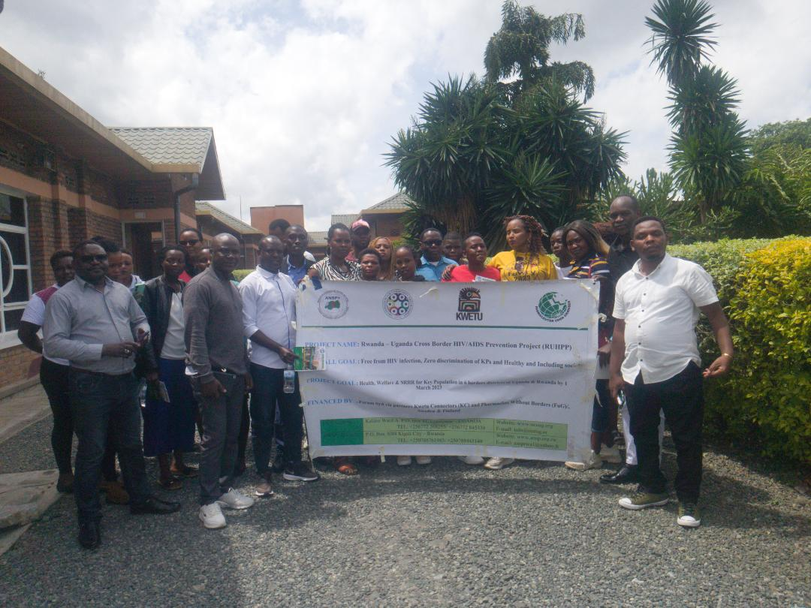
Picture of the memorial ANSP+Staffs with the health center provider and bar /lodge Managers

VII. CONCLUSION
The mission was concluded from Thursday 11 May to 12 May 2023. All the participants of the Training got enough knowledge about HIV prevention, TB, male circumcision, gender based violence so that they will share it with their team work and neighbor for prevention and they will contribute to our overall goal free from HIV infection, zero discrimination of KPs and healthy and including society.

Done at Kigali on the 16 May 2023
Mission team members

MUKASEKURU Deborah
MUKAYIRANGA Marceline
BUCYANAYANDI Aimable
NZIRINGIRIMANA Joseph
NIZEYIMANA Jean Marie Vianney
UMUTONI WA MANA Laurence

