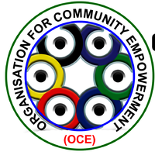
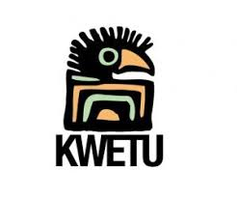
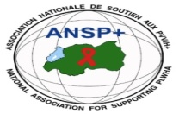

---------------------------------------------------------------------------------------

PROJECT: ANSP+/KC/FuG

PROJECT GOAL:
Greater compliance to treatment and increased social capacity in the key populations in selected border districts by July 31, 2019 as a result of close collaboration between OCE in Uganda and ANSP+ in Rwanda

ACTIVITY: Conduct a baseline survey of needs and priorities assessment and create a status map of the target beneficiaries (HIV prevalence & diagnosis, ART treatment, experience of the infection, motivation to comply with treatment and health care access/support)

MISSION REPORT FOR THE BASELINE SURVEY DONE FROM 25 TO 27/10/2018

- INTRODUCTION
As well known, ANSP⁺ as National Association for Supporting People living with HIV and AIDS (ANSP+) and Organization for Community Empowerment (OCE) are implementing a pilot project for HIV prevention and to fight against the spread of HIV/AIDS among female sex workers, LGBTs and truck drivers in the border Districts along the Uganda-Rwanda high ways during 2018-2019. This done under sponsorship of Forum Syd via the Pharmacist without Borders (FuG Sweden) and KWETU Connectors? Sweden.
After conducting the project consultative/introductory meeting with stakeholders and selection of project beneficiaries; the next project activity to follow was to conduct a baseline survey of needs and priorities assessment and create a status map of the target beneficiaries (HIV prevalence & diagnosis, ART treatment, experience of the infection, motivation to comply with treatment and health care access/support). This is why six staff members of ANSP⁺ have been mobilized to conduct a three-day field visit in order to collect all data that will be processed and produce a baseline survey report.

- MISSION OBJECTIVE
This mission aimed at knowing the target groups’ situation through collection of data on their needs and priorities, and then create their status map on health aspects especially HIV serology, health insurance, ARV treatment adherence, experience of the infection and economic growth and development.

- MISSION TARGETED GROUP
This three-day field work of Kigali City and Musanze District targeted 40 representatives of beneficiaries; it means 20 persons from Kigali City and 20 persons from Musanze District, including Female Sex Workers (15-24 years old), LGBT and truck drivers. This work was conducted by 6 project team members from ANSP⁺. To be more specific, the survey concerned Gasabo, Kicukiro and Nyarugenge Districts of Kigali City and then Musanze District of the Northern Province for Cyuve, Musanze/Muko and Muhoza sectors. Regarding the Female Sex Workers, the targeted group was between 15-24 years old, plus heads of the self-helping groups they are coming from.
- MISSION DATE AND VENUE
This activity was planned to take place on Thursday, Friday and Saturday the 25th- 27th October 2018, in Kigali City (Nyarugenge, Gasabo and Kicukiro Districts).
- MISSION ACHIEVEMENTS
5. 1. Baseline survey in Kigali City on 25/10/2018 (the 1st day of survey)
Twenty (20) representatives of beneficiaries were invited to come to the office of ANSP+ on the 25/10/2018 at 9h00’ AM for baseline survey purpose. The collection of data was introduced with presentation of the pilot project and encouraging beneficiaries to be fully involved in its implementation.
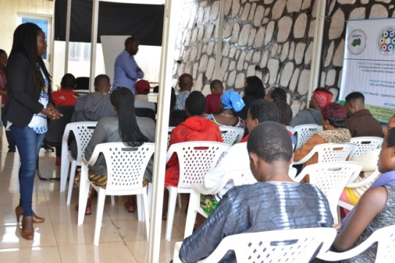 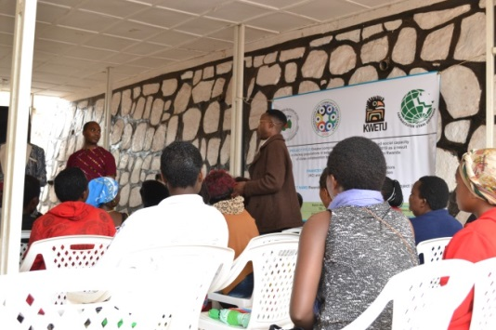bnnbbbb
- Presentation of the pilot project and exchange of ideas and exchange of ideas about it
After introducing the pilot project and exchanging ideas, the work of collecting data has started. The interviewees in Kigali City were composed of 6 MSM, 14 Female sex workers (FSWs) including 4 heads of their self-helping groups operating in Gasabo, Kicukiro and Nyarugenge Districts of Kigali City. The data collection was closed the same day at 3h22’ PM and all 20 persons were interviewed and questionnaires were fully completed.

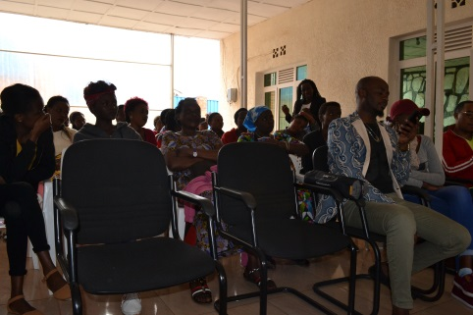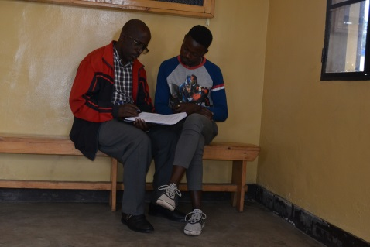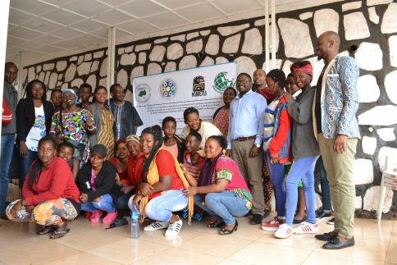
b) Opening the survey in Kigali City c) One of photos of survey d) Group photo after survey at Kigali City

5. 2. Baseline survey in Musanze District from 26 to 27/10/2018 (the 2nd and 3rd day of survey)
5. 2. a. Preparatory works on the 2nd day of survey
After accomplishing the work in Kigali City, the 6 project team members went to pass a night at Musanze District in order to start the work in early morning of the 26/10/2018. Thus, on this second day, the ANSP⁺ staff team met local authorities and reached 3 groups of Key Populations (KPs) at their places of work and/or hotspots in Musanze District. The first group of 41 members was visited in Muko Sector (some members were from Musanze Sector), the second of 19 persons in Cyuve Sector while the third of 22 members was in Muhoza Sector. The meeting with beneficiaries emphasized on advising them on strategies to have good life including HIV prevention, access to health care, works to increase income and selecting female sex workers of 15 – 24 ages to participate in the baseline survey of the third day. In this way, 5 FSWs were selected in the group we met at Muko Sector, 5 FSWs were chosen in Cyuve Sector and 4 FSWs were selected in Muhoza Sector. In addition to these 14 FSWs, 5 MSM and 1 truck driver were invited to come on the day of 27/10/2018 at 8h00’ and be interviewed in the framework of conducting a baseline survey.
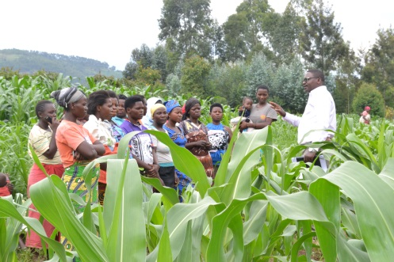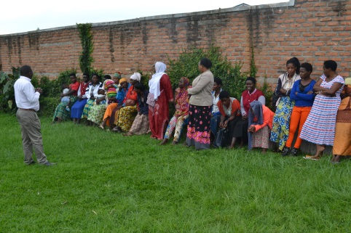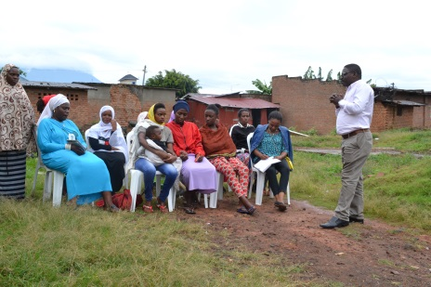
e) 3 groups visited at their areas of work or hotspot (from left to right, the 1st photo in Muko Sector, the 2nd in Cyuve Sector and the 3rd in Muhoza Sector)

5. 2. b. Survey on the 3rd day
On the 27/10/2018, data collection has been done to 20 representatives of 14 FSWs, 5 LGBTs and 1 truck driver by ANSP⁺ project team at Muhoza Health Center. As it was the case at Kigali, the interview was conducted in mother language (Kinyarwanda) using questionnaires elaborated in English and translated in Kinyarwanda. Started at 8h00’ AM, the baseline survey took end at 2h45’ PM, all 20 persons were interviewed and questionnaires were filled.
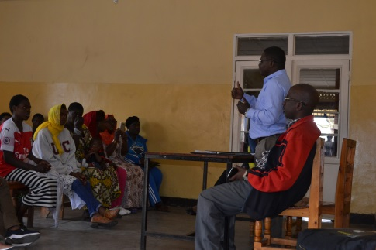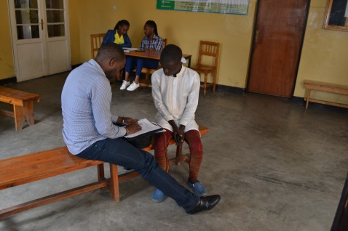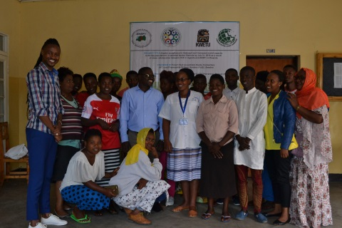
f) Opening the survey g) A beneficiaries is being interviewed h) A group photo at Musanze after the survey

- CONCLUSION
With the mission conducted from 25 to 27 October 2018, forty (40) representatives of pilot project were interviewed and the work of processing the data collected is going on to elaborate a Baseline Survey Report. The work was indeed very enjoyable since it has been well handled as planned. During the data collection, we have identified another group of Key Populations called none identified or Q, this is taken for us as a success story; to mean that we are going to have LGBTIQ. A Key Population has told us that as a Q, sometimes she feels as SHE and other times he feels as HE.

Done at Kigali, the 01/11/2018.

MISSION TEAM MEMBERS:
MUKASEKURU Deborah
MUKAYIRANGA Marceline
NDACYAYISENGA Patrice
NIZEYIMANA Jean Marie Vianney
RUTUKU Théoneste
UMUTONI WA MANA Laurence

