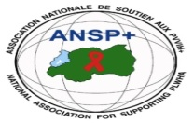 [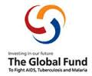](http://scottfiller.info/) 

_____________________________________________________________________________

**PROJECT NAME: ANSP+/RBC/SPIU**

**NAME OF ORGANIZATION: NATIONAL ASSOCIATION FOR SUPPORTING PEOPLE LIVING WITH HIV/AIDS (ANSP+)**

**NSP PROGRAM: COVID-19 IMPACT MITIGATION**

**ACTIVITY: FOUR DAYS FIELD WORK FOR BUILDING CAPACITY TROUGH WORKSHOP, TRAINING AND /OR COORDINATION MEETINGS WITH UMRELLA’S MEMBERS TO INCREASE THEIR ENGAGEMENT IN COMMUNITY MOBILIZATION AFTER COVID 19 AND TOWARDS OTHER HIGH BURDENED DISEASES (HIV,TB,STIS,HCV AND MENTAL HEALTH)**

**TARGET GROUP: KEY POPULATIONS**

**AREA OF INTERVENTION: MUSANZE DISTRICT**

**FIELD WORK REPORT**

1. **INTRODUCTION**

ANSP+ is a National Association Supporting People living with HIV. From its creation in 2000, the association had the objectives to improve the quality of its members affected by the pandemic of HIV.

Along with the implementation of its activities and under the sponsorship by the global fund through the Rwanda Biomedical Center (RBC), the National Association for Supporting People living with HIV (ANSP+)has organized a four days field work in Musanze district for key populations and health care providers serving in Musanze health facility with the purpose of increasing their engagements in community mobilization and advocacy as a contribution in the battle against COVID 19,HIVand other burdened diseases such as TB,EBOLA,HCV,,STIs, Malaria and mental health.

The field work in MUSANZE district started on the 21st and ended on the 24th Nov 2023. The first day, 21st was dedicated to the departure of the team from the headquarters of ANSP+ in Kigali and meeting with the head of Musanze health facility the afternoon for the preparation of the meeting with the heads of the department at this health facility the following day. The work for the second day (22nd Nov 2023) was scheduled to meeting the heads of department in this health facility. Those departments include laboratory, maternity, reception, consultation, PMTCT, HIV,TB and others depending on the availability of the personnel and load of work. The third and the fourth days were dedicated to the training of key populations which was hosted at Muhabura hotel and was facilitated by NIRERE Leopold, the head of Gacaca health facility.

**II.ACHIEVEMENTS OF THE FIELD WORK**

As it was early introduced, the first day of the work was for the departure of the ANSP+ team from Kigali to Musanze for the preparations of activities at site and meeting with the head of Musanze health facility to talk about and arrange for the meeting with the heads of departments in this health facility. On this first day,The team visited the hotel where the meeting/training for KPs would take place and arranged all the requirements; both technical and financial for the meeting to be well conducted. After checking in at the hotel, the team took off to Musanze health facility where they met the head of the health facility to arrange for the meeting with heads of departments. The team left the health facility after notifying the heads of departments for the meeting of the following dayat the health facility.

The following day, the 22nd November, the team of ANSP+ in mission met with the heads of departments at Musanze health facility with whom they had discussions about Covid 19 and key populations.. At place, the ANSP+ team was given a warm welcome by the head of the health facility in her office and invited the heads of departments to join the meeting. The visitors and participants introduced themselves and then started the meeting. The leader of the team from ANSP+ who is also the Director of Administration and Finance within ANSP+ Mr.NIZEYIMANA Jean Marie Vianney thanked the participants for availing their time and participate in the meeting despite the hard work at the health facility.. The chief of mission briefly explained the purpose of the visit, saying that its aim was to discuss the engagement of key populations and healthcare providers in community mobilization and advocacy against Covid 19.

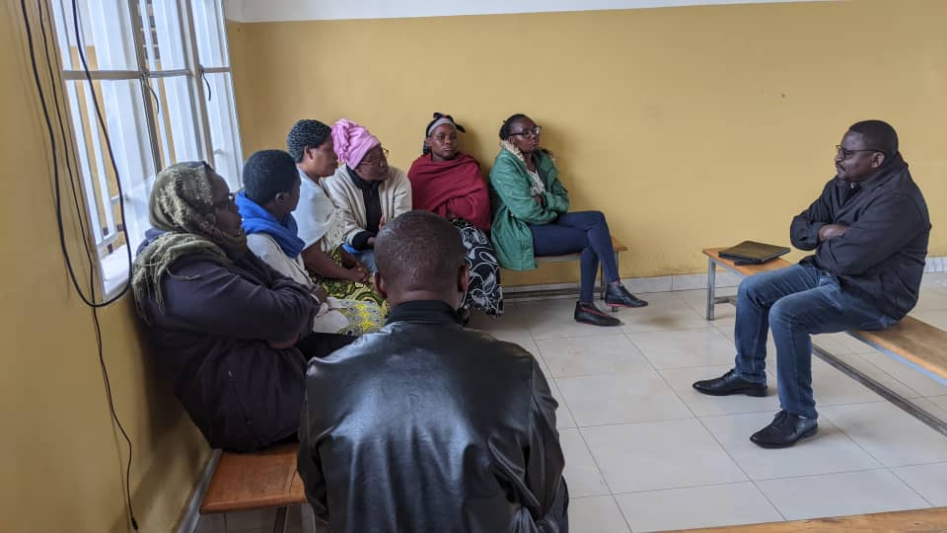

Photo: The team from ANSP+ discussing with health providers at Musanze health facility

The speech by the chief of mission was followed by discussions among all participants about the engagement of Key populations and providers in fighting against COVID 19 and discussions were guided by the volunteer with ANSP+ Mr NZIRINGIRIMANA Joseph.

The question about who Key populations are was asked to the heads of departments and the answers were different. Some said that key populations are those people having the key to stop the spread of HIV including the personnel in medical services and all stakeholders in HIV prevention. Others well defined KPs that it is those people likely to be contaminated by HIV. Those people include Female sex workers, MSMs, Lesbians and other group of people that can be easily contaminated such as soldiers, drivers of lorries ,etc. Clarifications to this question was that key populations are all people most likely to be contaminated by HIV and they include all those mentioned above and they are the ones to stop the spread of new infections of HIV as a way to reaching the global goals of eradicating HIV by 2030.

Discussions continued with the question to know whether key populations used to go to the health facility during covod 19 seeking for services. The answer was that, like other patients, key populations also used to go to the health facility for services despite difficulties to get there during that difficult period .When asked how providers could identify and differentiate KPs from other patients, the answer was that it is very easy for Kps to be identified basing on different things such as symptoms during consultation, dressing mode and different behaviours as well.

For the question to know if there was any special messages to key populations during the covid period, healthcare providers said that the message was single to all the people; the one of caring and preventing against covid 19. Nevertheless, providers added that as the pandemic was decreasing its virulence, the personnel in charge of key populations at the health facility had to remind them about prevention measures and that kind of education/message is always delivered whenever they meet for different occasions.

Different ideas were given on the issue of COVID 19 and key populations and finally discussions came up to the question whether covid 19 is still observed at this heath facility . Providers replied on this question that though covid 19 has remarkably reduced, one cannot say that it has ended. According to them, there are some cases where the patients shows the symptoms of covid 19 and they are immediately tested for it and some cases (very few) might be positive. In a word, though covid 19 has totally decreased, there is a need to continue educating people in general and key populations in particular about caring and preventing against covid 19.

In a conclusion for this session at Musanze health facility, some challenges on the sustainable prevention of covid 19 were mentioned. The major challenge is that neither the community nor public institutions no longer respect preventive measures that were set by the government. Washing hand stations were destroyed, others are full of dusty; sanitizers are no longer used. The community in general should be aware that covid 19 has decreased but has not gone!

As it was planned on the agenda, the third and the fourth days of the field work were dedicated to the training of key populations about covid 19 , HIV, TB,Ebola,HCV,STIS,Malaria and mental health. The facilitator during this training was Mr NIRERE Leopold, the head of Gacaca health facility and it was hosted at Muhabura hotel.The opening speech of the training was delivered by Mr. NIZEYIMANA Jean Marie Vianney , the Director of administration and finance within ANSP+. In his speech, much thanks were given to the administration of Musanze district who tirelessly works with ANSP+ in all activities oriented to fighting HIV among key populations in this district. The DAF continued thanking health facilities in collaboration with ANSP+ and also thanked participants /stakeholders in this training. Above all, the speaker thanked the global fund and the government of Rwanda/ Ministry of health for their sponsorship in these activities through the Rwanda Biomedical Center (RBC)

Photo: The DAF of ANSP+ addressing the audience

The speech by Mr NIZEYIMANA Jean Marie Vianney was followed by the welcome speech by the Director of youth center in Musanze district. As he said, he first thanked ANSP+ and donors for their contributions in fighting HIVand other epidemics in this district. He called the youth there present to use the knowledges and opportunities got from ANSP+ to build their personal future and therefore building the nation without HIV.

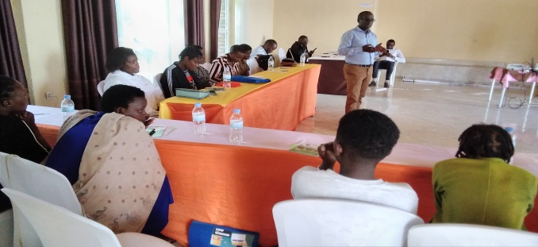

Photo: The Director of Musanze youth center addressing the audience

After the words by authorities followed the training that was started by a pretest. The trainer divided participants into three groups to which he allocated different topics . The first group worked on Covid 19 , HIV and malaria; the second group worked on TB,STIs and ebola while the third group worked on HCV and mental health. The groups were given one hour to work on the topics and then proceeded with presentations of the works in groups.

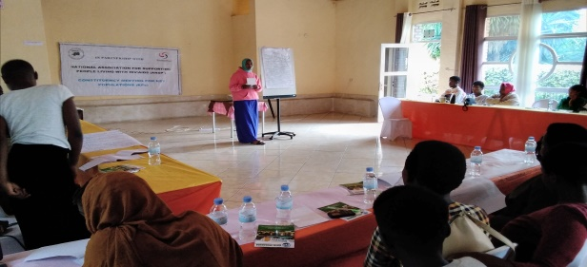

Photo: works in groups and presentation

After presentations of each group, participants asked questions and when all the groups have ended with their presentations, the trainer thanked them for the work done and then started his own presentations on each topic. The first day of the training covered covid 19, HIV and STIs .For each topic, the trainer together with participants gave the causes, symptoms and treatment and ways to prevent against that disease. Questions for clarifications followed each topic

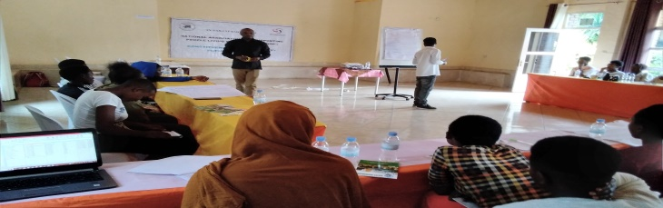

Photo: The trainer presenting

On the second day of the training and the last of the field work, the trainer started with the recapitulation of the first day and then proceeded with the topics that remained on the agenda.The topics for the day were HCV,Ebola, Malaria and mental health. Like the first day of the training, the trainer presented the topic after which questions for clarifications followed. The afternoon of the second day of the training after lunch, the trainer gave a posttest to evaluate the understandings of the participants. The participants worked in their respective groups and the question was to give similarities and differences between HIV and other above mentioned diseases. The answers from groups were as follows:

1.What is the relationships between HIV and other epidemics?

Answers:

-They are all caused by viruses

-They all destroy the economies of countries

-Possible for preventions

2.What are differences between HIV and other epidemics?

-Covid 19 and other epidemics have vaccines but HIV does not

-Other epidemics are cured but HIV is not

**III.RESULTS/EXPECTATIONS OF THE TRAINING**

As it was expected before going to the training, participants left with full knowledge about covid 19, HIV,STIs, Hepatitis, malaria, TB and mental health. Participants also took actions to prevent against all these diseases mentioned.

**IV.CONCLUSION**

The training that was taking place at Muhabura hotel ended its activities on the 24th Nov. 2023. The concluding remarks of the training were given by Mr.NIZEYIMANA Jean Marie Vianney . During his speech, he thanked the administration of Musanze district for the tireless efforts and assistance given to key populations. He also thanked the trainer for the content on the topics delivered to key populations who attended the training and lastly, he thanked key populations for attending and asked them to continue mobilization in the community by sensitizing people around them to prevent themselves about different diseases.

Before leaving, the group took a photo of remembrance.

A photo of remembrance

Mr. NIZEYIMANA Jean Marie Vianney during his concluding remarks.

Done at Kigali on 30 /11/2023

**The ANSP+ TEAM IN MISSION**

-Aimable BUCYANAYANDI

-NZIRINGIRIMANA Joseph

-MUKAYIRANGA Marceline

UMUTONIWAMANA Laurence

-NIZEYIMANA Jean Marie Vianney

-MUKASEKURU Deborah