  [](http://scottfiller.info/)

**PROJECT NAME: ANSP+/RBC/SPIU**

**NAME OF ORGANIZATION: NATIONAL ASSOCIATION FOR SUPPORTING PEOPLELIVING WITH HIV/AIDS (ANSP+)**

**ACTIVITY: SUPERVISION OF KPs ASSOCIATION TO**

**TARGET GROUP: KEY POPULATIONS**

**AREA OF INTERVENTION: MUSANZE**

**FIELD WORK ACHIEVEMENT**

This field work was organized in framework ofsupervisions KPs associations in order to Know how they work, what they work, challenges they are facing and propose some solution in order to be sustained .The field was supposed to be conducted at Musanze district from 11th to 15th at Musanze District and is there that it was realized. The first day was a departure from ANSP+ office to Musanze district; arrive there, we were warmly welcomed by the district officials. To start the meeting, The Director of Health said that is happy to host the team from ANSP+ just to sit together and see how the project is contributing to districts performance especial in social affairs by empowering some of Musanze population which is Key population as main group to be affected and infected by the different infections.

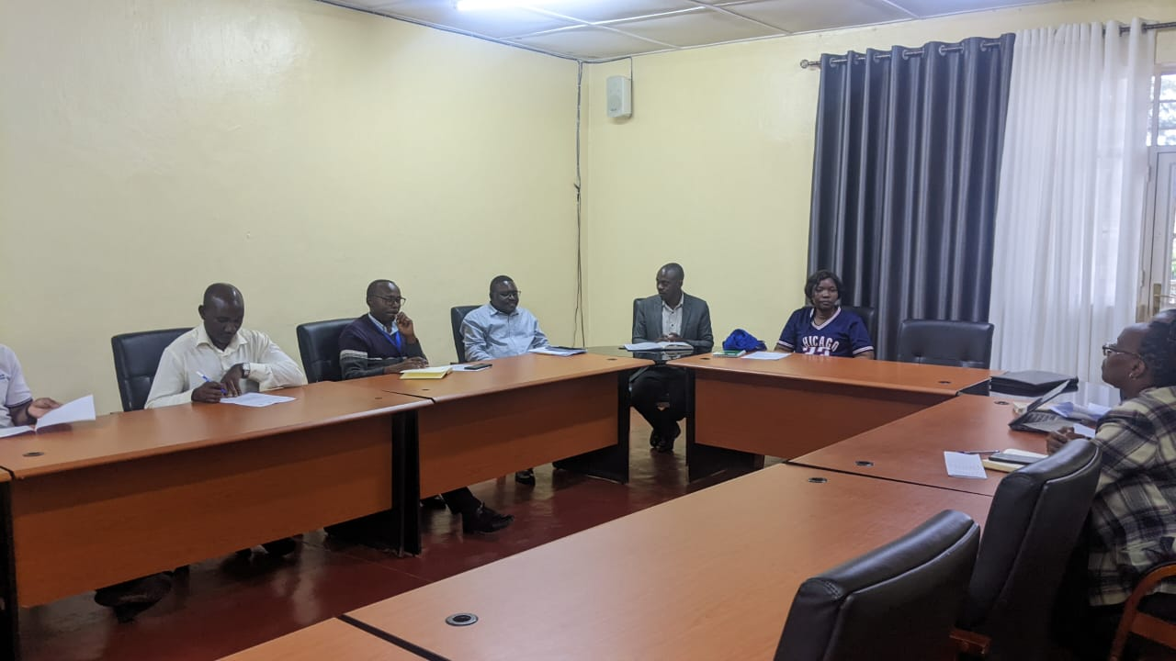 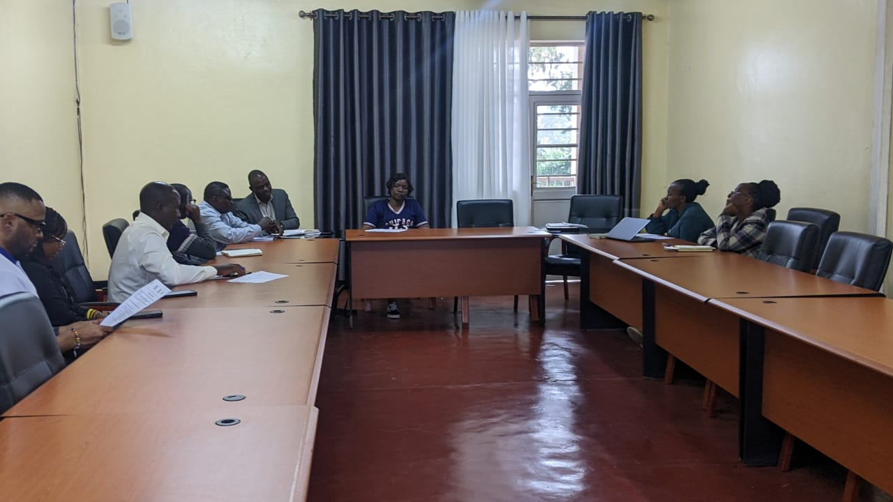

She said that once this group is affected it will be mainly affected by HIV/AIDS, and once it is not well managed, it might lead to a serious condition whereby the one who is living with can become weak and not perform the daily activities for living. This became a burden to the community and district itself, because the Rwandan’s richness is its population. She told the audience that Musanze district is a place where different peoples of the world meet as it is the touristic region due to the attraction of the gorillas and the particularity of this region due to its flesh climate. This factor makes Musanze district population to become sexual sellers to some of them, mainly young generation. She continued by saying that this district is counting about 700 Key Populations made by FSWs and MSM, some of them are grouped into 35 associations where they get educational, medical, financial support with easy. As district, we tried to be closer to these associations, trough different way either via mobilization and sensitization all aiming to enhance their skills and knowledge about HIV, STIs, TB, Hepatitis B& C virus, Family planning, Human rights, ASRHR etc. This leader closed her speech by appreciating different partners in support, especial Civil Societies and Local organizations to make big contributions to the district goal and performances. She said” Let me take this opportunity to thank too much our district partners especially ANSP+. Since I arrive in this district with my position, I saw the reports from JDAF saying that this partner has played a big role in HIV Prevention contribution and poverty reduction among our population of Key populations. In additional to that, ANSP+ stayed all along their existence with KPs and this made them for not being discriminated and stigmatized; from there, KPs started being tested from HIV/AIDS and other opportunistic diseases and infectious due to their daily behavior. As result, those who tested Positive were assisted to be linked to care and treatment but mainly to stay on treatment, and those tested Negative were helped to reinforce the preventives measures like condom and Lubricant use, PreP and PEP use etc. She finally called upon the organization of ANSP+ to continue in the same way by helping those groups and change their behavior positively.

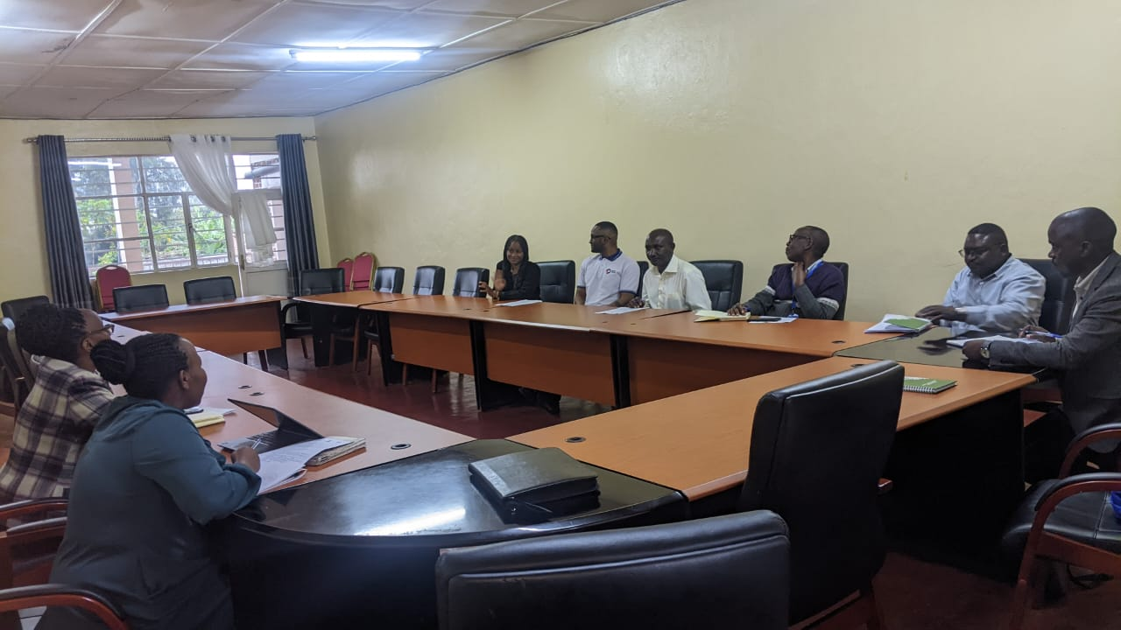 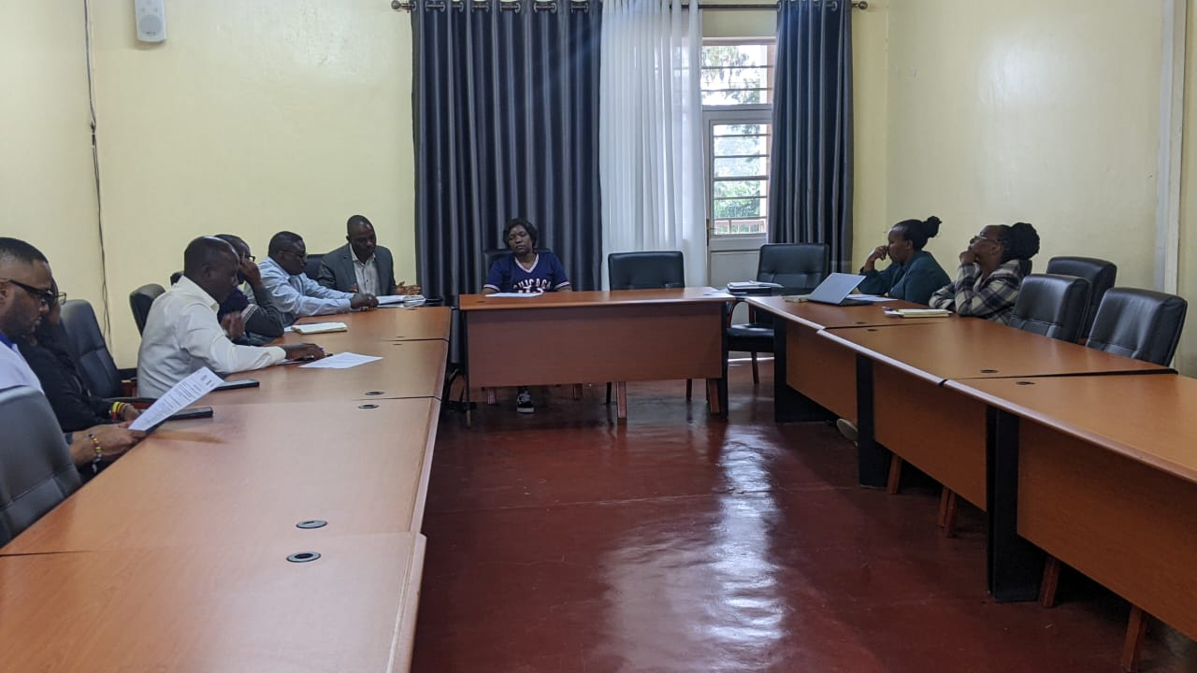

After this Leader opening speech, was a time to ANSP+ representatives to address the meeting participant’s objectives and expectations. In his speech Jean Marie vianney Nizeyimana, started by greeting everyone in the conference room, He said that himself and ANSP+ staff are deeply recognizing the way they have warmly welcomed in this District. This leader said that there is many years working with Musanze district because this is the touristic area where many people meet from different corners of the world. Again Musanze district officials have showed a very good collaboration o work with. He said” Since previous years we have been working with this district, and due to their good collaboration and communication we have decided to continue working with them, and we have experienced many achievement and we can’t hesitate saying that our goal is being achieved. Among activities planned to be done in this district, there are Training of KPs on different topics related to their need and priorities, mainly HIV, TB, and Malaria, Covid-19 and Ebola, Training on small job creation which can generate money and working with micro- finance institutions, Training on saving etc. During this speech, ANSP+ representative, took time to be thankful for the district partnership and collaboration and become on KP’s association working model and what they do in their respective group.

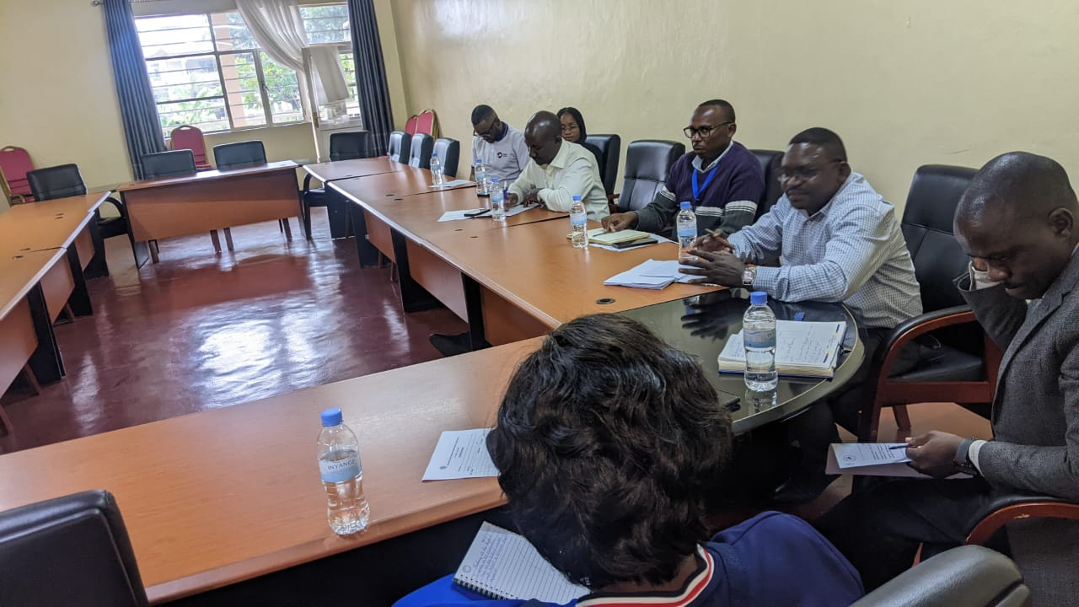 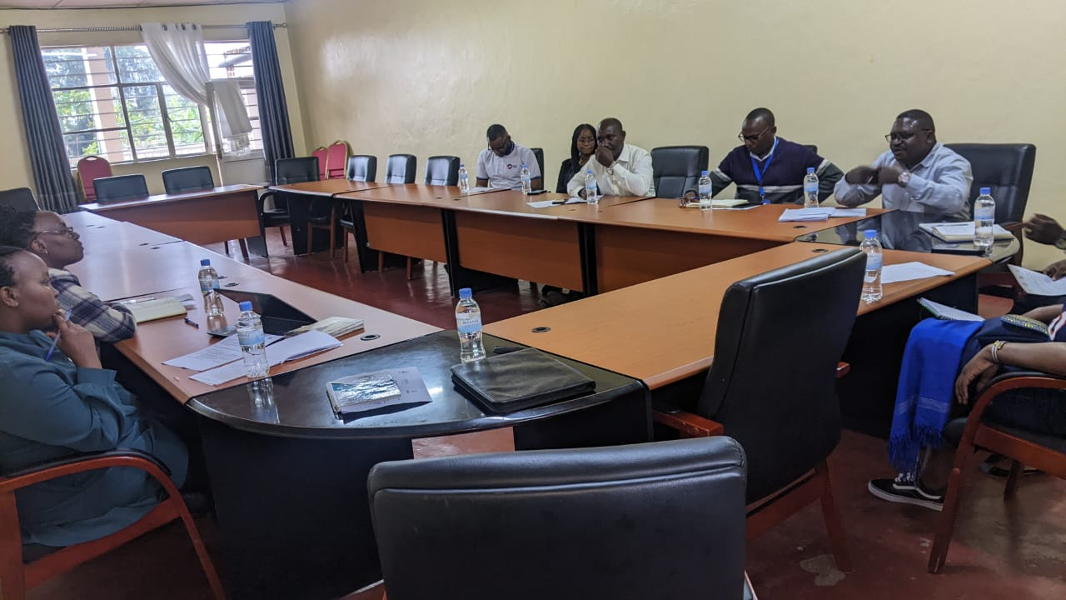

**Photo: A Meeting with District officials was vibrating and different ideas, suggestion and recommendations have been given out**

He said that they decide to do different activities together and share the production after, and this changed positively they daily life financially and economically. Jean Marie closed this speech by reminding the audience that the objective of this visit was just to come and assess how KPs’ association are working, how they are collaborating with the district, the challenges they are facing and serious measures to be taken in to improve the way of working. This meeting was closed by concluding that a continuous partnership between ANSP+ and the district has to be sustained in KPs’ support framework.

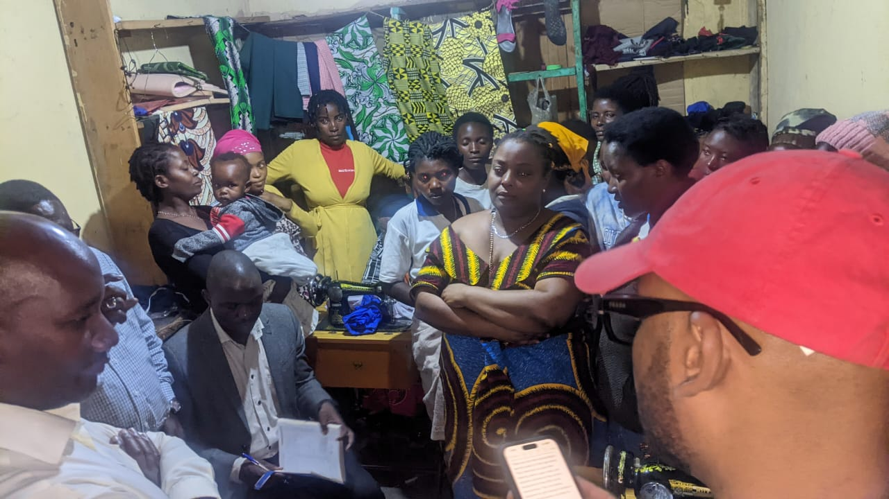 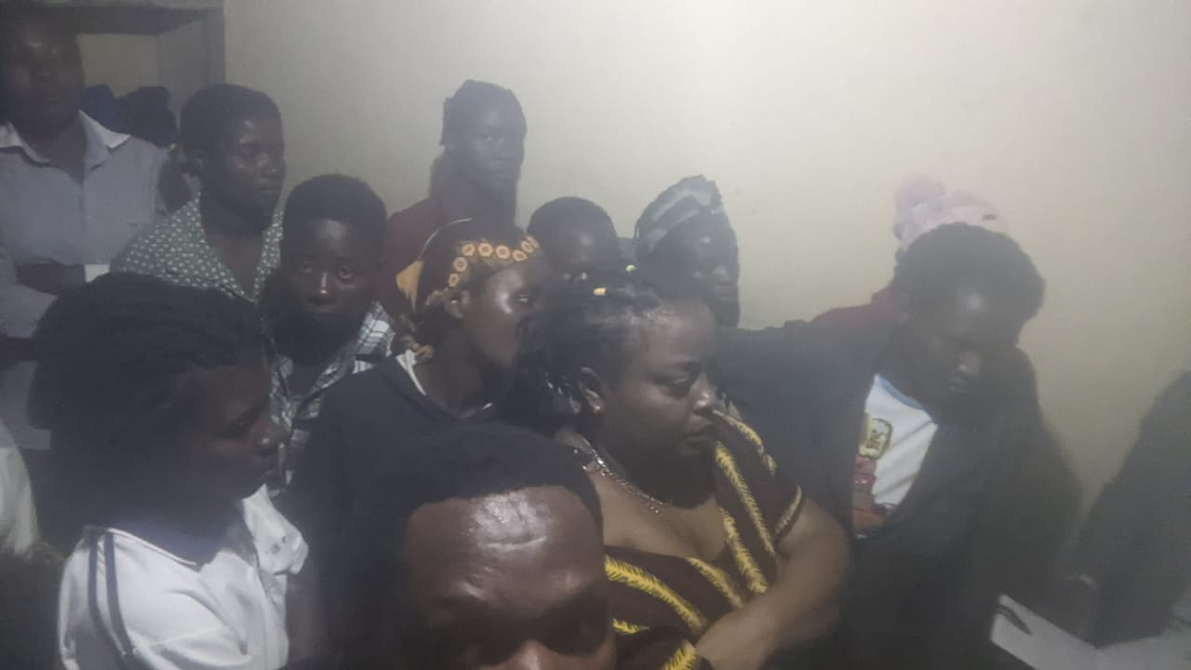

As indicated in the concept note of these activities, 3 Associations in Musanze have to be visited. Those are DUHINDUKE DUKORE, DUHOZANYE and TUZAMURANE all of those located in MUKO Sector. The second day of the field work was to visit TUZAMURANE association. Arrive there, we have well welcomed by the association’s members, this association is made by 7 FSWs whereby they do sugar canes cultivations. What we saw is that, there is a field of 30m*40m of those products which are ready to be harvested.

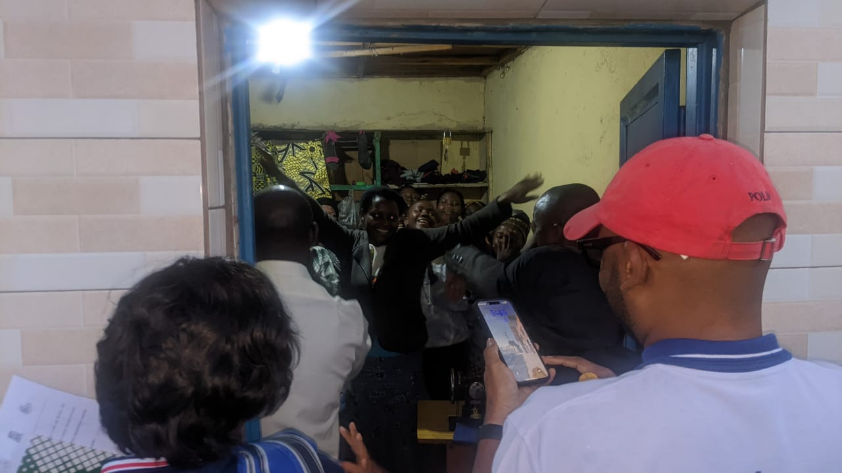 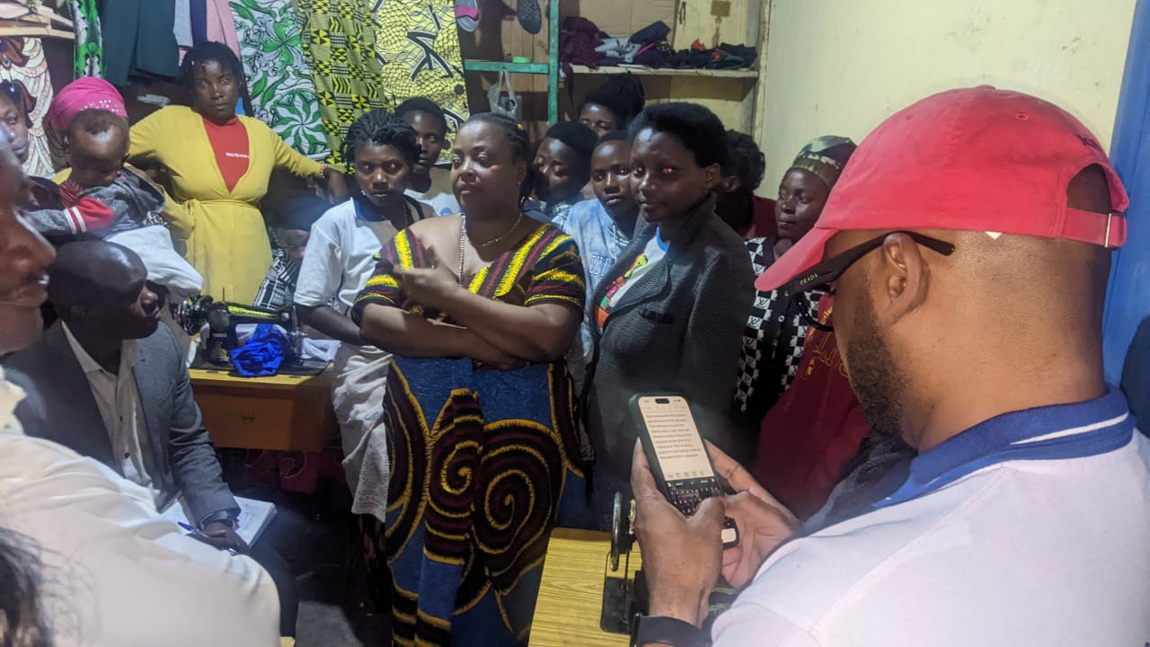

**Photo: ANSP+ Delegation visiting DUHINDUKE DUKORE Association with tailoring business**

In this association, a member’s share is 500 to be paid every weekend, and kept by the treasurer. After a period of one year they sit together and share the total amount. The president of this association said that before sharing the interest, they have to make sure that 10% of this amount is kept to use in social welfare. This one is served to help each in some events either positive or negative; these are like to visit some who are not having health insurance, visit those who got sick, those who experienced death, those who have other social events etc.

The third day was a time to visit another association which is DUHINDUKE DUKORE. This association is composed by 12 members, and deals with tailoring activities, as observation we saw that their business is well running, most of them they are experimented in this activity and it help them so much to solve their daily needs. As result, this business is being run smoothly and those 12 members came out of the poverty. After every day work, they collect all amounts, and then take 60% of them to the bank, then after share 40% to take home in order to help them daily to solve their needs. On the day of visit, we have seen 140 000 thousands saved in the saving book. During all along of this visit, this association’s members highlighted that even though they are running well this business some challenges are still facing them. Among those challenges we can say; Lack of clients, expensive fees for house rent, some members who want to work out of cooperative etc.

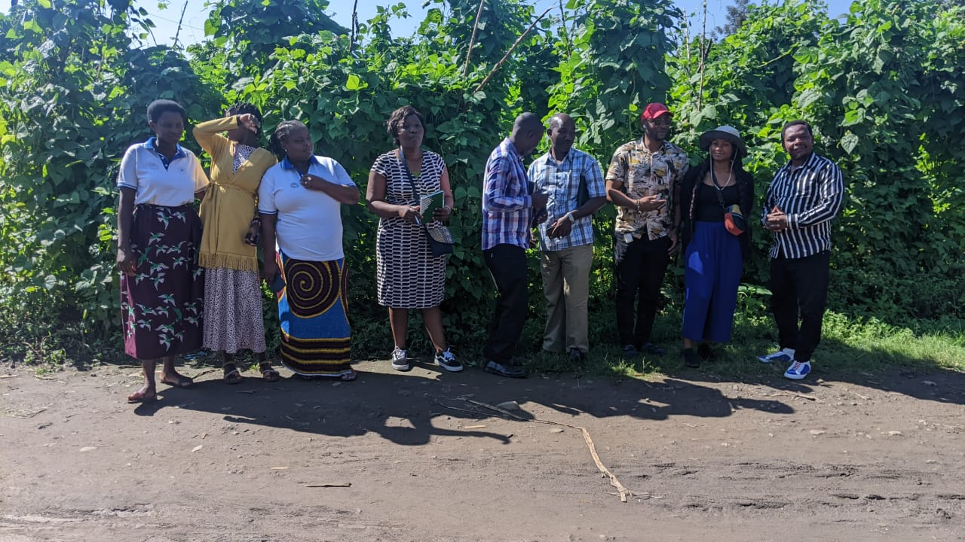 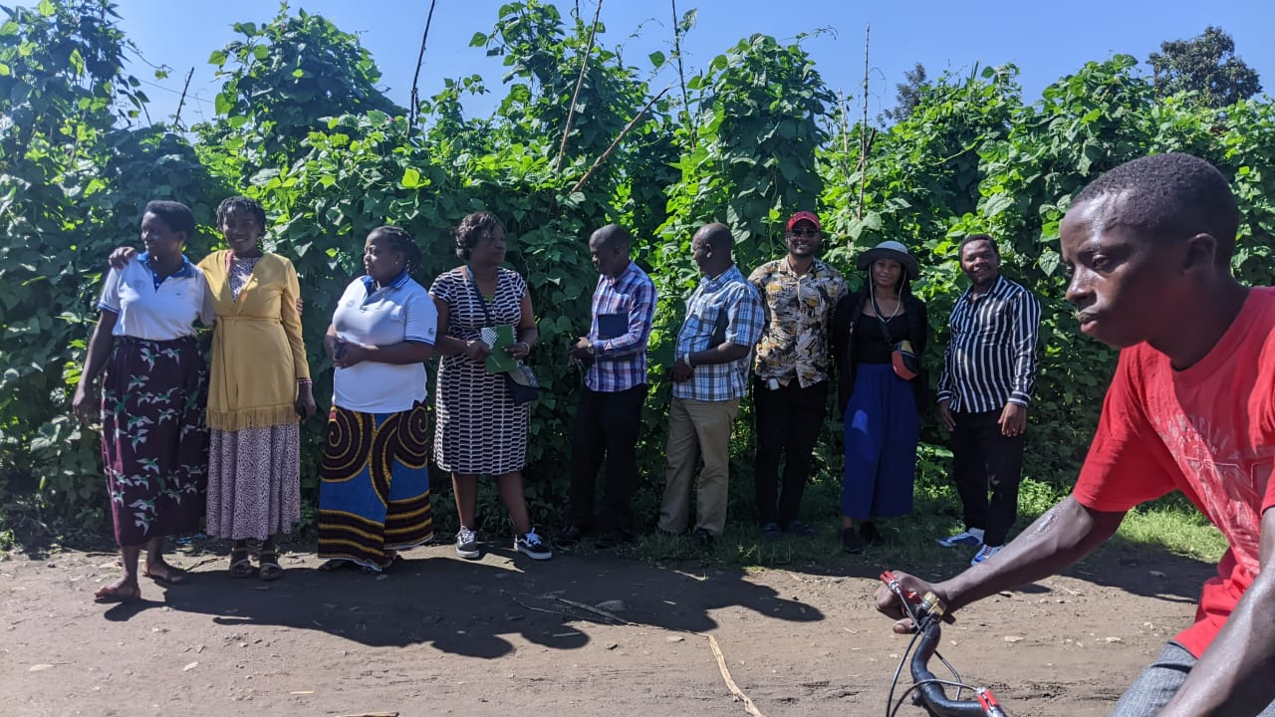

**Photo: A very good field of beans has showed to the delegation and ANSP+ were excited from this wonderful activity**

The fourth day of this visit was a time to visit DUHOZANYE association. This association is composed by 5 members, and deals with sweet potatoes and beans activities, as observation we saw that there is a field of sweet potatoes of 50m*45m and field of beans with 52m*48m ready to be harvested, and it help them so much to solve their daily needs. Arrive there; association’s members have warmly welcomed ANSP+ staff.

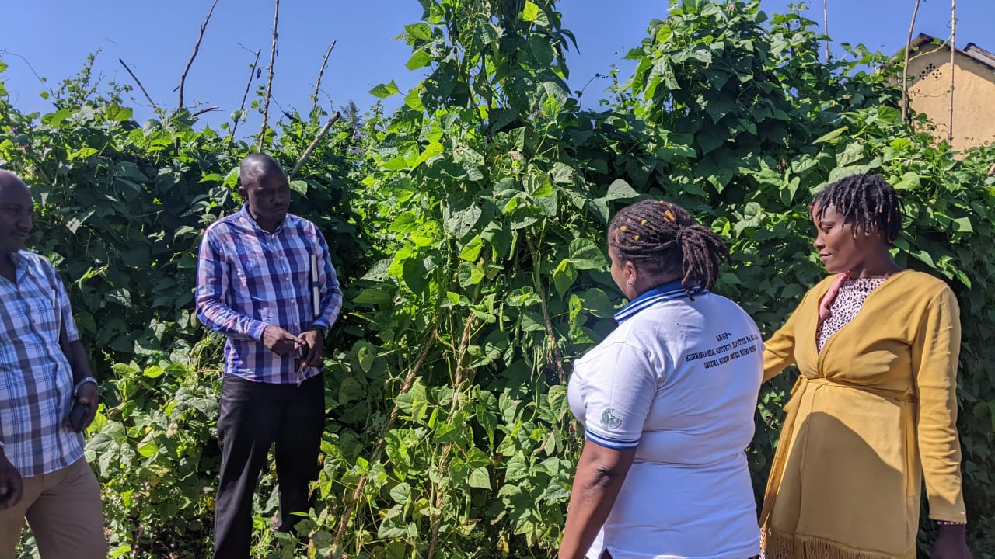 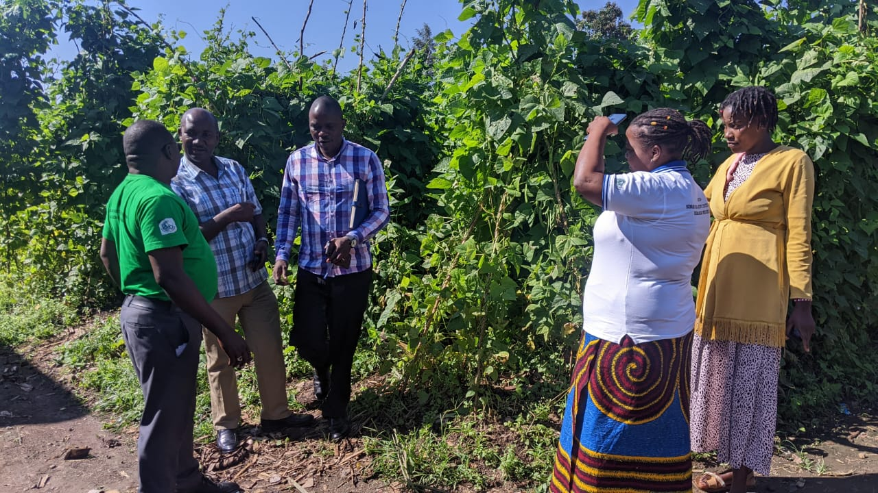

**Photo: Association’s representative are explaining how they did this project and addressing expectations production**

In his words this Association representative Nikiza Solange said that they have chosen to do this activity because in this region beans and sweet potatoes are favorable there due to the good climate and the market of this product is at high level. During this visit some challenges have listed out, among them there is a high intensity of rain which cause inundations then crops destruction, Cultivation field rent which is expensive. This association used to share the profits and interests after the harvest period.

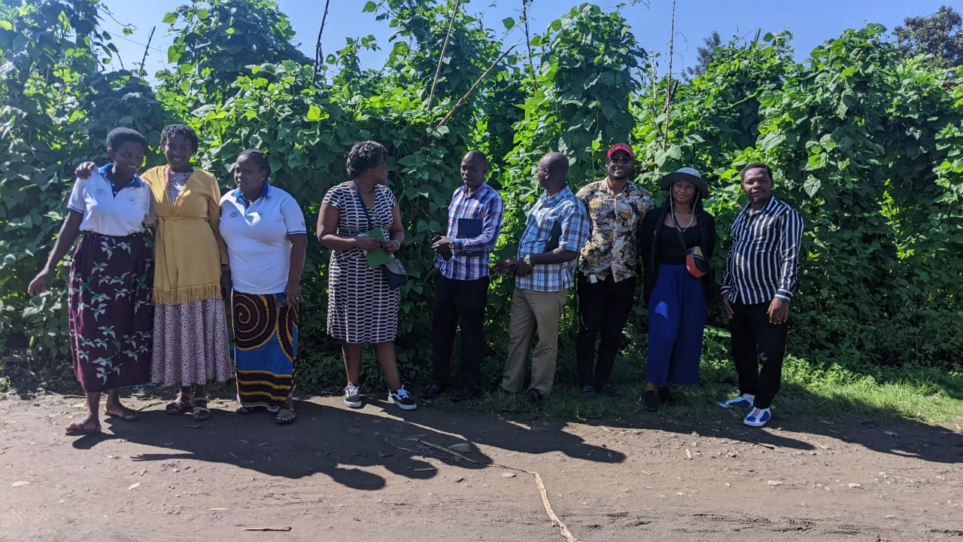 

**Photo: ANSP+ delegation with TUZAMURANE Association members visiting**

The members of this associations said that due to this business their lives have changed a lot from down to something. Now are able to feed themselves and their children, families etc. To sustain their association they have habit to contribute some amount weekly then share after 3 months. in saving book we have observed 40 thousands.

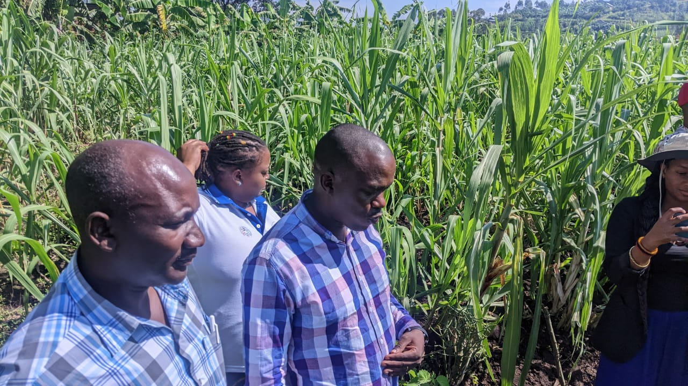 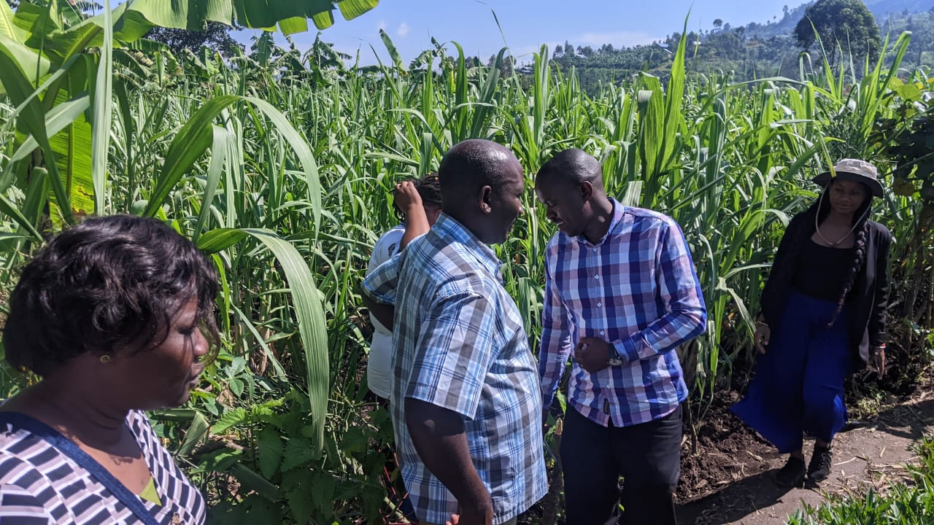

ANSP+ Delegation visiting DUHOZANYE at their sugarcanes field

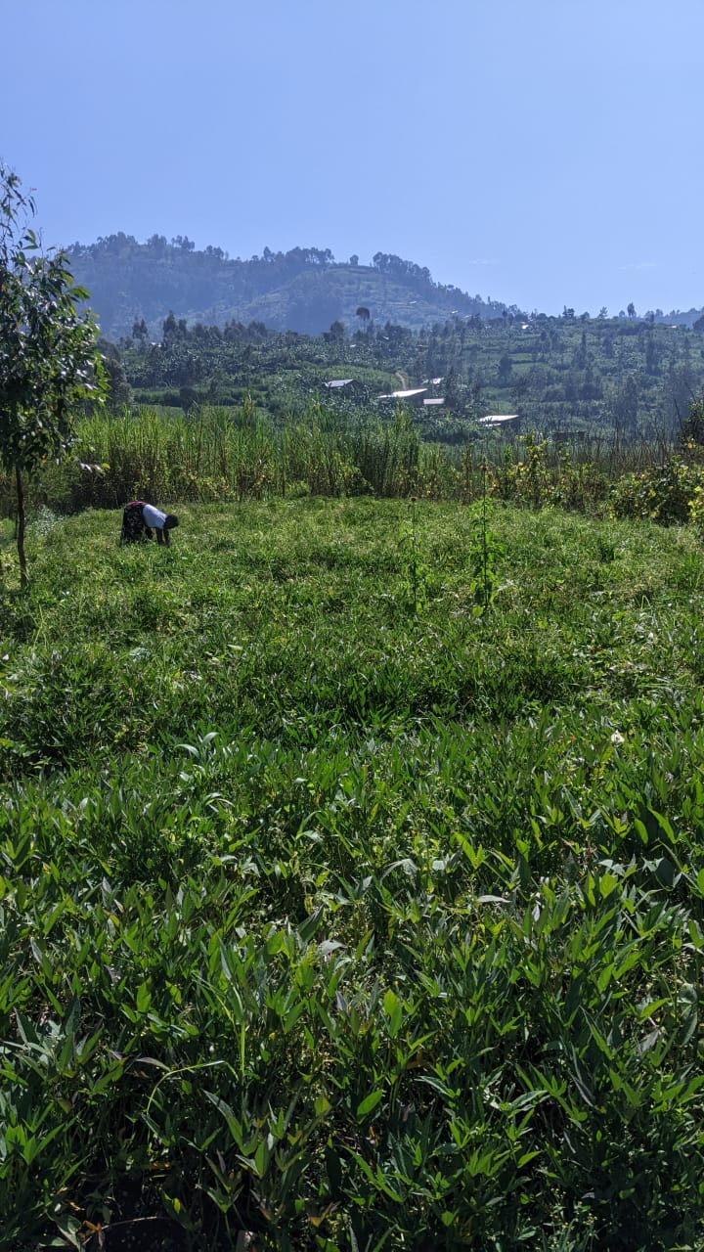 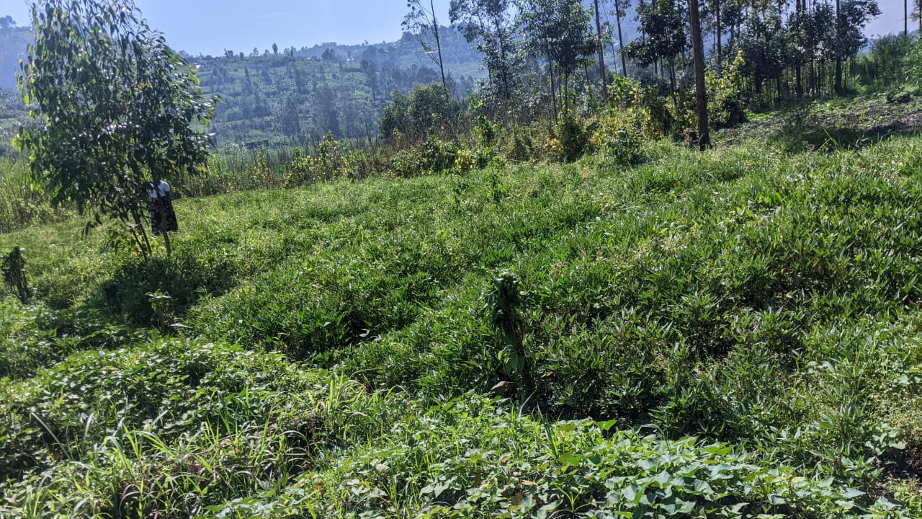 **Photo:** ANSP+ Delegation visiting DUHOZANYE at their sweet Potatoes field

**Conclusion**: This field activities was well conducted and objective of this activity was well achieved.

Done at Kigali 20/12/2023

**STAFF MEMBERS PARICIPATED IN FIELD WORK:**

MUKASEKURU Deborah

NIZEYIMANA Jean Marie Vianney

NZIRINGIRIMANA Joseph

MUKAYIRANGA Marceline

BUCYANAYANDI Aimable

MUTONIWAMANA Laurence