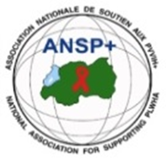

ANSP⁺website:www.ansp.org.rw,Tel.(250)0788761985/0788443140, e-mail: ansprwa1@yahoo.fr

PROJECT NAME: ANSP+/UN WOMEN

- INTRODUCTION
From 15th November ANSP+ in partnership with UN WOMEN started implementing the project aiming at “Regaining safe and dignified livelihood for former female domestic workers affected by covid-19”, where 41 former female domestic workers are supported in tailoring activities. Before starting the tailoring training itself, it has been crucial to train the beneficiaries on entrepreneurship, cooperative management, sexual based violence (SGBV), child abuse, sexual exploitation and neglect, in order to give them the package which will accompany them during and after tailoring training. This training took place at Five to Five Hotel from Monday the 15th to Wednesday the 17th November 2021.

After ending with this training, the activity to be following was to conducting short-term courses of tailoring and provision of starting tool kits and equipment. After buying all necessary tailoring materials and hiring the trainers, the tailoring training activities started on the 22th November 2021, within 41 trainees. They are divided into 2 groups where 21 trainees attend the training before noon and other 20 trainees in after noon.

- OBJECTIVES OF THE PROJECT
This project was proposed to mitigate the female domestic workers risks of Covid-19 and vulnerability in the City of Kigali. For being more specific, the project has the following objectives:

- Building capacity of beneficiaries in entrepreneurial and cooperative management skills towards professionalism development.

- Improving financial capacities of 41 former female domestic workers who experienced risks because of losing their employment due to Covid-19.

- ACHIEVEMENTS

ACTIVITY 1: ORGANIZING A THREE-DAYS TRAINING ON ENTREPRENEURSHIP, COOPERATIVE MANAGEMENT, SEXUAL GENDER BASED VIOLENCE (SGBV), VIOLENCE AGAINST CHILDREN, CHILD ABUSE, SEXUAL EXPLOITATION AND NEGLECT

As said in the introduction, this three-day training took place from the 15th to the 17th November 2021 in Five to Five Hotel and put together 40 former female workers, the chair person of ANSP⁺ board members, 3 staff of ANSP⁺ in charge of general supervision and any support needed, and 2 training facilitators who delivered the training.
3.1.1. Training objectives
The training had three major objectives:
- To increase knowledge of beneficiaries on entrepreneurship, cooperative management;
- To enhance knowledge on Sexual Gender Based Violence (SGBV),child abuse, Sexual exploitation and neglect for the Former Domestic Workers affected by COVID-19;
- To Promote human rights among Former Domestic Workers affected by COVID-19.

3.1.2. Training achievements
Before starting the training, every participant must get tested from covid-19 and fortunately everyone tested negative. After the registration and presentation of participants’ expectations, the training has been opened, and the introductive annotations by the coordinator of ANSP⁺ followed. She thanked all the participants for coming, continuing on explaining the project package, its duration and objectives. She asked the beneficiaries to consider the opportunity given to them and exploit it. He reminded them that there were so many demands, the reason why they must not take this opportunity for granted. She called on beneficiaries to follow the training carefully and wished the good training to all.
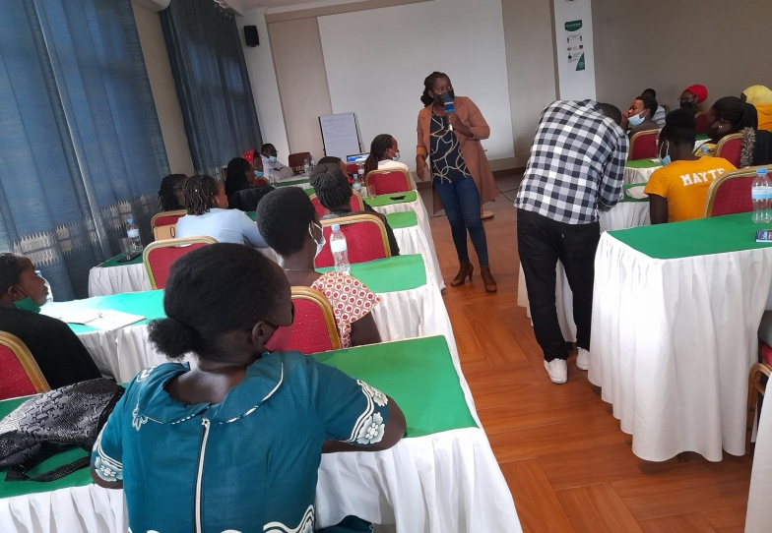
The coordinator of ANSP⁺ presenting the training introductive annotations
After the speech of ANSP⁺ coordinator, the pre-test has been given to trainees to enable evaluating evolution of knowledge of participants by comparing the final results at the end of the training with those of the pre-test at the beginning of it.
Considering the training agenda, the first topic concerned the cooperative and association, and the difference between them. As the training methodology followed the various interactive approaches, the training facilitator wanted to know the knowledge of beneficiaries about this topic for further explain it more after listening the answers from them.
The trainer defined the association as a group of people organized for a joint purpose. These people decided to put together their physical forces, intelligence or finances targeting their objectives.
He continued on the definition of a cooperative and its differentiation from association and the role of cooperatives. Here, the training facilitator defined the cooperative as a farm, business or other organization which is owned and run jointly by its members, who shared the profit or benefits or even losses in case they happen. He added that a cooperative involves mutual assistance in working towards a common goal. Different from cooperative, the association doesn’t target the profit or benefits. He put much emphasize on the importance of a cooperative for it contributes both to the country and members development.
The trainer explained all details about this topic saying that the cooperative has a legal status; it has rules, it is under the supervision of local and central authorities and when there is some misunderstanding in a cooperative, the Rwanda Cooperative Agency (RCA) and courts can intervene; while associations have no legal ways of conflict management and the committee members have the last word to the members.
The trainer chained on cooperative establishment and management starting by its administrative structure. He told the trainees that when they are managing the cooperative, they need discipline. He added that focusing on members’ development, time management and accountability are also the crucial things to put into consideration for successful cooperative goal. The trainer talked about the importance of working with microfinance institutions for avoiding keeping money at home, doing savings, asking for loans etc.
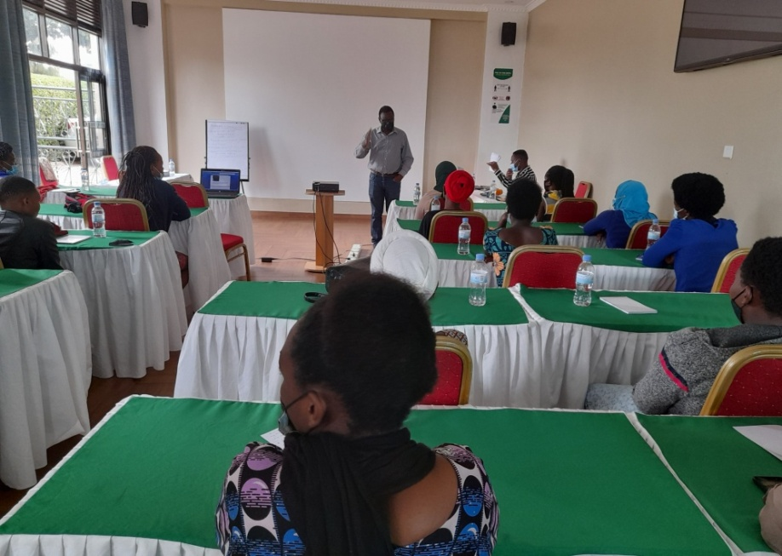
Training facilitator delivering the training
The training continued on entrepreneurship and self-employability. He said that entrepreneurship is the creation or extraction of value. With this definition, entrepreneurship is viewed as change, generally entailing risk beyond what is normally encountered in starting a business, which may include other values than simply economic ones. While employability refers to your ability to gain initial employment, maintain employment and obtain new employment if required. In simple terms, employability is about being capable of getting and keeping fulfilling work. It means having a set of skills, knowledge, understanding and personal attitudes.
The trainer matched this topic to the project, telling the trainees that this project has been conceived in the framework of making them entrepreneurs in the context of fighting unemployment among young girls and women for helping them to get out of vulnerable people. The first day of the training ended on the introduction to income generating activities where the trainees got much information on this subject by getting many examples of potential income generating activities including tailoring activities. Questions have been asked and answered by the trainer and ANSP⁺ staff members.
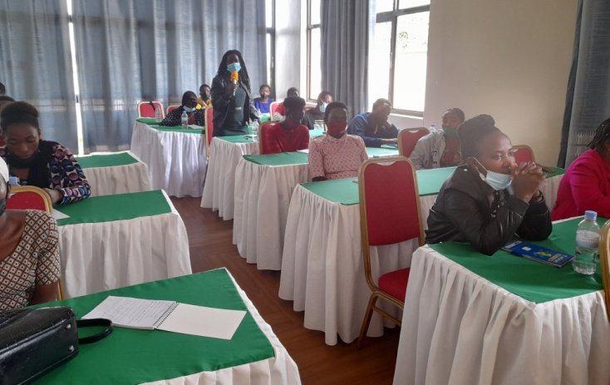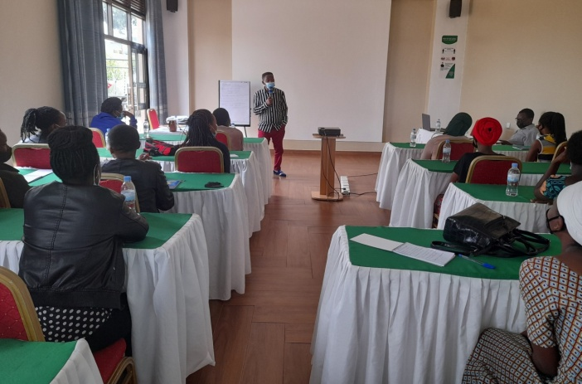
Beneficiaries asking for clarifications and ANSP+ staff intervening in the training
The second day has been started by the recapitulation of day one presentation and it was consecrated on a shot income generating activity, its management and the groups of saving and loan. Here the beneficiaries have been presented an example of a small business of agriculture products. He told the trainees that this can help them to elaborate their own project or business either in tailoring or in any other business they can start. He told them all necessary things to be with, when they want to start a business, such as the location of their business, the start-up capital, RRA conditions etc. He ended on groups of saving and loan (GSL, ibimina) persuading the beneficiaries working with microfinance institutions as UMURENGE SACCO and others.
The third day concerned the issues of child abuse, gender based violence and human rights linked to the violence faced by domestic workers. Here the trainer asked the trainees who they think is a child in Rwandan context and they answered a child is everyone under 18 years old. She defined the child abuse as physical, sexual and/or psychological maltreatment or neglect of a child or children, especially by a parent or a caregiver. It may include any act that results in actual or potential harm to a child and can occur in a child’s home, or in the organization, schools or community the child interacts with. This was related to their former work where some of them were in charge of caring children at home where they worked, but also with themselves because some of them started the domestic working before the maturity age. The training went on sexual gender based violence and sex exploitation as the issue mostly faced by female domestic workers though it can happen to male also. She called them on saying no to everyone who wants to destroy their future and report every person in this path.
The training ended on human rights issue where the trainer listed 7 fundamental rights, such as right to equality, right to freedom, right against exploitation, right to freedom of religion, cultural and education rights, right to property and right to constitutional remedies. She reminded the trainees their rights as they have the same rights as others, specifically linking them to their former work. She asked them to fight for their rights and to advocate for others. A post test has been given to trainees to see if they captured what they learnt.

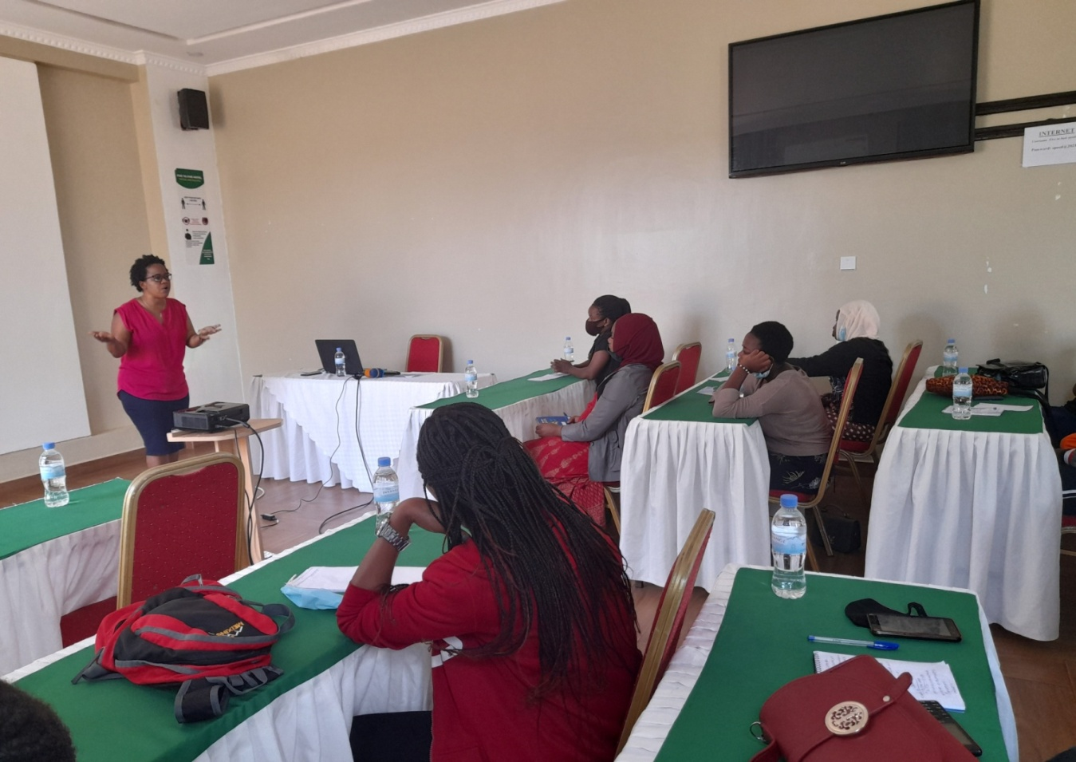
The second trainer facilitating the training

    - Training expected results

At the end of this training, participants got enough knowledge on entrepreneurship, cooperative management, Sexual Gender Based Violence (SGBV), child abuse, sexual exploitation, and neglect

Specifically, this training brought the following results:
- Female Domestic Workers affected by COVID-19 got enough information and knowledge on cooperative Management and entrepreneurship ,
- Appropriate information and knowledge on SGBV, Child abuse ,Sexual exploitation and neglect are given, and
- Promotion of Human Rights among Female Domestic Workers affected by COVID-19

    - Training closing remarks
After all training presentations, the speech has been given to everyone desiring to say anything. The trainees were very excited to express their feelings and one of them stood and addressed her speech to all participants. With great emotion, she thanked every participant starting by the trainers but especially ANSP⁺ and UN WOMEN who considered the way they were suffering, hopeless and waiting for the help without knowing where it will come from. She appreciated the package of the training, mostly the tailoring training which will be given to them. She promised that they will not disappoint ANSP⁺ and UN WOMEN.
Emotional for the speech of the representative of beneficiaries, the Director of Administration and Finance of ANSP⁺ invited the coordinator for further invite the Executive Secretary of Rwanda NGO Forum as the guest of honor. She started by thanking ANSP⁺ for his hardworking all aiming at advocating improving the life conditions of their potential beneficiaries. She thanked UN WOMEN for they never stop empowering and supporting women and girls so that they can be independent and develop themselves. She came back on the trainees and told them to never and never devalue the opportunity given to them. The coordinator of ANSP⁺ continued on the way forward and closed the training.
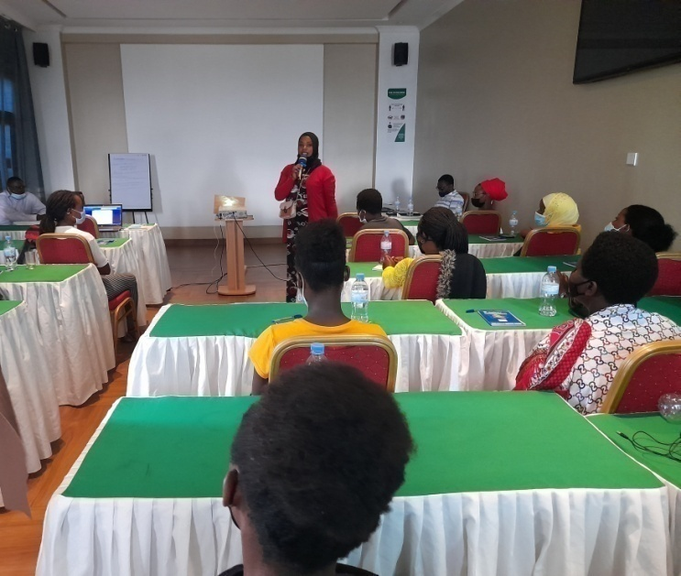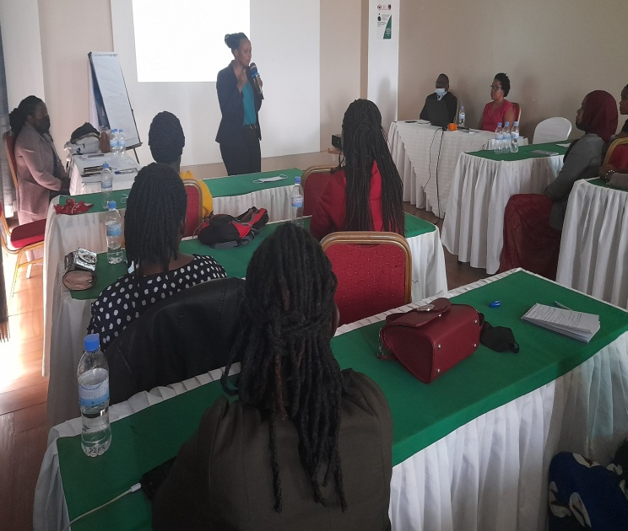
Beneficiary addressing her gratitude to ANSP⁺ and UN WOMEN and the speech of RNGOF Executive Secretary

  - ACTIVITY 2: CONDUCTING SHORT-TERM COURSES OF TAILORING AND PROVISION OF STARTING TOOL KITS AND EQUIPMENT
It’s been already 4 weeks since the tailoring training started. In the project proposal, it was supposed to target 40 trainees, but at the beginning of tailoring training, one beneficiary joined others and the number of beneficiaries increased to 41 participants. The training is happening at ANSP⁺ head office at GATSATA from the 22nd November 2021 with two training facilitators. One trainer facilitates 21 trainees of before noon and another one is helping the afternoon trainees which are 20. The training of before noon starts at 8:00 am and takes the end at 12:00 O’clock. We take one hour of cleaning up the space and the trainees of afternoon starts the training at 1:00pm to finish at 5:00pm. They have both 4 hours per day in four days of the week from Monday to Thursday.

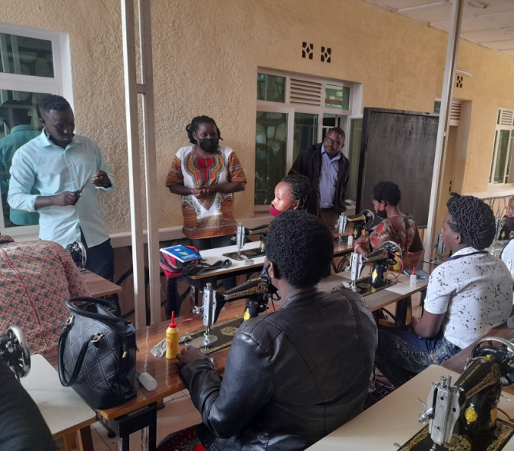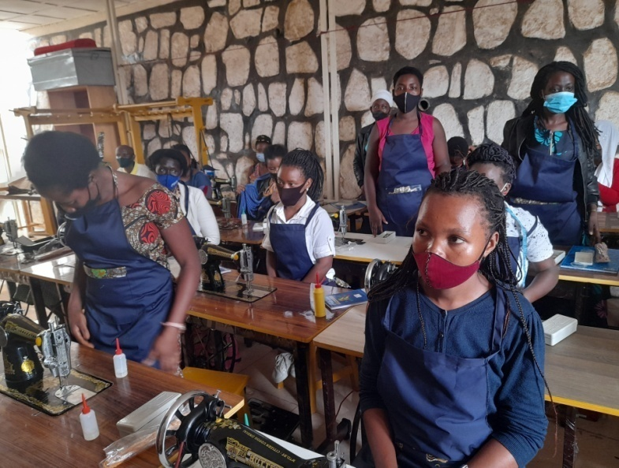
ANSP+ Coordinator welcoming the trainees and the photo of trainees on the first day

From when they started until now, they learnt lot of things. They started on the sewing machine parts and the role of each part in tailoring and other theories. After the flash theory, they started the practical work. They learnt to pedal the sewing machine, they continued on dressing on the papers, to cut on the fold (fold lines) etc, and all these starting learning-teaching process took the two first weeks. In the two following weeks, they continued on learning how to make a skirt and within this time, every trainee knows to make one model of skirt and they will learn more than one model depending on the duration of the project.

As beneficiaries’ initiative, they all initiated the ibimina where they collect one thousand everyday and give it to one of them, in the context of saving on one side and the way of solving their basic needs on the second side. This is a result of what they learnt in the training before starting the tailoring training itself. For this issue, ANSP+ will be there to help them if they face some misunderstanding.

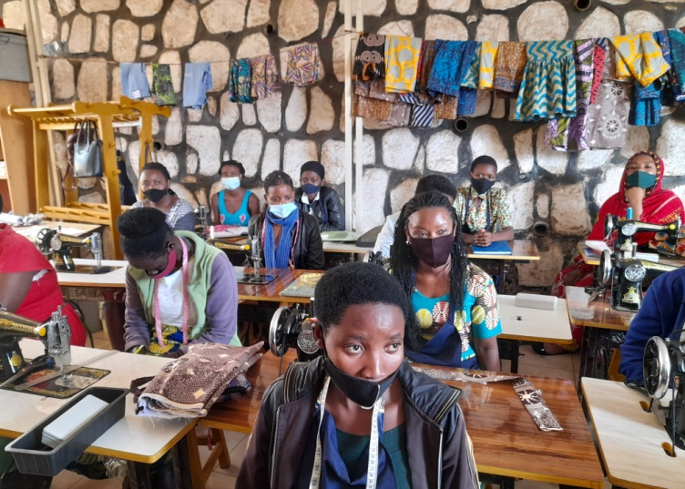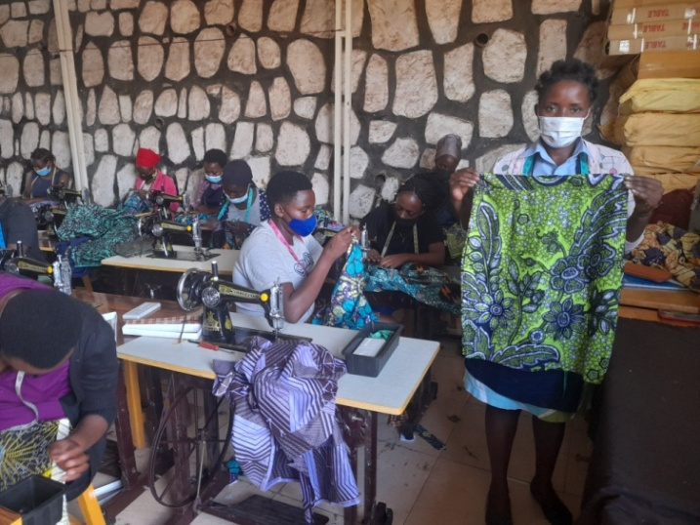
The trainees have already the skirts made by themselves
From yesterday, the 20th December, the training facilitators shifted to the shirts. They started on the model of a uniform shirt and they will continue to others. The trainees are not alone with their trainers only; ANSP+ staff members are always there for supervision, to encourage them and to see if they respect the covid-19 preventive measures or any challenge.

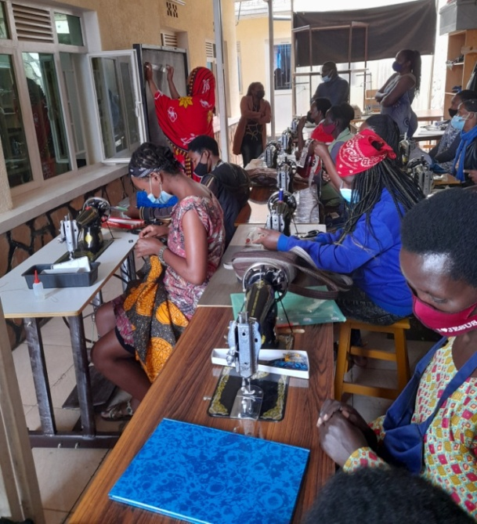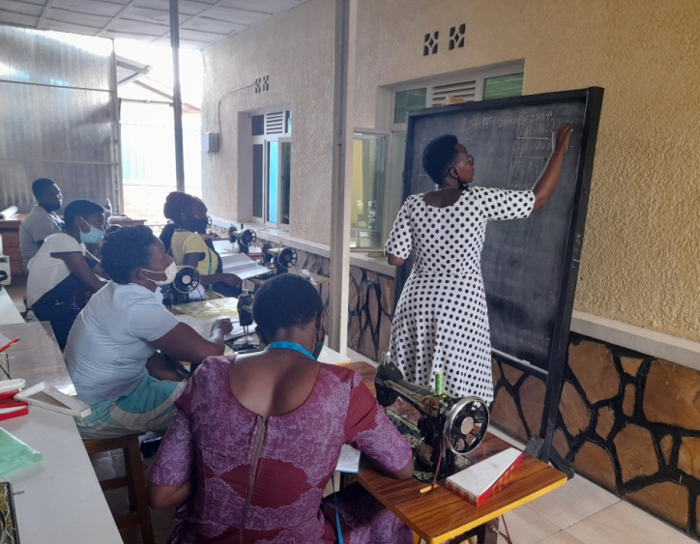
ANSP+ supervising the training Every practical work is started by the theory.

VISITS OF UN WOMEN DELEGATES

On the 13th December 2021, the delegates of UN WOMEN came to visit ANSP⁺ and beneficiaries. Their visit was much appreciated because it was a motivation to trainees on one side and the solution of some challenges on the other side. They asked the beneficiaries what they learnt since they started and what they benefit from the project and they have been answered. They encourage the beneficiaries and gave them some advices all aiming at the good results of this project.

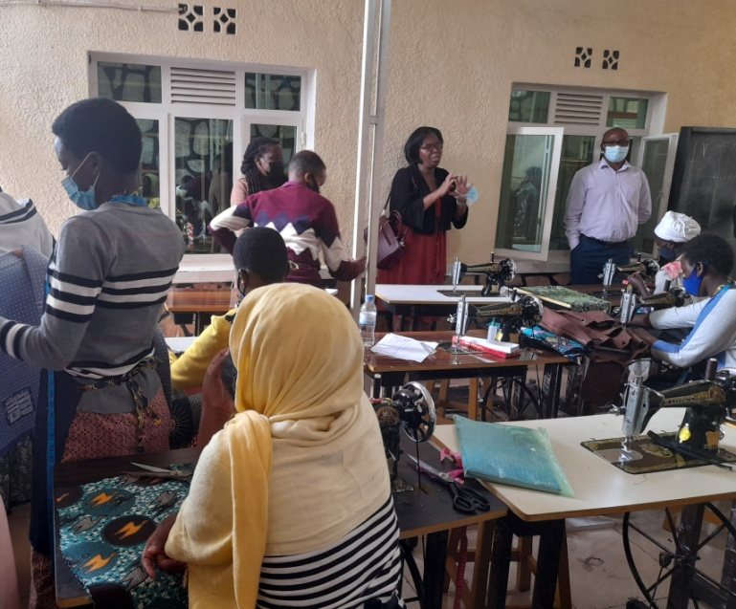
One of UN WOMEN Delegates talking to beneficiaries

CHALLENGES MET

- In the project proposal, it was planned to work with 40 former domestic workers; after, the number increased to 41 trainees and there was no way to say no to that new beneficiary, because she was very affected by consequences of Covid-19 and she was in need of urgent support. Therefore, ANSP+ took the risk and received that beneficiary and yet it was not planned in the budget. With the current situation, there is a need of materials for her including tailoring machine and accompanying materials like iron, loincloths, etc.

- There are 2 training facilitators but because of error in formula in excel sheet, we have budgeted and received allowances of one facilitator. But, as the days we have calculated for transport facilitation to trainees exceed the days that will be really used by trainees, the balance on transport facilitation cost to trainees can be used to cover cost for the second training facilitator and transport facilitation during the training for the 41st trainee. Those days are from the fact that we have generally counted 5 weeks of training for every month and normally a month is about 4 weeks and almost a half.

IV. CONCLUSION

ANSP+ recognizes the support of UN WOMEN and appreciates it. The beneficiaries don’t stop thanking ANSP+ and UN WOMEN for thinking about them. They are happy and committed. ANSP+ always finds a time to continue encouraging them and advising them about how they have to behave so that they can enjoy the fruits of this project. With the commitment of each and every stakeholder, we will achieve our objectives.

Done at Kigali, the 21st December 2021

Coordinator of ANSP+,

MUKASEKURU Deborah

