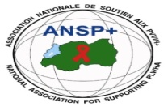  [](http://scottfiller.info/)

**PROJECT NAME: ANSP+/RBC/SPIU**

**NAME OF ORGANIZATION: NATIONAL ASSOCIATION FOR SUPPORTING PEOPLELIVING WITH HIV/AIDS (ANSP+)**

**NSP PROGRAM: COVID-19 IMPACT MITIGATION**

**ACTIVITY: CONDUCT AN AWARENESS ROBUST ABOUT HIV, SRHR, DRUG AND ALCOHOL ABUSE, USING VARIOUS FORM OF AWARENESS AND MEDIA CAMPAIGN**

**TARGET GROUP: KEY POPULATIONS**

**AREA OF INTERVENTION: NYAGATARE**

**MISSION REPORT**

1. **INTRODUCTION**

The National Association for Supporting People living with HIV (ANSP+) stands as a Rwandan Civil Society Organization created in September 2000.With the main purpose of improving the quality of life its beneficiaries. ANSP+ strives for quality of life of those infected directly affected by HIV and fights against the spread of HIV. To this mission, ANSP+ under the financial support from the global fund via the Rwanda Biomedical center (RBC) has organized a three days workshop/campaign for media professionals together with healthcare providers from different health facilities in the Nyagatare having partnership with the organization and key populations. The aim of the work will be to talk and discuss about HIV, SRHR, Drug and alcohol abuse, using various form of awareness and media campaign. In this context, a three-day workshop/campaign was organized for journalists for their roles in the community, quality reporting with articles, publications, talks, adverts and networking with media houses or newsletters industries.

1. **WORKSHOP/CAMPAIGN OBJECTIVES**

This activity was organized for the following objectives:

-Accentuate the role of journalist in community mobilization about HIV, SRHR, Drug and alcohol abuse, using various form of awareness and media campaign.

- Developing reporting model of journalists, for quality reporting with articles, publications and talks.

-Networking with media house or newsletters industries in HIV, SRHR, Drug and alcohol abuse, using various form of awareness and media campaign.

- Create a platform which connects journalists and healthcare providers for the purpose of fighting against HIV, SRHR, Drug and alcohol abuse, using various form of awareness and media campaign.

-Reinforce community mobilization by using Media in fighting against HIV, SRHR, Drug and alcohol abuse, using various forms of awareness and media campaign.

**3. TARGET GROUP**

This workshop/campaign will target 24 participants in Nyagatare District. This number includes 6 Journalists, 8 Key populations providers/stakeholders, I campaign facilitator and 6 staff members of ANSP+ who will be supervising and assist the campaign facilitator during the workshop campaign.

**4. DATE AND VENUE**

This three days workshop /campaign is due to take place in Nyagatare district from 08th to 10th November 2023 at moon’s charity Hotel located in Nyagatare Town.

**5. WORKSHOP/COMPAIGN EXPERTS RESULTS**

By the end of this workshop/campaign, participants will have enough knowledge on HIV, SRHR, Drug and alcohol abuse, using various form of awareness and media campaign. In particularly way, journalists will have a quality reporting with articles, publications, talk and networking with media houses or newsletters industries. The skills which will have been acquired by participants will help them to train their workmates and trough Media talks; the community will be educated on how to continue preventing against HIV, SRHR, Drug and alcohol abuse, using various form of awareness and media campaign.

- The role of journalist in community mobilization about HIV, SRHR, Drug and alcohol abuse, using various form of awareness and media campaign will be accentuated

- The reporting model of journalists, for quality reporting with articles, publications and talks, will be identified.

-Networking with media house or newsletters industries in HIV, SRHR, and Drug and alcohol abuse, using various forms of awareness and media campaign will be done

- The platform which connects journalists and healthcare providers for the purpose of fighting against HIV, SRHR, Drug and alcohol abuse, using various form of awareness and media campaign will be created.

-The community mobilization by using Media in fighting against HIV, SRHR, Drug and alcohol abuse, using various forms of awareness and media campaign, will be reinforced.

**6. FIELD ACHIEVEMENT**

This 3 days awareness campaign started on Tuesday, 7th 2023 whereby ANSP+ Staff left Kigali office to Nyagatare whereby they have a short briefing with Head of Nyagatare Health center to look together how this activity could be implemented. Arrive there a health center manager has warmly welcomed. In this meeting everything was discussed on, and activity’s agenda was talked about. By Wednesday 8th November 2023 was the day of starting awareness robust in action. This activity started around 8:00AM by participants’ registration; this one was followed by opening remarks done by ANSP+ representative Nizeyimana JMV.

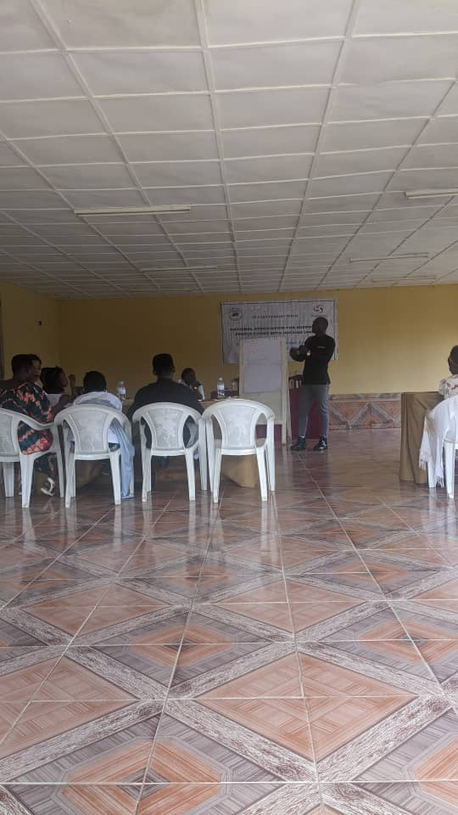 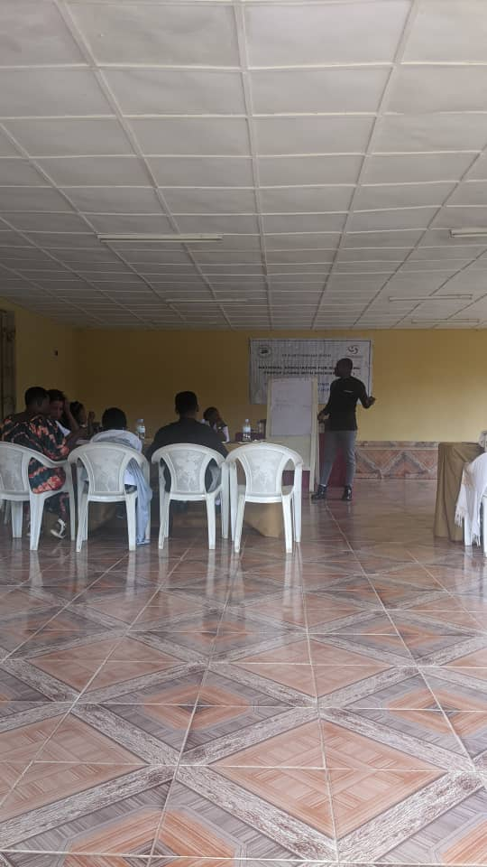

Photo: *Nyagatare District representative is addressing the audience the opening speech*

In his speech, this leader began his speech by greeting every participant in his respective position, and continued by addressing them the general and specific objectives, the purpose and expectations of this activity. He said that to be invited in this awareness campaign is significant, and after this awareness campaign everyone has to transmit the message from this forum to their mates especially media professionals. He closed this talk by reminding them that Journalists have to create a platform where they will meet themselves and help them to share information regarding KPs right and social wellbeing and report everything related to stigma and discrimination. Again, they have to publish the articles trough their media bodies and newsletters. He thanked everyone and called up on everyone to participative actively and be dynamic so that they will be able to teach their mates.

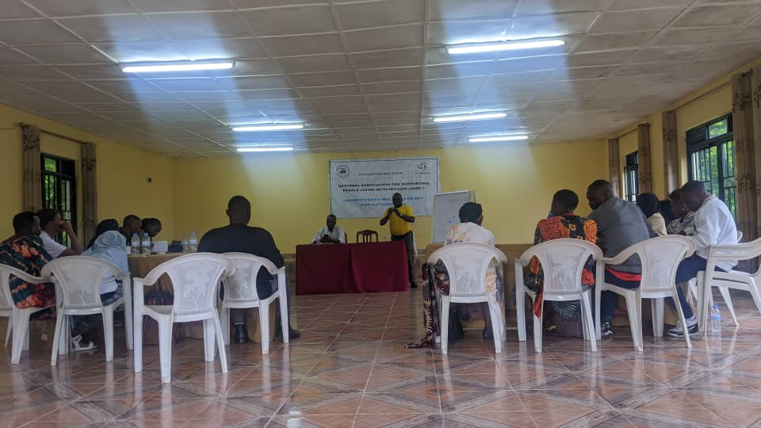 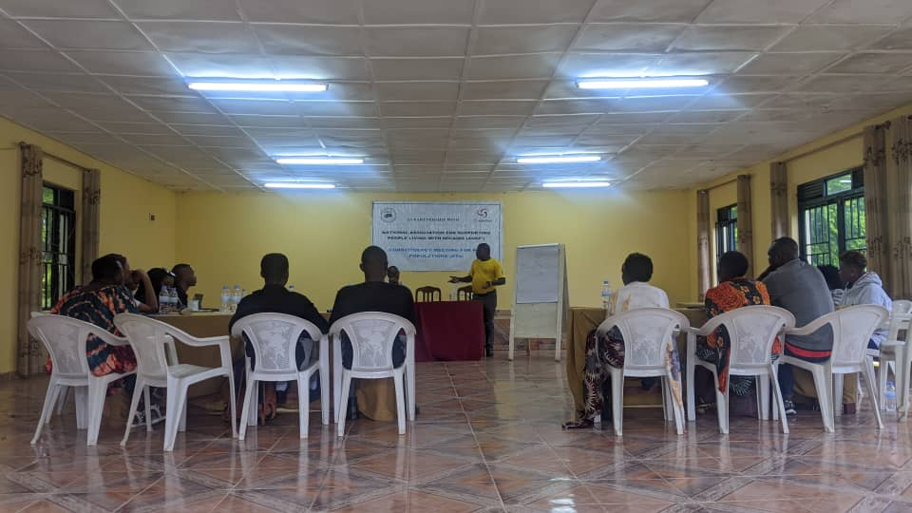

Photo: *ANSP+ Representative is addressing the objectives and expectations of this awareness campaign*

After this speech, was a time to training facilitator to start training? She began this training by self-introduction by every participant. She introduced her-self by telling them that she is expert in various health domains. She said that she is trained in SRHR, youth, and adolescents, KPs Management at Health center, ARV management, STIs management etc. She said that she used to be familiar with KPs at Nyagatare HC, whereby she served them accordingly. At the beginning the facilitator started by giving them pre-test just to assess their level of knowledge regarding the topic that was planned to teach on. After pre-test she asked them who is KP, what age of KP, where KP used to look for the clients, who are the client of KP, what are the major risks of being KPs, why do peoples prefer to do sexual selling?, what the society can do to live with KPs, what are the tasks and responsibilities that KPs have to respect in order not causes problems in the society, what the society can do to prevent the HIV contamination from KP, and STIs prevalence.

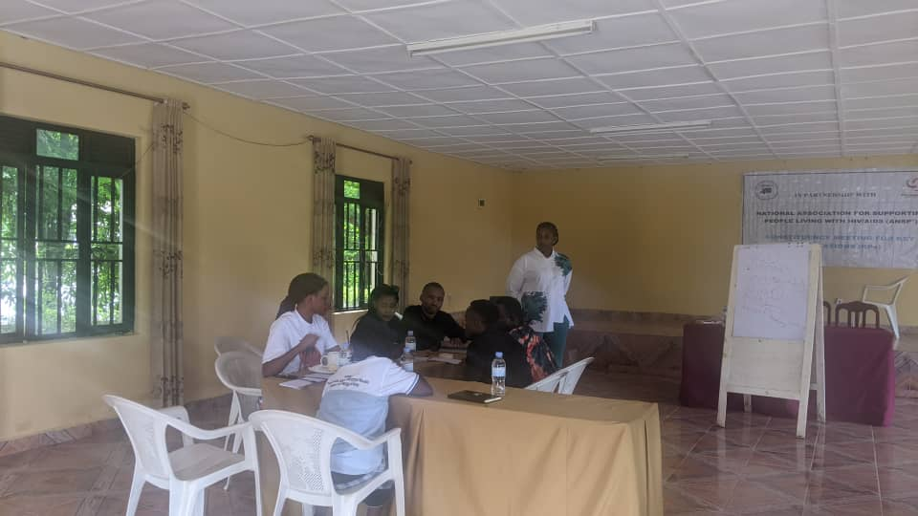 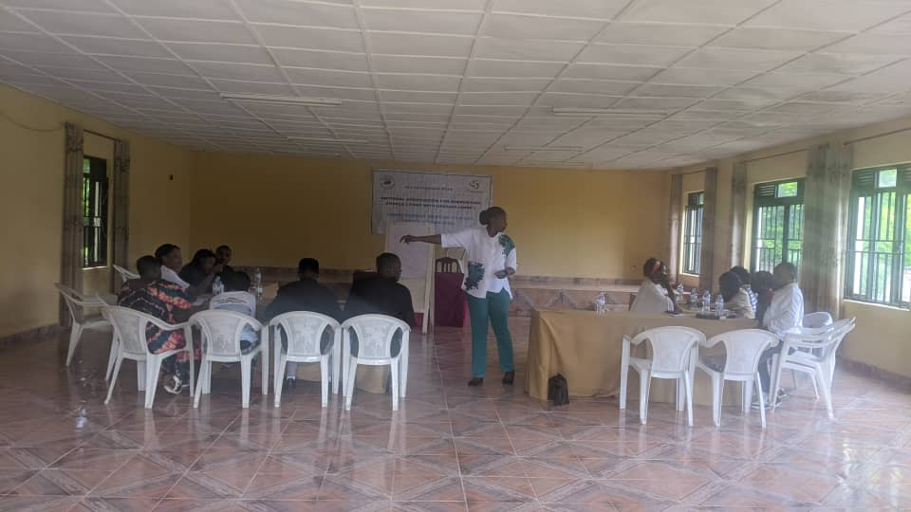

Photo: *A facilitator tried to give everything planned to teach, and participants got skilled and acknowledged*

During this training the facilitator told the participants that KPs are the group of people that are at high risks to be transmitted and contaminated by HIV/AIDS and those are the female sex workers that sell the sex for one reason to another again are the men who have sex with others. She said that those groups are aged between15-49. She said that KPs get clients from street in hotspots, at bars, hotels, mainly FSWs whereby they usually have a target to be attracted by the clients and go to work sex. The clients of female sex workers are heterosexual males who used to go the t said areas to choose or to meet them and make sex with them, the major risks of sex selling is to be contaminated from different infections including HIV/AIDS, STIs, Hepatitis B and C, cervical cancer unwanted pregnancy, etc. Furthermore once those infectious diseases once are not well managed can lead to chronic conditions and or to death. The main causes which make the peoples to sell sex are; poverty, family conflict, peers pressure, modernization, society habits, social-family misbehavior, ignorance etc. What the society can do to live with KPs, first of all is to accept their existence in the community and know what to do once they meet them, and not harm to them because this one can cause a serious issues which stigma and discrimination and this can cause them not to get essential service like health one and lead to serious condition even the death, again once KPs are discriminated will stay at home without taking medication and will anonymously contaminate many peoples. What the society can do to prevent HIV prevalence and STIs is to be screen from them, use preventive methods like condoms and lubricant use prep and Pep use etc.

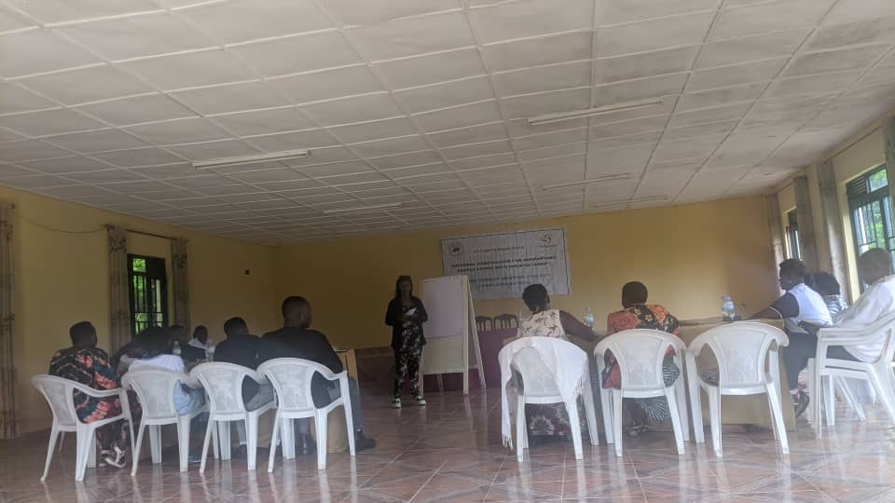 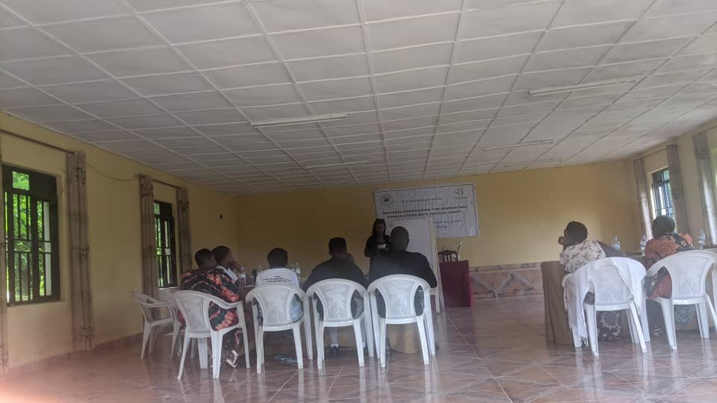

Photo*: KP representative of FSWs is appreciating how ANSP+ thinks every day to them*

The facilitator told them about different topics. Among them we can say; HIV prevention, STIs, Hepatitis B and C, TB, Malaria, ASRHR, Mental health, drug and alcohol abuse, Family planning, stay on treatment, stay on treatment etc. To every infection a facilitator tried to explain deeply the definition, agent cause, sign and symptoms, predisposing factors, complications, treatment and management and preventive measures. About available service at health center, the facilitator tried to clarify what is it, How it does, the benefits of using them and inconvenient of not using them, the criteria to use them, and the time when is available in a week.

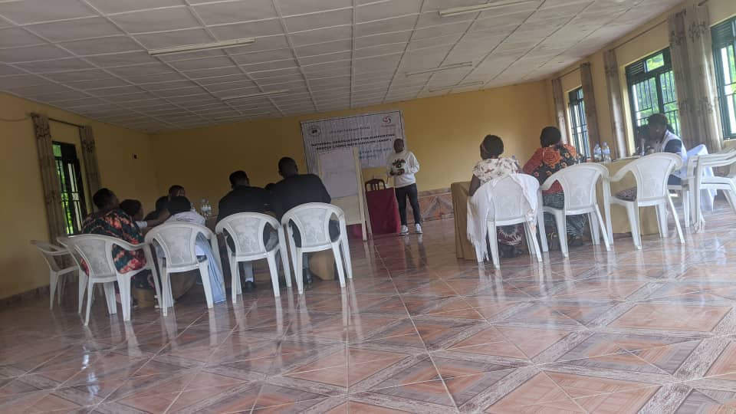 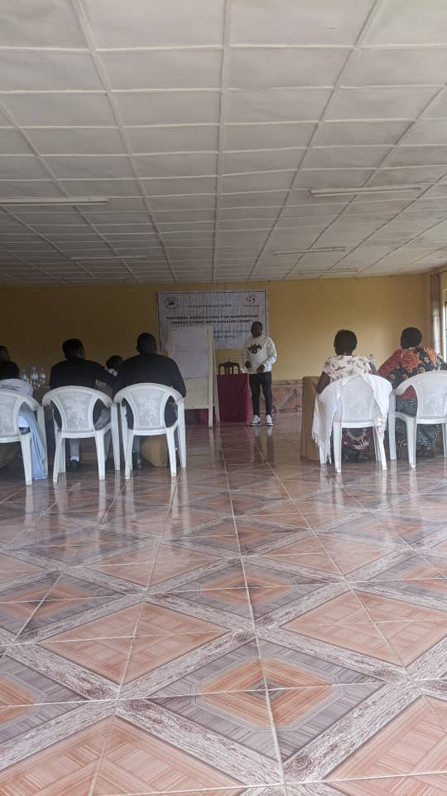

Photo: KP representative of MSMs is thanking ANSP+

During all along of these dialogues the participant tried to ask many questions and the facilitator answered them accordingly and perfectly. She grouped them into a small group of 6 in order to do group works and after them they made a very good presentation.

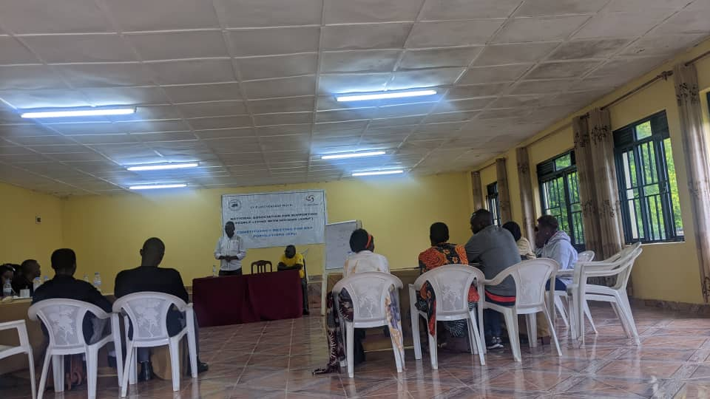 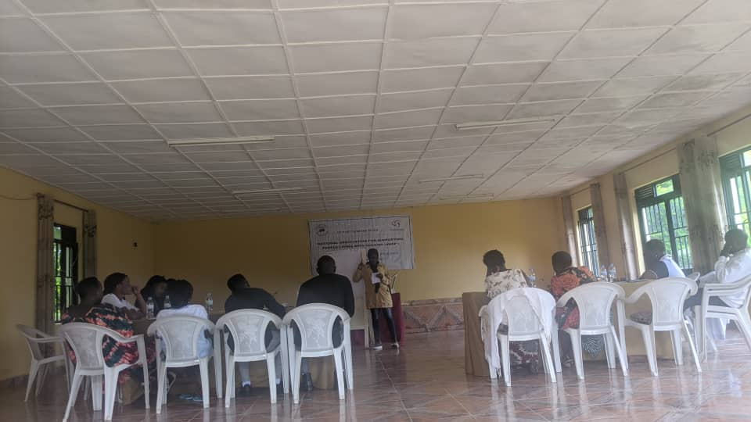

Photo: Media professionals and Journalists were excited from the knowledge get from campaign awareness

**7. RESULT**

Generally, this robust campaign has been well conducted and has achieved its expectations outcomes. This means that all of those expectations set before have all achieved. This means that all topics have been taught and discussed more. The participants have beneficiated what they were supposed to get and promise that they are going to transmit this message to their mate.

- The role of journalist in community mobilization about HIV, SRHR, Drug and alcohol abuse, using various form of awareness and media campaign has accentuated

- The reporting model of journalists, for quality reporting with articles, publications and talks, has identified.

-Networking with media house or newsletters industries in HIV, SRHR, and Drug and alcohol abuse, using various forms of awareness and media campaign was done.

- The platform which connects journalists and healthcare providers for the purpose of fighting against HIV, SRHR, Drug and alcohol abuse, using various form of awareness and media campaign was created.

-The community mobilization by using Media in fighting against HIV, SRHR, Drug and alcohol abuse, using various forms of awareness and media campaign, was done and reinforced.

**Impeccable achievements:** After this campaign session, some articles have been diffused on radio and YouTube channel. One of channel which was published this awareness is [www.radioishingiro.com](http://www.radioishingiro.com) and had 2600 views. Again, the same message was diffused on 107.5 FM Radio on 14/11/2023 at 6:30.

**8. RECOMENDATION**: After this robust campaign session, the participants has appreciated too much to ANSP+ for its organization and implementation; therefore they suggest to train more participants in order to reach a big number of people who are sensitized. They also suggest increasing the days of sensitization in order to get more skills. Again they suggest conducting the same activity at least once a month. 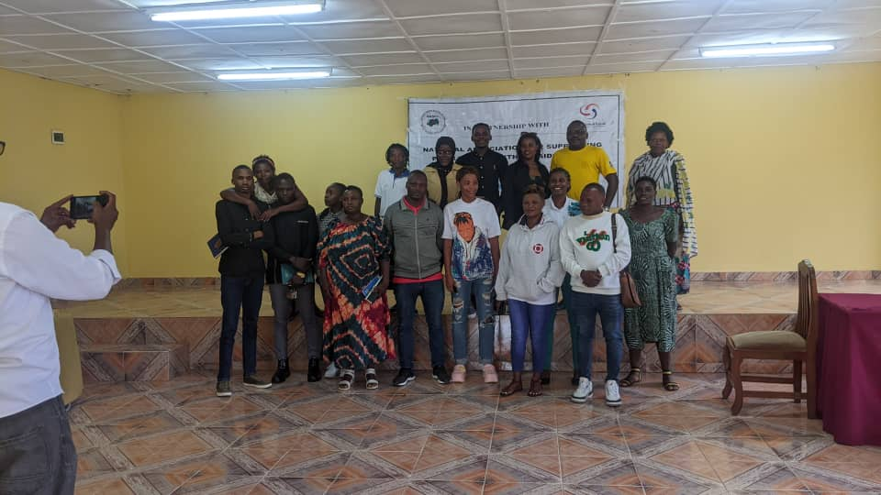

Photo: Memorial picture

Done at Kigali 15/11/2023

**STAFF MEMBER IN MISSION**

MUKASEKURU Deborah

NIZEYIMANA Jean Marie Vianney

NZIRINGIRIMANA Joseph

BUCYANAYANDI Aimable

MUKAYIRANGA Marcelline

MUTONI WA MANA Laurence