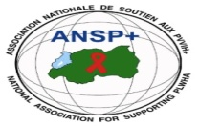  **[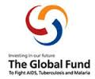](http://scottfiller.info/)**

**PROJECT NAME: ANSP+/RBC/SPIU**

**NAME OF ORGANIZATION: NATIONAL ASSOCIATION FOR SUPPORTING PEOPLELIVING WITH HIV/AIDS (ANSP+)**

**NSP PROGRAM: COVID-19 IMPACT MITIGATION**

**ACTIVITY: FOUR DAYS FIELD WORK FOR BULDING CAPACITY THROUGH WORKSHOP, TRAINING AND OR COORDINATIONS MEETINGS WITH UMBRELLA’S MEMBERS TO INCREASE THEIR ENGAGEMENT IN COMMUNITY MOBILIZATION AFTER COVID-19 AND TOWARDS OTHER HIGH BURDENED DISEASES (HIV, TB, HCV, AND MENTAL HEALTH)**

**TARGET GROUP: KEY POPULATIONS**

**AREA OF INTERVENTION: NYAGATARE**

**MISSION REPORT**

1. **INTRODUCTION**

ANSP+ stands as National Association for Supporting People living with HIV/AIDS. It is a Rwandan local Non-Governmental Organization created in September 2000 by People Living with HIV themselves, with the leading mission of striving for the quality of life of HIV infected /affected people in Rwanda and fighting against the spread of HIV/AIDS and other epidemic diseases. Towards this mission, our potential beneficiaries include Key Populations which run a high risk of getting covid-19.

Talking about covid-19,we can’t leave behind other burdened diseases such as HIV, TB, Ebola, HCV, Hepatitis B virus ,STIs, Malaria and mental health for, in one way or another, there some commodities, between these diseases especially to key populations on one hand to HIV positive people on the other hand because they are the most vulnerable to these epidemics. From the time covi-19 was observed in Rwanda, we are now counting more 4 years. As an international concern, through the government preventive measures, people took actions to prevent against the disease though day-to-day measures. Even if today the pandemic has reduced its virulence, it has not finished. People and health institutions need to keep up preventive measures against covid-19. These include all what used during the pandemic period like, Regular hand washing with soap and water, wearing masks (not an order to day) maintaining a social distance of at least one meter, avoiding touching the face, nose and mouth and being fully vaccinated.

Working in this framework, ANSP+ under the sponsorship by Global fund /RBC has organized a four day field work including a two days training to its constituencies in Nyagatare district to increase their engagement in community mobilization in order continue fighting against those pandemics.

1. **OBJECTIVE OF TRAINING**

As highlighted in the introduction said above, the objective of this activity was to increase the engagement of ANSP+ constituencies in community mobilization as a contribution in the fight of fighting against the Covid-19, HIV and other burdened diseases like HIV, TB, Ebola, HCV, STIs, malaria and mental health.

1. **FIELD WORK ACHIEVEMENT**

The terms of reference of this activity was clear, and indicated that the first day of field work on 28th November 2023 was dedicated to the departure of ANSP+ staff members from Kigali to Nyagatare district. As it was planned, the second day on the 29th November 2023 the team of ANSP+ went to Nyagatare health center to meet the heads of department. Among the heads of departments that ANSP+ met there is the in charge of Out-patients Department (OPD), VCT/PMTCT, ARV, ASRH, ANC/Maternity as well as the head of this health center. The objective of this meeting was to discuss on how health center is engaging Key Populations in covid-19 prevention and take actions.

After ANSP+ team was welcomed, there was a self-introduction of each of participants. After self-introduction, one of ANSP+ staff started by addressing them the objectives of the meeting and tells to them why Nyagatare HC was chosen for this activity. He said that is because Nyagatare H.C is located in the middle of the town of Nyagatare and serve many populations including KPs. Joseph continued to lead the discussion by telling them that the meeting has the same content as the previous one happened in June. The questions asked were different from the ones asked in June because previously the participants were asked information about KPs awareness and the services delivered to them during Covid-19 period, but currently was to ask and evaluate if preventive measures set by them in previous meeting are being implemented and assess if there are any challenges faced while providing services to KPs regarding Covid-19 and evaluate KPs participation in Covi-19 prevention.

He became on the reason why ANSP+ focuses on KPs in HIV prevention and other diseases and the advantage of engaging them in different health services. He said that this KPs engagement in Covid-19 eradication help them to mobilize their mates to use and adhere to these services and not to feel discriminated in the community.

Based on different point of views provided by the Heads of department, they mentioned that since they were informed about KPs need and priorities at Health center, currently KPs are welcomed at health center and some of them are engaging in Covid-19eradication.To end the discussions, ANSP+ wanted to know the way forward and plan the health center has to continue taking care of KPs at their health center not only in Covid-19 prevention, but also in HIV, TB and malaria prevention. The heads of departments appreciated the decision taken by ANSP/SPIU for this KPs engagement in covid-19 prevention and accept their continuous contribution to work closely with KPs as measure to limit the stigma and discrimination against them. Here they mentioned that after being trained they delegate some of them to be the volunteers in their respective habitation.

Finally, the health center thanked this activity and promised a good collaboration with ANSP+/SPIU and to continue to provide a high-quality service to service to KPs. Furthermore, accepted to continue to working together with them in Covid-19 prevention, but also in other different works and services given at HC in order to overcome stigma and discrimination KPs.

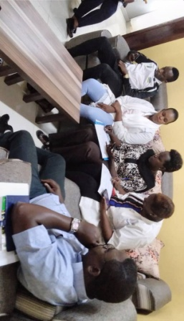

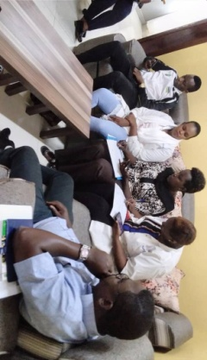

**Photo** 1: *The meeting at Nyagate HC with Heads of department was well conducted and was reminded their contribution to take care of KPs and involve them in different activities related to Covid-19 prevention*

After the meeting with the Heads of department, the following day on 29th November was the first day of training which took place from the 30th to 1st December 2022 at Moon Charity Hotel. This training grouped together 39 participants, made by 30 KPs, 2 healthcare providers, 6 staff members of ANSP+ which organized and supervised the training together with one trainer who facilitated the training.

The session to begin with, was the registration of the participants which was followed by self-introduction of every participant in the conference room. After registration, there was a speech done by ANSP+ representative NIZEYIMANA Jean Marie Vianney to address the audience an introductive annotations and expectations together with objectives of the training and also take time to highlight the main topics of the training. The Project Manager thanked all the participants for responding to the training invitations and closing his speech by inviting the local leader to address the audience the welcome speech.

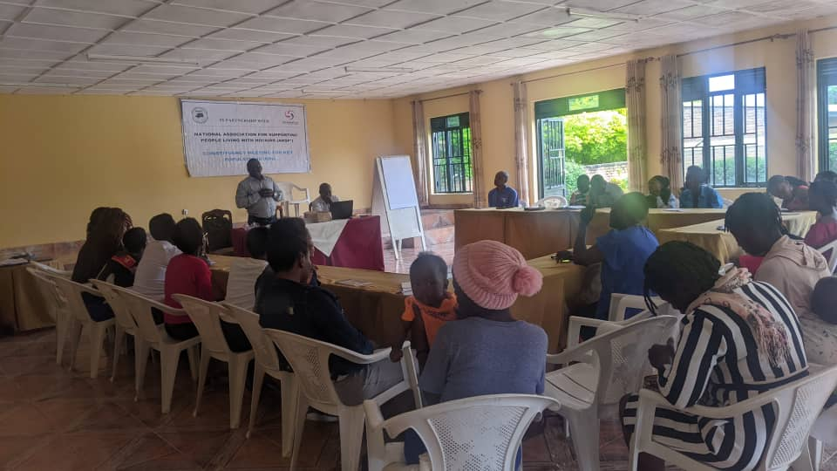 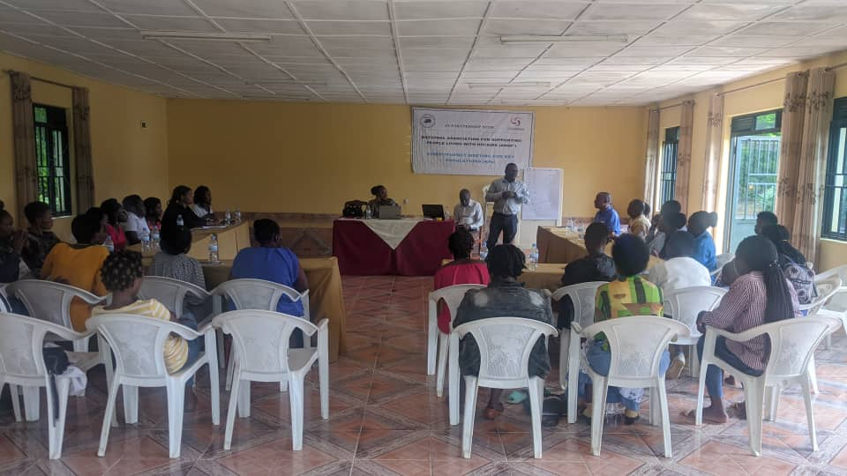

***Photo 2:*** *ANSP+ Director of administration and finance is addressing the audience the introductive annotations and expectations together with the objective of the training.*

A local leader in this training was NAKATO Agnes in charge of health and Nyagatare District. In her speech, this leader thanked too much ANSP+/SPIU for its consistent and significant activities to take care of KPs in Nyagatare district whereby through these activities KPs’ life in this district were greatly changed positively. She continued the speech by emphasizing how KPs’ skills and knowledge regarding HIV prevention, TB, Malaria and covid-19 were enhanced, and this helps them to minimize the rate of contamination from themselves and their clients. She ended her talk by asking the participants to follow the training and to be dynamic and participative and ask ANSP+/SPIU to continue in the same way and promise any support where it will be needed.

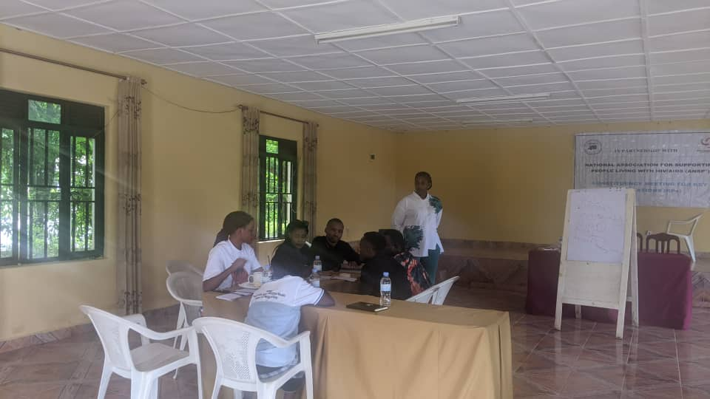Photo 3: *Local leader is addressing the audience the opening speech by appreciating ANSP+/SPIU for their big contribution in KPs well-being*

After all of these protocols including the speeches, the training facilitator started the training by giving them pre-test to the trainees. The purpose of the pre-test and post-test was to assess the participants’ knowledge before and after by doing a comparison of both tests, to see if after training there is an improvement related to the training expectations. This pre-test was composed by 4 questions.

* What is Outbreak, What is pandemic? Enumerate 3 outbreaks that do you know?
* What is the STI by definition? Enumerate 3 STIs that do you know
* Enumerate 5 symptoms that do you know
* What are preventives measures to be taken in order to fight against HIV/AIDS

She started asking to the audience what covid-19 is, its symptoms, how it spreads and ways to prevent from it. Different ideas from the audience were given. Some participants said that Covid-19 is a disease that is spread from breathing by a contaminated person. Some others added that Covid-19 is spread through touching each other. According to the participants, said that the symptoms of the disease are hard breathing, much fever, headache and others. After all of those answers given by the participants, a training facilitator has appreciated their answers and defined this disease as a highly contagious respiratory disease, caused by the Corona virus which is characterized mainly by fever and cough and is capable of progressing to severe symptoms and in some cases death especially in older people and those with underlying health conditions. It was originally identified in china in 2019 and became pandemic in 2020 and this virus infects both animals and people. Apart from the symptoms said above a trainer said that a person who is infected by covid-19 may experience a fatigue, General body pain nasal congestion and running nose, smell loss or taste etc.

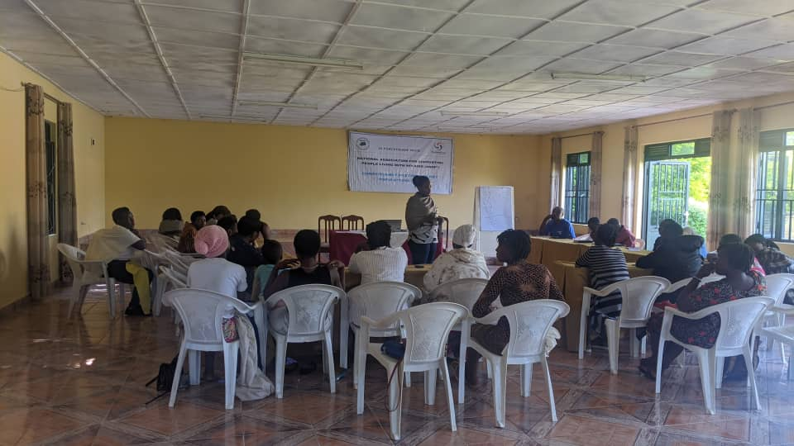 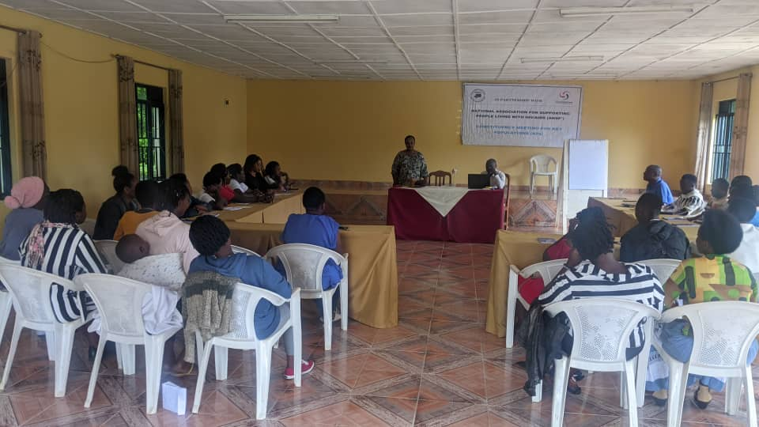

Photo 4: The training facilitator has given all the necessaries skills and knowledge to the training participants

After telling them what covid-19 is, mode of transmission and signs and symptoms, and people at high risks, he asked them if they know the methods of preventing Covid-19. Among the answers they have provided there are: Wearing mask covering nose and mouth, social distancing, properly hand washing and use of hand sanitizers. The training facilitator appreciated them for these answers and add that in additional to these preventive measures they listed, a fully vaccination is very crucial and meaningful to be sure that a person is well protected. After that, he asked the key populations how many of them who are vaccinated at least 4 vaccines. He has realized that among 30 KPs attending the meeting: 21 have received 4 doses, 4 have received 4 doses, and 1 of them received only 2 doses. This trainer appreciated those who received the required doses and ask those few ones who are not yet received at least 3 doses to go to the nearest health facility to be full vaccinated. He also asked 2 health providers attending the meeting the prevalence of covid-19 in their Heath center and replied that currently the rate of contaminated from corona virus is too low, but there are some who are still contaminated even though they don’t present the severe signs and symptoms related to covid-19. KPs were asked the measures taken to prevent themselves against the pandemic of Covid-19. To this question, participants replied that some of the measures undertaken to prevent against the spread of covid-19 include mobilization into the community to their peers for fully vaccination, hand washing to their clients (sex partners), use of face mask and many other measures helping in prevention of the pandemic.

The facilitator of the training asked KPs the consequences caused by the Covid-19. As they said, some of the problems caused by Covid-19 include poverty in families, the close of borders of Rwanda with the nearest countries, lack of housing fees (rent) and difficult transport. These problems were general to the whole population in general, but when it came to key populations, the case was more and more virulent.

The facilitator of the training asked for other diseases that might have the same symptoms as Covid-19. Participants listed the diseases likely to have similarities with covid-19. Those diseases include malaria, TB, flu and common cold. The training facilitator added that as covid-19 has the same symptoms as other respiratory diseases, the best way to know it is to be tested from it and respect the medical advises. He highlighted that once Covid-19 affect people with low immunity like People living with HIV/AIDS, elder peoples, peoples with chronic non-communicable diseases worsen and aggravates the symptoms and may cause a high morbidity and mortality to them.

As for the conclusion for the first day, the pandemic of covid-19 had many negative impacts to the whole community in general and particularly to key populations. Furthermore, the pandemic impacted to the rise up of HIV new infections in the community. This is because all peoples were in rock down, where by everyone was obliged to stay at home, no movements were allowed and key populations lack the clients coming from different areas. This caused KPs to make sex with their local neighbors without money or less just to get something to eat only. Also, the client might order the KP to make sex without condom and as there was no other alternative, he/she accepted to fear not to lack food. Consequently, HIV prevalence was scaled up among KPs but also among those who were not practicing sex selling before as the last solution to survive. All of those consequences experienced by KPs due to Covid-19 delayed the KPs social and financial development, whereby some of them sold their domestic animals, those who had small income activities have experienced a loss and they have asked advocacy to be reinstalled again.

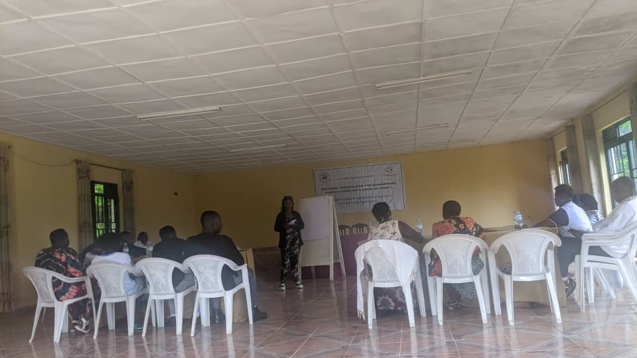 

***Photo5:*** *KPs have contributed of well conduction of the training*

The second day on the 1sr December was started by the recapitulation of day one and the topic to follow was HIV prevention. During this session KPs were reminded what HIV is, the different between HIV and AIDS, mode of transmission, predisposing factors to be contaminated with HIIV, AIDS Stages, and how to prevent HIV. Briefly, he said that you can’t separate HIV with KPs, and if you say KPs many people understand immediately HIV. This is because KPs are the main peoples who easily transmit and vehicle HIV/AIDS, and once they have this virus is very simple to transmit to the community trough non-protected sexual activities. He showed that in Rwanda, among 2 FSWs one of them is living with HIV, this means that HIV prevalence among FSWs is 45.8%, 4.1 % among Men who have sex with another men, while the prevalence among general population is 3%. He highlighted that adolescent girls and young women of age 20-24 are the ones who are at high risks to be contaminated with HIV, because the prevalence is 3.7% and is five times higher than in men of the same age. And prevalence among men is 2.2% while among women is 3.7 % and HIV incidence is 0.08% (according to 2018/2019 RPHIA). KPs have been mobilized to ARTs adherence and on consistent condom use in order to help themselves, their clients and the whole country. The trainer introduced TB and went to the COVID-19 with HIV, TB and malaria. He explained the risks to the people having these infections when they are combined with covid-19, saying that this condition will worsen their life with a high risk of mortality. Therefore, he called upon the beneficiaries to reinforce the preventive measures.

During this training, participants have time to be taught on Ebola epidemic disease as an outbreak occurred nearest Rwanda country. The facilitator outlined mode of transmission, predisposing factors to be contaminated with Ebola, signs and symptoms and how to prevent it. KPs were reminded that currently as Uganda border was opened, some of them may cross the borders from both countries for sexual activities or for any other business so that there would be the risks to be contaminated from Ebola. On this topic Phionah asked the healthcare providers if there are trained how to take care of a patient suffering from Ebola, they said that yes they are well trained and Ministry of Health elaborated a screening system from the people coming from Uganda and in Estern Province the transit center was located in Nyagatare, especially in Nyagatare Health center.

The two-day training ended on groups’ work which was about the contribution of KPs in Covid-19 prevention and HIV, TB and Malaria prevention. Here KPs mentioned their contributions. KPs were grouped into 3 groups to work on different topics.

**GROUP A:**

**Assignment:** As KPs try to outline the relationship and difference between HIV and Covid-19

**The relationship between HIV and Covid-19**

* Both are caused by the virus
* Both are contagious viruses
* Both are transmitted from the person to another
* Both affect human being
* Both affect immunological system
* Both are quickly transmitted
* Both are quick killers
* Both are preventable

**The difference between HIV and Covid-19**

* Covid-19 has a vaccine but HIV/AID doesn’t
* Covid-19 can be eliminated in the body but HIV can not
* Mode of transmission are totally different

**GROUP B**

**Assignment: what are the Contributions of KPs in covid-19 prevent**

* Respect all preventives measures as elaborated by Ministry of Health
* Respect all vaccination calendar at least 3 vaccines both clients and KPs themselves
* Cover the mouth and nose with clean mask
* Hand washing with soap and clean water in proper way
* Avoid unnecessary walk mainly in the public area
* Respect Social distancing
* Alert once you suspect a person to be contaminated with corona virus
* Reinforce the peer education system to our colleagues regardingcovid-19 prevention.
* Consult health center once you feel contaminated with Corona

**GROUP C**:

**Assignment: How can the KPs can help the government to prevent the epidemic disease**

* Teach our colleagues what we know about epidemic diseases
* Mobilize our colleagues the Negative effect and complications of epidemic diseases on the society mainly among KPs.
* Respect all preventives measures for epidemic diseases as elaborated by Ministry of Health
* Alert once you suspect a person to be contaminated with any epidemic diseases
* Provide a right and accurate information regarding epidemic diseases where necessary.
* Orient their mates at health center health center they suspect feel with

1. **TRAINING EXPECTED RESULTS**

At the end of this training, beneficiaries got much information on Covid-19, HIV, TB and Malaria, STIs and have been engaged in community mobilization as their contribution in fighting against these diseases. Additionally, the heads of departments of targeted health center took actions and committed to engage KPs in different health services delivered especially in Covid-19, HIV, TB and Malaria as it was the main topics of the field work.

1. **TRAINING CLOSING REMARKS AND RECOMMENDATIONS**

The closing remarks were done by Nyagatare Director of Health, and ANSP+ its-self. ANSP+ was thankful to all the participants’ participation and attention they showed during all along of the training, After ANSP+ closing remark was a time to Director of health to close the training. In her speech this health leader started her speech by appreciating everyone attending the training. She said” ***As you all know you are the representatives of your colleagues who are not here, I think everyone has beneficiated a lot regarding the training objective, I ask you to go and share this information to them so that they will be helping you to achieve at your mission of overcoming Covid-19 in your community****”*. She continued her speech by reminding them that they have to be participative in healthcare services, mainly in COVID-19 prevention, HIV, TB and Malaria, STIs, Ebola etc so that they will be helpful to their respective location. Generally, the District has appreciated too much ANSP+ and partner which is SPIU for their support to KPs all aiming at prevention of the epidemic diseases. She therefore, reminded them that even though the government of Rwanda used too many efforts to overcome Covid-19 trough different measures, but is still there, and any time can cause the problems as before. She took time to call upon all of the participants to use the skills they get from the training, in order to mobilize their colleagues who were not attending the training how to fight against covid-19 and other epidemics infection like Ebola etc. Finally, she guaranteed the district a continuous collaboration and support where it will be necessary.

**

*Photo 6: Nyagatare Health center Manager is addressing the audience the closing remarks.*

**VI. CONCLUSION**

Generally, as it was planned, this activity was successfully conducted and accomplished. From Kigali to Nyagatare and from Nyagatare to Kigali the journeys were safe, the meeting with Head of department was well conducted and objective were achieved, the training of 2 days at Moon charity Hotel was wonderfully conducted and objective were well achieved, all the participants were present in the training, no incident or any other unexpected incidents and everything was appreciable.

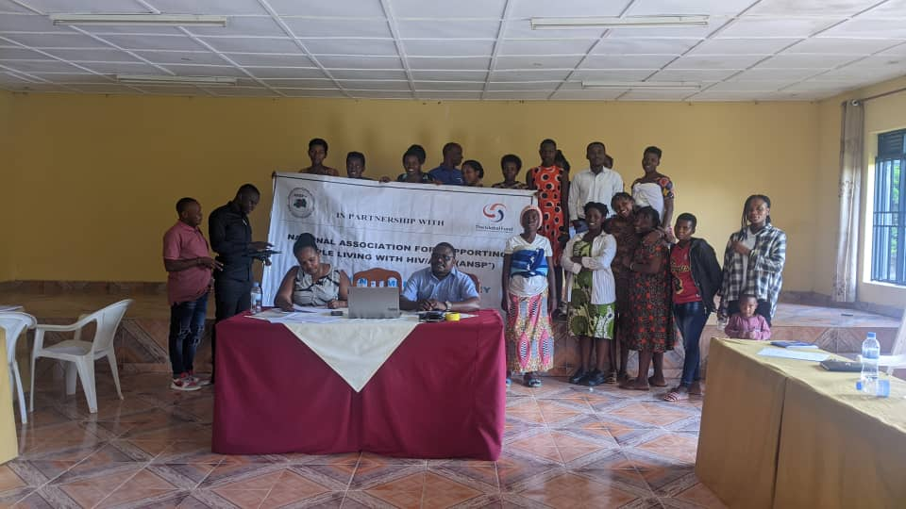

Photo 7: Memory picture of the training event.

Done at Kigali, the 3th December 2023

**STAFF MEMBERS IN MISSION**

NZIRINGIRIMANA Joseph

BUCYANAYANDI Aimable

UMUTONI WA MANA Laurence

MUKAYIRANGA Marceline

MUKASEKURU Deborah

NIZEYIMANA Jean Marie