**NATIONAL ASSOCIATION FOR SUPPORTING PEOPLE LIVING WITH HIV/AIDS**



***ANSP+ P.O BOX 3088 Kigali Rwanda, Tel. (250)0788761985/0788443140, e-mail: ansprwa1@yahoo.fr***

|  |  |
| --- | --- |
| **Institution** | **The National Association for Supporting People Living with HIV/AIDS ( ANSP+)** |
| **Reporting period** | **October - December 2022** |
| **Year** | **2022-2023** |
| **Project (Grant)** | **HIV/NSP** |

1. **INTRODUCTION**

ANSP+ stands for the National Association for Supporting People living with HIV/AIDS. It was created in 2000 by people living with HIV themselves for the main purpose of improving the quality of life of infected/affected people in Rwanda and fighting against its spread. Towards this mission, the main beneficiaries include Key Populations which run a high risk of getting and spreading HIV/AIDS.

Under the sponsorship of Global Fund through Rwanda Biomedical Center (RBC), ANSP+ organizes many activities every year that aim at sensitizing KPs to fight against HIV/AIDS, TB, Malaria and other diseases. Within this context, ANSP+ conducted 4 activities during the second quarter of activities implementation. Activities were conducted in Kigali City, Musanze and Nyagatare districts.

* **OBJECTIVE OF THE PROJECT**

The objectives of this project are set as follows:

* To Reduce New HIV Infection
* To supervise the quality of service delivery to Key population at Health Facilities
* To reduce HIV incidence, reduced HIV related mortality, morbidity among Key populations
* To fight stigma and discrimination so that Key populations should have same opportunities as the general population
* To distribute preventive items
* **DESCRIPTION OF THE PROJECT ACTIVITIES**

1. Supervision to assess the situation at Muhoza health center about reduced HIV incidence, reduced HIV-related mortality and morbidity and people infected and affected by HIV have the same opportunities as the general population
2. Training for capacity building of ANSP+ constituencies (members) to increase their engagement in community mobilization and advocacy during covid-19 in Kigali City
3. Training for capacity building of ANSP+ constituencies (members) to increase their engagement in community mobilization and advocacy during covid-19 in Nyagatare district
4. Training for capacity building of ANSP+ constituencies (members) to increase their engagement in community mobilization and advocacy during covid-19 in Musanze district
5. **SUMMARY OF ACCOMPLISHMENT**
6. Supervision to assess the situation at Muhoza health center about reduced HIV incidence, reduced HIV-related mortality and morbidity and people infected and affected by HIV have the same opportunities as the general population.

This activity was conducted on the 4th November 2022 in Musanze district and gathered 14 participants made by 10 key populations, 2 healthcare providers and 2 staff members of ANSP+. The objectives of this activity were set as follows:

* To assess the situation about reduced HIV incidence, reduced HIV related morbidity and mortality and people infected and affected by HIV have the same opportunities as the general populations.
* To raise awareness of KPs on HIV, TB, Malaria prevention
* To distribute condoms to KPs

This meeting has been started by self introduction and followed by a welcome speech by the head of Muhoza health center. He welcomed ANSP+ delegation and KPs representatives and took that opportunity to thank the project partners for their unconditional support. He said that in the previous years, this group of people (KPs) was somehow forgotten yet they are key to HIV prevention. He wished a good meeting to participants, asking KPs to be attentive and gave the speech to ANSP+.

The representative of ANSP+ thanked the leadership of Muhoza HC that facilitates the implementation of different project activities by availing the meeting room, facilitating the training etc. He continued on thanking KPs representatives for their support in HIV prevention as peer educators to their peers and community.

He introduced the subject of HIV prevention; STIs and HIV service accessibility to KPs and let the discussion to all participants for the meeting was interactive. The participants reminded each other the preventive measures of HIV such as condom use, circumcision, PrEp, PeP, avoiding sharp objects etc and talked about the HIV service accessibility at Muhoza health center.

KPs testified that things are going on well, whereby they appreciate the positive change at health center after different trainings organized by ANSP+ through different partners. They said they are friendly received at health center mostly when it is about the issue of ARV drugs. They added that they enjoyed the service when they meet the nurses who have been trained by ANSP+ on friendly service delivery to KPs.

According to the topic of reduced HIV incidence, mortality and morbidity situation, the head of Muhoza health center said that the problem still a concern whereby new cases of HIV are found in young generation. Regarding mortality and morbidity, the situation is still stable no abnormal cases. He added that NGOs contributed much to the well being of KPs through advocacy and trainings to healthcare providers and KPs and now KPs are well treated and motivated to compliance although it is not the same for all health facilities

The participants talked a bit about TB which is mostly found among HIV positive people, mentioning preventive measures and sensitizing KPs to fight against it. Malaria issue has been evoked by participants for this disease kills a lot of people worldwide. KPs have been mobilized to prevent from it, while sleeping under mosquito nets every night, using mosquito repellents, cutting bushes near their home, avoiding stagnant water, early closing doors and windows etc.

The meeting was concluded with the commitment of each participant in fighting against HIV/AIDS, TB, Malaria, auto stigma and discrimination. The contribution of each participant was described and everyone promised to do his/her best in HIV/AIDS and other diseases prevention.

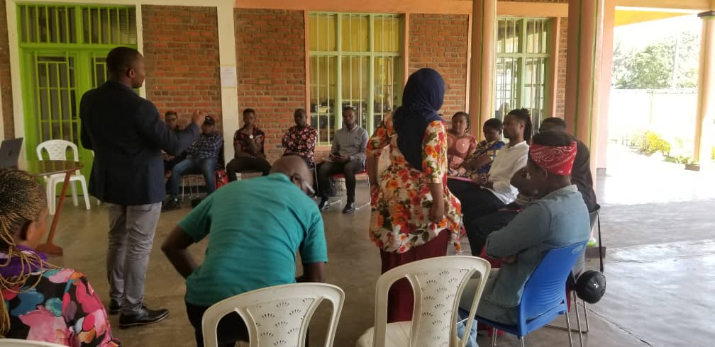 ***The head of Muhoza Health center explaining how KPs get services like other population***

1. **Trainings for Covid-19 mitigation**
   1. **Training for capacity building of ANSP+ constituencies (members) to increase their engagement in community mobilization and advocacy during covid-19 in Kigali City**

This activity took place from the 16th to 18th November 2022. The first day on the 16th, 6 Staff members of ANSP+ Visited 3 health centers working with in order to have information about the accessibility of health services to KPs towards Covid-19 and other diseases and how KPs are engaged in prevention measures. The meeting joined together 6 staff members of ANSP+, 6 staff of Biryogo health center, 6 staff from Kagugu and 6 of Rwampara health center, heading 6 departments in each HC. These departments were selected based on the services mostly sought by KPs. There was the staff in charge of Consultation, ARV, TB, Vaccination, Community and Environmental health Officer (CEHO), PMTCT and the heads of mentioned health centers.

After the welcome speech by the heads of targeted health centers, ANSP+ introduced the objective of the visit while explaining the relationship between KPs and HIV/AIDS, TB, Covid-19, Ebola and malaria. ANSP+ representative said that KPs stay vulnerable to these diseases because of their conditions of life and behaviors of meeting different partners from different areas. Furthermore; he was asking them special assistance to KPs so that they can give their contribution to these diseases prevention and treatment in order to save the whole community.

The healthcare providers responded that Key Population got information about covid-19 prevention and have been vaccinated as general populations ,but the health center still need ANSP+ and peer educators to mobilize the remaining Key Populations who did not take vaccine to come and get it for health centers cannot recognize all KPs.

Concerning Ebola issue, they said that nurses were trained about it, how to prevent and how to intervene in case of a positive case. They continued on saying that they are always available at health center to handle all patients’ issues. They added that some Key Populations still have auto stigma, which prevent them to go to the health facility to look for the services.

The heads of the health centers said that the strategies of Covid-19 prevention are still put into consideration by asking all people who come at health center to wash their hands ,to make at least one meter distance between people and to be fully vaccinated. They concluded on thanking ANSP+, RBC and Global Fund for their continuous support.

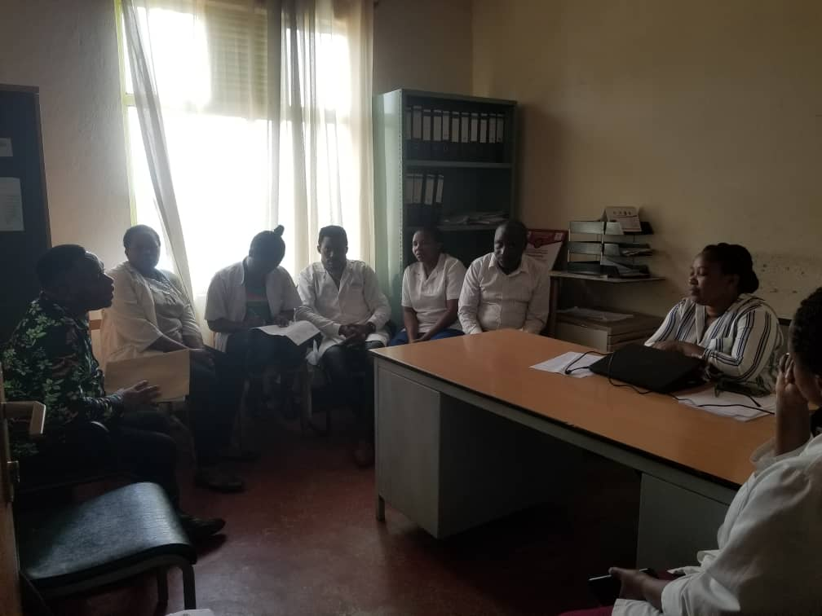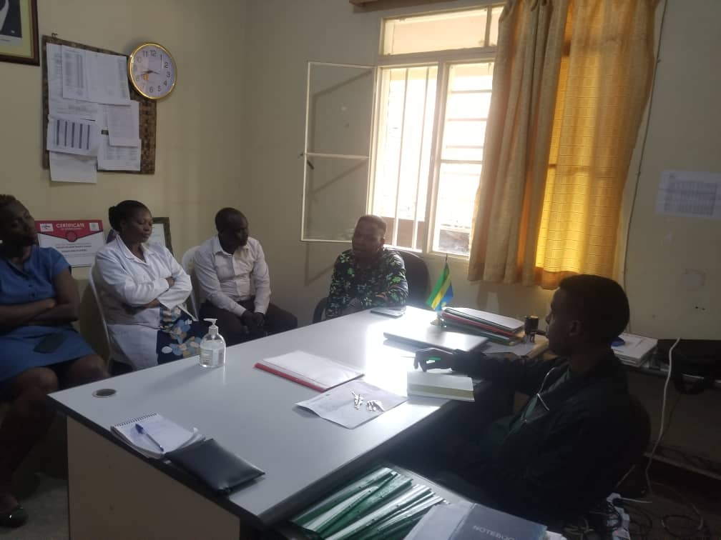

***ANSP+ staff members at Biryogo and Rwampara HC***

The last two days on the 17th and 18th November 2022 were dedicated to the training for capacity building of ANSP+ constituencies members to increase their engagement in community mobilization and advocacy during Covid-19. This training took place at Five to Five hotel with 42 participants made by 30 KPs, 1 facilitator, 5 healthcare providers and 6 staff of ANSP+.

The representative of ANSP+ welcomed all participants, asking them to follow the training and to feel free to ask questions if they don’t get well the information, for they will take the time to share information and knowledge to their peers. After his speech, he invited the training facilitator to deliver the training.

The training facilitator Mukeshimana Valentine (head of Rwampara HC) started by talking about Covid-19 , definition ,symptoms, People at high risks, mode of transmission and preventive measures. She said that COVID-19 is a serious global infectious disease outbreak with nearly 4.5% deaths worldwide. It is part of a family of viruses called corona viruses that infect both animals and people. This particular one originated in China at the end of 2019, in the city of Wuhan.

**The Symptoms of Covid-19:** Covid-19Symptoms are very similar to the flu – fever and a dry cough [(the two most common symptoms)](https://www.cdc.gov/coronavirus/2019-ncov/about/share-facts.html), fatigue, aches and pains, and nasal congestion. As the pandemic was spread around the world, other symptoms such as a loss of sense of smell or taste have emerged. Severe cases can lead to serious respiratory disease, and even pneumonia.

**People at high risks**

Those most at risk are the elderly, or people with underlying medical issues, such as heart problems or diabetes. According to the most recent global numbers, [14.8%](https://www.who.int/docs/default-source/coronaviruse/who-china-joint-mission-on-covid-19-final-report.pdf) of people over 80 years old, infected with the virus, have died from it, compared with 0.4% in people aged 40-49%

**Mode of transmission**

The evidence so far indicates that the virus is spread from person to person through small respiratory droplets. When a person coughs or sneezes, these droplets can also land on nearby surfaces. There is also evidence that the COVID-19 virus can [last on surfaces](https://www.gavi.org/vaccineswork/what-not-touch-how-avoid-contact-new-coronavirus) – especially plastic or metal.

**Preventive methods**

Wearing masks, social distance, hands washing using soap or sanitizer and Vaccination. The training facilitator continued on HIV prevention starting by its definition.

**II. What is HIV?**

* HIV is a virus that attacks the body’s immune system. If HIV is not treated, it can lead to [AIDS](https://www.cdc.gov/hiv/basics/livingwithhiv/opportunisticinfections.html)
* There is currently no effective cure. Once people get HIV, they have it for life.
* But with proper medical care, HIV can be controlled. People with HIV who get [effective HIV treatment](https://www.cdc.gov/hiv/basics/livingwithhiv/treatment.html) can live long, healthy lives and protect their partners. After the definition she went on prevention measures reminding KPs their role in this battle of fighting HIV. She mentioned the consistent condom use, male circumcision, PrEp and PeP etc.

The trainer chained on **TB** where she defined it as **a potentially serious infectious disease that mainly affects the lungs** but can also affect other parts of the body. The bacteria that cause tuberculosis (**Mycobacterium tuberculosis)** are spread from person to person through tiny droplets released into the air via coughs and sneezes.

**Symptoms:**

A persistent cough lasting at least 3 weeks, hemoptysis, a loss of appetite and weight, a general feeling of [fatigue](https://www.medicalnewstoday.com/articles/248002.php) and being unwell, swelling in the neck, a [fever](https://www.medicalnewstoday.com/articles/168266.php), night sweats, chest pain and soon.

**Risk factors**

People with weakened immune systems including HIV positive people are most likely to develop active TB.

**COVID 19 and TB**

In connection with the COVID-19 pandemic, wariness about tuberculosis should stay high. Less people are consulting health care providers for TB symptoms because at the beginning, COVID-19 and TB can be quite similar. First symptoms include cough, fever, chills, weakness and malaise. These symptoms are common for COVID-19 and TB. Therefore, tuberculosis may be a risk factor for disease progression. In conclusion, people with tuberculosis are not more likely to get COVID‐19, but pre‐existing tuberculosis has a higher danger of developing serious complications from COVID‐19.

**COVID 19 and Malaria**

The COVID-19 pandemic and its collateral damage severely impact health systems globally and risk to worsen the malaria situation in endemic countries. Malaria is a leading cause of morbidity and mortality and when it is mixed with Covid-19, the patient cannot resist.

The training facilitator concluded the training on **EBOLA**, its symptoms,how it is transmitted, how to prevent from it and soon. She said although there is any case found in Rwanda, it is a responsibility of everyone to fight against it, mostly KPs who travel much and who meet different partners from different countries.

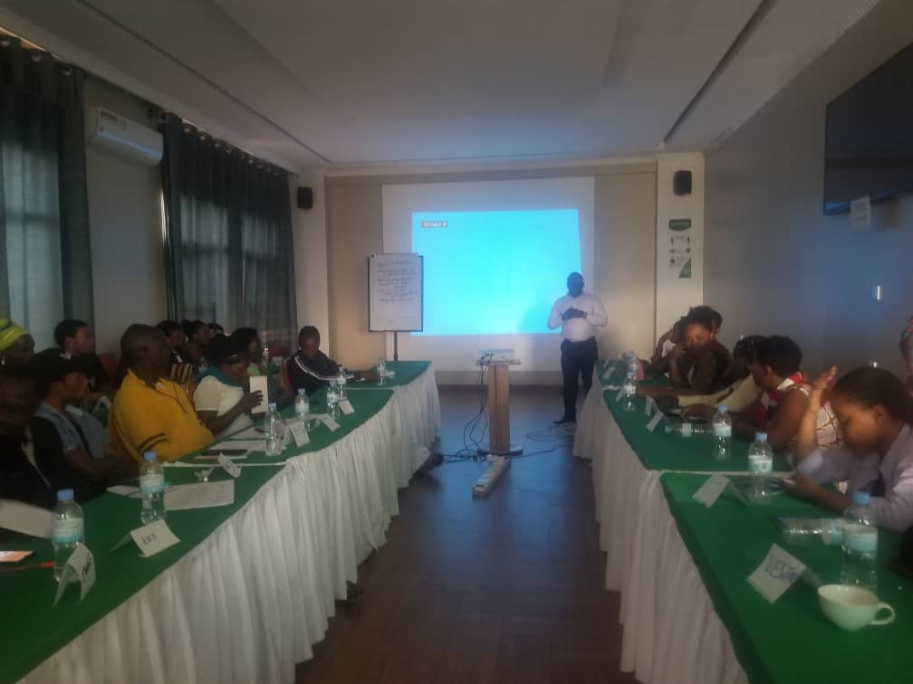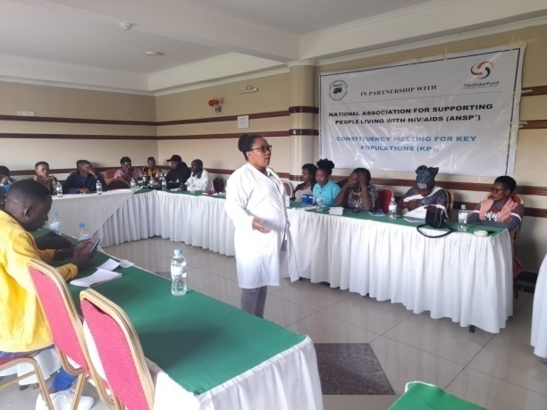

***The representative of ANSP+ introducing the training and the training facilitator delivering the training***

**2.2. Training for capacity building of ANSP+ constituencies (members) to increase their engagement in community mobilization and advocacy during covid-19 in Nyagatare district**

Different from this activity in Kigali, the first day of the work on the 29th November 2022 was for the departure of ANSP+ staff members from Kigali to Nyagatare district and preparations of the next day activities. On the second day, on the 30th November, the team had discussions with the heads of departments at Nyagatare health facility.

The main purpose of this meeting was to know if currently there is any specific message or other activities to key populations about Covid-19. Healthcare providers replied that the message about Covid-19 is still being given to the whole population in general and to KPs too for Covid-19 is still there, even if it has considerably reduced due to the strong measures taken by the government of Rwanda including vaccination and other preventive measures. Though the pandemic has reduced, health facilities are still observing positive cases. Therefore, there is a need to continue teaching key populations and the whole populations in general about preventive measures.

**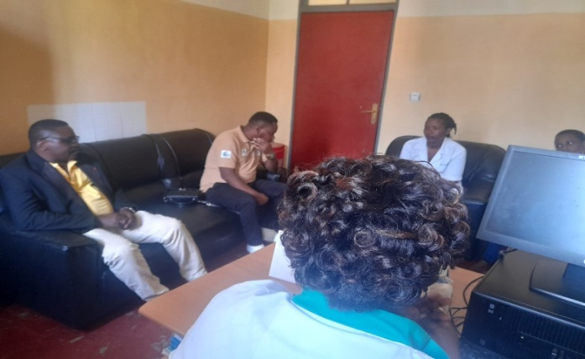 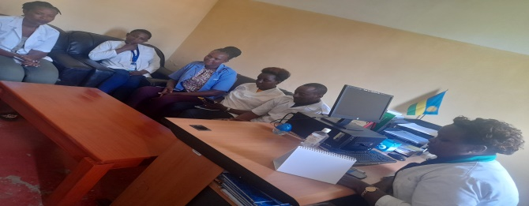  *ANSP+ staff members with heads of departments of Nyagatare health facility***

The third and fourth days of the work on the 1st and the 2nd December 2022 were dedicated to the training of key populations about Covid-19, HIV/AIDS, TB, Malaria and Ebola .Being facilitated by the head of Nyagatare health facility, the training was hosted at Moon’s charity hotel and participants were 30 key populations, 2 healthcare providers and the team from ANSP+ of 6 staff.

On the first December (third day), the training was about Covid-19.The facilitator of the training explained that the virus started in China in the city of Wuhan at the end of 2019. The interactive method was used during the training. The facilitator asked the participants the symptoms of Covid-19. Participants replied that the symptoms of Covid-19 include fever and dry cough, fatigue, aches and pains and nasal congestion. The facilitator further explained that the Covid-19 virus mostly attacks elderly and underlying medical issues people.

The mode of transmission of Covid-19 has been talked about and the preventive measures have been listed. The facilitator explained the relationship between Covid-19 and other epidemic diseases saying that they all cause major global health threat. As a result to health services, there were poor health outcomes and deaths from other conditions due to delay in seeking basic and preventive health services.

As for economic and social impact of Covid-19, the trainer said that regulations implemented by the government banned businesses, school and churches, closure and limitations of intra and international transport that made the country economic growth slowing down. For key populations, the Covid-19 affected them much for most of them do not have other alternative jobs.

The last day on the 2nd Dec 2022, the trainer focused on HIV, TB, Malaria, Ebola and their ways of transmission and prevention. The last session of the day was Ebola. The facilitator said that Ebola is a severe and often deadly disease caused by a virus. Ebola can occur in humans and other primates (gorillas, monkeys, and chimpanzees).

**The Preventive methods for Ebola** include case management, surveillance and contact tracing, a good laboratory service, safe burials and social mobilization. Community engagement is a key to successfully controlling outbreaks. Raising awareness of risk factors for Ebola infection and protective measures (including vaccination) that individuals can take is an effective way to reduce human transmission.

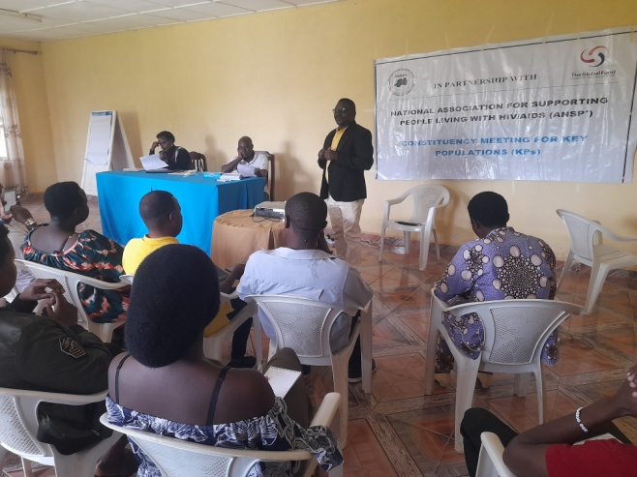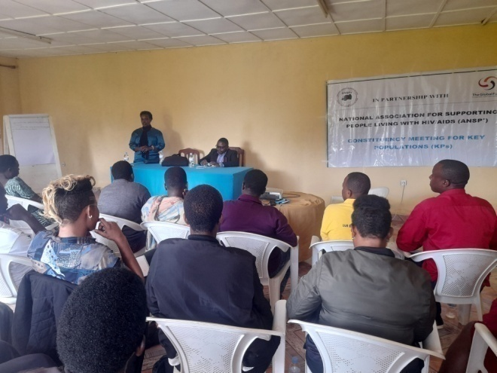

***Training introduction by ANSP+ and the head of Nyagatare HC facilitating the training***

**2.3. Training for capacity building of ANSP+ constituencies (members) to increase their engagement in community mobilization and advocacy during covid-19 in Musanze district**

This activity was conducted from the 6th to 9th December 2022. The same as in Nyagatare district, the first day of the field work on 6th December 2022 was dedicated to the departure of ANSP+ staff members from Kigali to Musanze district. The second day on the 7thDecember 2022 the team of ANSP+ went to Muhoza health center to meet the heads of departments. After introducing the meeting objectives by ANSP+, discussions about how KPs are engaged in community mobilization and advocacy during Covid-19 was evoked. Healthcare providers replied that currently KPs are well received at health center and some of them are engaged in Covid-19 response where they mobilize their peers to come to the health facility to get vaccinated. The meeting concluded on agreeing on continuous mobilization.

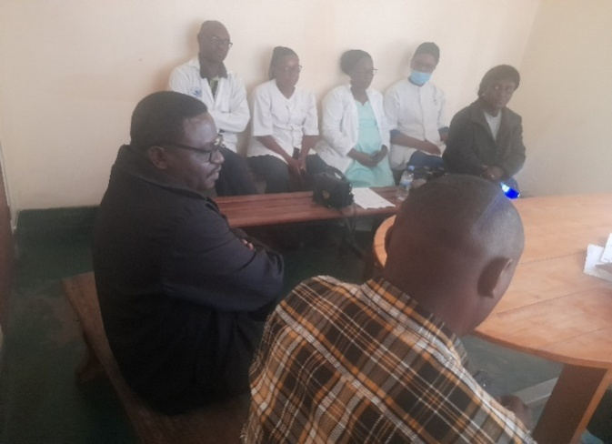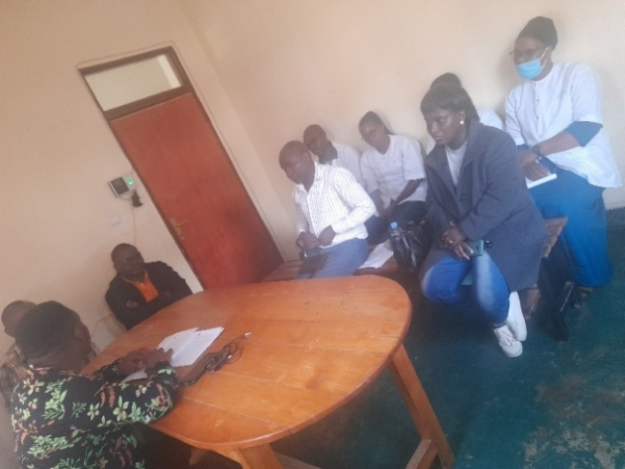

***The meeting at Muhoza HC with Heads of departments***

The following two days were about the training to ANSP+ constituencies about Covid-19, HIV, TB, Malaria and Ebola diseases.

As other training facilitators of Kigali and Nyagatare, the trainer in Musanze district defined Covid-19 as a highly contagious respiratory disease, caused by the Corona virus which is characterized mainly by fever and cough and it is capable of progressing to severe symptoms and in some cases death, especially in old people and those with underlying health conditions. It was originally identified in china in 2019 and became the worldwide pandemic in 2020.

The facilitator was interacting with the trainees and sometimes asked them some questions to facilitate the understanding of trainees. He asked KPs the consequences caused by the Covid-19 and they mentioned poverty in families, depression, loss of jobs etc. He listed the measures of prevention emphasizing on vaccination as the main solution to this disease.

The training facilitator continued on HIV prevention defining HIV, the difference between HIV and AIDS, mode of transmission, predisposing factors to be contaminated, AIDS Stages, and how to prevent from it. Briefly, he said that you can’t separate HIV with KPs for it is easy for them to get it and/or to spread it through different partners when they are not protected.

The training continued on TB, Malaria and talked about Ebola as a disease which can kill a lot of people when no serious preventive measures put in place. He said it is not yet found in Rwanda, but as it is in our neibours in Uganda, it is very easy to find it in our country. He mobilized KPs to play their role in fighting against all these diseases, in the purpose of saving their lives and the lives of their clients and the whole community.

The two-day training ended on groups’ work, emphasizing on KPs contribution in different diseases prevention in general, but especially in Covid-19 and those diseases mentioned above. Here KPs listed their contributions and committed to do their best in community mobilization so that they can minimize the risks to themselves and the whole community.

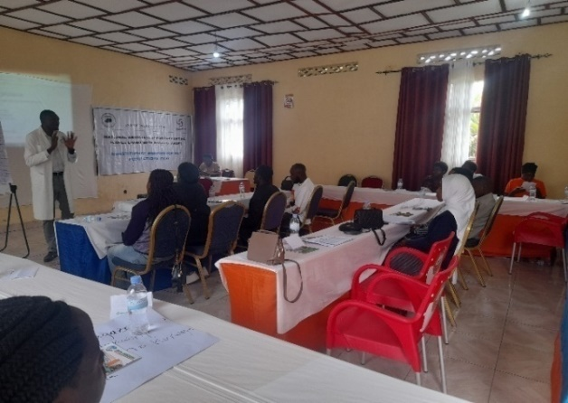 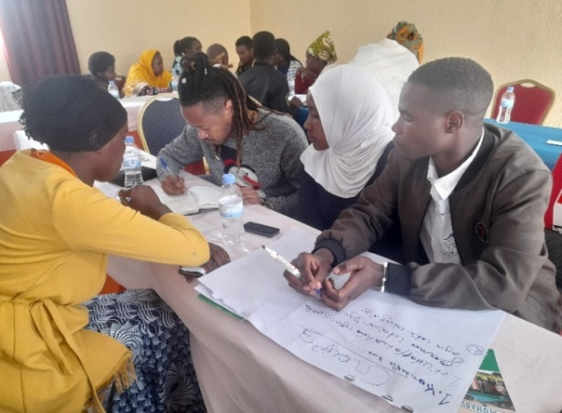

***The training facilitator facilitating the training and trainees in groups work***

1. **PROJECT ACTIVITIES and RESULT/OUTPUTS**
2. Supervision to assess the situation at Muhoza health center about reduced HIV incidence reduced HIV -related morbidity and mortality and people infected and affected by HIV have the same opportunities as the general population.

**When:** This field visit took place from the 3rd to the 4th November 2022.

**Where:** It has been conducted in Musanze district at Muhoza health center.

**Results/Outputs:**

A meeting was conducted with 14 participants made by 10 key populations, 2 healthcare providers and 2 staff members of ANSP+. The following was done:

* Assessment of the situation about reduced HIV incidence, reduced HIV related morbidity and mortality and people infected and affected by HIV have the same opportunities as the general populations;
* Raising awareness of KPs on HIV, TB, Malaria prevention;
* Distributing 3,900 condoms to KPs and these ones were mobilized on consistent condom use.

**Challenges:** No challenges met

1. **Training for capacity building of ANSP+ constituencies (members) to increase their engagement in community mobilization and advocacy during covid-19**

**When:** The first field work took place from the 16th to 18th November 2022, the second from the 29th November to the 2nd December 2022 and the last happened on the 6th to the 9th December 2022.

**Where:** In Kigali City, in Nyagatare and in Musanze districts

**Result/Outputs:**

90 Key populations were on their role and contribution in Covid-19, HIV, TB, Malaria and Ebola prevention and committed their engagement in community mobilization. 5 health centers were visited, assessment on how KPs are being engaged in Covid-19 mitigation was done and actions for improvement were taken. Additionally, the heads of departments of targeted health centers committed to continue engaging KPs in different health services delivered at health center as other alternative to the mentioned diseases prevention. The more KPs populations feel engaged and involved, the more they feel motivated.

1. **Budget execution**

|  |  |  |  |  |  |  |  |
| --- | --- | --- | --- | --- | --- | --- | --- |
| **Periodical budget** | | | | | | | **Comments** |
| **Activity name** | **Total Budget Planned FY October to December 2022 (in detailed OP) (a)** | **Achievement for this quarter** | | | **Cumulative budget utilized (d)** | **General Variance (a)-(d)** |
| **Quarterly Planned Budget (b)** | **Quarterly Budget Spent (c)** | **Quarterly variance (b)-(c)** |
| Human resources | 29,086,340 | 7,271,585 | 13,197,162 | (5,931,577) | 13,197,162 | 15,889,178 | Funds of Quarter was not received during the quarter |
| Running costs | 14,510,024 | 3,627,506 | 7,206,520 | (3,579,014) | 7,303,504 | 14,510,024 | Funds of Quarter was not received during the quarter |
| Covid-19 impact mitigation | 23,862,858 | 11,931,429 | 11,860,672 | 11,931,429 | 12,002,186 | 23,862,858 | Funds of Quarter was not received during the quarter |

**VII. Conclusion.**

ANSP+ is thankful to Global Fund and RBC for their support contributes much in KPs well being and behavior change. This makes a significant contribution to HIV prevention and treatment and other diseases prevention such as Covid-19, TB, Malaria and so on.

**VIII. Recommendations and Responsible Institutions**

1. **Recommendations to ANSP+**

* Continuous training to other KPs and healthcare providers so that the knowledge and information can reach many more others.

*Advocating for condoms and lubricants availability for sometimes condoms are insufficient and lubricants are no longer available

1. **Recommendation to KPs**

* KPs are recommended to continue protecting themselves, clients and the whole community and sharing the knowledge and information with other KPs in their associations /Cooperatives

1. **Recommendations to RBC**

* To avail Lubricants

* To avail Condoms

**Done at Kigali, the 10/01/2023.**

**Coordinator of ANSP+,**

**MUKASEKURU Deborah**