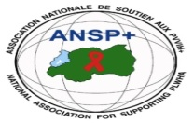[](http://scottfiller.info/)

**PROJECT NAME: ANSP+/RBC/SPIU**

**NAME OF ORGANIZATION: NATIONAL ASSOCIATION FOR SUPPORTING PEOPLELIVING WITH HIV/AIDS (ANSP+)**

**ACTIVITY: CONDUCTING SUPERVISIONS OF ACTIVITIES OF KEY POPULATIONS (LGBTIs/MSM and/or FEMALE SEX WORKERS**

**AREA OF INTERVENTION: RUBAVU DISTRICT**

**FIELD WORK REPORT**

**I.INTRODUCTION**

ANSP+ stands as a National Association for Supporting People living with HIV/AIDS. It is a Rwandan local Non-Governmental Organization created in September 2000 by People Living with HIV themselves, with the leading mission of striving for the quality of life of HIV infected /affected people in Rwanda and fighting against the spread of HIV/AIDS and other epidemics. Not only ANSP+works in the domain of HIV, but also serves in the domain of poverty reduction and human rights. Towards this mission, our core beneficiaries include Key Populations which most of them live in poverty that, in a way or another leads them into sex working and therefore running a risk of getting HIV.

Apart from mobilizing key populations about drug compliance and preventive techniques, the ANSP+ also initiates key populations on profitable activities. Through cooperatives and associations, the national association for supporting people living with HIV has been supporting key populations in how to make profitable activities that would help them going away from sex working and therefore making money leading to their welfare.

Working in this framework, ANSP+ under the sponsorship by Global Fund /RBC has organized a four days supervision to its constituencies to see how well they are getting engaged in income generating activities so as to learn about their achievements and challenges and therefore advising them accordingly. The field work was organized in Rubavu district specifically in Gisenyi, Nyamyumba,Rubavu and Rugerero sectors from the 5 December up to the 8 Dec 2023.The supervising team from ANSP+ was made by six personnel/volunteers to gether with incharge of social affairs in the above mentioned sectors.The objectives of the work wasto discuss with the KP cooperatives/associations members on the income generating activities being carried out,o discuss with local leaders about income generating activities by key populations, to visit the activities of KPs at the groundto evaluate the opportunities, challenges being faced along with the implementations of their activities,to advise KP cooperatives/association members on how to continue working with their cooperatives/associations.

1. **ACHIEVEMENTS OF THE FIELD WORK**

As it was mentioned in the introduction above, the field work was organized to take place in Gisenyi, Nyamyuma, Rugerero and Rubavu sectors of Rubavu district. These sectors were chosen because they have more sex workers members of the cooperative KOAGUGI grouping sex workers in Rubavu district.

On the first day on the 5 Dec 2023, the team of ANSP+ together with the representative of sex workers in Rubavu district met with the personnel in charge of social affairs in GisenyiSector.In his office, the social affairs gave a warm welcome to the visitors . After a short introduction, the Director of administration and Finance within ANSP+ Mr .NIZEYIMANA Jean Marie Vianney briefly explained what ANSP+ is and what it is doing to key populations in Rubavu district and countywide.

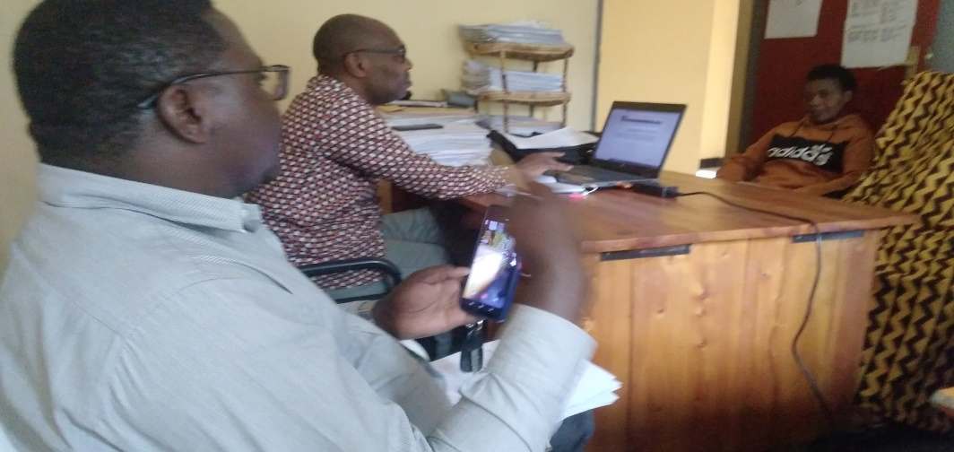

Photo: The team of ANSP+ conversing with the incharge of social affairs in Rubavu sector

After the short conversation , the team of ANSP+in accompaniment of the personnel from the sector set off to the office of the cooperative KOAGUGI in Mbugangari cell. At place, the team was very well welcomed .In her speech, the president of the cooperative thanked the ANSP+ for the visit and the district of Rubavu who tirelessly assisted them even during difficult periods of covid 19.

The president of the cooperative introduced the members of her cooperatives and after gave some historical features of KOAGUGI cooperative.As she mentioned, the cooperative is made up by 30 members, among them 29 women and only one man.The members of the cooperative come from different corners of Rubavu district such as Gisenyi, Nyamyumba,Kanama,Nyundo,Rugerero Rubavu and Nyakiriba sectors of Rubavu district.The president of KOAGUGI cooperative said that the cooperative has a full committee of the president, vis president, Secretary and treasuryand two advisors. The cooperative started with many problems of poverty of its members and it was assisted by the district of Rubacu and the organization called Ihorere munyarwanda that facilitated them to pay the loan of the house where the cooprative was working from.The cooperative KOAGUGI works on handcraft and tailoring .It started with 10 tailoring machines and today thecooperative owns 20 tailoring machines but all of them got from donors. Some of the good initiatives and realizations of the cooperative are that it taught tailoring to 180 children issuing from families of sex workers and it also helped old people members of the cooperative to find the capital to start small busineses. Some of the challenges raised include ones related to covid 19 that halted their business. Another challenge faced by the cooperative is that children issuing from families of sex workers are mentally affected because of the bad job of sex working by their parents.Today, the cooperative is renting two rooms; one is where the cooperative members work from with their 10 machines while another room is where other 10 remaining machines being rent to other people are and cost for renting one machine is 4000 RWF per month. It is from this amount of money from renting machines plus other ressources that the cooperative can pay the rent for two rooms which, the cost for one is 50,000 rwf.As the so called cooperative has no legal status, the members wished that the sector would assist them to find legal personality.The president Of KOAGUGI cooperative said that the coopearative have got 46 associations in Rubavu district and she wished that both ANSP+ together with other stakeholders and the district would assist them so that the menbers of these associations find other things to do rather than relying on working sex.

The speech by the president of the cooperative was followed by the annotations of the Director of Administration and Finance within ANSP+.This personality thanked the district of Rubavu for not going far from key population in this district.He also thanked the members of KOAGUGi cooperative for good realizations and initiatives that, in a way or another contribute to the reductions of new infections of HIV and this in a way to reaching the UNAIDS odf eradicating HIV within 2030.The DAF of ANSP+ advised the members of KOAGUGI to be legally known because it is the only way to benefit from assistance of government.

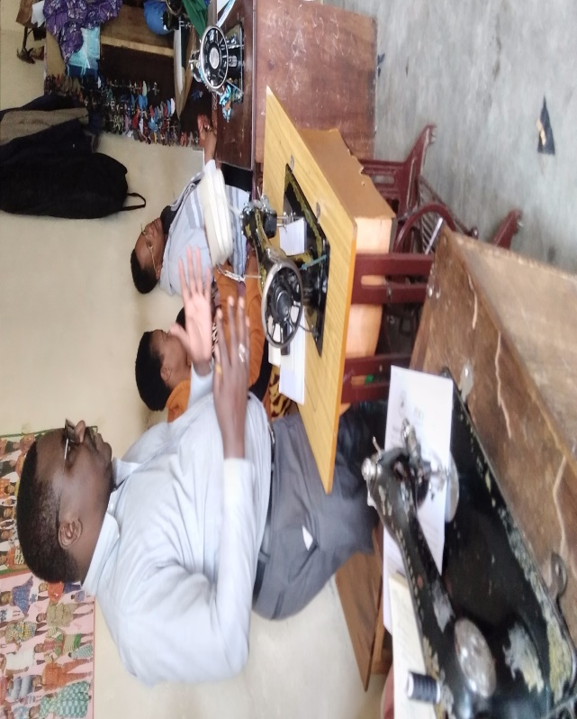

Photo: The speech by DAF of ANSP+

During his concluding remarks, the personnel in charge of social affairs in Gisenyi sector said that time has gone where people have to wait for assistance from the government and partners. We need people willingly to work. The official said. He therefore called the members of KOAGUGI to maintain what they have earned either from the government or from different partners.The official concluded by thanking ANSP+ for its contribution in the fight against HIV and poverty among key populations in Rubavu district in General and in Gisenyi sector in Particular.

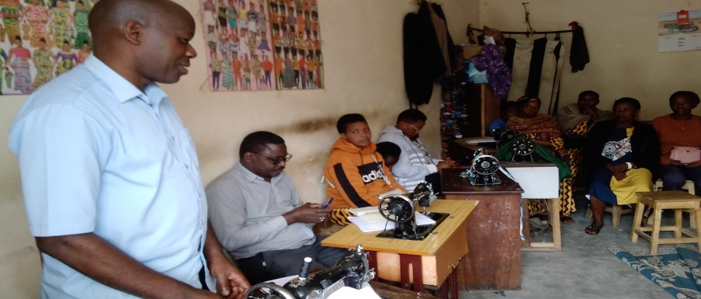

Photo: The speech by the social affairs in Gisenyi sector

The second day of the work was carried out in Nyamyumba sector. It was on the 6th Dec 2023.Here, the team of ANSP+ together with the representative of key populations went to the sector office to see the sector leaders and share with them about this activity.At the sector office, the team could find the personnel in charge of good governance.Like in Gisenyi sector , the team introduced itself and its leader was given time to explain what ANSP+ is and what was the purpose of the field work in Rubavu district as stated in the terms of reference.

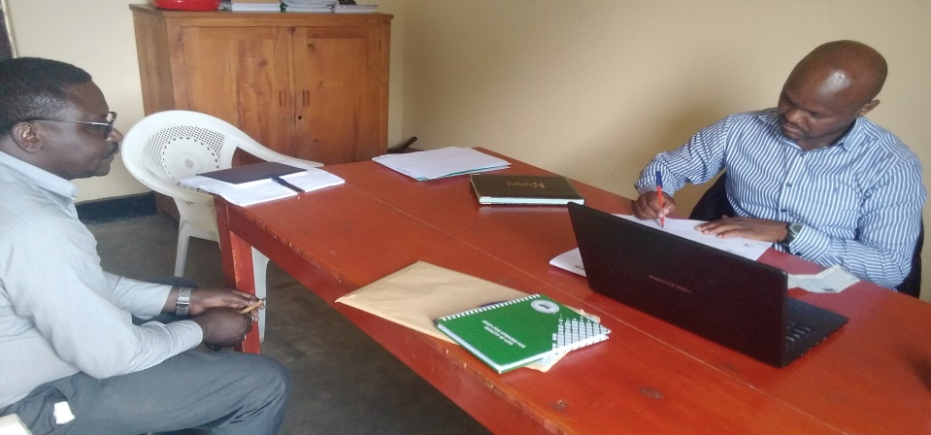

Photo: The DAF of ANSP+speaking out to the in charge of good governance in Nyamyumba sector

The personnel in charge of Good governance in Nyamyumba sector thanked the administration of ANSP+ and its partners for their contributions in eradicating HIV and poverty among key populations in this sector.

The visit at Nyamyumba sector office was followed by the the visit to Rubona Cell where we met with members of 5 associations of sex workers in this cell.Participants introduced themselves and then after the coordinator of sex workers in this cell explained how they work and challenges being faced.As she mentioned, the members of the associations meet every week and collect their savings . The money collected is taken to the bank and after a year the money is withdrawn from the bank and paid back to the members with interest got from the members that took a loan with a small interest.

Apart from sex working , the members of associations of key populations in Nyamyumba sector work on selling small fishes, banana and other small activities. Some of the challenges raised include poverty in families that most of the tine is them the reason why they deliver themselves to sex trafficking.

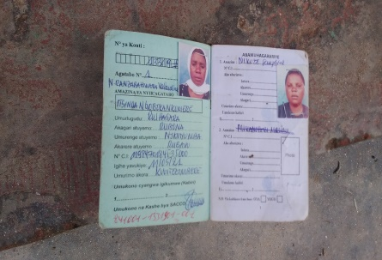

Photo of bank books in Nyamyumba sectot/Rubona cell

The 7th December was the third day of the fields work.Like the previous days, the team of ANSP+ went to the sector of Rubavu sector where it met with the incharge of social affairs together with the personnel in charge of education.These officials were very happy of the visit and thanked ANSP+ and its partners for having thought about people in Rubavu sector.

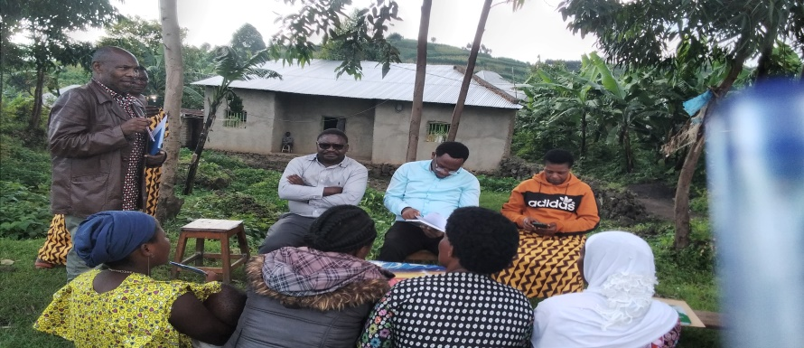

Photo: The social affairs in Rubavu sector speaking to the audience

The leader of ANSP+ team in his turn explained the purpose of the mission, that it was to see what key populations are doing rather than working on sex.

The team left the sector office and together with the personnel in charge of social affairs went to visit the association of key populations called URUMURI.The committee of the association introduced her team and then continued presenting the association and its dids.As she mentioned, the association is made up by 25 members,all females. Among the activities carried out include small businesses from which they earn some money to survive. The members of the association meet every week and collect money which is taken to the bank and will be brought to members after a year with interest .The interest is got from the money taken as a loan by members who bring back the money with a small interest.By that day, the association had 124,300 RWF on account. The personnel in charge of social affairs in this sector told the members of Urumuri that they are working well and that the administration of Rubavu sector will be nerat and assist them whenwver possible.He therefore reminded them that there are other organizations such as CARITAS that help vulnerable people.He also insisted on the program of government called NSDS SHISHAKIBONDO that facilitates poor pregnant women until the kid is 2 years old.The only condition for a woman to be enrolled in this program is that a woman gets 4 standard visits and delivers at the health center

The last day of the field work was the 8th December and it was carried out in Rugerero sector. At the sector office, the team of ANSP+ also met with the personnel in charge of social affairs.The team was given a warm welcome after which the DAF of ANSP+ explained to the sector officer the purpose of the visit.

Much thanks were given to the administration of ANSP+ together with its partners for their contributions to eradicating poverty and HIV among key populations in Rugerero sector. The last step of the field work was the visit to the association URUKUNDO RW’IMANA RUGERERO working in this sector.At place , the committee of the association had a big morale and danced for the team of ANSP+. The president of association told the team that the association has got 25 members and all are women.The association started in 2019 and the activities done by its members include selling small fishes(isambaza),charcoal tomatoes ,vegetables, etc. The membersof the association also meet every week and collect money that is shared after a year with interest depending on the money each has contributed.

Among the challenges they have include the small capital, paying school fees for children, renting houses.Nevertheless ,they all said that they have paid their Mutuelle de sante for their families.

Some of the wishes of the association are that donors would assist them to get enough capital so as they can create the cooperative legally known by the sector.

The Director of Administration and Finance within ANSP+ called them to work together and respect all the requirements of a good citizen. The DAF ended his speech by inciting them to work hard to strive for their good lives

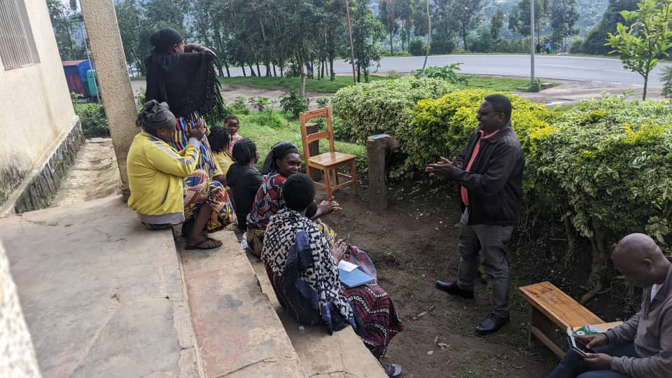

Photo of DAF addressing the audience

**III.FIELD WORK**RESULTS AND **EXPECTATIONS**

By the end of the field work,the team of ANSP+ in mission well got aware of the state os associations /cooperatives of key populations in Rubavu district.The team also got to know about the challenges being faced by key populations in this district and therefore plan for them accordingly. Local leaders in the area also got to know what ANSP+ is and its activities in the area.

IV.CONCLUSION

The field work in Rubavu district was conducted as it was planned. Both the local leaders at the sector level in Rubavu district and the team of ANSP+ got aware of the activities of the associations of key population in this district and advices were given to these associations to perform well.

Done at Kigali on the 15 Dec 2023

The team of ANSP+ in mission

1.Aimable BUCYANAYANDI

2.NZIRINGIRIMANA Joseph

3.MUKAYIRANGA Marceline

4.UMUTONI WA MANA Laurence

5.NIZEYIMANA Jean Marie Vianney

6.MUKASEKURU Deborah