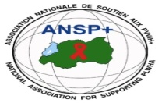  **[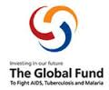](http://scottfiller.info/)**

**PROJECT: ANSP+/RBC/SPIU**

**ACTIVITY: FOUR DAYS FIELD WORK FOR CAPACITY BUILDING THROUGH WORKSHOP, TRAINING AND /OR COORDINATION MEETINGS WITH UMBRELLA’S MEMBERS TO INCREASE THEIR ENGAGEMENT IN COMMUNITY MOBILIZATION AFTER COVID 19 AND TOWARDS OTHER HIGH BURDENED DISEASES** **(HIV, TB, STIS, HCV, EBOLA AND MENTAL HEALTH**

**→ WORKSHOP TAKES PLACE IN SOUTHERN PROVINCE - HUYE DISTRICT**

**TARGET GROUP: KEY POPULATIONS**

1. **INTRODUCTION**

The National Association for Supporting People Living with Hiv/Aids (Ansp+)in collaboration with the Rwanda Biomedical Centre (RBC) through the Global Fund, commenced a two-days comprehensive training program aimed at enhancing group of key population from Southern Province, Huye District. Workshop aimed to mobilize efforts towards combatting HIV, TB, STIS, HCV, Ebola and Mental Health.

1. **DATE AND VENUE**

Workshop takes a place in Southern Province, Huye District, on 19th March 2024 was a departure from Kigali to Huye District for fieldwork preparation. The next day was dedicated to conduct a training with head of department at Huye Health Center. Workshop took place at Kalibu Peace Center, on 21st – 22nd March 2024.

1. **TARGET GROUP**

After having discussions with 6 head of health center service departments, the workshop continued where it was attended by four staff members of ANSP+, one facilitator from Centre Universitaire de la Sante Public (CUSP), and twenty-nine female sex workers coming from different Sectors located in Huye District.

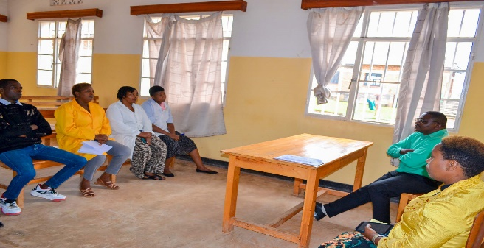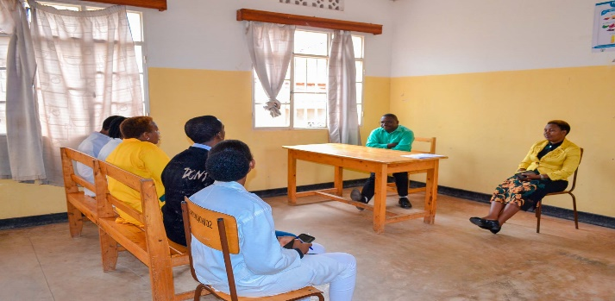

Photos: DAF at ANSP+ Rwanda interacting with Huye health center service departments

Jean Marie Vianney Nizeyimana, the Director of Administration and Finance (DAF) at ANSP+ Rwanda, started discussions with doctors by explaining its origin. It was established in the year 2000 by people who had HIV/AIDS, seeking support among themselves and wanting to stay away from sadness. The main aim of the visit was to create awareness for key populations, including female sex workers and MSM. The health center should provide special treatment for them and not fight them, as they have manners that society does not accept.

The session of workshop commenced with an introduction by Jean Marie Vianney Nizeyimana, by highlighting the association's role in supporting people living with HIV/AIDS and creating awareness about prevention within the Rwandan community.

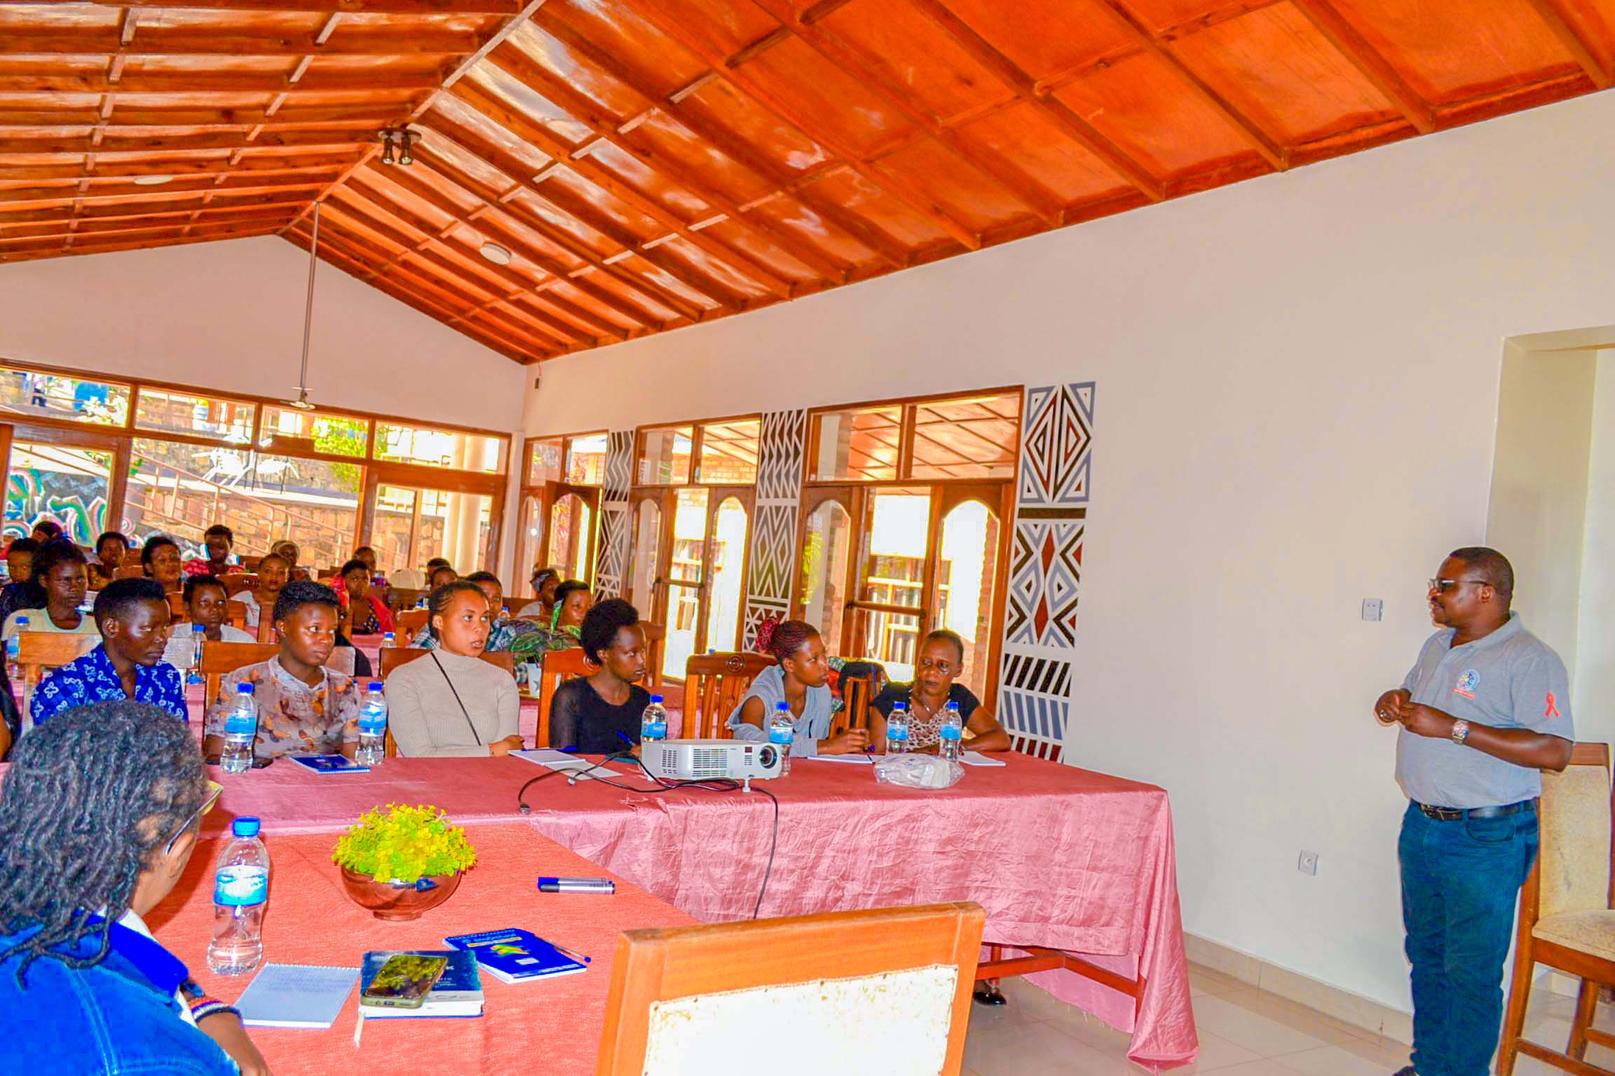

Photo: Jean Marie Vianney Nizeyimana highlighting the role of ANSP+

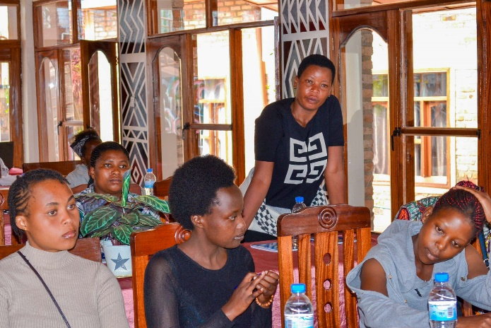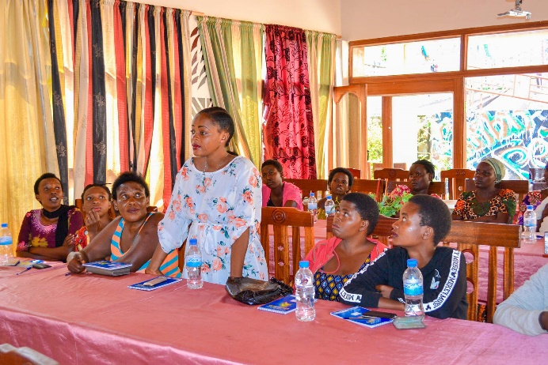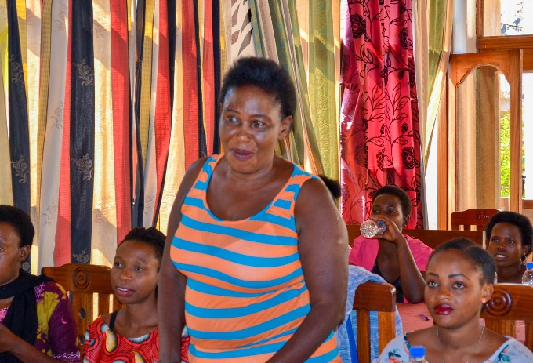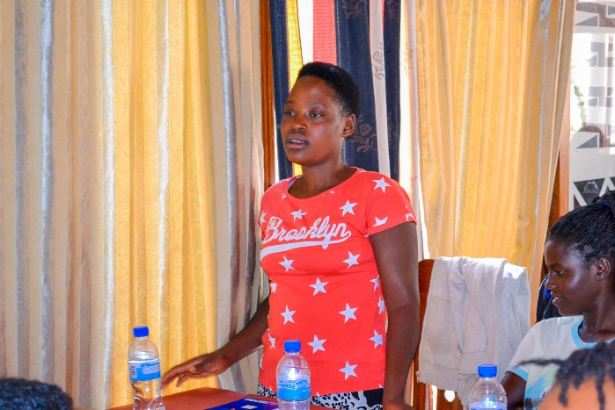

Photos: Attendees, including beneficiaries and facilitators, then introduced themselves

1. **WORKSHOP ACHIEVEMENTS**

**#### Workshop Achievements**

**\*\*1. Understanding COVID-19 and Its Impact on Mental Health\*\***

Vumiriya Jeanine, the facilitator, explained COVID-19, its transmission, symptoms, and prevention measures. She emphasized that certain groups, including those with diabetes, heart diseases, HIV, and older individuals, are particularly vulnerable. Attendees shared how the pandemic affected them, including the loss of clients due to lockdowns. They also expressed fears about taking medications due to hunger and a fatalistic attitude toward pregnancy and STIs.

**\*\*2. Awareness and Prevention of HIV/AIDS and Other Diseases and their impacts on Mental Health\*\***

Certainly! Here are examples of how HIV, TB, Hepatitis, and malaria transmit, along with their effects on mental health:

**1. HIV (Human Immunodeficiency Virus):**

- Transmission: HIV is transmitted through contact with certain body fluids, such as blood, semen, vaginal fluids, and breast milk. This typically occurs through sexual contact, sharing needles, or from mother to child during childbirth or breastfeeding.

Preventive measures include practicing safe sex (e.g., using condoms), avoiding sharing needles, and receiving pre-exposure prophylaxis (PrEP) for individuals at higher risk. Early diagnosis and access to antiretroviral therapy (ART) can also help prevent the spread of HIV.

**2. TB (Tuberculosis):**

- Transmission: TB is an airborne disease caused by the bacterium Mycobacterium tuberculosis. It spreads when a person with active TB disease coughs or sneezes, releasing bacteria into the air, which can then be inhaled by others.

Prevention strategies include ensuring proper ventilation in indoor spaces, identifying and treating active TB cases promptly, and providing preventive therapy for individuals at high risk of developing TB, such as close contacts of TB patients.

**3. **Hepatitis:\*\***

- Transmission: Hepatitis can be caused by several different viruses (e.g., Hepatitis A, B, C). Hepatitis B and C are primarily transmitted through contact with infected blood or body fluids, while Hepatitis A is typically spread through contaminated food or water.

Prevention measures include practicing good hygiene (e.g., handwashing), receiving vaccinations for Hepatitis A and B, practicing safe sex, and avoiding sharing needles or personal items that may be contaminated with blood.

**4. Malaria:**

- Transmission: Malaria is caused by parasites transmitted through the bites of infected female Anopheles mosquitoes. It is most common in tropical and subtropical regions.

Prevention strategies include using insecticide-treated bed nets, wearing protective clothing, using insect repellent, and taking antimalarial medication if recommended. Vector control measures, such as mosquito control programs, can also help prevent the spread of malaria.

It's important to note that mental health issues related to these infections can vary widely among individuals and may require tailored interventions and support.

Implementing these preventive measures is crucial for reducing the transmission and impact of these diseases on individuals and communities.

**\*\*3. Understanding Tuberculosis and Hepatitis\*\***

The session covered TB transmission, signs, and prevention measures. If TB medication is not taken properly, it can lead to Miliary TB. Attendees also learned about the differences between Hepatitis B and C, with Type C being curable but lacking a vaccine, while Type B cannot be cured but can be prevented through vaccination. Hepatitis is primarily spread through poor hygiene practices.

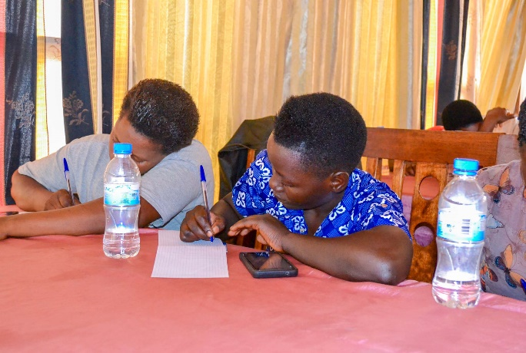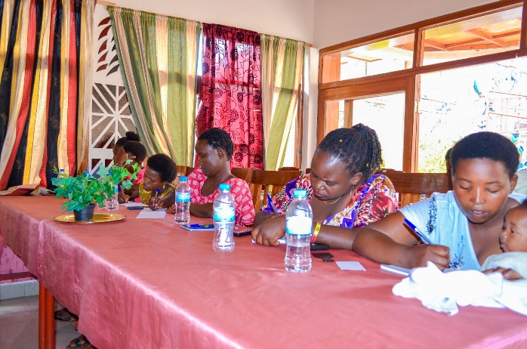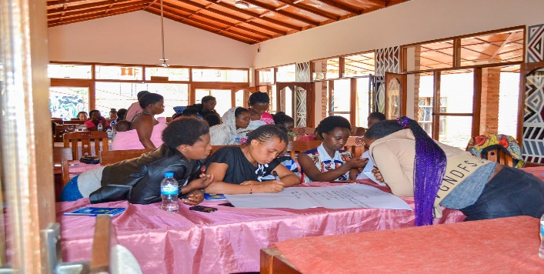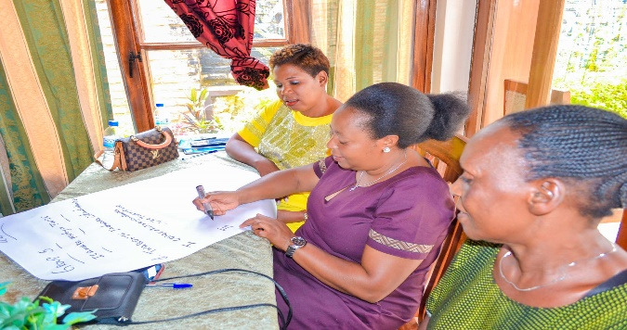

Photos: Beneficiaries had group work

In conclusion, the workshop provided female sex workers with valuable information on COVID-19, HIV/AIDS, and other related diseases. It emphasized the importance of prevention, proper medication adherence, and hygiene practices to protect their health and that of their clients and families. The insights gained from this workshop will contribute to a more informed and empowered community of sex workers in Rwanda.

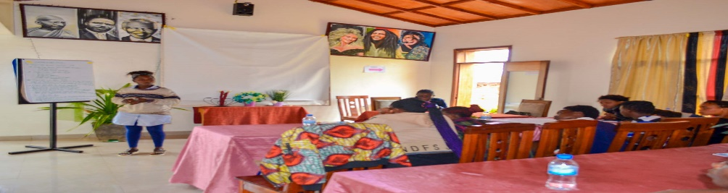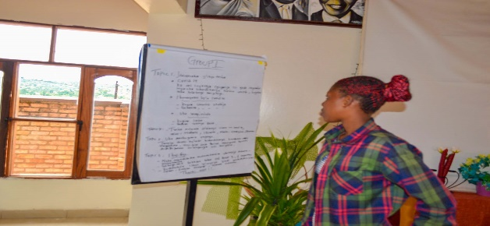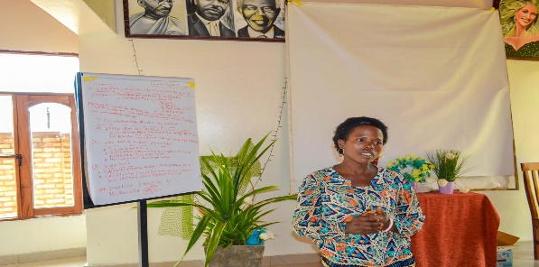

Photos: After group work, beneficiaries did representation

**Recommendations & Challenges: Based on the challenges identified, beneficiaries recommended the following:**

Doctors and key populations urged that there is a shortage of condoms and recommended ANSP+ to help solve it.

Female sex workers recommended for help/support to start their own businesses and leave the streets. They urged that even though they do prostitute, they are not happy with it, and they would be grateful if they find other occupations.

They also recommended ANSP+ that it should link them with other female sex workers from different provinces to share experiences of their lifestyle.

A representative of female sex workers in Huye District said that they face the issue of not having identification papers and a uniform that would allow her to conduct her job of teaching and helping her colleagues in certain ways.

**ANSP+ TEAM MEMBERS WHO ATTENDED THE WORKSHOP:**

UMUTONI WA MANA Laurence,

NIZEYIMANA Jean Marie Vianney,

UZABAKIRIHO Jean Gabriel

MUKASEKURU Deborah