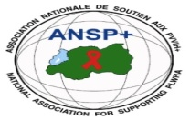  [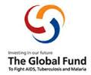](http://scottfiller.info/)

**PROJECT NAME: ANSP+/RBC/SPIU**

**NAME OF ORGANIZATION: NATIONAL ASSOCIATION FOR SUPPORTING PEOPLELIVING WITH HIV/AIDS (ANSP+)**

**NAME OF ORGANIZATION: NATIONAL ASSOCIATION FOR SUPPORTING PEOPLELIVING WITH HIV/AIDS (ANSP+)**

**NSP PROGRAM: COVID-19 IMPACT MITIGATION**

**ACTIVITY: TWO DAYS FIELD WORK FOR CAPACITY BUILDING THROUGH WORKSHOP, TRAINING AND/OR COORDINATIONS MEETINGS WITH UMBRELLA'S MEMBERS TO INCREASE THEIR ENGAGEMENT IN COMMUNITY MOBILIZATION AFTER COVID-19 AND TOWARDS OTHER HIGH BURDENED DISEASES (HIV, TB, STIs, HCV AND MENTAL HEALTH).**

**TARGET GROUP: KEY POPULATIONS**

**AREA OF INTERVENTION: KIGALI CITY**

**MISSION REPORT**

**I.INTRODUCTION**

ANSP+ stands as a National Association for supporting People living with HIV/AIDS. It is a Rwandan Local Non-Governmental Organization created in September 2000 by People Living with HIV themselves, with the leading mission of striving for the quality of life of HIV infected /affected people in Rwanda and fighting against the spread of HIV/AIDS and other epidemics. Towards this mission, our potential beneficiaries include Key Populations which runs a high risk of getting HIV.

In the partnership of the Global Fund and Rwanda Biomedical Center (RBC), National Association for Supporting People Living with HIV (ANSP+) has carried out a two days’ field work for 27 KPs at FIVE TO FIVE HOTEL in Kigali titled Capacity Building through workshop, training and /or coordination meetings with umbrella s members to increase their engagement in community mobilization after Covid-19 and towards other high burdened diseases(HIV,TB, STIs, HCV,EBOLA AND MENTAL HEALTH)from 11 March 2024 up to 12 March 2024.

**TARGET GROUP: KEY POPULATIONS**

**AREA OF INTERVENTION: KIGALI CITY**

Two days field work aiming to 27 key populations in Kigali City with the assistance of 3 team of ANSP+, 1 trainer who is the head of Rwampara health center and 1 Journalist. the aim of this training is increasing KPs their engagement in community mobilization to fight against the spread of the disease **(HIV, TB, STIs, HCV AND MENTAL HEALTH)**.

**II.TRAINING OBJECTIVE**

As highlighted in the introduction above, the objective of this activity is for capacity building through workshop, training and /or coordination meetings with umbrella ‘s members to increase their engagement in community mobilization after covid-19 and towards other high burdened diseases **(** **HIV, Malaria, TB, STIs, HCV AND MENTAL HEALTH)**.

**III. HOW THE ACTIVITIES WERE CONDUCTED**

The First day the trainer from Rwampara Health center started by introducing herself to KPs the the beneficiaries of the training ,and then all participants introduce their self.the trainer highlighted that the training will be participative where all KPs will contribute to the training . The trainer continue by explaining what is HIV, how can it be infected ,How to prevent it ?

**What is HIV?**

**HIV**: human immunodeficiency virus)

**AIDS:** acquired immunodeficiency syndrome

**What is HIV? She said that HIV**: is a virus that attacks the body’s immune system. If HIV is not treated, it can lead to [AIDS](https://www.cdc.gov/hiv/basics/livingwithhiv/opportunisticinfections.html)

* There is currently no effective cure. Once people get HIV, they have it for life.
* But with proper medical care, HIV can be controlled. People with HIV who get [effective HIV treatment](https://www.cdc.gov/hiv/basics/livingwithhiv/treatment.html) can live long, healthy lives and protect their partners .**How do I know if I have HIV?**

The only way to know for sure whether you have HIV is to [get tested](https://www.cdc.gov/hiv/basics/testing.html). Knowing your HIV status helps you make healthy decisions to prevent getting or transmitting HIV.

**She continues explaining the mode of HIV Transmission**

Most people who get HIV get it through anal or vaginal sex, or sharing needles, syringes, or other drug injection equipment (for example, cookers). But there are powerful tools that can help [prevent HIV](https://www.cdc.gov/hiv/basics/prevention.html) transmission.

This section answers some of the most common questions about the risk of HIV transmission for different types of sex, injection drug use, and other activities.

For the Prevention she said that

Today, more tools than ever are available to prevent HIV. You can use strategies such as abstinence (not having sex), never sharing needles, and using condoms the right way every time you have sex. You may also be able to take advantage of HIV prevention medicines such as [pre-exposure prophylaxis](https://www.cdc.gov/hiv/basics/prep.html) (PrEP) and [post-exposure prophylaxis](https://www.cdc.gov/hiv/basics/pep.html) (PEP). If you have HIV, there are many actions you can take to prevent transmitting HIV to others.

After talking about HIV , The trainer continues saying about Covid-19,what is it and how it can be infected ?she said that COVID-19 is a serious global infectious disease outbreak with nearly 4.5% deaths worldwide. It is part of a family of viruses called coronaviruses that infect both animals and people. This particular one originated in China at the end of 2019, in the city of Wuhan, which has 11 million residents. In the past two decades coronavirus outbreaks have caused global concern, including one in 2003 with the Severe Acute Respiratory Syndrome (SARS) and more recently in 2012 with the Middle East Respiratory Syndrome (MERS).

**Symptoms**

COVID-19 can cause symptoms very similar to the flu – fever and a dry cough [(the two most common symptoms)](https://www.cdc.gov/coronavirus/2019-ncov/about/share-facts.html), fatigue, aches and pains, and nasal congestion. As the pandemic spread around the world, other symptoms such as a loss of sense of smell or taste have emerged – these are not yet conclusive evidence of infection with the new coronavirus, and the World Health Organization is investigating this.

**People at high risks**

Severe cases can lead to serious respiratory disease, and even pneumonia. Those most at risk are the elderly, or people with underlying medical issues, such as heart problems or diabetes. According to the most recent global numbers, [14.8%](https://www.who.int/docs/default-source/coronaviruse/who-china-joint-mission-on-covid-19-final-report.pdf) of people over 80 years old, infected with the virus, have died from it, compared with 0.4% in people aged 40-49%

**Mode of transmission**

The evidence so far indicates that the virus is spread from person to person through small respiratory droplets. When a person coughs or sneezes, these droplets can also land on nearby surfaces. There is also evidence that the COVID-19 virus can [last on surfaces](https://www.gavi.org/vaccineswork/what-not-touch-how-avoid-contact-new-coronavirus) – especially plastic or metal.

**Preventive methods**

Wear masks,

Social distance

Hand washing using soap or sanitizer

Vaccination .

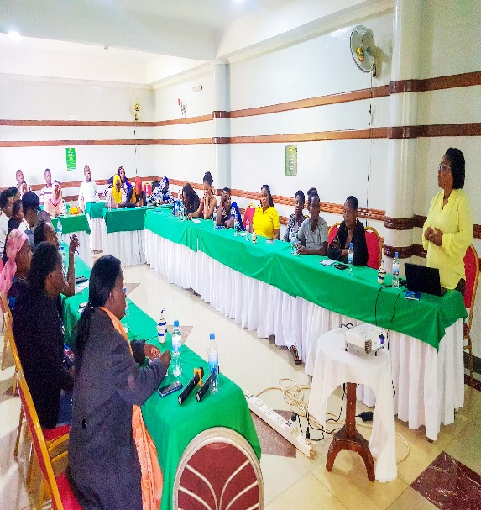

**Picture of the head of Rwahama health center training KPs at Five to Five Hotel**

The second days the trainer divided KPs in 5 Groups where she asked them to work on ꞉What is Malaria and how to prevent from it ? What is TB,STIs ,HCV,EBOLA AND MENTAL HEALTH and how to prevent them ?

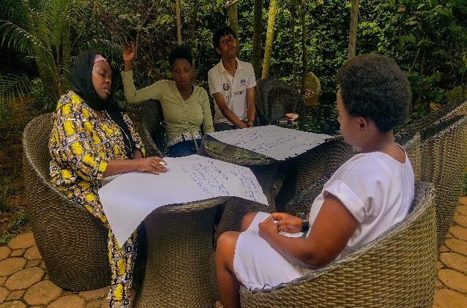

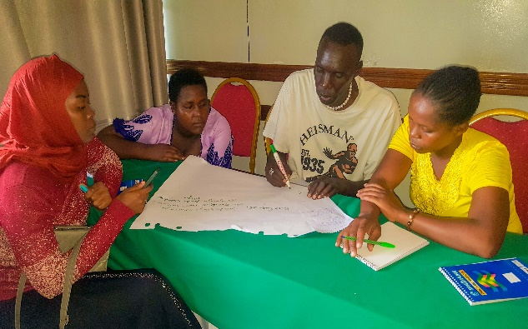

**KPs working in Group at Five to Five Hotel**

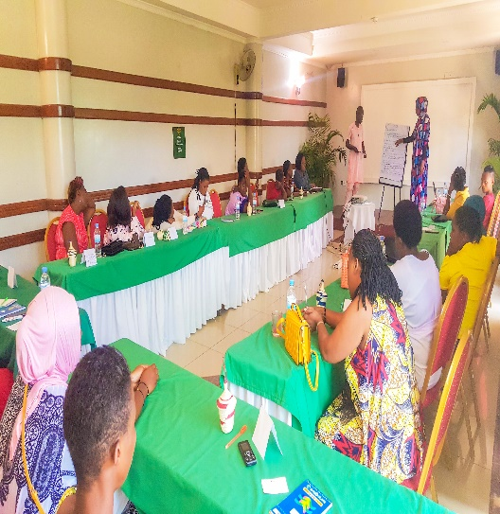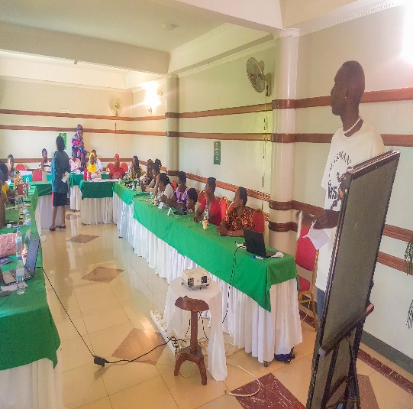

**KPs presenting their work at Five to Five Hotel**

After the presentation of KPs work , the trainer Mukeshimana Valentine requested KPs who get opportunity to be trained to share their experience with their friends,collegues ,associations /cooperatives members .

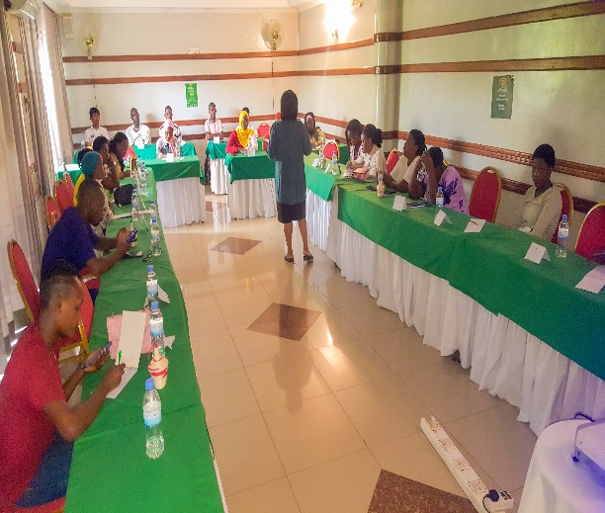

**Picture of the Trainer Valentine Mukeshimana at Five to Five Hotel**At the end of the training ,The Director of Finance and Administrative finished by thanking all participant and asking KPs to write well their bank account number at the list so that their transport facilitation will be transferred well and on time.

**IV. Conclusion**

KPs suggested ANSP+to train new KPs who are young on different diseases and to target more KPs next time by inviting more of them so that the skills learned will be shared to more KPs and community. the training finished by taking a memorial picture at Five to Five Hotel.

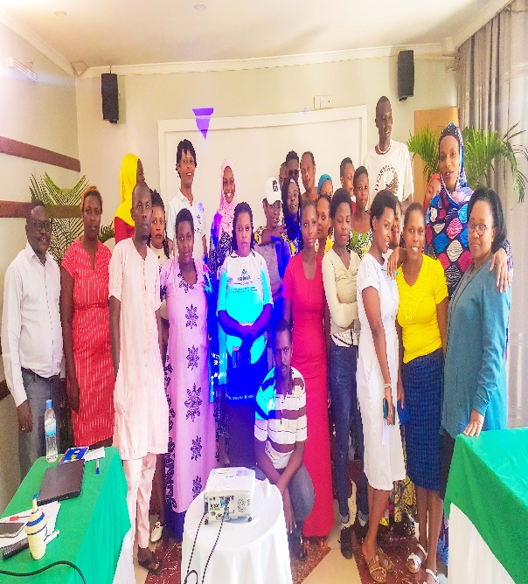

**Photo of the participants at Kigali City**

Done at Kigali on the 18 March 2024

**ANSP+ TEAM MEMBERS IN MISSION**

MUKASEKURU Deborah

UMUTONI WA MANA Laurence

NIZEYIMANA Jean Marie Vianney

UZABAKIRIHO Jean Gabriel