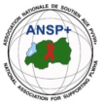  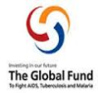

**PROJECT NAME: ANSP+/RBC/SPIU**

**NAME OF ORGANIZATION: NATIONAL ASSOCIATION FOR SUPPORTING PEOPLE LIVING WITH HIV/AIDS (ANSP+)**

**NSP PROGRAM: COVID-19 IMPACT MITIGATION**

**ACTIVITY: FOUR DAYS FIELD WORK FOR CAPACITY BUILDING THROUGH WORKSHOP, TRAINING WORKSHOP, AND OR COORDINATION MEETINGS WITH UMBRELLA'S MEMBERS TO INCREASE THEIR ENGAGEMENT IN COMMUNITY MOBILIZATION AFTER COVID-19 AND TOWARDS OTHER HIGH BURDENED DISEASES (HIV, STIs, TB, HEPATITIS, HCV, MALARIA, MARBURG VIRUS, EBOLA AND MENTAL HEALTH).**

**TARGET GROUP: KEY POPULATIONS**

**AREA OF INTERVENTION: HUYE DISTRICT**

1. **INTRODUCTION**

ANSP+ stands for the National Association for Supporting People Living with HIV/AIDS. It is a Rwandan local Non-Governmental Organization created in September 2000 by People Living with HIV themselves, with the leading mission of striving for the quality of life of HIV infected /affected people in Rwanda and fighting against the spread of HIV/AIDS and other epidemics. Towards this mission, our potential beneficiaries include Key Populations that run a high risk of getting HIV.

When we talk about HIV/AIDS, we can’t forget other epidemics such as TB, malaria, and nowadays COVID-19; in one way or another, there is a relationship between them, because HIV-positive people are most vulnerable to these epidemics.

Incidentally, it has been over three years since the Covid-19 pandemic reached Rwanda. As an international concern, through government preventive measures, people took action to prevent the disease through day-to-day measures. These include regular hand washing with soap and water, wearing masks, maintaining a social distance of at least one meter, avoiding touching the eyes, nose, and mouth, the lockdown, and being vaccinated. Due to these serious preventive measures taken and respected, the pandemic reduced its virulence, which is why the government has decided to soften some regulations regarding the pandemic, where wearing masks is no longer an obligation, while other preventive measures remain. Though the severity of the pandemic has reduced, it is still a concern.

Working in this framework, ANSP+ under the sponsorship of Global Fund organized four field works including a two-day training workshop for its constituencies to increase their engagement in community mobilization to continue fighting against pandemics. The fieldwork was conducted in the Huye District, from December 3 to 6, 2024.

This report highlights the key activities, outcomes, and recommendations from the mission, which included workshops, training, and coordination meetings.

1. **TRAINING WORKSHOP OBJECTIVE**

The overall objective of the fieldwork was to enhance community mobilization and strengthen the capacity of key populations, healthcare providers, and umbrella members to address health challenges. The specific objectives were:

* To increase community engagement in health service delivery post-COVID-19.
* To foster collaboration between healthcare providers, umbrella members, and ANSP+ to promote effective health service delivery.
* To equip participants with the knowledge and skills to combat high-burden diseases, including HIV, STIs, TB, hepatitis, HCV, malaria, Marburg virus, Ebola, and mental health issues.
* To build the capacity of key populations, healthcare providers, and stakeholders in prevention of the mentioned diseases.

1. **TARGET GROUP**

The training workshop targeted 20 KPs for the training workshop, 6 heads of health center service departments, 4 healthcare providers/other stakeholders, 1 training workshop facilitator, and 5 staff members of ANSP+ for the training workshop organization, supervision, and other support needed.

1. **DATE AND VENUE**

The fieldwork took place in the Huye District from the 3rd to the 6th of December 2024.

On Tuesday, the 3rd of December was a departure from Kigali to Huye District. Wednesday, the 4th of December 2024, was for fieldwork preparation and meeting with heads of Departments at Huye Health Center (former Police health center).

The next days of 05th and 6th of December 2024 were dedicated to conducting training workshops with KPs and health care providers/stakeholders at Karibu Peace Center.

1. **ACTIVITIES CONDUCTED**

**V.1. MEETING WITH HEADS OF DEPARTMENTS AT HUYE HEALTH CENTER**

**Date:** December 4, 2024  
**Location:** Huye Health Center (former Police Health Center)

The meeting with heads of departments at Huye Health Center focused on the quality of healthcare services provided to key populations. Nizeyimana Jean Marie Vianney, the Director of Administration and Finance (DAF) from ANSP+ provided an overview of ANSP+'s work and the rationale for engaging healthcare providers.

Nizeyimana Jean Marie Vianneyexplained that ANSP+ was established by people living with HIV/AIDS to support their community. Over time, its mission expanded to support key populations at high risk of HIV infection, and also poverty reduction.

Discussions centered on how services are delivered to key populations and how healthcare providers ensure their needs are met. Nurses acknowledged that identifying MSM and lesbians among patients was challenging. They also noted that, in the past, some providers mistakenly believed these groups had mental health issues.

Nizeyimana alsourged healthcare providers to adopt stigma-free and friendly service delivery, emphasizing that all patients should feel comfortable and respected when seeking health care.

The health center’s tutor promised to strengthen customer care services for key populations.

**KEY OUTCOMES OF THE MEETING:**

* Health center staff committed to delivering stigma-free, friendly services for key populations.
* Providers acknowledged the need to challenge myths and misconceptions about key populations.
* Enhanced understanding of the specific needs of key populations and how to address them.

**V.2. CAPACITY BUILDING WORKSHOP FOR KEY POPULATIONS (KPS) AND HEALTHCARE PROVIDERS / STAKEHOLDERS**

**Dates:** December 5-6, 2024  
**Location:** Karibu Peace Center, Huye District

The two-day capacity-building workshop aimed to strengthen the ability of key populations and healthcare providers to engage in community mobilization and address health challenges. The workshop covered various topics, with a focus on COVID-19, HIV, TB, hepatitis, and other high-burden diseases.

1. **TRAINING WORKSHOP OBJECTIVES:**

The training workshop aimed to provide practical knowledge on health issues affecting key populations. It sought to build advocacy and mobilization capacity for key populations and healthcare providers, enabling them to play a more active role in community mobilization. Additionally, the workshop aimed to increase understanding of COVID-19 and how pandemics, such as HIV, STIS, TB, hepatitis, HCV, malaria, Marburg Virus, EBOLA, and Mental Health**.**, impact key populations and the broader health system.

1. **WORKSHOP METHODOLOGY:**

The workshop employed interactive learning methods to ensure maximum participant engagement. These methods included brainstorming, group work, and participant presentations, allowing attendees to actively contribute and share their perspectives. To assess knowledge retention, a pre-test and post-test were administered. The use of Kinyarwanda as the language of instruction facilitated accessibility and encouraged full participation from all attendees.

1. **KEY WORKSHOP TOPICS:**

**Day 1:**

Nzayisenga Alfonse, the facilitator who is also the nurse, conducted a pre-test to assess participants’ knowledge about the virus and diseases to be discussed on day one. Participants of the training workshop explored the transmission, symptoms, and treatment of COVID-19, TB, Hepatitis, and HCV.

**COVID-19:** COVID-19 is primarily spread through respiratory droplets released when an infected person coughs, sneezes, or talks. It can also be transmitted through contact with contaminated surfaces followed by touching the face. Symptoms include fever, cough, shortness of breath, loss of taste or smell, and body aches. Treatment for COVID-19 focuses on symptom management, as most cases are mild and resolve on their own. Severe cases may require hospitalization, oxygen therapy, or ventilator support.

**Tuberculosis (TB):** TB spreads through the air when a person with active TB disease of the lungs coughs, sneezes, or talks. Symptoms include a persistent cough lasting more than three weeks, chest pain, and coughing up blood. Treatment involves a 6 to 9-month course of antibiotics, with strict adherence required to prevent drug resistance.

**Hepatitis and HCV:** Hepatitis, including hepatitis B (HBV) and hepatitis C (HCV), is transmitted through contact with infected blood, unprotected sex, and mother-to-child transmission during childbirth. Symptoms include jaundice, dark urine, fatigue, and abdominal pain. Treatment varies depending on the type; HBV can be managed with antiviral medications, while HCV can be cured using direct-acting antivirals (DAAs).

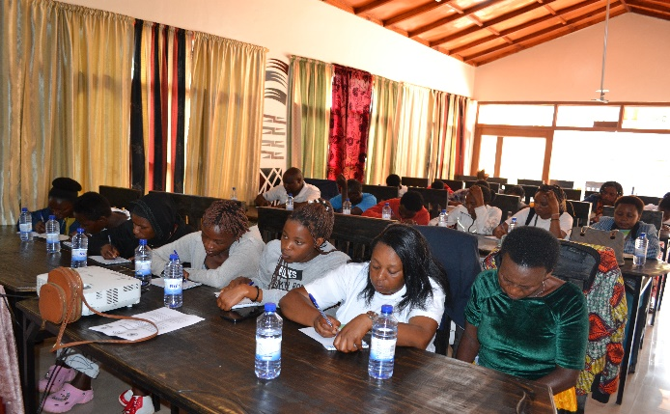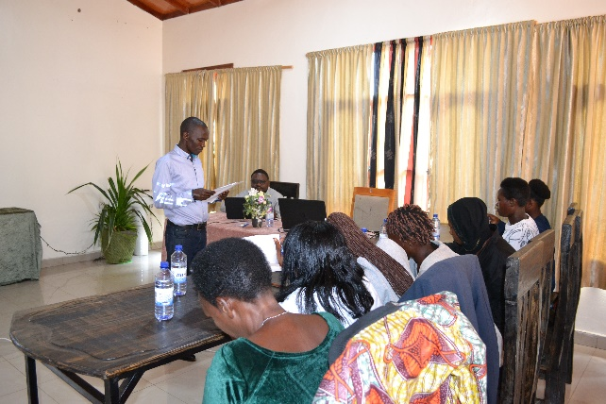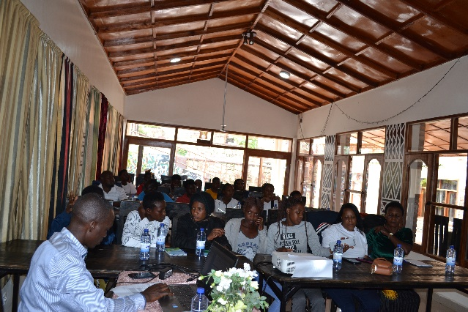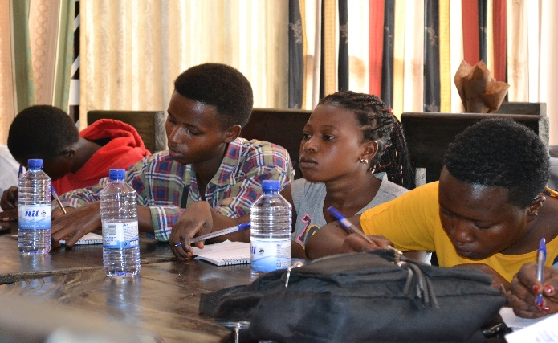

PHOTOS: Day-one of training/workshop

**Day 2:**

On the second day, the focus shifted to recapitulation of day one presentations and discussions, and then continued with HIV, sexually transmitted infections (STIs), malaria, Marburg virus, Ebola, and mental health issues affecting key populations.

**HIV:** HIV is transmitted through contact with certain body fluids, including blood, semen, vaginal fluids, rectal fluids, and breast milk, typically through unprotected sex, needle sharing, or from mother to child during childbirth or breastfeeding. Symptoms may not appear for years, but early signs include flu-like symptoms such as fever, chills, and rash. While there is no cure for HIV, antiretroviral therapy (ART) effectively manages the virus, allowing people living with HIV to lead healthy lives and reduce the risk of transmission.

**STIs:** Sexually transmitted infections (STIs) like gonorrhea, chlamydia, and syphilis are transmitted through sexual contact with an infected person. Symptoms vary depending on the infection but can include genital pain, discharge, itching, and sores. Treatment depends on the specific STI, with bacterial infections treated using antibiotics, while viral STIs like herpes are managed with antiviral medications.

**Malaria:** Malaria is transmitted through the bites of infected female Anopheles mosquitoes. Symptoms include high fever, chills, sweating, headaches, and vomiting. Treatment typically involves antimalarial drugs, with the type of medication depending on the strain of malaria and the patient’s condition.

**Marburg Virus:** Marburg virus spreads through direct contact with the bodily fluids of infected people or animals. Symptoms include high fever, severe headache, muscle pain, vomiting, and internal bleeding. There is no specific treatment for Marburg virus, so supportive care, such as rehydration and treatment of symptoms, is essential.

**Ebola:** Ebola is transmitted through direct contact with bodily fluids of an infected person or contaminated surfaces. Symptoms include sudden onset of fever, fatigue, muscle pain, vomiting, and bleeding. Treatment is primarily supportive, involving rehydration and management of symptoms, though some experimental treatments are being used.

**Mental Health Issues:** Mental health challenges in key populations often arise from stigma, discrimination, and the stress of living with chronic health conditions. Symptoms vary but may include anxiety, depression, and social withdrawal. Treatment involves counseling, psychotherapy, and, in some cases, medication to address specific mental health conditions.

1. **KEY OUTCOMES:**

The capacity-building workshop achieved several key outcomes that will contribute to the improvement of health services for key populations.

The workshop successfully increased awareness of the need for stigma-free healthcare services. Healthcare providers acknowledged the importance of creating a friendly environment for key populations and committed to ensuring that patients feel safe and respected while accessing care.

Participants demonstrated a better understanding of the links between pandemics and other health challenges, particularly how COVID-19 relates to other diseases like HIV, TB, and STIs. This knowledge is crucial in helping communities adopt preventive measures and seek early treatment.

The workshop enhanced the capacity of healthcare providers and key populations to advocate for better health services. Participants acquired skills in community mobilization, advocacy, and health education, which they can now apply in their respective roles within the community.

The use of interactive learning methods, such as group work and participant presentations, fostered active engagement. This approach promoted peer learning, allowing participants to share experiences and best practices that they can replicate in their local communities.

The pre-test and post-test results indicated an improvement in participants' knowledge. The post-test results revealed an increase in the understanding of disease transmission, symptoms, and treatments, particularly for diseases like COVID-19, TB, hepatitis, and Ebola.

Through the coordination meetings with umbrella members, ANSP+ strengthened collaboration and established a shared commitment to continuous community-led monitoring (CLM) efforts. This ongoing collaboration will ensure continuous improvement in the delivery of health services to key populations.

1. **CHALLENGES FACED IN THE TRAINING WORKSHOP:**

One of the main challenges faced during the training workshop was the persistent stigma and discrimination against key populations, especially sex workers. Some healthcare providers had preconceived notions about these groups, which made it difficult to create an open and inclusive learning environment. Addressing these biases requires deliberate efforts from facilitators to promote empathy and understanding.

Limited access to healthcare services and treatment was another challenge faced by key populations, sex workers as well as MSM. Many participants noted difficulties in accessing essential health services due to stigma, discrimination, and fear of judgment from healthcare providers.

1. **RECOMMENDATIONS:**

Efforts should be made to challenge stigma and discrimination through continuous awareness-raising activities. Facilitators should be equipped with skills to handle sensitive topics and encourage healthcare providers to adopt a stigma-free approach to patient care.

To address access issues, it is recommended to establish mechanisms to support key populations, in accessing healthcare services and treatments. Healthcare providers should be trained to deliver non-discriminatory, friendly services to all patients.

More capacity-building training sessions should be organized to ensure ongoing education for healthcare providers, key populations, and stakeholders. Continuous training will ensure that participants remain well-equipped to handle emerging health challenges.

Lastly, support for income-generating activities should be provided for key populations, especially sex workers. These activities would enable them to sustain their livelihoods, reduce vulnerability, and improve their overall well-being.

1. **Conclusion**

The four-day capacity-building fieldwork in Huye District successfully engaged key populations, healthcare providers, and umbrella members in activities aimed at improving community mobilization and health service delivery. Commitments from health center staff to offer stigma-free services, along with increased knowledge and skills among participants, marked significant achievements.

**Prepared by:** Jean Gabriel UZABAKIRIHO  
December 2024

**STAFF MEMBERS IN MISSION**

**MUKAYIRANGA Marceline**

**UMUTONI WA MANA Laurence**

**NIZEYIMANA Jean Marie Vianney**

**MUKASEKURU Deborah**

**UZABAKIRIHO Jean Gabriel**