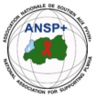  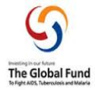

**PROJECT NAME: ANSP+/RBC/SPIU**

**NAME OF ORGANIZATION: NATIONAL ASSOCIATION FOR SUPPORTING PEOPLE LIVING WITH HIV/AIDS (ANSP+)**

**NSP PROGRAM: COVID-19 IMPACT MITIGATION**

**ACTIVITY: TWO DAYS FIELD WORK FOR CAPACITY BUILDING THROUGH WORKSHOP, TRAINING WORKSHOP, AND OR COORDINATION MEETINGS WITH UMBRELLA'S MEMBERS TO INCREASE THEIR ENGAGEMENT IN COMMUNITY MOBILIZATION AFTER COVID-19 AND TOWARDS OTHER HIGH BURDENED DISEASES (HIV, STIs, TB, HEPATITIS, HCV, MALARIA, MARBURG VIRUS, EBOLA AND MENTAL HEALTH).**

**TARGET GROUP: KEY POPULATIONS**

**AREA OF INTERVENTION: KIGALI CITY**

1. **INTRODUCTION**

ANSP+ stands for the National Association for Supporting People Living with HIV/AIDS. It is a Rwandan local Non-Governmental Organization created in September 2000 by People Living with HIV themselves, with the leading mission of striving for the quality of life of HIV infected /affected people in Rwanda and fighting against the spread of HIV/AIDS and other epidemics. Towards this mission, our potential beneficiaries include Key Populations that run a high risk of getting HIV.

When we talk about HIV/AIDS, we can’t forget other epidemics such as TB, malaria, and nowadays COVID-19; in one way or another, there is a relationship between them, because HIV-positive people are most vulnerable to these epidemics.

Incidentally, it is about more than three years since the Covid-19 pandemic reached Rwanda. As an international concern, through government preventive measures, people took action to prevent the disease through day-to-day measures. These include regular hand washing with soap and water, wearing masks, maintaining a social distance of at least one meter, avoiding touching the eyes, nose, and mouth, the lockdown, and lastly being vaccinated. Due to these serious preventive measures taken and respected, the pandemic reduced its virulence and it is the reason why the government has decided to soften some regulations regarding the pandemic, where wearing masks is no longer an obligation, while other preventive measures remain. Though the severity of the pandemic has reduced, it is still a concern.

Working in this framework, ANSP+ under the sponsorship of Global Fund organized the two-days training workshop to its constituencies to increase their engagement in community mobilization in order to continue fighting against pandemics. The field work was conducted in the Kigali City.

**REPORT ON TWO-DAY CAPACITY BUILDING FIELDWORK IN KIGALI CITY**

1. **OBJECTIVES**

The overall objective of the fieldwork was to enhance community mobilization and strengthen the capacity of key populations, healthcare providers, and umbrella members to address health challenges. The specific objectives were:

* To increase community engagement in health service delivery post-COVID-19.
* To foster collaboration between healthcare providers, umbrella members, and ANSP+ to promote effective health service delivery.
* To equip participants with the knowledge and skills to combat high-burden diseases, including HIV, STIs, TB, hepatitis, HCV, malaria, Marburg virus, Ebola, and mental health issues.

1. **TARGET GROUP**

The training workshop targeted 20 KPs for the training workshop, 3 healthcare providers/other stakeholders, 1 training workshop facilitator, and 5 staff members of ANSP+ for the training workshop organization, supervision, and other support needed.

1. **DATE AND VENUE**

The fieldwork took place in the City of Kigali from the 11th to the 12th of December 2024.

But on Tuesday, the 10th of December ANSP+ team conducted the preparations of the training workshop at hotel while Wednesday and Thursday, respectively, the 11th and 12th December 2024, training workshop with KPs and health care providers/stakeholders was conducted at Five to Five Hotel in Kigali City.

1. **ACTIVITIES CONDUCTED**
2. **LAUNCH OF THE TRAINING WORKSHOP**

On December 11th 2024, the training workshop was officially launched by ANSP+ Coordinator, Mukasekuru Deborah. During her remarks, she welcomed participants and introduced ANSP+, highlighting its mission to improve the quality of life for people living with HIV/AIDS and to combat the spread of HIV and other high-burden diseases. She emphasized the importance of open discussion and engagement on key health issues, setting a positive tone for the training sessions.

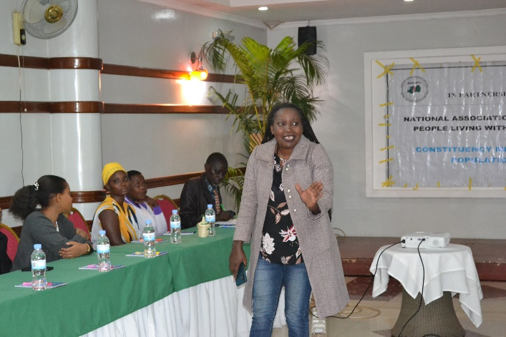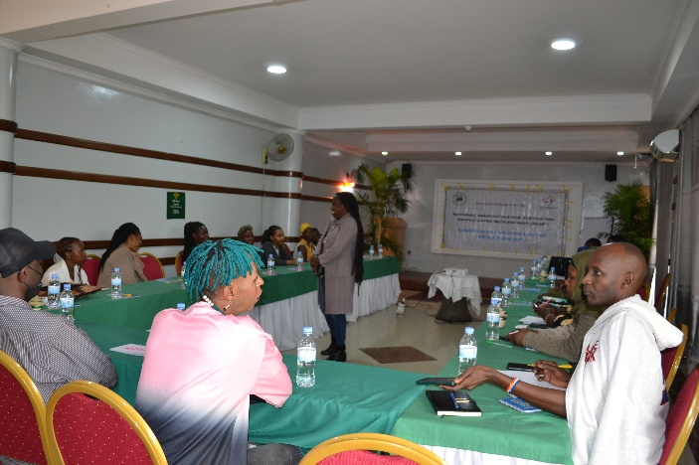

Photos: Coordinator giving her remarks

1. **Day 1 Activities**

The first day of the workshop focused on providing participants with foundational knowledge of COVID-19, HIV, and related health challenges.

**Key Topics Covered:**

* **COVID-19:** COVID-19 spreads primarily through respiratory droplets and contact with contaminated surfaces. Symptoms include fever, cough, shortness of breath, and loss of taste or smell. Prevention includes wearing masks, maintaining social distancing, and vaccination.
* **HIV:** HIV is transmitted through body fluids like blood, semen, and vaginal fluids. Symptoms range from flu-like conditions to severe immune suppression if untreated. Prevention includes condom use, PrEP, and antiretroviral therapy (ART) for those infected.
* **STIs:** Sexually transmitted infections such as syphilis, gonorrhea, and chlamydia present symptoms like genital sores, pain, and discharge. Prevention includes safe sex practices and early treatment with antibiotics.

Participants engaged in Q&A sessions and group discussions to deepen their understanding of these diseases and prevention strategies.

**Key Outcomes of Day 1:**

* Enhanced understanding of COVID-19, HIV, and STIs.
* Increased awareness of preventive measures and the importance of community mobilization.
* Active engagement through open discussions and interactive group work.

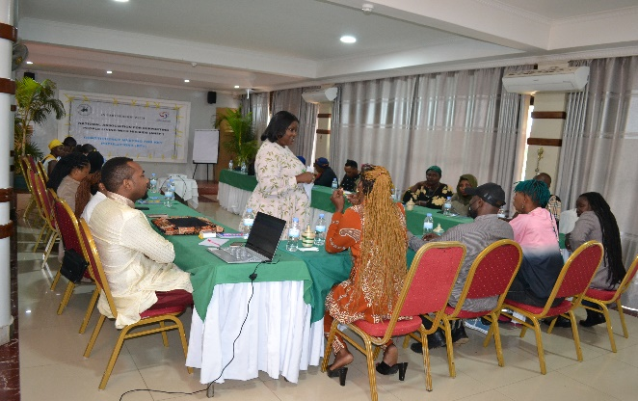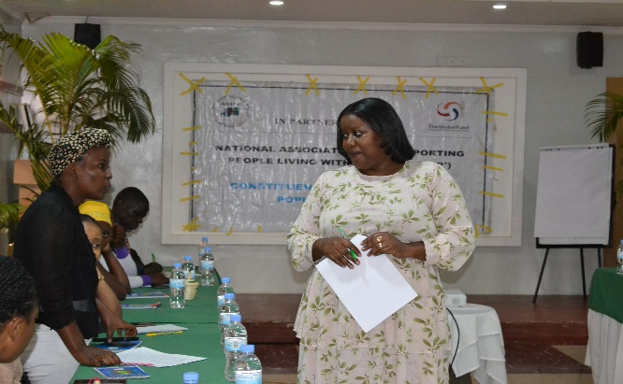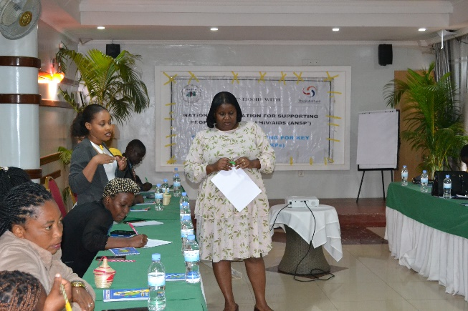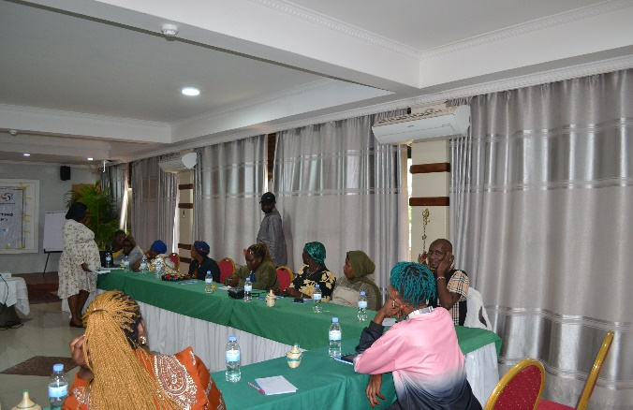

PHOTOS: Interaction between training/workshop facilitator and beneficiaries

1. **Day 2 Activities**

The second day of the workshop focused on TB, hepatitis, mental health, and other key health challenges.

**Key Topics Covered:**

* **Tuberculosis (TB):** TB spreads through airborne droplets when infected individuals cough or sneeze. Symptoms include persistent cough, fever, and weight loss. Prevention involves early diagnosis, treatment adherence, and vaccination.
* **Hepatitis and HCV:** Hepatitis, including types B and C, is transmitted through contact with infected blood and body fluids. Symptoms include jaundice, fatigue, and abdominal pain. Prevention includes vaccination for hepatitis B and avoiding sharing needles.
* **Mental Health:** Common challenges include anxiety and depression caused by stigma and discrimination. Treatment involves counseling and therapy, with a focus on reducing stigma in healthcare settings.

Group discussions and presentations allowed participants to analyze these issues and propose community mobilization strategies for addressing them effectively.

**Key Outcomes of Day 2:**

* Strengthened understanding of TB, hepatitis, and mental health issues.
* Practical knowledge of community mobilization strategies to tackle health challenges.
* Enhanced confidence in discussing and advocating for health issues within communities.

**4. Key Outcomes and Achievements**

The following key outcomes were achieved during the two-day training workshop:

* Increased Knowledge and Skills: Participants demonstrated improved knowledge on the causes, symptoms, and prevention of high-burden diseases, including HIV, STIs, TB, and mental health issues.
* Strengthened Community Engagement: Attendees were equipped with the knowledge and skills needed to mobilize their communities toward better health outcomes. They committed to applying these skills within their communities.
* Commitment to Address Health Challenges: Participants pledged to engage in advocacy and raise awareness on health issues affecting their communities.
* Support for Key Populations: Emphasis was placed on the rights and needs of key populations, ensuring they have access to friendly health services and support.

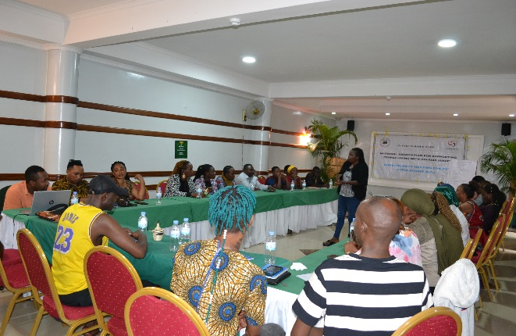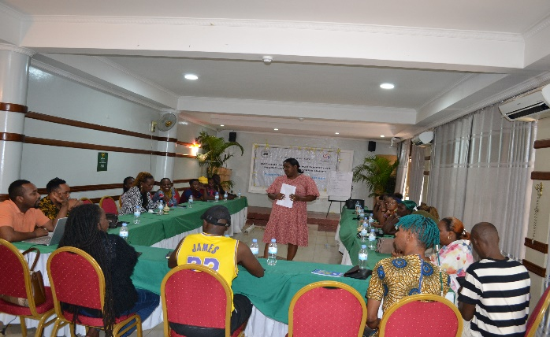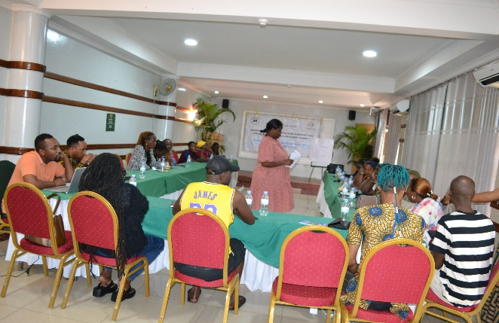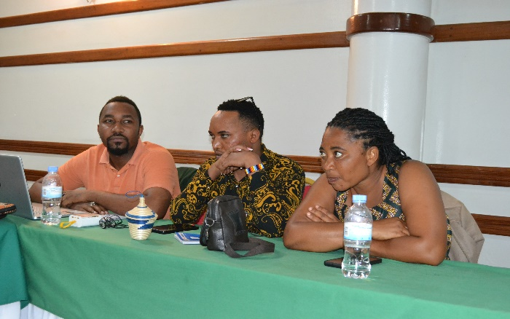

PHOTOS: Day-two of trainig/workshop

**5. Challenges Faced**

While the training was successful, certain challenges were noted:

* Limited Time for Content Coverage: Given the extensive nature of the topics, participants felt that more time was needed to fully grasp all the concepts.

**6. Recommendations**

* Extend Training Time: Allocate additional days for future workshops to allow participants more time to engage deeply with each topic.
* Continuous Advocacy Against Stigma: Implement ongoing campaigns to address stigma and discrimination against key populations. Awareness-raising sessions should be incorporated into all future workshops.
* More Training Opportunities: Provide more training opportunities for healthcare providers and key populations to build continuous capacity and reinforce knowledge retention.

**7. Conclusion**

The two-day capacity-building workshop held in Kigali City was a significant step toward strengthening the capacity of key populations, healthcare providers, and stakeholders to address major health challenges. The sessions promoted engagement, learning, and collaboration, equipping participants with the knowledge and skills to advocate for better health outcomes within their communities. The interactive and participatory approach used throughout the workshop empowered participants to become community health champions. Moving forward, ANSP+ aims to sustain these efforts through continuous training, advocacy, and collaboration with stakeholders.

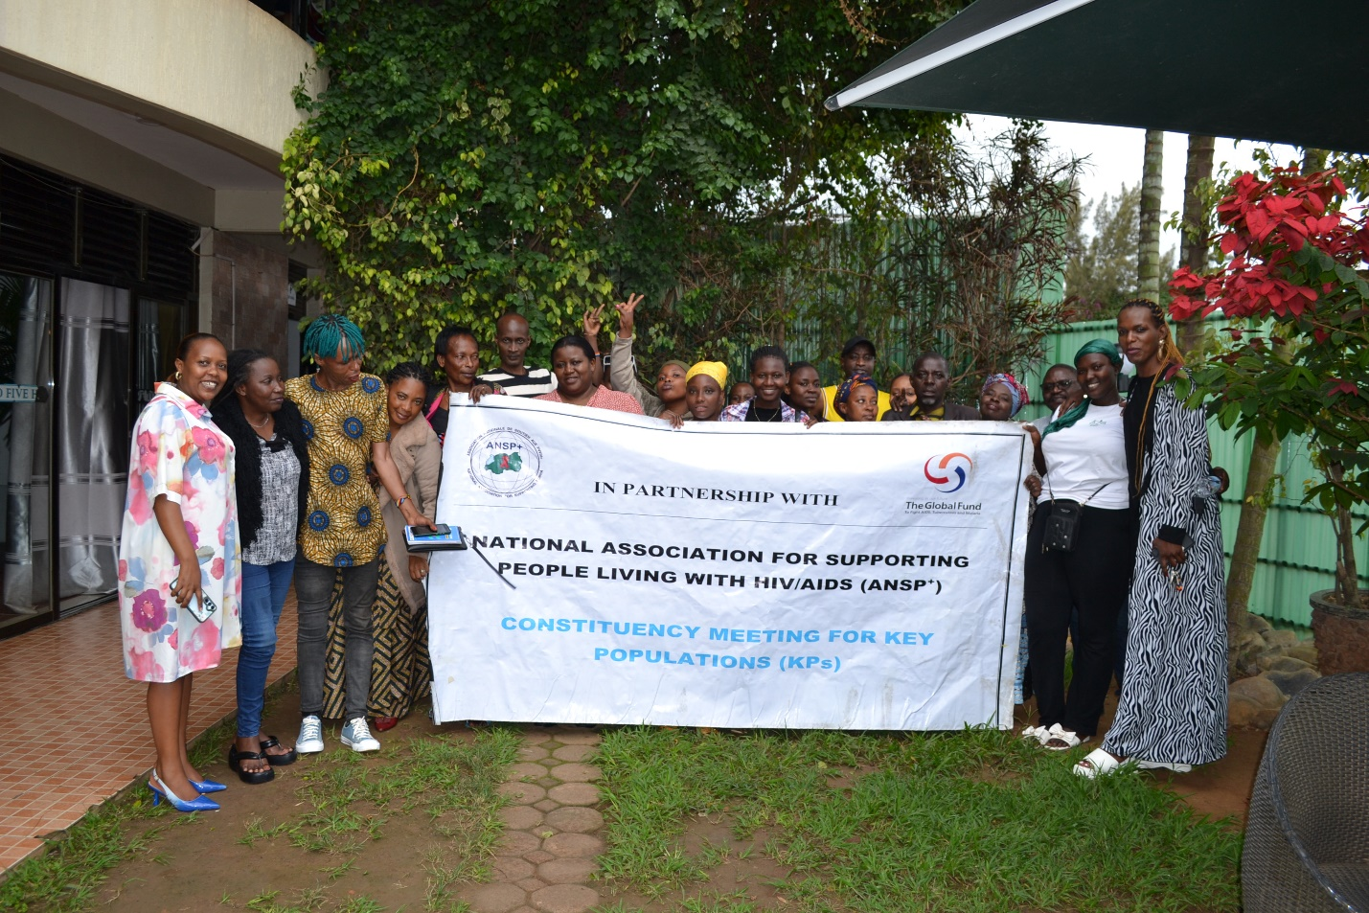

GROUP PHOTO at the end of training/workshop

**Prepared by:** Jean Gabriel UZABAKIRIHO  
December 2024

**STAFF MEMBERS IN MISSION**

**MUKAYIRANGA Marceline**

**UMUTONI WA MANA Laurence**

**NIZEYIMANA Jean Marie Vianney**

**MUKASEKURU Deborah**

**UZABAKIRIHO Jean Gabriel**