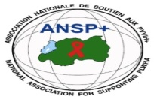 [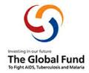](http://scottfiller.info/) 

_____________________________________________________________________________

**PROJECT NAME: ANSP+/RBC/SPIU**

**NAME OF ORGANIZATION: NATIONAL ASSOCIATION FOR SUPPORTING PEOPLE LIVING WITH HIV/AIDS (ANSP+)**

**NSP PROGRAM: REDUCED HIV INCIDENCE**

**ACTIVITY: Two days of conducting a robust awareness targeting youth focusing on HIV, SRHR, Drug and alcohol abuse, using various form of awareness and media campaign.**

**AREA OF INTERVENTION: MUSANZE DISTRICT**

**FIELD WORK REPORT**

1. **INTRODUCTION**

ANSP+ is a National Association Supporting People living with HIV. From its creation in 2000, the association had the objectives to improve the quality of its members affected by the pandemic of HIV.

Along with the implementation of its activities and under the sponsorship by the global fund through the Rwanda Biomedical Center (RBC), the National Association for Supporting People living with HIV (ANSP+) has organized a two days training /workshop in Musanze district for key populations ,journalists and health care providers serving in different health facilities in Musanze district with the purpose of increasing their engagements in community mobilization and advocacy talking about HIV ,SRHR, drug and alcohol abuse and other burdened diseases such as STIs ,EBOLA ,Mpox, and Marburg disease.

The training in MUSANZE district started on the 07th and ended on the 08th Nov 2024.The objective of the training was to accentuate the role of journalists and healthcare providers in community mobilization about HIV ,talk about SRHR ,alcohol abuse and other pandemics; developing reporting model of Journalists, for quality reporting with articles, publications and talks; networking with media houses or newsletters industries in HIV, SRHR, Drug and alcohol abuse, using various form of awareness and media campaign ; Create a platform which connects Journalists and healthcare providers for the purpose of fighting against HIV, Drug and alcohol abuse, using various form of awareness and media campaign and reinforce community mobilization by using Media in fighting against HIV. The training was hosted at Muhabura hotel and was facilitated by Mr. NZIRINGIRIMANA Joseph, a specialist in the domain of health. Participants of the training were 10 key populations from different associations of key populations in Musanze district, ten (10) healthcare providers and journalists in Musanze district and the personnel of ANSP+.

1. **ACHIEVEMENTS OF THE FIELD WORK**

The training for key populations, healthcare providers and journalists in Musanze district was opened by Mr. NIZEYIMANA Jean Marie Vianney who is also the Director of Administration and Finance in ANSP+. During his annotations, the DAF of ANSP+ thanked the participants for responding to the invitation. The DAF went on saying that HIV has been a serious barrier to the development of many countries for many years. Not only HIV, but also other pandemics such as Mpox and malburg contributed to the decrease of economies of counties and to death of people. He therefore called for the contribution of each and everyone in the fight against HIV and other pandemics. Above all, the speaker thanked the global fund and the government of Rwanda/ Ministry of health for their sponsorship in these activities through the Rwanda Biomedical Center (RBC)

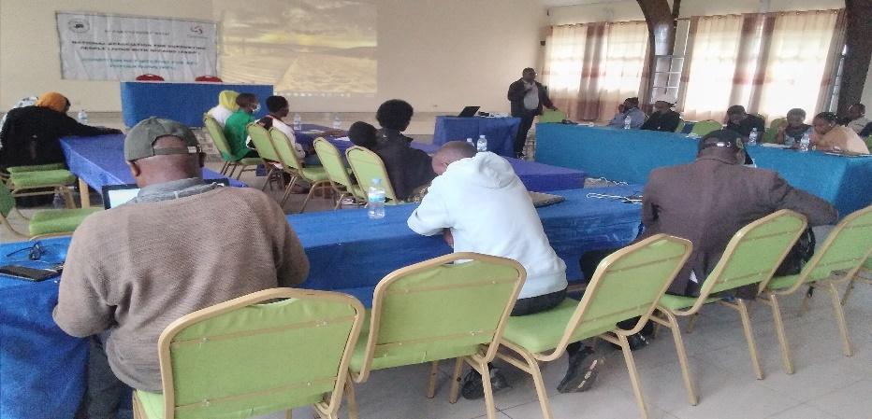

Photo: The DAF in ANSP+ addressing participants of the training

The speech by the chief of mission was followed by presentations of the training facilitator. The first topic was HIV. The trainer, using the interactive approach asked some questions to participants to check their knowledge about HIV. “What do you understand by HIV? How is HIV infected and what are the different methods to prevent against it? The participants of the training responded to the questions after which the trainer gave all the details about HIV, how it is infected and different methods to prevent against it.

As he explained, HIV stands for human immunodeficiency virus. It is a virus that attacks the body's immune system, specifically the white blood cells called CD4 cells. HIV destroys these cells, which weakens the immune system and puts a person at risk for other infections and diseases. The trainer further explained that HIV is caused by a virus. It can spread through sexual contact, shooting of illicit drugs or use of shared needles and contact with infected blood. It also can spread from parent to child during pregnancy, childbirth or breastfeeding. The trainer also detailed different methods of preventing against the contamination of HIV. As he said, one can reduce a risk of getting HIV by getting tested for HIV, choose less risky sexual behaviors, use condoms every time you have sex, limit your number of sexual partners, get tested and treated for STDs and use PrEp.

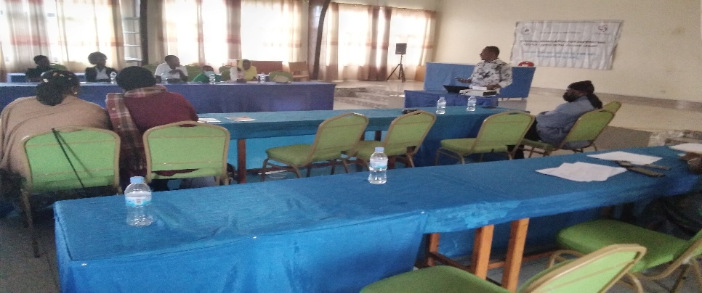

The training facilitator during his presentations

The second topic of the first day was STIs. The trainer explained that STI stands for sexually transmitted infection. STIs are infections that spread through sexual activity, such as vaginal, anal, or oral sex. They can be caused by bacteria, parasites, or viruses. The trainer explained that one can prevent against STIs by using condoms every time you have sex, avoid sharing towels or underclothing, wash before and after intercourse get a vaccination for hepatitis B and getting tested for HIV.

The sexual Reproductive Health and rights was another topic next to HIV and STIs. On this topic, the trainer explained that SRHR is the application of human rights to sexuality and reproduction. Sexual and reproductive health and rights (SRHR) are key to improving health outcomes and empowering women and adolescents to live healthy, productive lives. The topic of reproductive health raised many questions from participants /Key populations which the majority was youth. Connected to this topic, the trainer introduced a new topic which was the drug and alcohol abuse. As it is defined, drug and alcohol abuse is the use of illegal drugs or the use of prescription or over use of drugs or alcohol for purposes other than those for which they are meant to be used, or in excessive amounts. This abuse may lead to social, physical, emotional, and job-related problems. As for side effects of drug and alcohol abuse, this may result to Cardiovascular disease, Stroke. Cancer. HIV/AIDS, Hepatitis B and C. Lung disease and mental disorders.

After the presentations of the first day, participants were given time to ask questions. Most of the questions asked were oriented to SRHR, HIV and Aids.

The topics for the second day were Ebola, Mpox and malbourg. Like the first day of the training, the trainer asked some questions to participants to check their knowledges about Ebola, Mpox and malbourg after which he gave fully details.

The trainer explained that Ebola disease is caused by a group of viruses**,** that can cause serious illness that, without treatment, can cause death. This disease was discovered in 1976 in the Democratic Republic of the Congo. The disease can be prevented by avoiding habitats where Ebola viruses may be present, avoid handling or eating bush meat and avoid close contact with wild animals in areas where ebolaviruses may be present. The symptoms for this disease include fever, Severe headache, Sore throat, Joint pain [Muscle pain](https://www.mountsinai.org/health-library/symptoms/muscle-aches), Weakness and Fatigue, Loss of appetite, [abdominal (stomach) pain](https://www.mountsinai.org/health-library/symptoms/abdominal-pain) and [diarrhea](https://www.mountsinai.org/health-library/symptoms/diarrhea-overview).

As for M pox, the trainer said that it is an infectious disease caused by the monkey pox virus. It can cause a painful rash, enlarged lymph nodes and fever. Most people fully recover, but some get very sick. Mpox spreads from contact with infected persons, through touch, kissing, or sex animals, when hunting or cooking them. It can also spread through materials, such as contaminated sheets, clothes or needles, pregnant persons who may pass the virus on to their unborn babies.

Prevention method of M pox include washing your hands often with soap and water, or use an alcohol-based hand sanitizer, especially before eating or touching your face and after you use thebathroom. Handwashing is one of the best ways to protect you, your family, and your friends from getting sick.

The last topic of the second day was Marburg. For this disease, the presenter explained that it is a virus that is transmitted to people from fruit bats and spreads among humans through human-to-human transmission. It causes severe viral hemorrhagic fever in humans.

The symptoms for this disease include high fever, severe headache and severe malaise. Severe watery diarrhea, abdominal pain, nausea and vomiting. The session was closed by many questions about these pandemics.

**III.RESULTS/EXPECTATIONS OF THE TRAINING**

As it was expected before going to the training, participants left with full knowledge about HIV, SRHR, drug and alcohol abuse, STIs, Mpox and Malburg. Participants also left being engaged to spread informations into the community where they came from on how to prevent against these diseases. On the side of journalists, they accepted that they will contribute to the eradication of HIV, to the promotion of SRHR, to the fight against different diseases in the community through their publications, quality reporting and advocating for key populations through their articles. As it is their prime role to care for and treat everyone equally, healthcare providers also agreed to increase the quality of services rendered to key populations and this in line with eradicating HIV and promoting the sexual reproductive health and rights to the community they serve. Lastly, key populations there present were committed to spread the knowledge got during the two days of the training to the rest of their peers in the community who did not have a chance to participate in the training.

**IV.RECOMMENDATIONS**

It was recommended after the training that ANSP+ together with its donors would continue advocating for key populations, providing them with trainings on HIV and other diseases and ; on this way, increasing the number of people attending these trainings in the community. It was also recommended to ANSP+ to increase the welfare of key populations by providing not only trainings but also by providing financial supports to associations of key populations.

**V.CONCLUSION**

The training that was taking place at Muhabura hotel ended its activities on the 08th November 2024. The concluding remarks of the training were given by Mr. NIZEYIMANA Jean Marie Vianney. During his speech, he thanked the administration of Musanze district for the tireless efforts and assistance given to key populations. He also thanked the trainer for the content on the topics delivered to key populations, healthcare providers and journalists who attended the training and lastly, he thanked participants for attending and asked them to continue mobilization in the community on how to prevent themselves about different diseases.

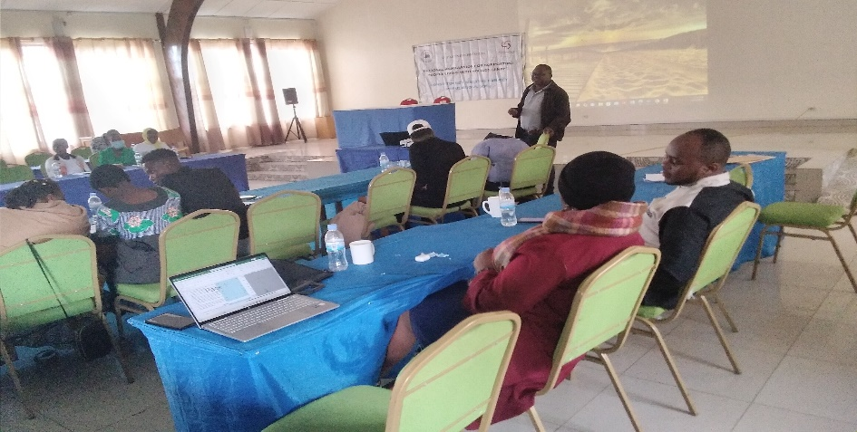

The DAF in ANSP+ during his concluding remarks

Done at Kigali on 10 /11/2024

**The ANSP+ TEAM IN MISSION**

-Aimable BUCYANAYANDI

-MUKAYIRANGA Marceline

-UMUTONIWAMANA Laurence

-NIZEYIMANA Jean Marie Vianney

-MUKASEKURU Deborah