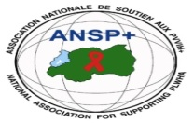  **[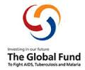](http://scottfiller.info/)**

**PROJECT: ANSP+/RBC/SPIU**

**ACTIVITY: CONDUCT A ROBUST AWARENESS TARGETING YOUTH FOCUSING ON HIV, STIs, SRHR, DRUG AND ALCOHOL ABUSE, USING VARIOUS FORMS OF AWARENESS AND MEDIA CAMPAIGN**

**→ WORKSHOP/MEDIA CAMPAIGN AT NYAGATARE DISTRICT**

1. **INTRODUCTION**

The National Association for Supporting People Living with Hiv/Aids (Ansp+) in collaboration with the Rwanda Biomedical Centre (RBC) through the Global Fund, commenced a two-days comprehensive training program aimed at enhancing group of people from key population from Musanze District, including female sex workers and MSM, mobilization efforts towards combatting HIV/AIDS and STIs.

1. **DATE AND VENUE**

Workshop took place in Eastern Province, Nyagatare District, at Moonlight Hotel, on 20th – 21st November 2024.

1. **TARGET GROUP**

The workshop was attended by five staff members of ANSP+, four journalists from different media houses working at Nyagatare District, three health care providers from Nyagatare, Rurenge and Bugaragara Hospital and nine female sex workers and MSM coming from different KPs’ associations.

1. **CAMPAIGN ACHIEVEMENTS**

**IV.1. WORK DONE**

This report outlines the key discussions during the ANSP+ two-day training workshop on health, focusing on HIV, sexually transmitted infections (STIs), Sexual Reproductive Health and Rights (SRHRs) Ebola Virus Disease (EVD), Marburg Virus Disease (MVD), and Mpox. The sessions aimed to educate healthcare providers and key populations on the symptoms, transmission, and prevention strategies of these diseases to enhance awareness and promote healthier communities. Joseph Nziringirimana, the trainer of this workshop, opened the day-one session by discussing on HIV/AIDS and Sexual Transmitted Infections (STIs).

1. **HIV/AIDS**

**Symptoms:**  
HIV infection progresses through stages, with initial symptoms including fever, fatigue, sore throat, and swollen lymph nodes. In advanced stages (AIDS), symptoms can include rapid weight loss, recurring fever, prolonged swelling of lymph glands, diarrhea, and opportunistic infections like tuberculosis or pneumonia.

**Transmission:**

* Through unprotected sexual contact with an infected person.
* Sharing needles or syringes.
* From mother to child during pregnancy, childbirth, or breastfeeding.
* Through transfusions of infected blood or blood products.

**Prevention Strategies:**

* Consistent and correct use of condoms.
* Regular HIV testing and knowing one’s status.
* Using antiretroviral therapy (ART) for those infected to reduce transmission.
* Safe needle practices and avoiding sharing syringes.
* Education and awareness about safe sexual practices.

1. **Sexually Transmitted Infections (STIs)**

**Symptoms:**  
STIs encompass various infections such as gonorrhea, syphilis, chlamydia, herpes, and HPV. Symptoms vary by disease but may include genital sores, unusual discharge, pain during urination or intercourse, and rashes. Some STIs, like chlamydia and gonorrhea, may initially show no symptoms, increasing the risk of complications if untreated.

**Transmission:**  
STIs primarily spread through unprotected sexual contact (vaginal, anal, or oral) with an infected partner. They can also be passed from mother to child during childbirth or, in some cases, through shared needles or personal items.

**Prevention Strategies:**

* Consistent and correct use of condoms during sexual activity.
* Limit the number of sexual partners and avoid risky sexual behaviors.
* Regular STI screenings, particularly when changing partners.
* Timely treatment of both partners to prevent reinfection.
* Vaccination against HPV and Hepatitis B.

1. **Ebola Virus Disease (EVD)**

**Symptoms:**  
Ebola presents a wide range of symptoms, which typically appear between 2 and 21 days after exposure. Early signs include high fever, severe headaches, and muscle pain. As the disease progresses, symptoms intensify, including abdominal pain, vomiting, diarrhea, skin rash, and red eyes. In severe cases, internal and external bleeding may occur, leading to organ failure.

**Transmission:**  
Ebola spreads through direct contact with body fluids such as blood, saliva, sweat, feces, urine, breast milk, or semen from an infected person. It can also be contracted through contact with contaminated surfaces or materials. The virus remains highly infectious even in deceased individuals, making burial practices a significant risk if not handled properly.

**Prevention Strategies:**

* Maintain rigorous hand hygiene using soap and water or alcohol-based hand sanitizer.
* Avoid direct contact with infected individuals or their bodily fluids.
* Use protective equipment (gloves, masks, gowns) when caring for suspected cases.
* Report symptoms promptly to health authorities and isolate suspected cases to prevent further spread.
* Avoid consumption of wild animals or bushmeat in outbreak areas.

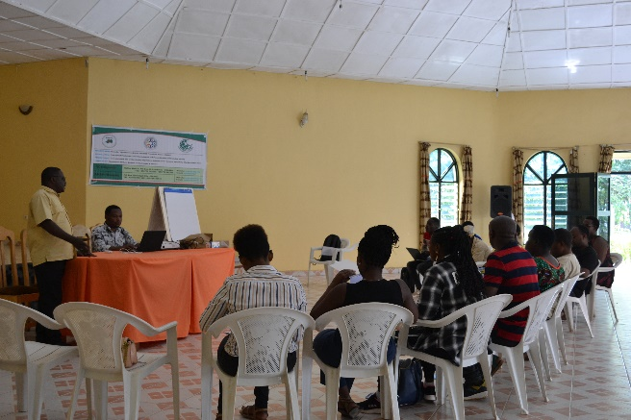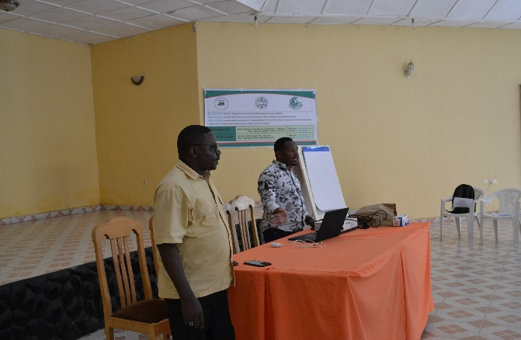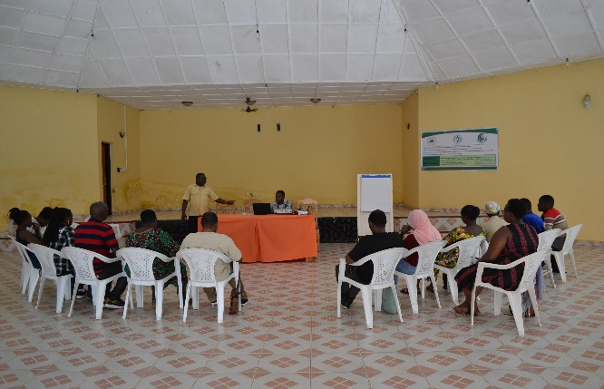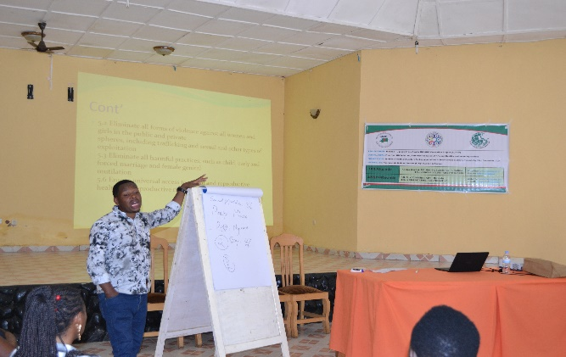

**Photos: Day-one of Training workshop**

**On the following day**, Mr. Joseph together with the group, reminded one another on the day-one subject to continue with the second day whereby they started by discussing new viruses that were recently detected in Rwanda.

1. **Marburg Virus Disease (MVD)**

**Symptoms:**  
Symptoms of MVD appear between 3 and 21 days post-exposure. Initial signs are similar to other febrile illnesses, including high fever, severe headaches, muscle aches, and extreme fatigue. As the disease advances, symptoms include vomiting, abdominal pain, diarrhea, and bleeding from multiple body orifices.

**Transmission:**  
MVD is primarily transmitted through direct contact with the body fluids of an infected individual or contaminated objects and surfaces. It can also spread through handling infected animals, such as fruit bats, which are natural hosts.

**Prevention Strategies:**

* Avoid direct contact with infected individuals or their fluids.
* Use personal protective equipment in healthcare or caregiving settings.
* Avoid entering caves or mines inhabited by fruit bats.
* Cook all meat thoroughly before consumption, especially bushmeat.
* Report any symptoms immediately to local health authorities.

1. **Mpox (Monkeypox)**

**Symptoms:**  
Mpox symptoms typically begin with fever, chills, and muscle aches, followed by the appearance of a rash. This rash often starts on the face or genital area and spreads to other parts of the body. The lesions progress from flat red spots to raised pustules that scab over before healing. Additional symptoms may include swollen lymph nodes, fatigue, and headaches.

**Transmission:**  
The virus spreads through close contact with an infected person's skin lesions, bodily fluids, or respiratory droplets. It can also spread through sexual contact, shared personal items like towels or bedding, and contact with infected animals.

**Prevention Strategies:**

* Avoid close physical contact with infected individuals or their belongings.
* Practice good hand hygiene, including regular washing with soap and water.
* Refrain from engaging in sexual activity with symptomatic individuals.
* Get vaccinated if in a high-risk group, especially healthcare workers and those in endemic areas.

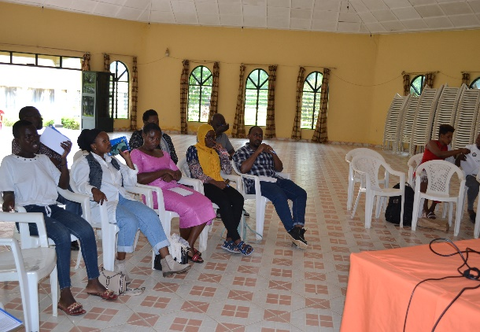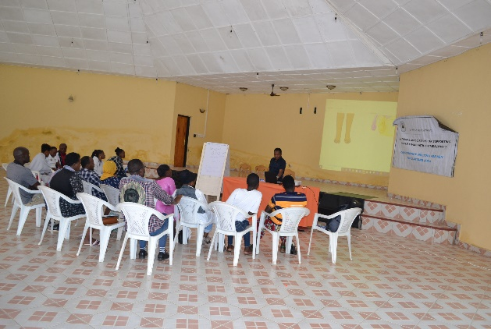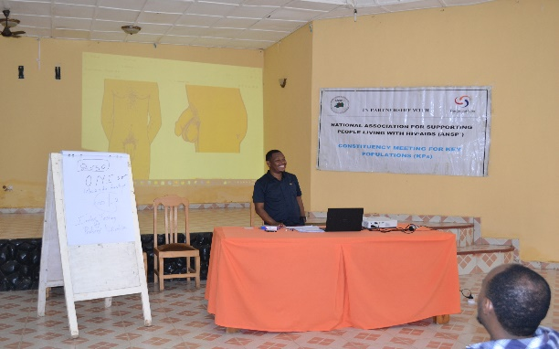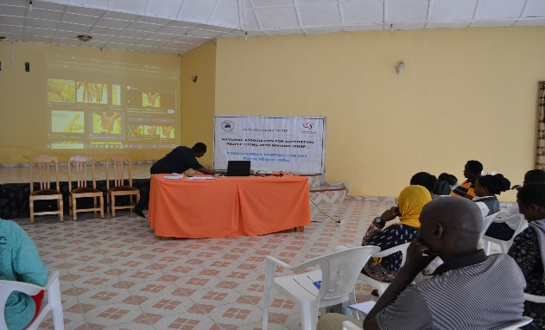

**Photos: Day-2 of training workshop**

**IV.2. Key Takeaways**

* The importance of timely diagnosis and treatment of infectious diseases to prevent long-term health impacts.
* Hygiene and preventative measures remain the most effective way to curb transmission.
* Community engagement and education are critical in addressing health challenges.

**Recommendations and Suggestions**

* **Sustain and Expand Financial Support Programs**  
  Building on the promise by Mr. Nizeyimana Jean Marie Vianney, ANSP+’s Director of Administration and Finance (DAF) should continue to provide financial assistance to support income-generating activities, including poultry farming, sorghum cultivation, and pig breeding. Expanding these programs to reach more beneficiaries can enhance self-reliance and improve community livelihoods.
* **Provide Capacity Building for Sustainable Practices**

**Conclusion**

The ANSP+ training workshop emphasized the critical importance of awareness, early diagnosis, and adherence to prevention measures to combat these diseases effectively. By equipping healthcare providers and key populations with this knowledge, communities can mitigate the impact of these serious health threats. Continuous education and resource provision will be essential for sustaining these efforts and protecting public health.

This detailed breakdown provides a clear understanding of each disease, empowering stakeholders to take informed actions in their prevention and management efforts.

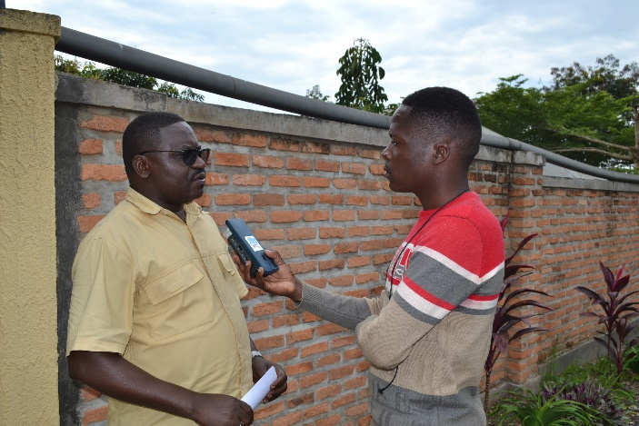

**Photos: DAF having interviews with journalists**

**LINKS TO ARTICLES PRODUCED:**

* 1. **Kigali Today:** [**https://www.kigalitoday.com/ubuzima/indwara/article/35-by-abakora-uburaya-bafite-virusi-itera-sida-minisante**](https://www.kigalitoday.com/ubuzima/indwara/article/35-by-abakora-uburaya-bafite-virusi-itera-sida-minisante) **(**This story have got people’s attention as they gave their comments on it on Kigali Today’s website.)
  2. **Flash Radio - 90.4 FM: The story was published on this radio on 22nd November 2024, at 1:00 PM**
  3. **Salus Radio - 97.0 and 101.9: The story also was published on 22nd November 2024, at 5:00 PM**

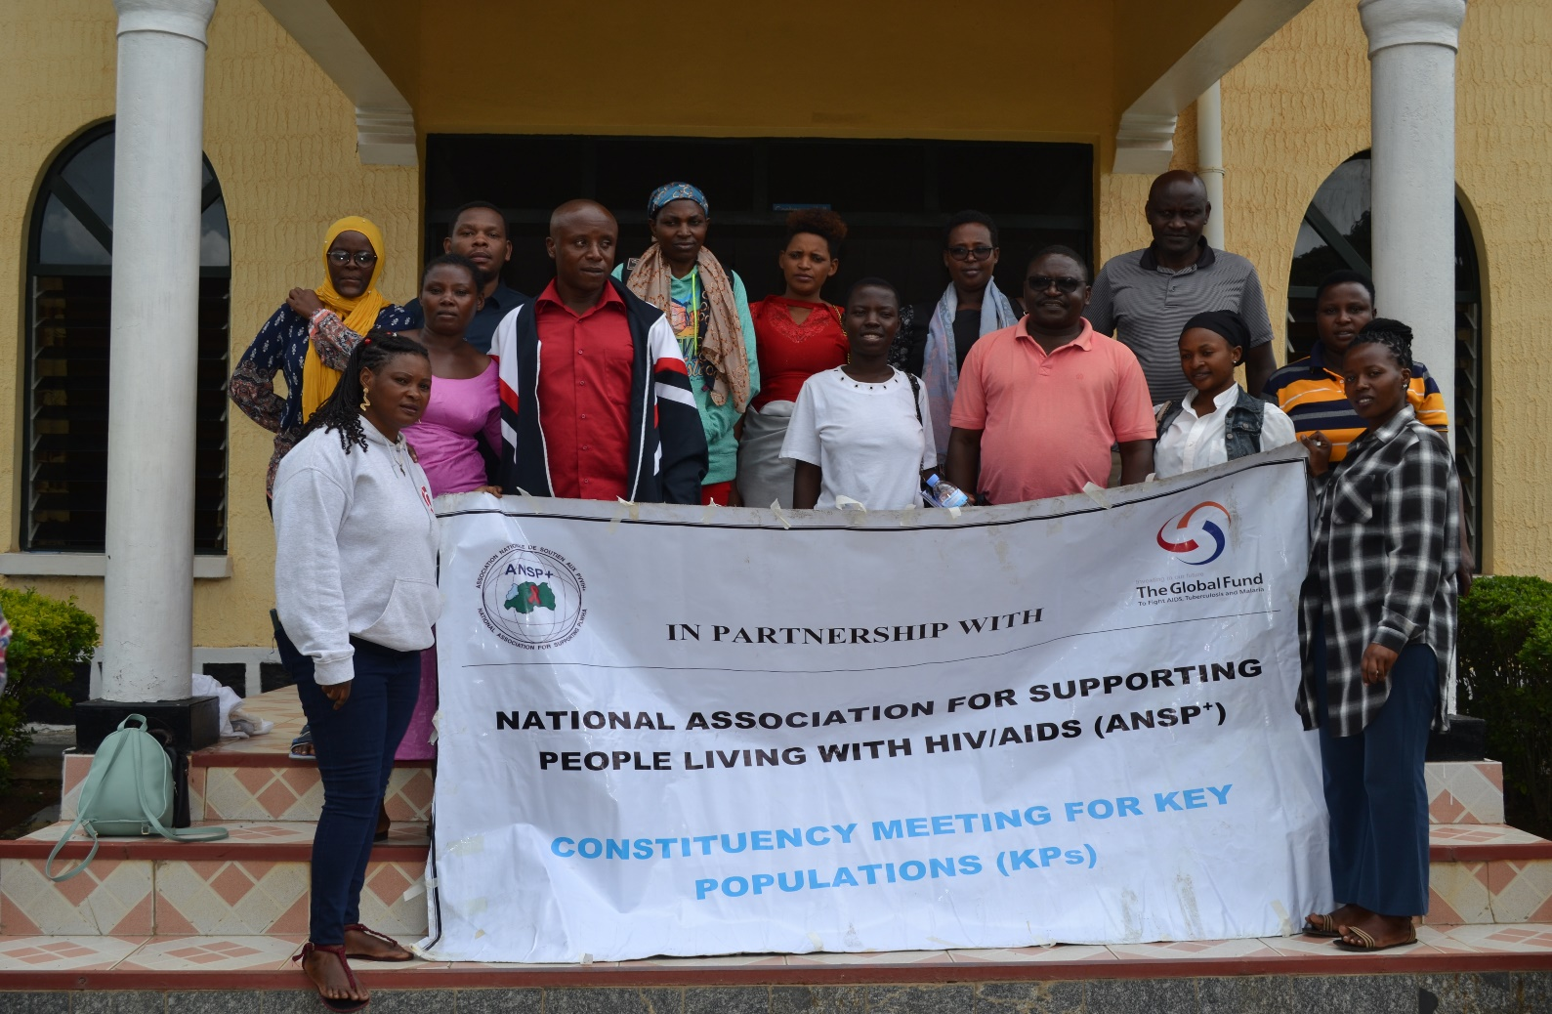

**A group photo that was captured after the workshop**

**ANSP+ TEAM MEMBERS WHO ATTENDED THE WORKSHOP:**

**UMUTONI WA MANA Laurence,**

**NIZEYIMANA Jean Marie Vianney,**

**UZABAKIRIHO Jean Gabriel,**

**MUKASEKURU Deborah,**

**NZIRINGIRIMANA Joseph.**