

**PROJECT NAME: ANSP+/RBC/SPIU**

**NAME OF ORGANIZATION: NATIONAL ASSOCIATION FOR SUPPORTING PEOPLELIVING WITH HIV/AIDS (ANSP+)**

**ACTIVITY: CONDUCTING SUPPORTIVE SUPERVISIONS OF ACTIVITIES OF KEY POPULATIONS (LGBTIs/MSM and/or FEMALE SEX WORKERS)**

**AREA OF INTERVENTION: NYAGATARE**

**MISSION EXECUTION REPORT**

**I`INTRODUCTION**

ANSP+ stands as a National Association for Supporting People living with HIV/AIDS. It is a Rwandan local Non-Governmental Organization created in September 2000 by People Living with HIV themselves, with the leading mission of striving for the quality of life of HIV infected /affected people in Rwanda and fighting against the spread of HIV/AIDS and other epidemics. Not only ANSP+ works in the domain of HIV, but also serves in the domain of poverty reduction and human rights. Towards this mission, our core beneficiaries include Key Populations which most of them live in poverty that, in a way or another leads them into sex working and therefore running a risk of getting HIV.

Apart from mobilizing key populations about drug compliance and preventive techniques, the ANSP+ also initiates key populations on profitable activities.

Through cooperatives and associations, the national association for supporting people living with HIV has been supporting key populations in how to make profitable activities that would help them going away from sex working and therefore making money leading to their welfare.

Working in this framework, ANSP+ under the sponsorship by Global Fund via RBC has organized a two days supervision to its constituencies to see how well they are getting engaged in income generating activities so as to learn about their achievements and challenges and therefore advising them accordingly

1. **FIELD WORK OBJECTIVE**

The objectives of this field work are designed as follows:

* To discuss with the KPs’ cooperatives/associations/self-helping groups members on the income generating activities being carried out;
* To visit the activities of KPs at the ground;
* To evaluate the opportunities, challenges being faced along with the implementations of their activities;
* To advise KP cooperatives/associations/groups members on how to continue working with their cooperatives/associations.

**MISSION EXECUTION**

This supervision work has been conductedin Nyagatare for two days. It was organized by the technical staff of ANSP+ and it was carried out targeting KPs in areas mentioned here below.

Hope for future Organizations Associations of Mimuri Sector was visited on the 15/11/2024 and

Duterimbere Association of Rwempasha Sector.

**1.HOPE FOR FUTURE ASSOCIATION**

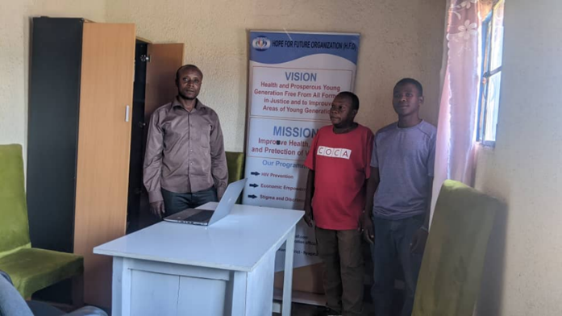 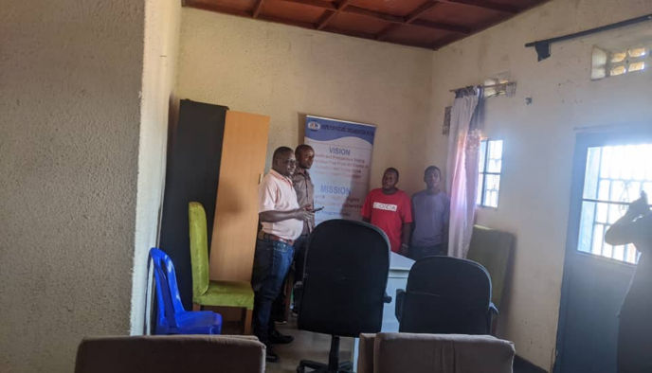

Fig1. This Association is committed with poultry farming activities and now they are able to solve their own needs.

***Findindings and observation:*** This association is located in Est Province,Nyagatare District,Mimuri Sector; is formed by 13 members made by LGBTIs themselves. They have decided to do Income generating activities in order to solve their daily living challenges. At the beginning they were suported finacially by ANSP+/FuG/KC with a start up capital of 300.000Frw. Basically, at the beginning they bought 100 hens composed by 50 which produce eggs and others 50 to produce meat. They said that the business is running well but they need to increase the number of the hens from 100 to 200.ANP+ team were excited to this wonderfull business and ask them how they do it a day by day. The President and Executive secretary of this Association both have explained how they take care those hens by buying the industrial products and help to feed the hens. Again they said that the have a market whey supply eggs and meats. They said that every month, they collect their income then take 20% of this income to be shared by them in order to helping them to solve their own basic needs. Then, they take 45.000 Frw to rent house and take the remain one to the bank. After one year they sit together and see what they have deposited at Bank and take 40% to be shared by association members in order to pay health insurance and solve other family problems, then the 60% remained has to be reinvesited in the Business.

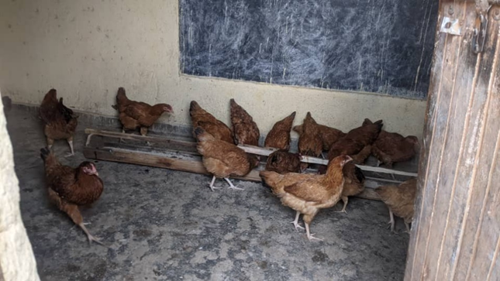 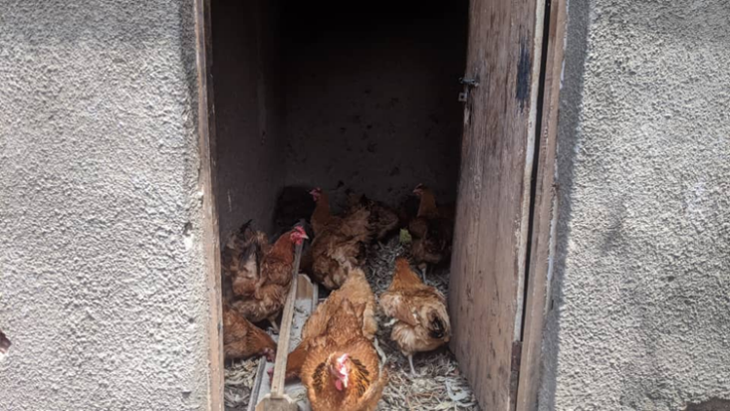

Fig 2: The poultry farming was the best choice to do by Hope for future Association

II.DUTERIMBERE ASSOCIATION

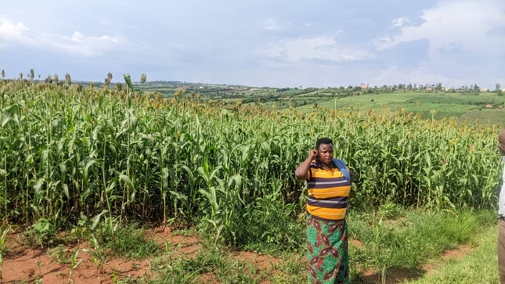 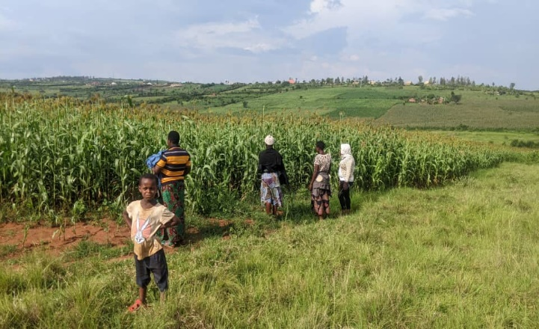Fig 3:This association is dealing with sorghum cultivation business in Rwempasha Sector and is having a hope of boosting their business once they get another support

***Findindings and observation:*** This association is called DUTERIMBERE located in Est Province,Nyagatare District,Rwempasha Sector; is formed by 20 members made by FSWs themselves. This association was provided with 400.000 FRw as start up capital from ANSP+/FUG/KC. They actual activities is to combine farming and domestic animals breeding. For this season, they prefered to do sorghum cultivation as Nyagatare is very good area to do this business as a fertilized soil region. They have rent this field for one year,with amount of 300.000 Frw. They told us that they will cultivate 3 seasons within one year, with 2 seasons of sorghum and one season of maizes. Again, they assured us that they will harvest around 3 tones of production. We asked them how they do their activities to take care of their business and told us that every month they meet together and work in the field. After the period of three months when the crops are ready to be harvested , they collect their production then take 20% of this income to be shared by them in order to helping them to solve their own basic needs. Then, take the remain one to the bank. After one year they sit together and see what they have deposited at Bank and take 40% of it has to be shared by association members in order to pay health insurance and solve other family problems, then the 60% remained has to be reinvesited in the Business.

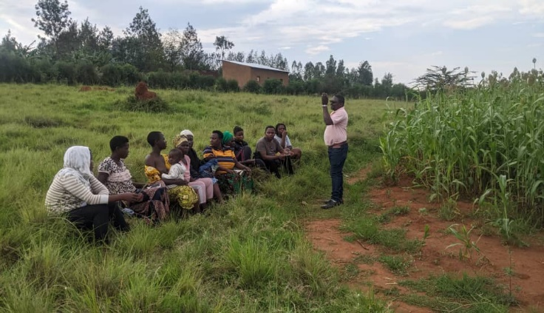 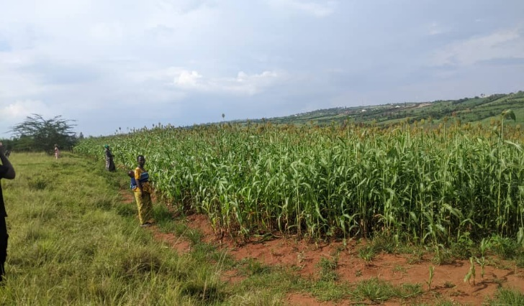

ANSP+ deleguation team took time to exchange and discuss with Duterimbere association members on how they can increase the level of understnding regarding business boosting.

**RECOMMENDATION:** Both Associations are well conducting their activities as usual, but they are all complaining about insufficient capital in order to boost their business. If any little startup capital will be available, they might be supported accordingly.

**CONCLUSION:** In general, this mission was highly well conducted and we assume that the objective was well achieved.

**STAFF IN MISSION**

MUKASEKURU Deborah

NIZEYIMANA Jean Marie Vianney

NZIRINGIRIMANA Joseph

MUTONIWAMANA Laurence

UZABAKIRIHO Jean Gabriel