NATIONAL ASSOCIATION FOR SUPPORTING PEOPLE LIVING WITH HIV/AIDS (ANSP+)

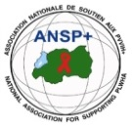

***In partnership with***

[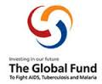](http://scottfiller.info/blog/)

**PROJECT NAME: ANSP+/RBC/SPIU**

**ACTIVITIES NARRATIVE REPORT**

***Period: October – December 2024***

BY

ANSP+

***Kigali, January 2025***

**QUARTER NARRATIVE REPORT OCTOBER-DECEMBER 2024**

1. **INTRODUCTION**

The National Association for Supporting People Living with HIV/AIDS (ANSP+), in partnership with the Rwanda Biomedical Center (RBC) and funded by the Global Fund, implemented a series of activities during the reporting period to support key populations (KPs), healthcare providers, and other stakeholders. These activities aimed to address health challenges, improve service delivery, and promote community engagement.

The report outlines three key activities conducted during this period: supervision of Key Populations’ activities, robust awareness campaigns, and capacity-building workshops. These initiatives were implemented in Musanze District, Nyagatare District, Huye District, and Kigali City. All those fieldwork activities were conducted during this period of three months from October to December 2024.

1. **CONDUCTED ACTIVITIES:**
2. **SUPERVISION OF ACTIVITIES**

**Dates**: November 7–8, 2024 (Musanze District) and November 15–16, 2024 (Nyagatare District)

1. **Objectives**

The supervision aimed to:

1. Assess the progress of income-generating activities conducted by KP cooperatives and associations.
2. Evaluate challenges and provide recommendations to improve their sustainability.
3. Encourage collaboration among members to strengthen community support.
4. **Activities and Findings**
   1. **Musanze District**  
      Supervision visits were conducted in Muko and Cyuve Sectors. Associations such as Duhozanye, Tubureke, and Abihuje demonstrated innovative approaches to income generation, including tailoring, maize, and sweet potato cultivation. Members showcased robust saving mechanisms that support health insurance and reinvestment in business activities.

**Duhinduke Dukore Association** consists of 10 Members, their activities are; tailoring and maize cultivation. Members contribute 20% of monthly income for basic needs, 40% for rent, and the remainder is saved. Annual savings are split, with 40% used for health insurance and family support, and 60% reinvested in business activities.

**Tubureke Association** is made up of three members.Their income generating activities is **t**ailoring, including training peers for additional income. Members allocate 20% of income for basic needs, 50,000 RWF for rent, and save the remainder. Annual savings are split similarly to Duhinduke Dukore.

**Abihuje Association** has two Members, they are Hairdressers, with previous members transitioning to other trades such as motorcycling and construction. Members contribute 20% of income for basic needs, 55,000 RWF for rent, and save the rest. Annual savings follow the same distribution model as other associations.

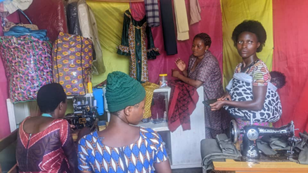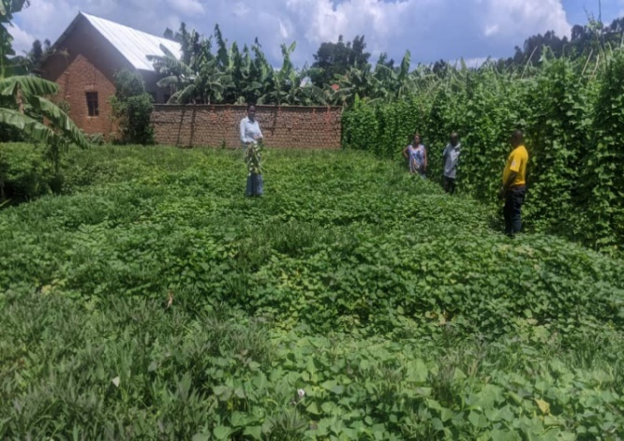

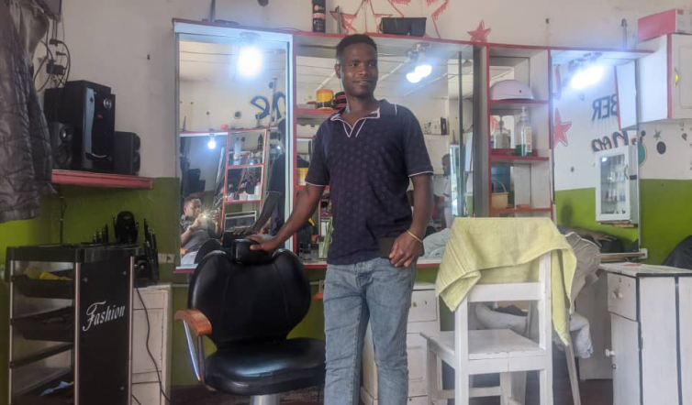

PHOTOS THAT SHOW MUSANZE BENEFICIARIES AND THEIR INCOME GENERATING ACTIVITIES

* 1. **Nyagatare District**

**Hope for Future Association** (Mimuri Sector) with 13 members engaged in poultry farming. Monthly income is allocated with 20% for basic needs, 45,000 RWF for rent, and the remainder saved. Annual savings are split with 40% used for health insurance and family needs, and 60% reinvested.

**Duterimbere Association** (Rwempasha Sector) which has 20 Members, they cultivate Sorghum and maize, leveraging fertile soils in Nyagatare. The association also engages in domestic animal breeding. Monthly income is divided with 20% for basic needs, and the remainder saved. After annual reviews, 40% of savings support health insurance and family needs, while 60% is reinvested.

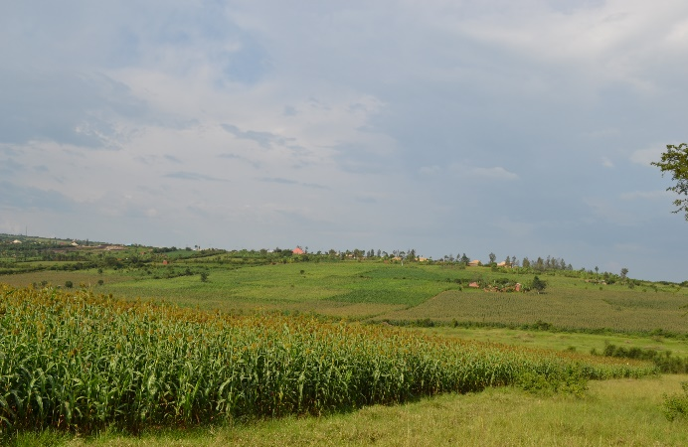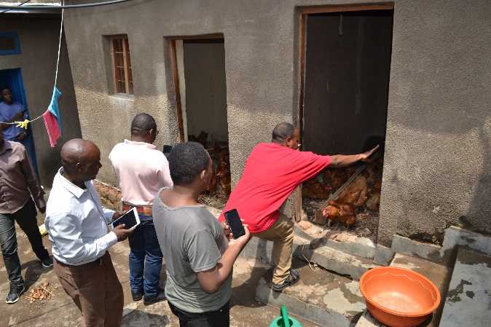

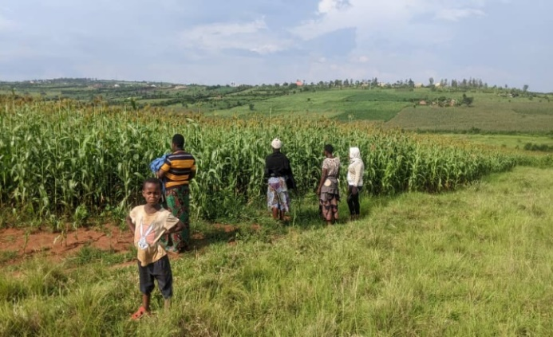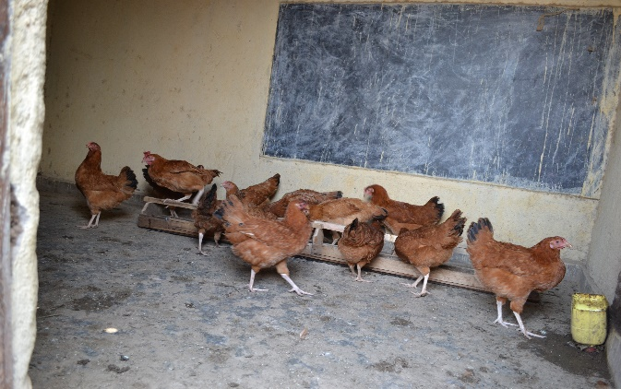

PHOTOS: Activities that are carried out by Duterimbere Association (RIGHT) and Hope for Future Association (LEFT)

* 1. **General Challenges**

1. Limited access to financial resources to scale up business activities.
2. Persistent stigma and discrimination faced by some association members.
   1. **General Recommendations**
3. Provide additional startup capital to support income-generating activities.
4. Organize regular capacity-building sessions for association members to strengthen their business management skills.
5. **ROBUST AWARENESS CAMPAIGNS**

**Dates**: November 7–8, 2024 (Musanze District) and November 20–21, 2024 (Nyagatare District)

1. **Objectives**
2. Raise awareness on HIV, SRHR, STIs, drug and alcohol abuse, and emerging diseases (Ebola, Mpox, Marburg).
3. Enhance the role of journalists and healthcare providers in community mobilization.
4. Create platforms for collaboration among healthcare providers, journalists, and key populations.
5. **Activities and Findings**
   1. **Musanze District**  
      The campaign targeted 10 key populations, 10 healthcare providers, and journalists. Discussions covered topics such as HIV transmission, prevention methods, and SRHR. Participants highlighted the need for ongoing education and collaboration to combat stigma and discrimination.
   2. **Nyagatare District**

The two-day training included participated by four journalists from different media houses working at Nyagatare District, three health care providers from Nyagatare, Rurenge and Bugaragara Hospital and nine female sex workers and MSM coming from different KPs’ associations. Participants discussed the importance of early diagnosis and community mobilization in addressing health challenges.

* 1. **Articles that were published:**

**Kigali Today:** [**https://www.kigalitoday.com/ubuzima/indwara/article/35-by-abakora-uburaya-bafite-virusi-itera-sida-minisante**](https://www.kigalitoday.com/ubuzima/indwara/article/35-by-abakora-uburaya-bafite-virusi-itera-sida-minisante) **(**This story have got people’s attention as they gave their comments on it on Kigali Today’s website.)

**Flash Radio - 90.4 FM: The story was published on this radio on 22nd November 2024, at 1:00 PM**

**Salus Radio - 97.0 and 101.9: The story also was published on 22nd November 2024, at 5:00 PM**

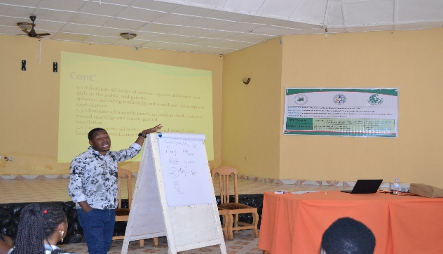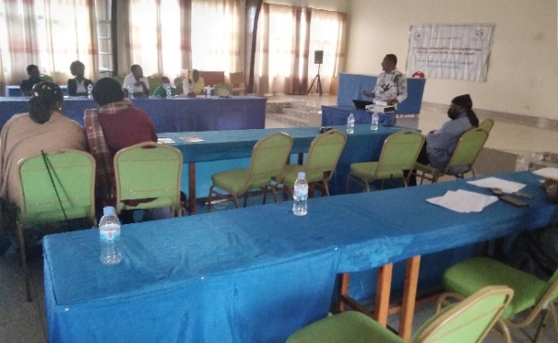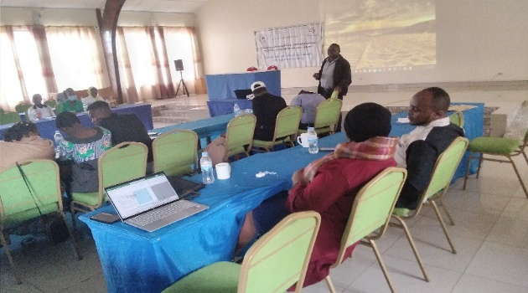 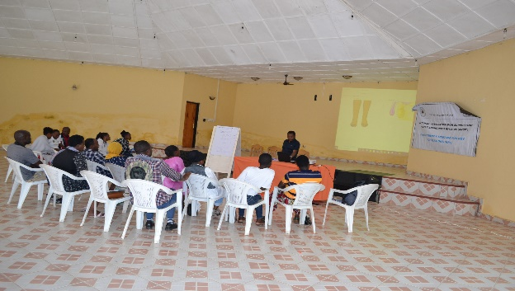

PHOTOS: Beneficiaries during awareness campaigns in Musanze District (Right) and Nyagatare District (Left)

* 1. **Challenges**

1. Persistent stigma and discrimination against key populations.
2. Limited access to healthcare services due to fear of judgment.
   1. **Recommendations**
3. Increase awareness campaigns to address stigma.
4. Train healthcare providers to offer non-discriminatory, friendly services.
5. **CAPACITY-BUILDING WORKSHOPS**

**Dates**: December 3–6, 2024 (Huye District) and December 10–12, 2024 (Kigali City)

1. **Objectives**
2. Equip participants with knowledge to address high-burden diseases (HIV, STIs, TB, malaria, Ebola, Mpox, and Marburg).
3. Foster collaboration among healthcare providers, umbrella members, and ANSP+ staff.
4. Build capacity in disease prevention and health advocacy.
5. **Activities and Findings**

**2.1. Huye District**  
The four-day workshop engaged 20 KPs, 6 healthcare providers, 4 healthcare providers/other stakeholders, 1 training workshop facilitator, and 5 staff members of ANSP+. Participants gained knowledge on disease prevention and health service delivery. The workshop also addressed stigma among healthcare providers and emphasized the importance of empathy in service delivery.

**2.2. Kigali City**

The two-day workshop focused on strengthening the capacity of 20 KPs and 3 healthcare providers, 1 training workshop facilitator, and 5 staff members of ANSP+. Interactive sessions covered a range of topics, including mental health and emerging diseases. Participants noted the need for more time to thoroughly cover all topics.

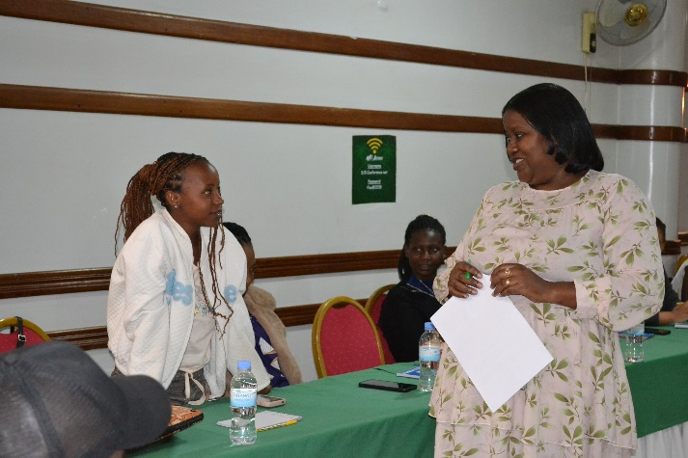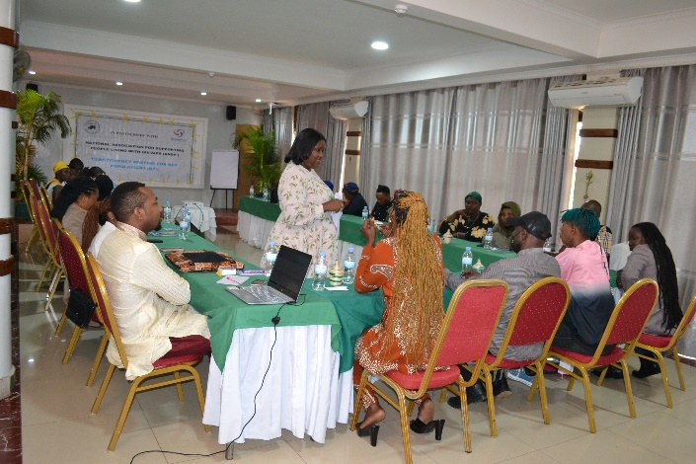

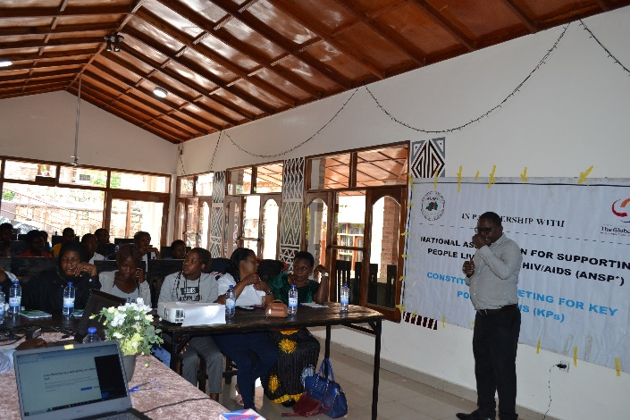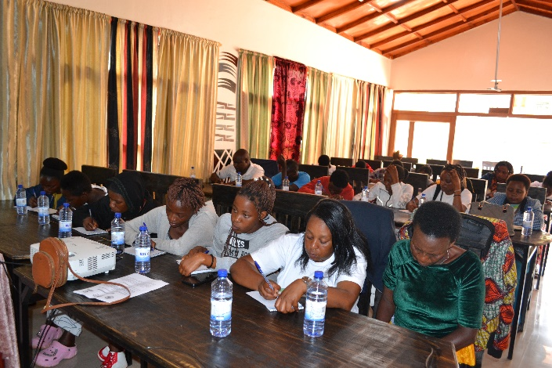

PHOTOS: Beneficiaries during capacity building workshopsKigali City (up) & Huye District (down)

* 1. **Challenges**

1. Stigma among healthcare providers toward key populations.
2. Insufficient time for in-depth coverage of extensive topics.
   1. **Recommendations**
3. Extend the duration of workshops to ensure comprehensive learning.
4. Organize regular capacity-building sessions to reinforce knowledge retention.
5. **Conclusion**

The activities implemented during this quarter significantly contributed to improving the lives of key populations and enhancing community mobilization in addressing health challenges. Despite challenges such as stigma and financial constraints, the initiatives achieved notable success in raising awareness, promoting collaboration, and building capacity.

Moving forward, ANSP+ remains committed to sustaining these efforts through continued advocacy, training, and delivering financial support from its partners.

**OTHER PHOTOS:**

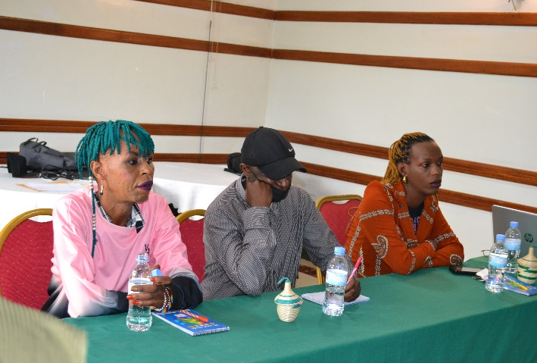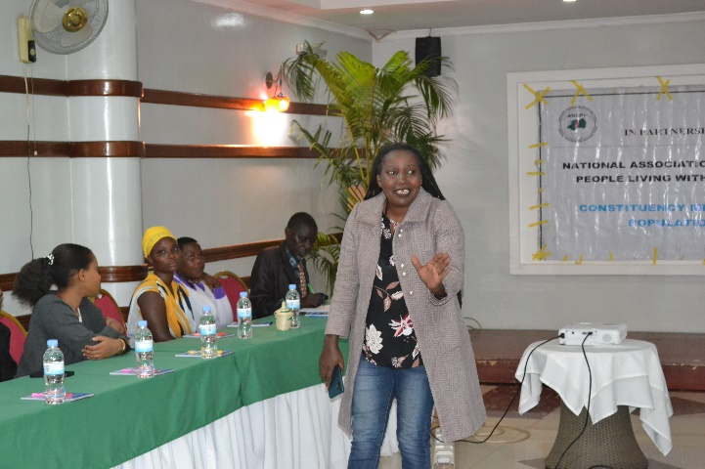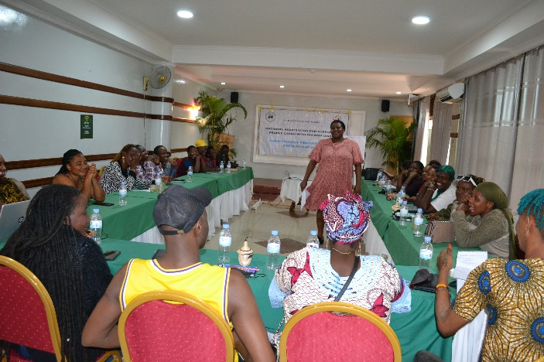 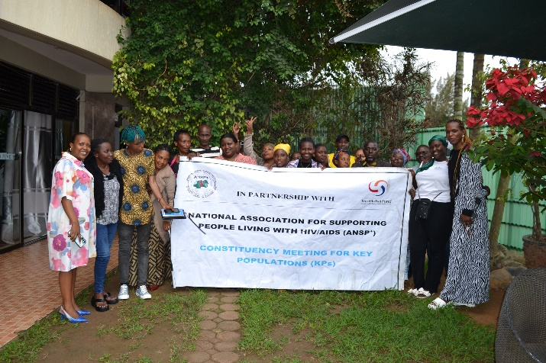

PHOTOS: Kigali city during capacity building trainings/workshop

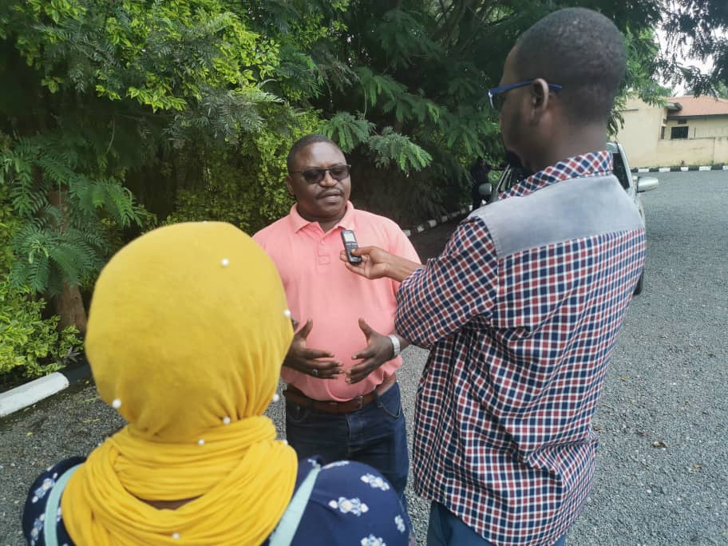 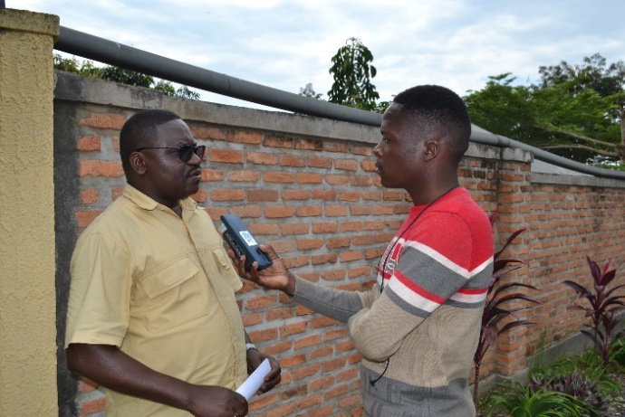

Photos: Journalists interviewing DAF, Nizeyimana J.M Vianney

Prepared by Jean Gabriel UZABAKIRIHO

Approved by Coordinator, Deborah MUKASEKURU