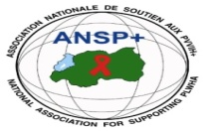

PROJECT NAME: ANSP+/RBC/SPIU

NAME OF ORGANIZATION: NATIONAL ASSOCIATION FOR SUPPORTING PEOPLE LIVING WITH HIV/AIDS (ANSP+)
ACTIVITY: CONDUCTING SUPPORTIVE SUPERVISIONS OF ACTIVITIES OF KEY POPULATIONS (LGBTIs/MSM and/or FEMALE SEX WORKERS)
AREA OF INTERVENTION: Karongi District

MISSION REPORT

- INTRODUCTION
The National Association for Supporting People Living with HIV/AIDS (ANSP+) is a national non-governmental organization established in September 2000 by People Living with HIV. Its core mission is to improve the quality of life of HIV-infected and affected people while contributing to the prevention of HIV/AIDS and other epidemics. In addition to health interventions, ANSP+ works in the areas of human rights, poverty reduction, and socio-economic empowerment.
Key Populations, particularly Female Sex Workers (FSWs), continue to face economic vulnerability, stigma, and discrimination, which increase their exposure to health and social risks. In response, ANSP+, with support from the Global Fund through Rwanda Biomedical Centre (RBC), promotes income-generating activities as a strategy to reduce vulnerability and improve livelihoods.
Within this framework, ANSP+ conducted a three-day supportive supervision and coordination meeting in Karongi District to engage with Key Populations, assess ongoing income-generating activities, identify challenges, and provide guidance and advocacy support.
- OBJECTIVES OF THE VISIT
The objectives of the visit were to:
- Introduce the purpose of the visit and reaffirm ANSP+’s supportive role;
- Engage with cooperative members to understand their needs for improving income-generating activities;
- Assess existing economic activities conducted by the cooperative;
- Identify key challenges affecting income generation and social inclusion;
- Provide guidance on personal safety, health protection, and future economic opportunities.
- TARGET GROUP
The activity targeted 10 members of Tubureke Twihangire Imirimo Cooperative, composed entirely of Female Sex Workers operating in Karongi District.

- DATE AND VENUE
The field supervision was conducted from 10th to 12th December 2025 in Karongi District, Bwshyura Sector.
- MISSION EXECUTION AND KEY DISCUSSIONS
The supervision meeting was opened by the Director of Administration and Finance, Nizeyimana Jean Marie Vianney, who introduced the purpose of the visit. He emphasized that ANSP+ was conducting the visit to provide support and to listen directly to the cooperative members regarding their needs for strengthening and expanding their income-generating activities.
During the discussions, Ms. Cecile Uwimana, President of Tubureke Twihangire Imirimo Cooperative – Karongi, expressed her appreciation for the support received from ANSP+. She acknowledged that the assistance provided has positively contributed to the cooperative’s organization and resilience. However, she raised concerns about persistent stigma and discrimination faced by the members within the community, noting that they are often labeled as prostitutes and excluded from society. She requested ANSP+’s advocacy support to promote social acceptance and recognition of cooperative members as normal and productive members of society.
The cooperative reported that its 10 members are currently engaged in small-scale income-generating activities, including:
- Selling fruits in local markets;
- Selling isambaza fish sourced from Lake Kivu.

Members explained that while these activities help meet basic needs, they are limited by insufficient capital. They expressed a strong interest in expanding their income-generating activities and indicated that, with additional capital, they would engage in crop cultivation, particularly maize and potatoes, to increase and stabilize their income.
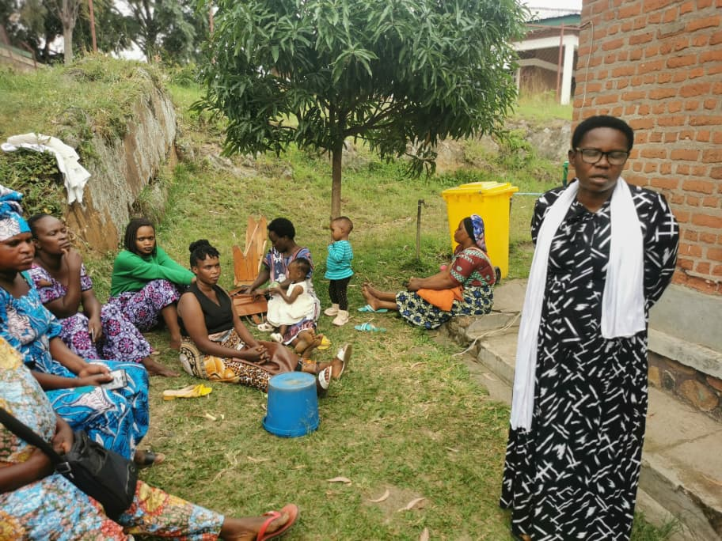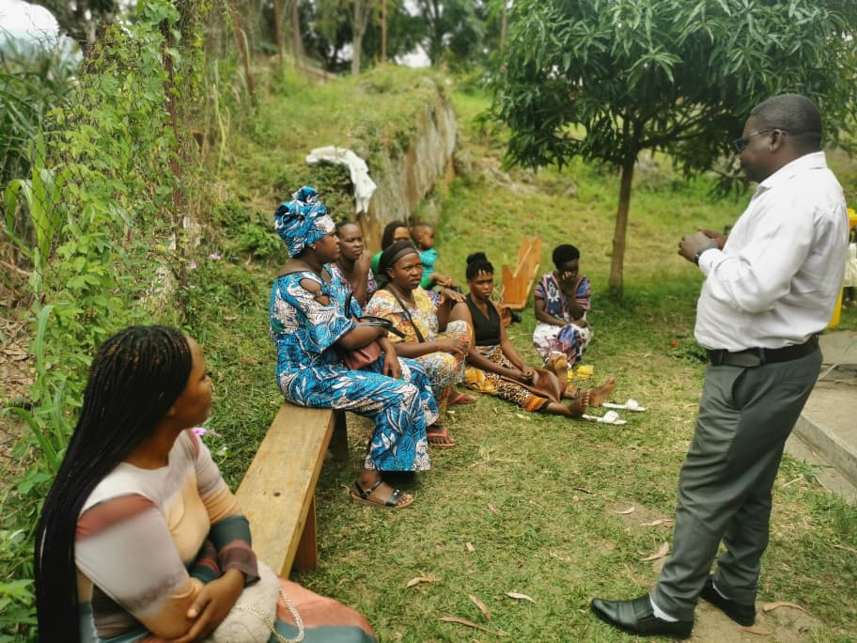
DAF and Cecile addressed their message to the association members

- CHALLENGES IDENTIFIED
- Persistent stigma and discrimination against Female Sex Workers in the community;
- Limited startup and expansion capital for income-generating activities;
- Limited diversification of economic activities due to financial constraints.

- RECOMMENDATIONS
- Strengthen advocacy efforts to reduce stigma and promote social inclusion of Key Populations;
- Mobilize additional resources to support startup or expansion capital for income-generating activities;
- Support cooperative members in diversifying income-generating activities, including crop cultivation;
- Conduct regular supportive supervision and follow-up visits to monitor progress and provide guidance.
- Advocacy for them to have access to condoms and lubricants, to strengthen their life protection.
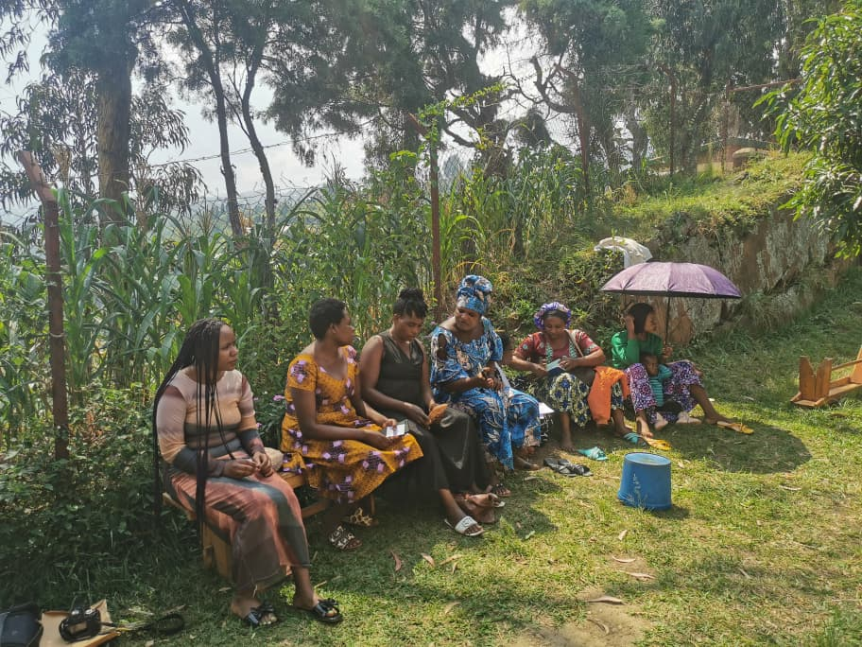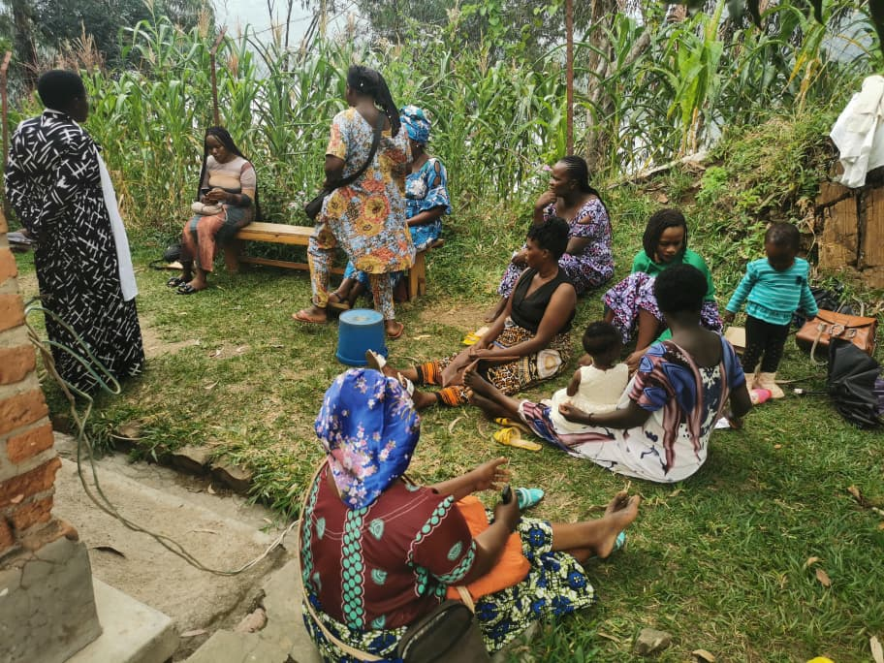
Photos of members during a supportive supervision meeting

- CONCLUSION
The supportive supervision in Karongi District provided valuable insights into the socio-economic realities and challenges faced by Female Sex Workers organized under Tubureke Twihangire Imirimo Cooperative. Despite limited resources and social barriers, the members demonstrated strong motivation and commitment to improving their livelihoods.
ANSP+ reaffirms its commitment to advocacy, socio-economic empowerment, and protection of the rights of Key Populations, in collaboration with RBC and other stakeholders, to ensure sustainable and dignified livelihoods.
DAF, further committed to conducting advocacy on behalf of the cooperative, particularly in addressing stigma and discrimination and exploring opportunities to support the expansion of their income-generating activities.

STAFF MEMBERS IN MISSION
- UZABAKIRIHO Jean Gabriel
- UMUTONI WA MANA Laurence
- NIZEYIMANA Jean Marie Vianney
- MUKASEKURU Deborah

