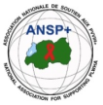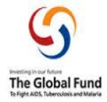
PROJECT NAME: ANSP+/RBC/SPIU

NAME OF ORGANIZATION: NATIONAL ASSOCIATION FOR SUPPORTING PEOPLE LIVING WITH HIV/AIDS (ANSP+)
NSP PROGRAM: COVID-19 IMPACT MITIGATION
ACTIVITY: THREE DAYS FIELD WORK FOR CAPACITY BUILDING THROUGH WORKSHOP, TRAINING WORKSHOP, AND OR COORDINATION MEETINGS WITH UMBRELLA'S MEMBERS TO INCREASE THEIR ENGAGEMENT IN COMMUNITY MOBILIZATION AFTER COVID-19 AND TOWARDS OTHER HIGH BURDENED DISEASES (HIV, STIs, TB, HEPATITIS, HCV, MALARIA, MARBURG VIRUS, EBOLA AND MENTAL HEALTH).
TARGET GROUP: KEY POPULATIONS
AREA OF INTERVENTION: MUSANZE DISTRICT
- INTRODUCTION

ANSP⁺ stands for the National Association for Supporting People Living with HIV/AIDS. It is a Rwandan local Non-Governmental Organization created in September 2000 by People Living with HIV themselves, with the leading mission of striving for the quality of life of HIV infected /affected people in Rwanda and fighting against the spread of HIV/AIDS and other epidemics. Towards this mission, our potential beneficiaries include Key Populations that run a high risk of getting HIV.

When we talk about HIV/AIDS, we can’t forget other epidemics such as TB, malaria, and nowadays COVID-19; in one way or another, there is a relationship between them, because HIV-positive people are most vulnerable to these epidemics.

Incidentally, it has been over three years since the Covid-19 pandemic reached Rwanda. As an international concern, through government preventive measures, people took action to prevent the disease through day-to-day measures. These include regular hand washing with soap and water, wearing masks, maintaining a social distance of at least one meter, avoiding touching the eyes, nose, and mouth, the lockdown, and being vaccinated. Due to these serious preventive measures taken and respected, the pandemic reduced its virulence, which is why the government has decided to soften some regulations regarding the pandemic, where wearing masks is no longer an obligation, while other preventive measures remain. Though the severity of the pandemic has reduced, it is still a concern.

Working in this framework, ANSP+ under the sponsorship of Global Fund organized four field works including a two-day training workshop for its constituencies to increase their engagement in community mobilization to continue fighting against pandemics. The fieldwork was conducted in the Huye District. .

This report highlights the key activities, outcomes, and recommendations from the mission, which included workshops, training, and coordination meetings.
- DATE AND VENUE
Workshop took place in Northern Province, Musanze District, at Muhabura Hotel, from 25th to 27th November, 2025.

- TARGET GROUP
The workshop was attended by four members of ANSP+, two local authorities, and 16 Key populations from different associations, such as TUBUTSINDE, ABIHUJE, and TUZAMURANE These associations include sex workers and MSM, and one training.

- ACTIVITIES IMPLEMENTED AND KEY DISCUSSIONS

Opening Session
The meeting was officially opened by Mr. NIZEYIMANA Jean Marie Vianney, Director of Administration and Finance (DAF) of ANSP+. In his opening remarks, he welcomed participants and emphasized that HIV and other pandemics remain a major barrier to socio-economic development. He highlighted the importance of collective responsibility in fighting HIV, substance abuse, and emerging diseases, while appreciating the support of the Global Fund and the Government of Rwanda through RBC.

Day One: COVID-19 Awareness and Public Health Preparedness
The first day of the awareness meeting focused on COVID-19, with the objective of reinforcing community knowledge on prevention, response, and public health preparedness. The facilitator engaged participants through interactive discussions to assess their understanding of COVID-19 and address prevailing misconceptions.
Key topics covered included:
- Definition and transmission of COVID-19;
- Common symptoms and warning signs;
- Preventive measures including hand hygiene, mask use, vaccination, and physical distancing;
- The importance of early testing, isolation, and seeking timely medical care;
- The impact of COVID-19 on vulnerable populations, particularly key populations and youth.
Participants actively contributed by sharing their experiences during and after the COVID-19 period, highlighting challenges such as access to healthcare services, stigma, and misinformation. The session emphasized the continued importance of vigilance, vaccination, and community responsibility in preventing future outbreaks.

On day-one participants also learnt about; HIV, STIs, and SRHR
The first day focused on HIV/AIDS, Sexually Transmitted Infections (STIs), and Sexual and Reproductive Health and Rights (SRHR). Using an interactive approach, the facilitator engaged participants through questions and discussions to assess their baseline knowledge.
Key topics covered included:
- Definition, transmission, and prevention of HIV;
- Importance of HIV testing, condom use, PrEP, and reduction of risky behaviors;
- Overview of STIs, symptoms, prevention, and treatment;
- SRHR as a fundamental human right and its role in empowering youth and key populations.
Participants actively engaged, particularly on SRHR-related issues, raising questions linked to reproductive health, access to services, and stigma.
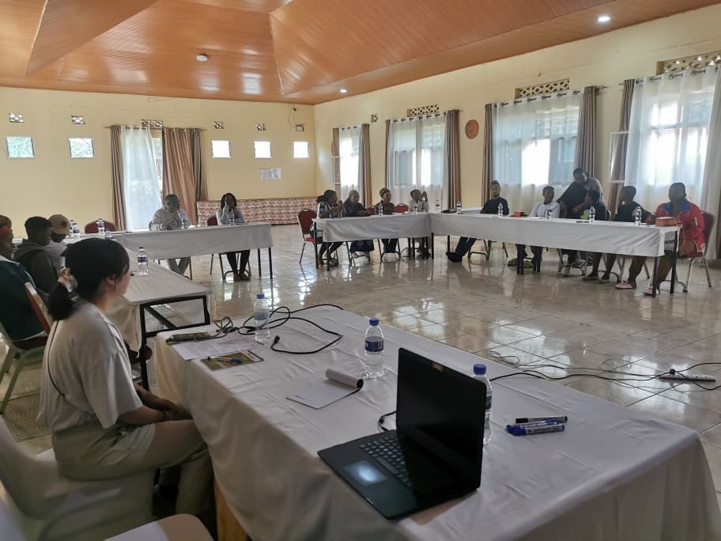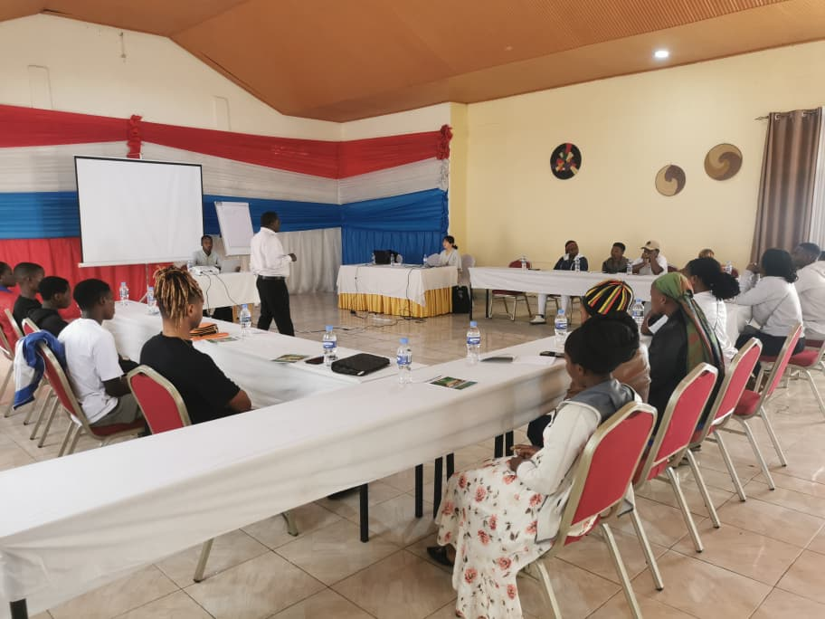
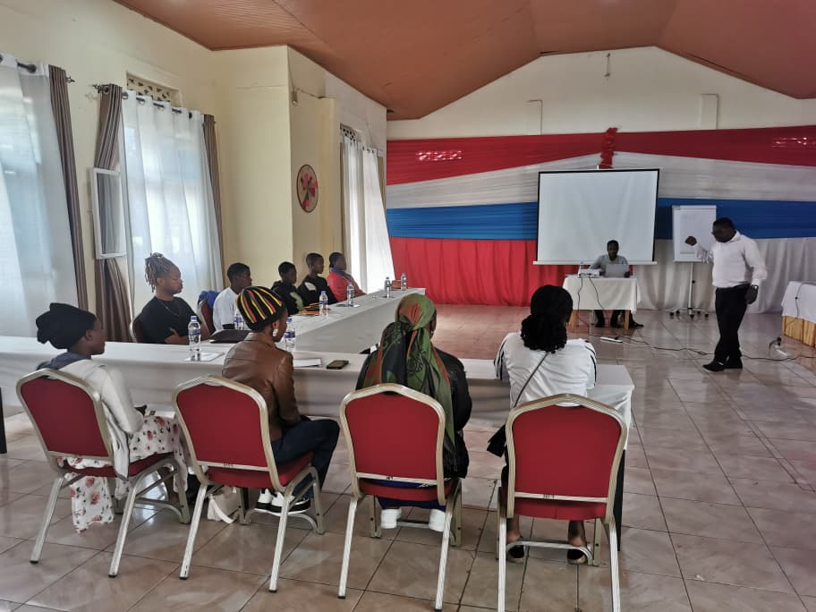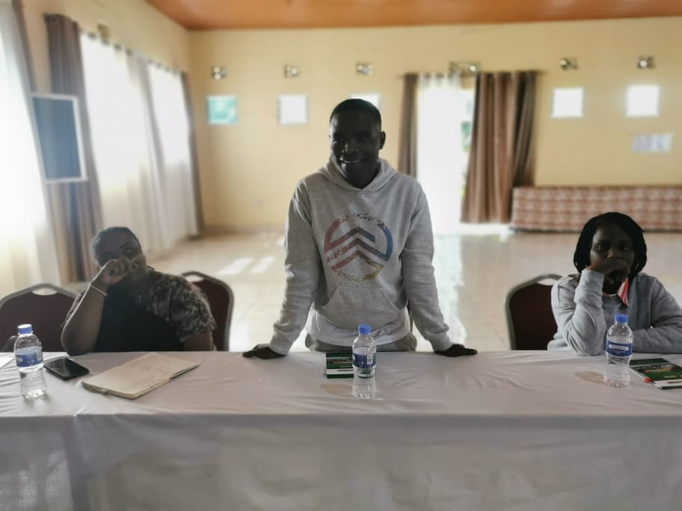
Photos were taken on the day one of training/workshop

Day Two: Drug and Alcohol Abuse and Public Health Risks
The second day addressed drug and alcohol abuse, highlighting its definition, causes, and consequences. The facilitator explained the link between substance abuse and increased vulnerability to HIV, mental health disorders, cardiovascular diseases, and other health complications.
Discussions emphasized prevention strategies, community awareness, and the role of peer education in reducing substance abuse among youth and key populations.
The final day also focused on Ebola Virus Disease (EVD), Mpox, and Marburg Virus Disease (MVD). Participants were informed about symptoms, transmission routes, and prevention measures for each disease.
Key prevention messages included:
- Importance of hand hygiene and infection prevention measures;
- Avoiding contact with infected individuals and contaminated materials;
- Early reporting of symptoms to health authorities;
- Community vigilance and timely response to outbreaks.
The sessions concluded with open discussions, allowing participants to ask questions and clarify misconceptions about these diseases.
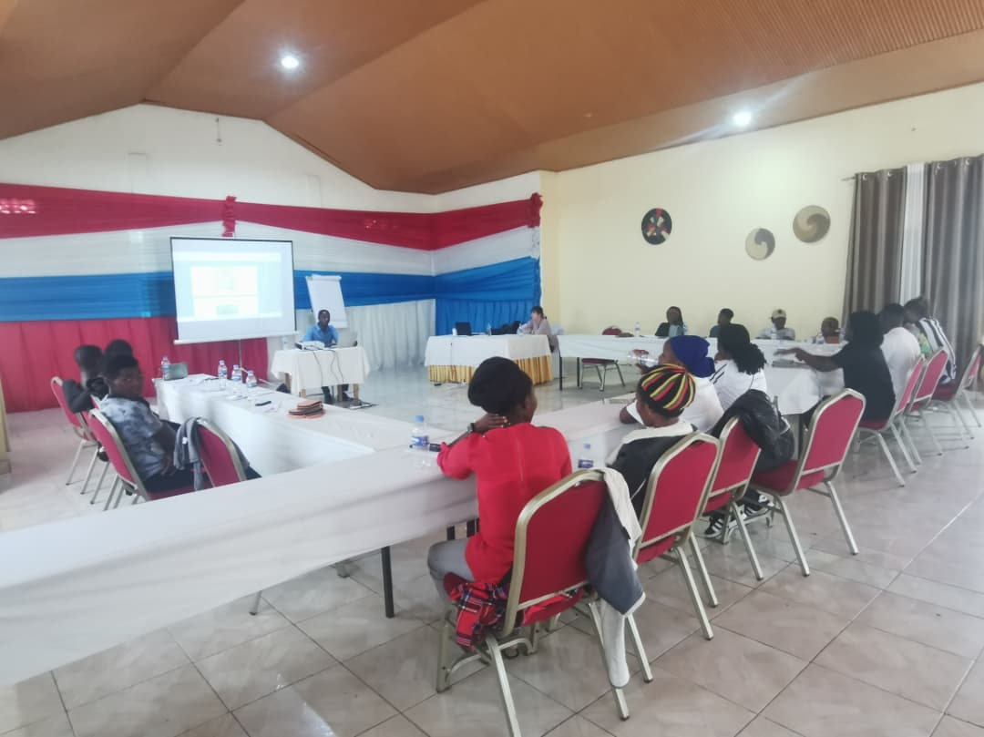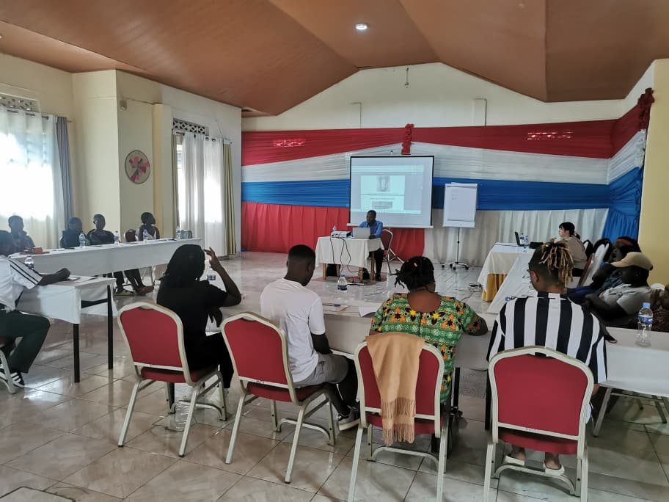
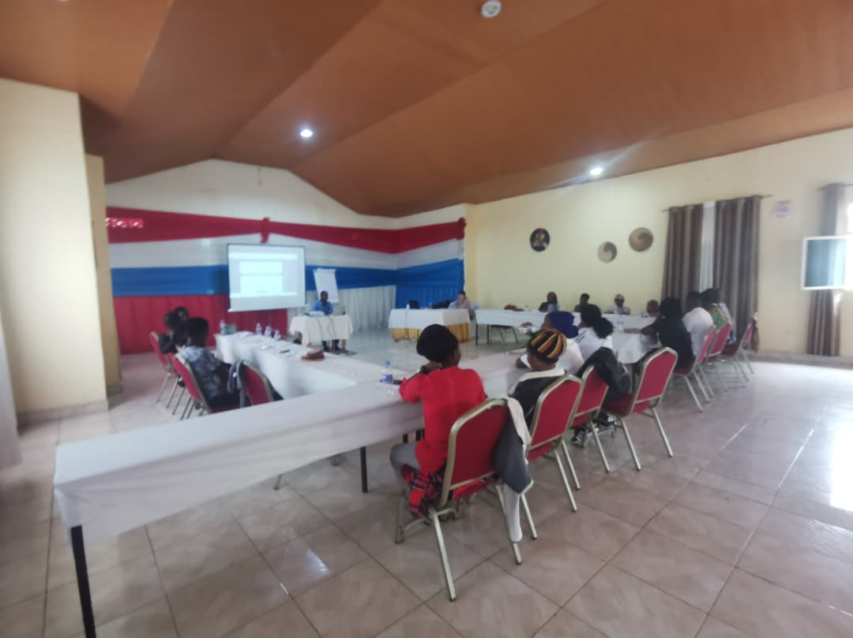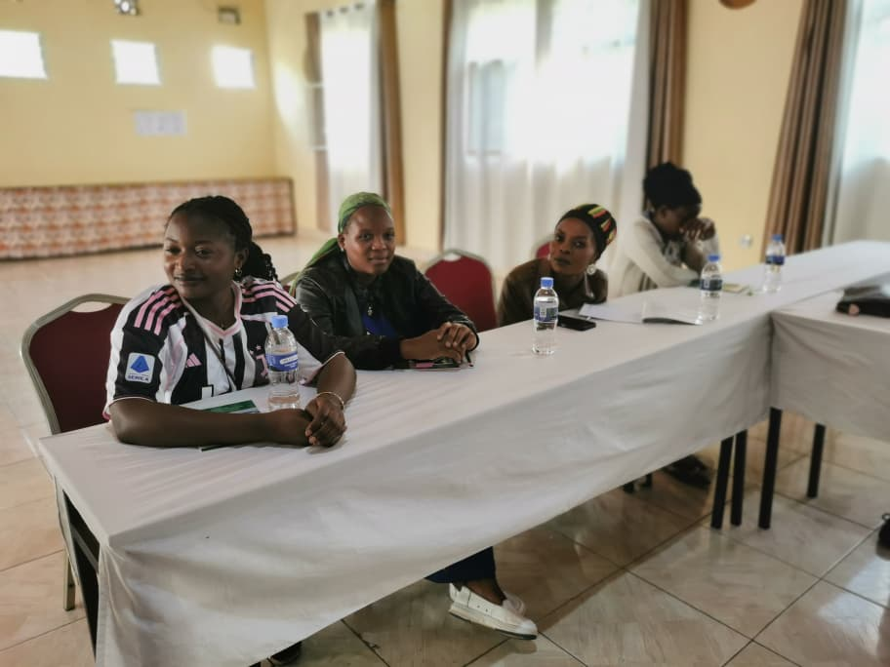
Photos of day-two of training workshop
- RESULTS AND ACHIEVEMENTS
- Participants gained improved knowledge on COVID-19, HIV, STIs, SRHR, drug and alcohol abuse, and emerging pandemics;
- Participants committed to disseminating the knowledge acquired within their communities to enhance prevention and early health-seeking behaviors.

- CHALLENGES IDENTIFIED
- Persistent stigma and discrimination against key populations, which hinders them from joining other activities ;
- Limited time to cover all topics in depth due to the wide scope of subjects;
- Ongoing misinformation within communities regarding emerging diseases.

- RECOMMENDATIONS
- Continue organizing regular awareness meetings and trainings for communities and key populations;
- Strengthen advocacy and anti-stigma campaigns targeting healthcare providers and the general community;
- Allocate more time for future awareness activities to allow deeper engagement on complex topics.
- CONCLUSION
The three-day robust awareness meeting conducted in Musanze District from 25th to 27th November 2025 successfully strengthened community awareness and engagement on key public health issues. Through interactive discussions and knowledge sharing, participants were empowered to play an active role in HIV prevention, promotion of SRHR, reduction of substance abuse, and response to emerging diseases.
ANSP+ remains committed to working with RBC, the Global Fund, and other stakeholders to sustain community mobilization efforts and improve health outcomes for key and vulnerable populations.
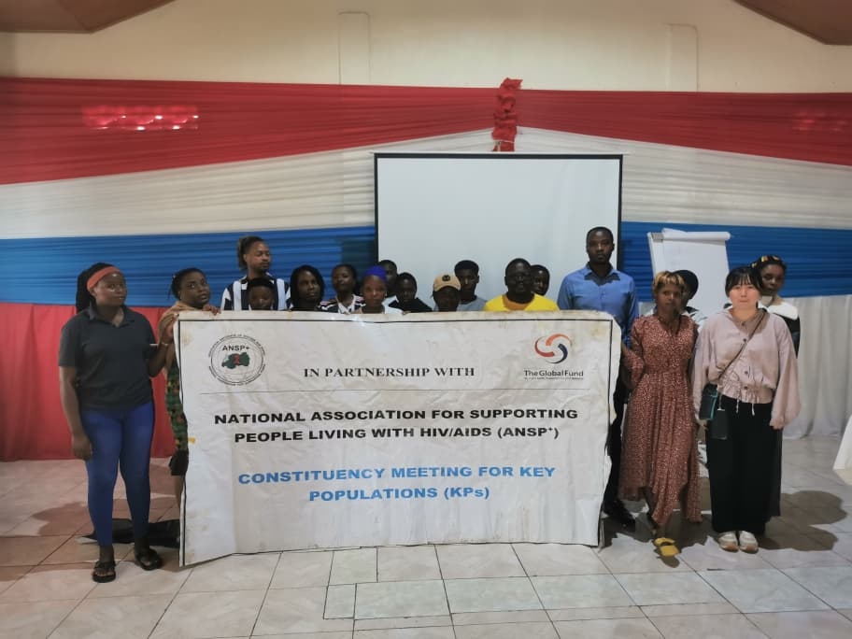
A group photo was captured after the training/workshop

STAFF MEMBERS IN MISSION
UMUTONI WA MANA Laurence
NIZEYIMANA Jean Marie Vianney
MUKASEKURU Deborah
UZABAKIRIHO Jean Gabriel

