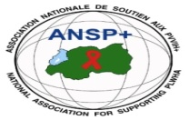

PROJECT NAME: ANSP+/RBC/SPIU

NAME OF ORGANIZATION: NATIONAL ASSOCIATION FOR SUPPORTING PEOPLE LIVING WITH HIV/AIDS (ANSP+)
ACTIVITY: CONDUCTING SUPPORTIVE SUPERVISIONS OF ACTIVITIES OF KEY POPULATIONS (LGBTIs/MSM and/or FEMALE SEX WORKERS)
AREA OF INTERVENTION: Musanze District

MISSION REPORT
- INTRODUCTION
ANSP+ stands as the National Association for Supporting People Living with HIV/AIDS. It is a Rwandan local Non-Governmental Organization created in September 2000 by People Living with HIV themselves, with the core mission of striving for the quality of life of HIV-infected and affected people in Rwanda, while fighting against the spread of HIV/AIDS and other epidemics.
Beyond this mission, ANSP+ plays a role in poverty reduction and the promotion of human rights. Key Populations (KPs) remain among its core beneficiaries, many of whom face economic challenges that push them into sex work, increasing their exposure to HIV.
In addition to mobilizing KPs on drug adherence and prevention techniques, ANSP+ supports them in developing sustainable income-generating activities (Income-generating activities). Through cooperatives, associations, and self-help groups, ANSP+ empowers KPs to pursue financial stability and reduce dependence on sex work.
In this context, and with support from the Global Fund/RBC, ANSP+ conducted a one-day supportive supervision field mission in Musanze District. The mission aimed to assess KP engagement in Income Generating Activities, evaluate their progress, identify challenges, and provide tailored guidance.
- OBJECTIVES OF THE FIELDWORK
- To discuss with KP cooperative/association/self-help group about the income-generating activities being carried out.
- To visit the activities of KPs on the ground.
- To evaluate the opportunities and challenges faced in implementing their activities.
- To provide advice on how members can strengthen and sustain their cooperatives and associations.

- TARGET GROUP
The fieldwork targeted 12 members of TUZAMURANE association located in Musanze District, Muko Sector.
- DATE AND VENUE
The field supervision was conducted from 26th to 27th November 2025 in Musanze District, Muko Sector.
- FIELD VISITS AND FINDINGS

Key Findings:
- Members of the Association engaged in maize cultivation on a small scale of land, and they expect to have productivity of 150,000 RWF in January 2026.
- The members have demonstrated a strong commitment to their saving culture and are able to maintain health insurance.
- Regular activities that bring them together allow members to discuss and address various issues, both financial and related to mental health, through open discussions among themselves.
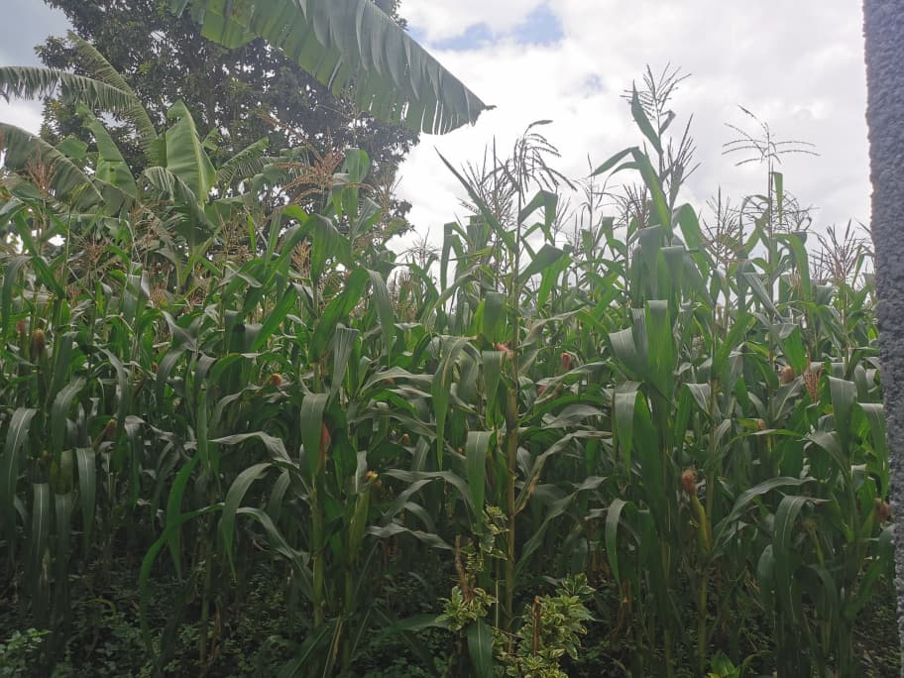
Photo that shows where they cultivate maize
- CHALLENGES IDENTIFIED
- Limited access to condoms, lubricants, and other essential health services.
- Insufficient financial resources to initiate or expand their income-generating activities.
- Stigma, discrimination, and social exclusion of KPs, particularly those living with HIV.
- RECOMMENDATIONS
- Advocate for increased supply of condoms and lubricants at health centers serving KPs.
- Provide entrepreneurship and financial literacy training to enhance the sustainability of Income-generating activities.
- Engage community leaders to reduce stigma and promote inclusion of KPs.
- Improve mental health services and psychosocial support for Key Populations.
- Strengthen continuous follow-up with KP groups to monitor progress and identify emerging needs.
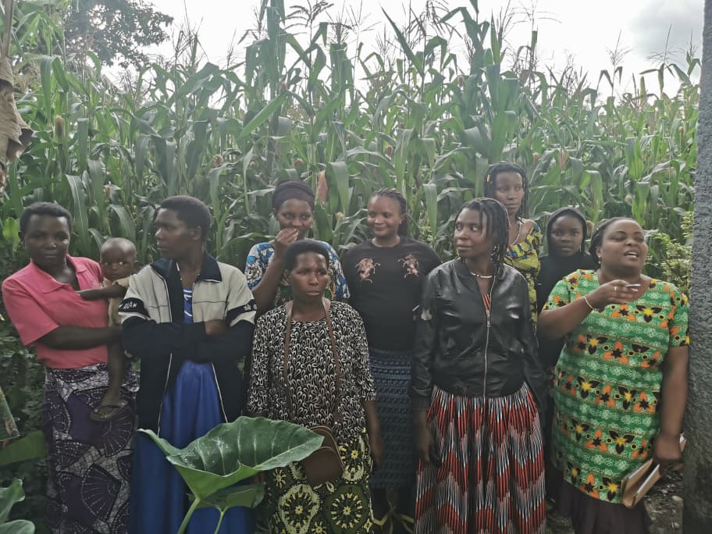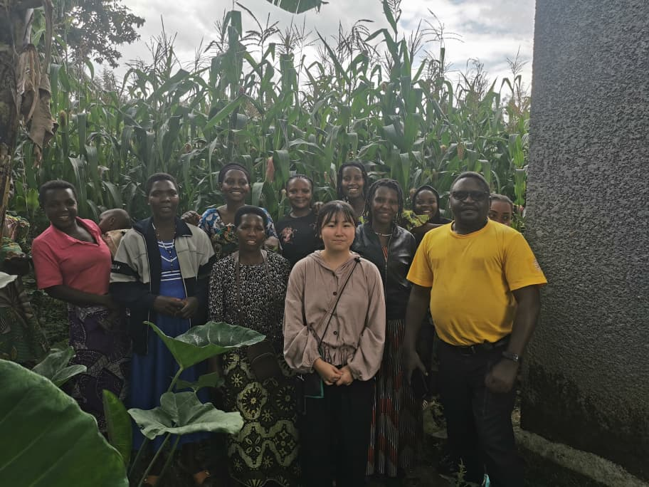
After the visit and discussions DAF and association members took a souvenir photo
- CONCLUSION
The field supervision mission in Musanze District offered the ANSP+ team valuable insights into the progress, needs, and challenges of KP associations in the region. Visits to TUZAMURANE Association helped the team directly assess the status of Income-generating activities, health access, and social challenges faced by members.
ANSP+ remains committed to working with partners and local stakeholders to enhance economic resilience, health outcomes, and social well-being for Key Populations in Musanze District.

STAFF MEMBERS IN MISSION
- UZABAKIRIHO Jean Gabriel
- UMUTONI WA MANA Laurence
- NIZEYIMANA Jean Marie Vianney
- MUKASEKURU Deborah

