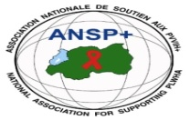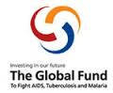

PROJECT NAME: ANSP+/RBC/SPIU

NAME OF ORGANIZATION: NATIONAL ASSOCIATION FOR SUPPORTING PEOPLE LIVING WITH HIV/AIDS (ANSP+)
ACTIVITY: CONDUCTING SUPPORTIVE SUPERVISIONS OF ACTIVITIES OF KEY POPULATIONS (LGBTIs/MSM and/or FEMALE SEX WORKERS)
AREA OF INTERVENTION: Nyagatare District

MISSION REPORT
- INTRODUCTION
ANSP+ stands as the National Association for Supporting People Living with HIV/AIDS. It is a Rwandan local Non-Governmental Organization created in September 2000 by People Living with HIV themselves, with the core mission of striving for the quality of life of HIV-infected and affected people in Rwanda, while fighting against the spread of HIV/AIDS and other epidemics.
Beyond this mission, ANSP+ plays a role in poverty reduction and the promotion of human rights. Key Populations (KPs) remain among its core beneficiaries, many of whom face economic challenges that push them into sex work, increasing their exposure to HIV.
In addition to mobilizing KPs on drug adherence and prevention techniques, ANSP+ supports them in developing sustainable income-generating activities (IGAs). Through cooperatives, associations, and self-help groups, ANSP+ empowers KPs to pursue financial stability and reduce dependence on sex work.
In this context, and with support from the Global Fund/RBC, ANSP+ conducted a three-day supportive supervision field mission in Nyagatare District. The mission aimed to assess KP engagement in Income Generating Activities, evaluate their progress, identify challenges, and provide tailored guidance.
- OBJECTIVES OF THE FIELDWORK
- To discuss with KP cooperatives/associations/self-help groups about the income-generating activities being carried out.
- To visit the activities of KPs on the ground.
- To evaluate the opportunities and challenges faced in implementing their activities.
- To provide advice on how members can strengthen and sustain their cooperatives and associations.
- TARGET GROUP
The fieldwork targeted members of KP associations located in Nyagatare District, specifically:
- Hope for Future Association – Mimuri Sector
- DUTERIMBERE Association – Rwempasha Sector
- DATE AND VENUE
The field supervision was conducted from 5th to 7th November 2025 in Nyagatare District.
The ANSP+ team engaged members in discussions focused on:
- Health-related issues affecting KPs
- Their income-generating activities
- Socio-economic inclusion
- Evaluation of progress following earlier training workshops
- FIELD VISITS AND FINDINGS

V.1. Visit to Hope for Future Association – Nyagatare Sector
The first visit was conducted with members of the Hope for Future Association in Nyagatare Sector. Members are engaged in small-scale activities such as farming and saving groups.

Key Findings:
- Members cultivated sorghum on 2 hectares and they are expecting to produce 3 tons where they will earn approximately 1,000,000 RWF when they reap.
- Members are also actively participating in savings and lending initiatives.
- Several income-generating activities lack enough capital to expand or stabilize.
- Members expressed a need for support to strengthen and diversify their income activities.
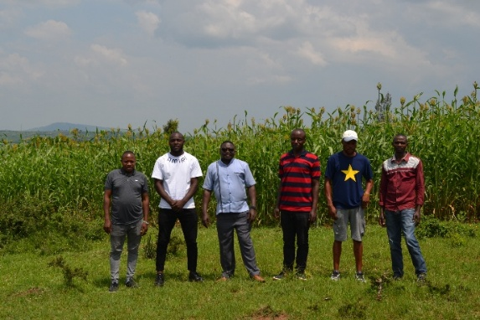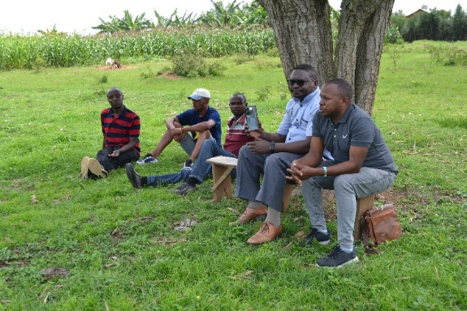
Photos taken at the field with Hope for Future Association members

V.II. Visit to DUTERIMBERE Association – Rwempasha Sector
This second visit involved members of DUTERIMBERE Association who work together in the cultivation of maize on almost 2 hectares.

Key Findings
- Members of the Association engaged in maize cultivation on 1.5 hectares expect to harvest more than 6 tons of maize, which could generate approximately 2,000,000 RWF in income.
- The members have demonstrated a strong commitment to their saving culture and are able to maintain health insurance.
- Regular activities that bring them together allow members to discuss and address various issues, both financial and related to mental health, through open discussions among themselves.
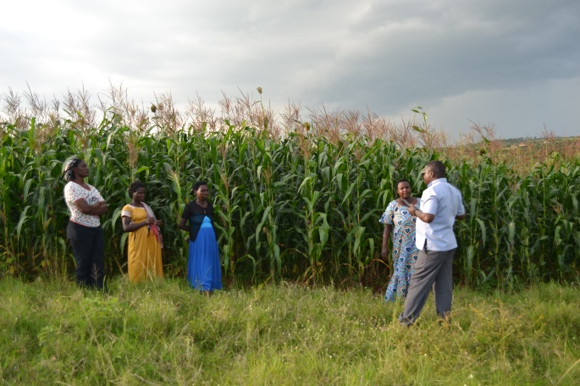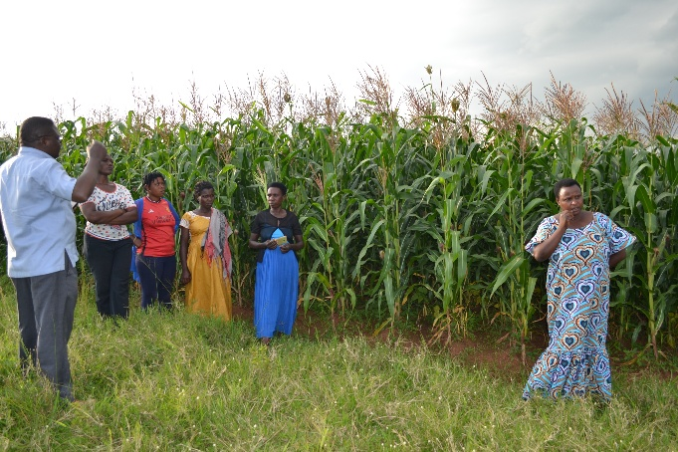
Photos taken at the field with DUTERIMBERE Association members

- CHALLENGES IDENTIFIED
- Limited access to condoms, lubricants, and other essential health services.
- Insufficient financial resources to initiate or expand IGAs.
- Stigma, discrimination, and social exclusion of KPs, particularly those living with HIV.
- RECOMMENDATIONS
- Advocate for increased supply of condoms and lubricants at health centers serving KPs.
- Provide entrepreneurship and financial literacy training to enhance the sustainability of IGAs.
- Engage community leaders to reduce stigma and promote inclusion of KPs.
- Improve mental health services and psychosocial support for Key Populations.
- Strengthen continuous follow-up with KP groups to monitor progress and identify emerging needs.
- CONCLUSION
The three-day field supervision mission in Nyagatare District offered the ANSP+ team valuable insights into the progress, needs, and challenges of KP associations in the region. Visits to Hope for Future and DUTERIMBERE Associations helped the team directly assess the status of IGAs, health access, and social challenges faced by members.
ANSP+ remains committed to working with partners and local stakeholders to enhance economic resilience, health outcomes, and social well-being for Key Populations in Nyagatare District.

STAFF MEMBERS IN MISSION
- UZABAKIRIHO Jean Gabriel
- UMUTONI WA MANA Laurence
- NIZEYIMANA J.M. Vianney
- MUKASEKURU Deborah

